**First Army, Division West**

**Knowledge and Information**

**Management Plan and SOP**

**(KIMP)**

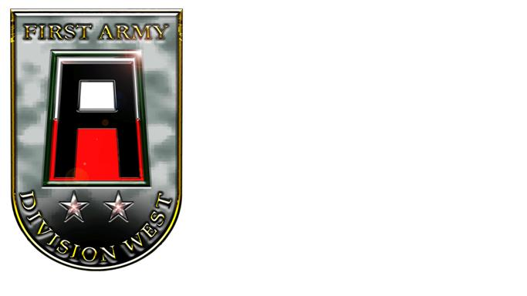

**January 2013**

## **DEPARTMENT OF THE ARMY**

FIRST ARMY DIVISION WEST

BUILDING 410, 761st TANK BN AVENUE

FORT HOOD, TX 76544

January 31, 2013

**Message from the Chief of Staff**

Knowledge Management is a discipline which helps transform our current decision-making processes from difficult, incremental, iterative information and data hoarding efforts to streamlined processes complete with knowledge sharing. Documenting these streamlined processes is critical; we need to capture what we do and how we do it.

It is important for everyone to understand that the cultural aspect of knowledge sharing is critical to First Army Division West. Our Knowledge Management emphasis will focus on our people and teams, building a mutual trust between all parties. Throughout our daily operations we must look for opportunities to share what we have learned. Additionally, we’ll capture key knowledge and share it using the appropriate collaborative tools.

We will operate using the “smart push” and “trainer/supporter pull” concept. Only critical or time-sensitive information will be pushed or disseminated. All other information will be available via DIV WEST’s collaborative environment to allow for reach back by our distributed training warriors. Knowledge and information sharing require the use of the collaborative best practices outlined in this Knowledge Management Standard Operating Procedures (KM SOP).

This SOP is applicable to all DIV WEST teammates.

TOBIN S. GREEN

Colonel, GS

Chief of Staff

**Table of Contents\***

**I. References. 5**

**II. Purpose. 5**

**III. Scope, Duties and Responsibilities. 4-6**

1. **Introduction.**
2. **Division KMO.**
3. **Division Deputy KMO.**
4. **Division KM NCO.**
5. **Division IT/CM Specialist.**
6. **Unit/Section KMRs/Page POCs.**
7. **KM Working Group (KMWG.)**
8. **Responsibility for the KIMP.**
9. **Mission.**

**IV. Knowledge Management Principles. 5-6**

**A. Introduction.**

**B. Definition of Knowledge Management.**

**C. Levels of Information.**

**D. Understanding.**

**V. Distributive Tools. 6-11**

**A. Introduction. 6**

**B. Goal of WESTNET. 6-7**

**C. Types of WESTNET Networks. 7-8**

**D. Standardized Design. 8-9**

**E. Web Page Procedures and Rules. 9-11**

**VI. Processing Information. 12-25**

**A. Commander’s Critical Information Requirements (CCIR.) 11-14**

**B. SIGACTS. 14-15**

**C. Requests for Information (RFIs) Procedures. 15-18**

**D. Managing Document Files. 18-19**

**E. File Naming Conventions. 19-22**

**F. Alerts. 22-24**

**G. Managing Photos and Other Multi-media Files. 24-25**

**VII. Collaboration Tools. 25-33 A. Tasking Lists (Taskers). 25-27**

**B. Calendar. 27-31**

**C. Discussion Forums and Wikis. 31-33**

**VIII. Additional Digital TTPs. 33-35**

**A. Bandwidth. 33**

**B. Email. 33-34**

**C. Media Storage. 34-35**

**D. Video. 35**

**E. Outside Agency Collection Efforts. 35**

**IX. Troubleshooting & Submitting Changes. 35-37**

**A. Technical Problems.**

**B. Submitting Portal Changes.**

**C. Portal Surveys.**

**D. Approving Portal Changes.**

**E. KIMP Changes.**

**EXHIBITS**

**Exh A. KM Definitions.**

**Exh B. WESTNET Portal and Network Structure. TBP**

**Exh C. Best Practices for AKO and SharePoint.**

**Exh D. Disaster and Recovery Plan. TBP.**

**Exh E. AKO Administrator Guide.**

**Exh F. SP Administrator Guide.**

**\*Supersedes Division West OPSOP, Tab J, Appendix 13 KM 20101101, which is obsolete.**

1. **References.**
   1. [AR 11-33. Army Lessons Learned Program (ALLP.), 17 Oct 2006.](http://armypubs.army.mil/epubs/pdf/r11_33.pdf)
   2. [AR 25-1. Army Knowledge Mgmt and Information Technology, 04 Dec 2008](http://www.apd.army.mil/pdffiles/r25_1.pdf).
   3. [ADP 3-0. Unified Land Operations, 10 Oct 2011](http://armypubs.army.mil/doctrine/DR_pubs/dr_a/pdf/adp3_0.pdf).
   4. [ADRP 3-0. Unified Land Operations, 16 May 2012](http://armypubs.army.mil/doctrine/DR_pubs/dr_a/pdf/adrp3_0.pdf).
   5. [ADP 5-0. The Operations Process, 17 May 2012](http://armypubs.army.mil/doctrine/DR_pubs/dr_a/pdf/adp5_0.pdf).
   6. [ADRP 5-0. The Operations Process, 17 May 2012](http://armypubs.army.mil/doctrine/DR_pubs/dr_a/pdf/adrp5_0.pdf).
   7. [ATTP 5-0.1. Commander and Staff Officer Guide, 14 Sep 2011.](http://armypubs.army.mil/doctrine/DR_pubs/dr_a/pdf/attp5_0x1.pdf)
   8. [ADP 6-0. Mission Command, 17 May 2012](http://armypubs.army.mil/doctrine/DR_pubs/dr_a/pdf/adp6_0.pdf).
   9. [ADRP 6-0. Mission Command, 17 May 2012](http://armypubs.army.mil/doctrine/DR_pubs/dr_a/pdf/adrp6_0.pdf).
   10. [FM 6-01.1. Knowledge Management Section, 16 Jul 2012](http://armypubs.army.mil/doctrine/DR_pubs/dr_a/pdf/fm6_01x1.pdf).
   11. 41st Fires Brigade Knowledge/Information Management Plan, Nov 2011.
   12. JFCOM, JECC KM SOP.
2. **Purpose.** This document provides First Army, Division West (Division West-DW) leaders, staff, and subordinate units with baseline guidance in regarding development, display and dissemination of information and knowledge within the Division and external to it using various information tools. For the purposes of referring to the *Microsoft Office SharePoint Services* suite, the Division West presence on AKO, or other networked systems, will be collectively known as the Div West Network or “WESTNET.” It further assists by providing guidance and recommendations on how to exploit present technologies to streamline decision making cycles with staff sections and units. It will be tailored, as necessary, in adjustment to operational changes. This SOP is applicable to all personnel assigned or attached to First Army Division West and its subordinate units, to include units in training. The proponent for this document is the DW Knowledge Management Officer (KMO.)
3. **Scope, Mission, Duties and Responsibilities.** 
   1. **Introduction.** Knowledge Management (KM) is the process of enabling knowledge flow to enhance shared understanding, learning, and decision making. KM is a shared responsibility. Each functional element in Division West is tasked to provide input to the G3, DW KMO and the KM section (which may contain an assistant KM Officer, a KM non-commissioned officer, and a Content Management / Information Technology specialist,) and G6 specifying how critical information is handled within each subordinate unit and staff section. This consolidated input forms the Division West Knowledge and Information Management Plan (DW KIMP.)
   2. **Mission.** The DW KM Section implements procedures and operations to ensure successful accomplishment of the following tasks:
      1. Manage/Supervise Knowledge Management Operations.
         1. Standardize KM training across the Division’s formation.
         2. Provide formal/informal supervision to all S6 / KM trainers within the command.
         3. Coordinate and execute KM training for brigade/staff KMRs.
      2. Provide Supervision/Management/Administration.
         1. Establish and maintain reporting with brigade and staff section KMRs.
         2. Monitor KM, SharePoint, and AKO training as required.
         3. Supervise, support and assess brigade and staff section KMRs.
      3. Provide Professional Support to the Command.
         1. Advise the commander and staff on potential knowledge gaps within the command and solutions to close them.
         2. Monitor information and knowledge transfer trends within the organization and nominate potential solution sets to improve a common understanding and improve mission situational awareness.
   3. **Division KMO.** The KMO’s primary duties and responsibilities include creating, facilitating, and managing a horizontally-based, vertically-integrated knowledge transfer system designed to harness emerging knowledge and information enabling leaders and staff to make timely decisions through technological innovation and cultural engagement. This is accomplished by leveraging existing and emerging technologies such as Microsoft SharePoint Services 2010, Army Knowledge Online (AKO), milSuite provided tools/portals, Direct Connect Online (DCO), and any other authorized applications. The KM officer directs the KM section. KM officers ensure KM processes and procedures are understood within the unit. They demonstrate how these processes and procedures can improve efficiency and improve a common understanding during operations, especially in a resource-constrained environment. The KM officer reports to the First Army Division West Chief of Staff. The Division Knowledge Management Officer’s responsibilities include the following:
      1. Help the staff perform internal and external knowledge gap analyses. Create techniques to bridge gaps.
      2. Recommend creating an organizational knowledge network and provide metrics for evaluating its effectiveness.
      3. Create a unit KM plan and execute it through the unit staff. Ensure the KM section fully supports this plan.
      4. Continuously assess KM as it applies to staff readiness, unit infrastructure, and unit performance.
      5. Advise the commander and staff on integrating KM practices and procedures throughout the organization.
      6. Monitor emerging KM trends for incorporation into unit operations.
      7. Monitor formal and informal social networks that transfer knowledge. This monitoring answers the questions: Who are the unit subject matter experts (SMEs)? Who goes to them? What connects seekers with SMEs?
      8. Facilitate achieving greater knowledge creation and transfer across the organization. Seek feedback to evaluate the progress of knowledge sharing initiatives.
      9. Show staff teams how to develop knowledge sharing within their areas of expertise.
      10. Develop KM policies and procedures and ensure command-wide dissemination and compliance.
      11. Develop effective techniques and procedures for organizing, applying, and transferring observations, insights, and lessons from after action reviews into unit operations, standing operating procedures, and training.
      12. Oversee planning and implementing KM activities across the unit by communicating with other commands’ KM officers, both horizontally and vertically.
      13. Establish and chair a working group made up of staff representatives and KM officers from subordinate units.
      14. Plan the creation, management, and monitoring of active participation in a knowledge network within the unit’s organizational structure to facilitate operational synchronization.
      15. Oversee the unit’s content management efforts.
      16. Serve as the chief architect for the KM structure. Understand the functions of its information systems and other technical networks and how to best use them to integrate their products into the common operational picture.
      17. Coordinate with the G6 to ensure that the unit’s technical network supports knowledge creation, organization, application, and transfer across the unit.
      18. Help subordinate units without KM sections apply KM.
   4. **Division Deputy KMO.** The Deputy KM officer ensures members understand KM processes and technology. The Deputy KMO is responsible for understanding the Global Information Grid and Army operational KM, and for helping the unit use the capabilities of these resources. The Deputy KMO also helps the G3 and G6 map the processes and information systems that produce the common operational picture. The Deputy KMO reports to the Division KMO. The Deputy KMO responsibilities include:
      1. Coordinate and integrate the creation and organization of the common operational picture.
      2. Initiate, coordinate for, and maintain a virtual right-seat ride capability where possible.
      3. Execute KM policies and plans within the KM section.
      4. Improve knowledge sharing and overall unit effectiveness by continuously assessing the unit’s KM program, infrastructure, and readiness.
      5. Develop, organize, and supervise implementation of the unit’s content management effort.
      6. Help the staff perform knowledge analysis to answer the commander’s critical information requirements and create solutions for closing persistent gaps.
      7. Seek techniques to incorporate experiential learning into organizational learning.
      8. Map the unit’s KM network among personnel. Develop metrics for evaluating KM effectiveness.
      9. Identify operationally relevant trends; observations, insights, and lessons; and significant actions. Ensure they are distributed vertically and horizontally.
      10. Ensure systems for directing requests for information work efficiently.
      11. Coordinate with the G6 to ensure connectivity to the NIPR/SIPR networks and application of its capabilities.
      12. Oversee KM-related roles and responsibilities as directed by the KM officer.
      13. Direct the KM Working Group (KMWG.)
      14. Monitor the unit’s databases and Web sites to determine appropriateness of content and eliminate redundant files.
      15. Develop the unit’s KM training and certification program.
      16. In coordination with the G6, recommend integration of human and technical KM processes into the command and control system’s technical structure to improve information flow.
   5. **Division KM NCOIC**. The KM noncommissioned officer advises the KM officer on improving knowledge creation and transfer within the staff. KM noncommissioned officers help integrate KM training concepts into the unit’s individual and collective mission-essential tasks. They oversee KM training and certification programs. Other responsibilities include:
      1. Coordinate appropriate audiovisual displays of the common operational picture and other operationally relevant KM products in command posts and other areas.
      2. Monitor collaboration sites and knowledge networks to alert the staff to relevant content.
      3. In coordination with the G2, address KM aspects of operational security.
      4. Advise on designing briefings and text documents.
      5. Help design templates and formats for recurring knowledge products to increase standardization, reduce redundancy and improve information storage and retrieval processes.
      6. Participate in the KMWGs.
      7. Ensure the unit content management plan meets DoD requirements and is fully understood and implemented across the organization.
      8. Review the unit’s file management techniques. Recommend adjustments through the KMO/AKMO as appropriate.
      9. Remain abreast of current and future trends in KM and content management. Integrate them into unit operations as needed.
      10. Supervise training in knowledge transfer procedures.
      11. Serve as the unit expert for KM tool and system training, design and use.
      12. Coordinate with G6 technical teams at Division West and First Army to identify and implement KM technical solutions.
   6. **Division KM Information Technology (IT) Content Manager (CM) Specialist.** The IT/CM Specialist (can also assume the position of the Deputy KMO if it is not filled,) serves as the Division’s expert on content management and information retrieval. This person ensures knowledge is available to Soldiers when they need it. This specialist helps the KMO/G6 manage digital content with tools that exchange explicit knowledge, collaborate, and connect with SMEs across the organization. The IT/CM Specialist duties include:
      1. Support implementation of the unit’s KM policies and procedures.
      2. Search for and capture observations, insights, and lessons from other units and individuals via non-secure and secure Internet protocol router networks (NIPRNET and SIPRNET) sites and forums.
      3. Facilitate knowledge transfer between units and leaders.
      4. Develop comprehensive document naming conventions, data tagging policies, and data organization for the unit.
      5. Train staff members on how to obtain explicit knowledge stored in knowledge networks, databases, and information systems.
      6. Help review the unit’s databases and web sites to determine the security and relevance of content.
      7. Help the KM NCO design briefings, text documents, templates, and other recurring knowledge products.
      8. Help the KMO and Deputy KMO provide expertise and training in using KM tools, processes, and systems.
      9. Remain abreast of current and future trends in KM and content management.
      10. Coordinate with the G6 (through the KMO) on incorporating current standards to improve information search and retrieval across various data sources.
      11. Supervise and conduct KM process training, including content management procedures for staff members.
      12. Coordinate with G6 technical teams to identify and implement effective solutions in content management.
   7. **Unit / Section KM Representatives (KMRs) (aka Page POCs or Site Owners.)**  Each subordinate unit and staff section within the Division must identify a KMR in order to facilitate KM processes within the organization. Aptitude, not rank, should be the primary consideration when designating a KMR.
      1. The unit/section KMR’s duty description is: Brigade/Section) KMR for a training Brigade (battalion/staff/) headquarters (Manage unit (or section) WESTNET areas in order to facilitate knowledge sharing and collaboration down to the Soldier level to harness and share all relevant information.  Conduct quality control of unit information and synchronize the KM effort in conjunction with the Division West KMO.  Provide feedback to the higher headquarters facilitating the evolution and refinement of the KM tools within WESTNET or other systems. Conduct remedial assistance and troubleshooting for units in order to allow for uninterrupted use of the system at the lowest levels.
      2. Unit/section KMRs do not need to be the most computer savvy individual in the unit/section; however, they clearly need to understand the information requirements of their commanders and/or section leaders.
      3. These KMRs will be listed on WESTNET as Page POCs for all areas within their sections, even if it is only one page. These Page POCs will have the permissions required to create work orders and communicate directly with all WESTNET administrators and the KMO.
   8. **KM Working Group (KMWG.)** The unit KMRs/Page POCs will meet with the Division West KMO to resolve KM issues, discuss updates, and other relevant topics on a regular basis. This forum is called the DW KMWG, and will be conducted in accordance with the Division West Battle Rhythm, typically twice a month. The Division West KMO and/or other designated personnel will also attend the First Army (1A) KMWG/Governance Board as scheduled on the 1A Battle Rhythm, typically also twice a month.
   9. **Responsibility for the KIMP.** The Division West KMO has overall responsibility for implementation of this KIMP. Subordinate unit and Brigade staff section KMRs are responsible for implementing control measures as required within their organizations.
4. **KM Principles.**
   1. **Introduction.**  This plan provides the Division with a variety of guidelines and techniques to harness information for use by commanders and staffs at all levels within 1A DW.
   2. **Definition of KM.** The definition of KM is theart of creating, applying, organizing, and transferring knowledge to facilitate situational understanding and decision making. KM supports improving organizational learning, innovation, and performance.  KM processes ensure that knowledge products and services are relevant, accurate, timely, and usable to commanders and decision makers as one of the four primary staff tasks supporting mission command (ADP 3-0.) KM is of value only when it is available to use to improve organizational effectiveness, operational processes, and decision-making. (FM 6-01.1) Knowledge creation is the process of developing new knowledge or combining, restructuring, or repurposing existing knowledge in response to identified knowledge gaps (FM 6-01.1.)
   3. **KM Components.** It’s critical to understand that KM is much more than SharePoint, AKO, or some other automated tool. KM is comprised of four major components: the People, the Processes, the Tools, and the Organization in which they operate. (FM 6-01.1.) See Figure 1a.

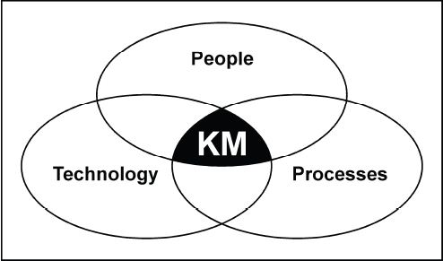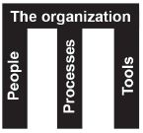

**Figure 1a – KM Components**

* 1. **KM and the Cognitive Hierarchy.** In order to effectively harness data and transition it into knowledge, prescriptive rules must be applied. These rules, used within a manageable organized framework, will allow commanders and staffs to determine those pieces of information that are important. Information can be broken down into three (3) levels as the first three foundations taken from FM 6-01.1 and portrayed in Figure 1b:
     1. Level-3 – Data. Data is raw and unprocessed “stuff”: numbers, pictures, letters, etc. It serves as the building blocks of information. Typically it does not answer the “So what?” question. Data is simply the “what” and in today’s world of information/data systems, there’s a log of “what” to capture, store, and retrieve. It provides background to decision makers, is NICE TO KNOW and often creates more questions than answers. An example of datais “*Ten enemy tanks moving in column*.”
     2. Level-2 – Information. Information is processed and packaged data. Information places elements of data into context which begins to apply meaning to the data elements themselves. When applied, it begins to paint the picture for the decision maker making situations/events understandable. This is GOOD TO KNOW information. An example of information is “*Ten enemy tanks moving west in column at grid AB12345678 at 310700OCT2009*.”
     3. Level-1 – Knowledge. Knowledge is information with context and experience (cognition.) It answers the “How?” question. This is MUST KNOW information. Examples of knowledge include of Commander’s Critical Information Requirements (CCIR) consisting of: Priority Intelligence Requirements (PIR), Friendly Force Information Requirements (FFIR) and, if utilized, Essential Elements of Friendly Information (EEFI.) These pieces of information are situation-dependent and will change with operational conditions. Following the continuing example of knowledge from the *information* above is: “*Ten enemy tanks moving west in column at grid AB12345678 at 310700OCT2009*” means that the enemy has responded to our feint and is committing its once hidden reserve in that direction and we can begin our main attack to the south.” Knowledge begins to answer the “So what?” questions.

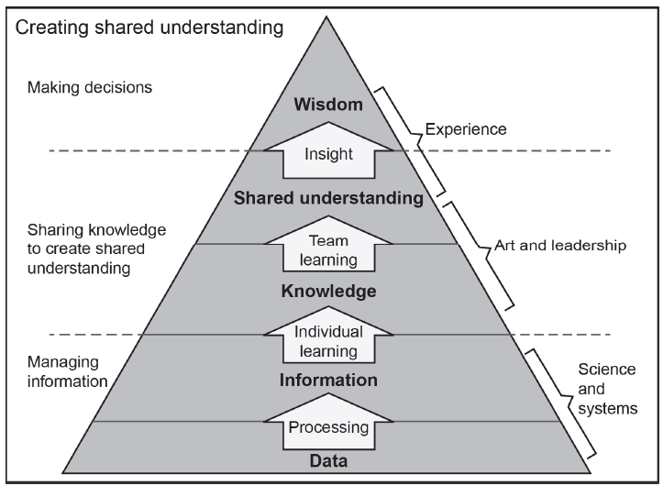

**Figure 1b – Hierarchy of Knowledge Creation**

* 1. **Understanding.** These three levels of the Cognitive Hierarchy synthesize data and information into knowledge which then becomes intellectual capital, know-how, or experience to be leveraged, shared and applied via a quickened decision making cycle, in order for the Commander to make a well-informed decision. This is where the “now what?” question is ready for the commander’s decision, perhaps based on this decision point, and/or the commander’s experience and wisdom.

1. **Distributive Tools.**
   1. **Introduction.** Within Division West, information is primarily disseminated in the form of web-based products. While the Division will use other tools, such as face-to-face encounters, BlackBerry, DISA’s DCO web-conferencing system and telephone to pass information, the primary means of information exchange will be network-based using three major types of tools: a distributive and collaborative tool utilizing a form of Microsoft SharePoint (SP) for NIPR and SIPR, with AKO as the NIPR archive (and AKO-S as a SIPR backup and temporary storage; and a communication tool in the form of email, mainly using Outlook. The Division West KMO is responsible for operational implementation and content management of all Division portals. This includes the provision of one or more dedicated system administrator/s and if funds are available, a civilian SharePoint contractor developer to form the WESTNET Portal Team.
   2. **Goal of WESTNET.** The goal of WESTNET is to have ONLY the most relevant and updated information up front and designed for easy use and navigation.
      1. Level-1 knowledge should be no more than one (1) mouse click away, typically using shortcut links, buttons and tabs.
      2. Level-2 information should reside on section/unit pages, located in easily identifiable areas which aid in:

* + - 1. Build the picture for decision makers.
      2. Have visible links to that information (i.e. menus, hot buttons, and links,)
      3. Follow the two (2) click rule.
    1. WESTNET pages should include Level-3 data, but that information should not clutter the front end of a web/portal page. A better practice would be to make that content accessible within document libraries, lists, other web parts/channels, or server partitions.
  1. Each section applies its own inherent expertise to turn its relevant information into a suitable, informative web-based product. The WESTNET assists in digitizing the Division Mobilization/De-mobilization Operations Center at Division HQ (DMOC) and the Mobilization/Demobilization Operation Centers(MDOC) at our MTCs replacing the old butcher-block easels, map boards, and acetate status charts that were maintained and updated in an analog Operations Center. Much of the conveyed information is the same, but the distribution and transmission medium affords EVERYONE – not just those in the TOC within eyesight of the information– access to real-time operational information.
  2. **The WESTNET’s Network.** There are four types of WESTNET network-based tools utilized within Division West: WESTNET, WESTNET-AKO-S, WESTNET-N, and WESTNET-AKO. Other sites are not formally part of WESTNET, but are included for situational awareness.
     1. WESTNET (SIPR.) **TBD if available.** Classified **US SECRET** and kept up on a semi-permanent basis unless in a deployment or redeployment shipping status: (http:// TBD.) This portal’s hardware, software and related periphery is Division-owned with infrastructure and administration maintained by the DW G6 and KMO utilizing a version of SharePoint (07/10) housed in the Ft Hood Network Enterprise Center (NEC) building, using the most up-to-date service packs and patches. This WESTNET is the primary SIPR portal for the Division, but is ONLY accessible within a .mil domain in garrison or field conditions. When deployed, anyone with SIPR access can enter WESTNET anonymously with “Read only” access. The color scheme is tan with a RED banner across the top, with the above label. Certain portions of WESTNET can be restricted to **NOFORN**, by removing some of the shared permissions as required and clearly labeled as NOFORN or LIMDIS.
     2. WESTNET-AKO-S. (SIPR) Classified **US SECRET** and kept up on a permanent basis within the AKO-S network>. It can also be accessed by clicking “Groups” and typing “First Army Division West” in the search box, and then clicking “Homepage” <<https://www.us.army.smil.mil/suite/page/16074>> in the upper left of the displayed Division West group <<https://www.us.army.smil.mil/suite/group/10882>> All other groups under Division West begin with “1ADW…” except 85th Support Command that begins with “85SC …”. WESTNET-AKO-S is used for archiving classified files to include exercises. WESTNET-AKO-S is accessible world-wide from any domain with SIPR access. Any files posted to this portal should also be posted to WESTNET as soon as practical. AKO-S is also a valuable tool for saving files when Division West subordinate units, or those returning from contingency operations that do not have their own parent unit, are in the RIP/TOA process that wish “immediate use” upon return to home station, or for uploading “take home” PDSS packages without having to hand-carry these files under courier orders as provided by the G2. The Portal Team is the primary administrator, but delegates the administrative control to staff and subordinate units for managerial control upon satisfactory completion of AKO training or show competency in its use.
     3. WESTNET-AKO. **UNCLASSIFIED** and kept up on a permanent basis, which is accessible by all AKO users at <<https://www.us.army.mil/suite/page/388476>> or searched by using search name “First Army Division West”. All other groups begin with “1ADW …” except 85th Support Command that begins with “85SC …” Group unit assignment into the Division West and subordinate unit groups is automatic, based on a user’s assignment and Unit Identification Code (UIC) during in-processing using a Rule-based group entry within the headquarters’ of that unit. Joining anything other than a unit group/s requires being added to that group by a unit or brigade administrator. The WESTNET-AKO color scheme is a white background, cardinal red borders with white lettering, and a green UNCLASSIFIED banner on the homepage. The highest classification that can be put on WESTNET-AKO is FOUO. This is the archive and backup NIPR portal for the Division and is accessible world-wide with an Internet connection and an AKO account. For full functionality in AKO, users must log in with a valid CAC card, instead of the alternate method of username and password, with Knowledge Based Access (KBA—the three personal questions.) Certain portions may be restricted for anonymous access depending on the permissions imposed on those pages or files and subject to CAC-only access to the “Green” FOUO folders.
     4. WESTNET-N (NIPR). **UNCLASSIFIED** and is a permanent presence accessible on NIPR computers with a CAC reader within the Ft Hood NEC network, or worldwide from any .mil domain only, unless one has a Virtual Private Network (VPN) account for use off post. The homepage of WESTNET-N is: <<https://extranet.first.army.mil/DW/SitePages/Home.aspx>>, whether on a Ft Hood installation or using the VPN connection, or an AirCard. For those who are on USAR, ARNG, other military networks without a trust, or commercial networks, the alternate address uses AKO authentication and is accessed by this link: <<https://ako.first.army.mil/dw/SitePages/Home.aspx> > and one must have a CAC reader on their work station or computer.  
          
        The hardware infrastructure and overall administrative control is controlled by First Army G6 at Rock Island Arsenal, IL with a local site collection administrative control of this *SharePoint 2010* portal by KM Portal Admin, the KMO, and DW G6 Admin. The WESTNET-N color scheme is the same as the First Army scheme with a green UNCLASSIFIED// FOUO and the Division West or unit icons’ in the upper left corner. This is the primary operational NIPR portal for the Division. This portal will also be used for training for WESTNET and as a “Test Portal,” by DW Portal Team administrators for testing and development of new tools and web-parts for use on the WESTNET portals.
     5. Division West SAN NIPR Partition (File Shares/Shared Drive.) The Division maintains XXX GB of server space on the Ft Hood NEC’s NASW network at UNC: <\\hooda7necsr0146\Division West\ >. Folder permissions must be given to the user/s by the Division IASO/G6 before navigation and editing can occur. These file areas are de-centrally managed, with overall administration by DW G6, subordinate unit S6s, and the DW KMO. Contact your local IASO to be added to the appropriate permission group or folder. Units outside of Ft Hood will not be able to access this drive. This area is for storing “in progress” files prior to final publishing to a WESTNET portal. It is also utilized as an archive for published documents.
     6. Division West Server. **TBD if available**. Classified **US SECRET** and kept up on a semi-permanent basis by the Division G6. The server (UNC: \\sXXXXXXXX ) is the primary means of storage of all Division SIPR backup files. This server is divided into several partitions that include the Large Files repository (files over 50MB) and Archives repository (files older than 90 days that previously resided on WESTNET,) both managed by the DW Portal Team. The SIPR File Shares will also reside on this server with decentralized management and permissions by units and sections allocated one or more folders in this area.
     7. Defense Connect Online (DCO). <https://connect.dco.dod.mil/> is the Department of Defense’s chat and web conferencing service that several staff sections and units utilize. DCO is provided by a managed service provider team of Carahsoft and Adobe Systems. This service is offered free of charge by the Defense Information Systems Agency, or DISA. It is available to all military services, to anyone with a CAC, and to individuals sponsored by a CAC holder who is also a registered DCO user. Non-CAC holders can also be invited to join a DCO Connect session. SIPRNET also has the same service.
     8. Division West Public Web Site. **UNCLASSIFIED** and kept up on a permanent basis, which is accessible by all public users at: <<http://www.hood.army.mil/div_west/>> for the Division, and subordinate units, unless their installation maintains one for them. The site is maintained and controlled by the Division PAO and their webmaster.
     9. Division West Social Networks. These social networks are maintained by the Division PAO unless otherwise noted. Subordinate units maintain their own sites.
        1. Facebook. <http://www.facebook.com/DivWest>
        2. Flickr. <http://www.flickr.com/photos/firstarmydivwest/>
        3. Twitter. <http://twitter.com/firstarmywest>
        4. Vimeo. <http://www.vimeo.com/9535829>
        5. Army FRG. <https://www.armyfrg.org/skins/frg/home.aspx> (FRSA and FRGs.)
  3. **Standardized Design.** The WESTNET web pages (whether NIPR or SIPR) will use a standardized web design, created by the DW KMO and KM Portal Team. The purpose of the standardized design is to have similar types of information in the same location on a given page. A web user moving from the G2 to the G3 to the Safety Office or unit homepages will find similar types of information at similar locations, regardless of whose page is being visited. A sample template is shown below in Figure 2.

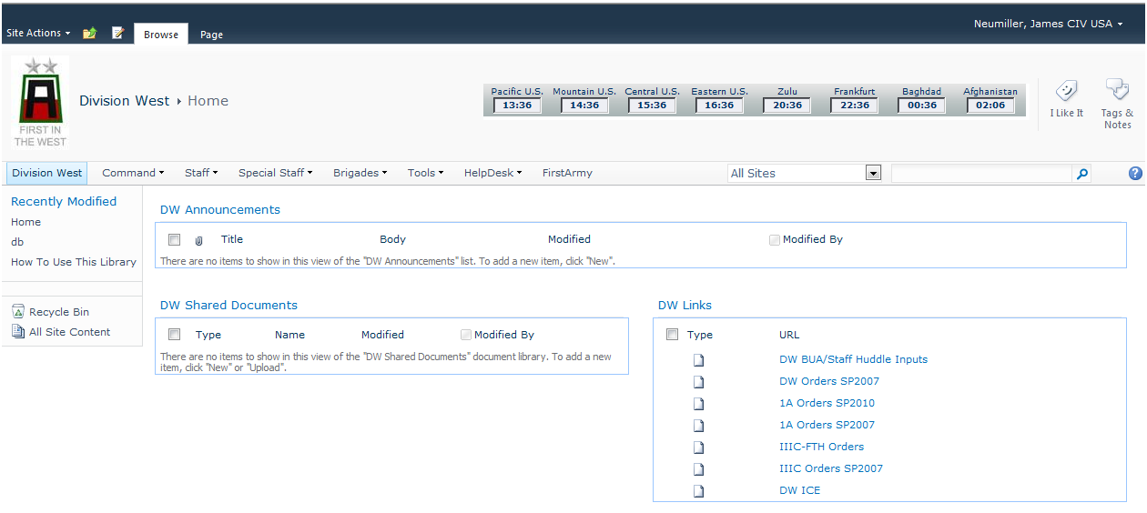

**Figure 2. Example of a Homepage Templated Page on WESTNET-N.**

* + 1. The DW KMO oversees development of the portal ensuring all pages adhere to best practices so that users can quickly find information in similar locations from one section/unit page to another. The KM IT Specialist/Deputy KMO is responsible for the technical control of the WESTNET-N/SharePoint Portal.
    2. Other customized web parts on the standardized pages will be designed as required on a “by exception” basis.
  1. **Webpage Procedures, Rules, and Best Practices.** When managing web pages Division staff sections and subordinate units will adhere to the following guidelines on all WESTNETs:
     1. All sections and subordinate units will typically use a standardized web design that includes the following (AKO is similarly structured, but are called “channels” instead of web parts):
        1. Contact Information. This web part displays contact information (position, rank/name, email and phone numbers,) while the “displayed” information will be abbreviated with Position, Rank and Last Name only, or displaying more detailed information including email and / or phone numbers. The list should contain an “appearance” column to force the order of the displayed list on the web page, if desired, so rank/position ordering may occur. If no appearance number is used for all entries, the list reverts to alphabetical order by last name. The concept of a contact list is to have the most updated information versus a published phonebook, which can be outdated within a short period of time due to personnel movements, office changes, or VOIP equipment moves or reassignments. For WESTNET-N, a filtered view of the First Army Phone Book is utilized on each page.
        2. Announcements. (Note: Some sections use alternate titles including “Hot Topics” or “Hot Box.”) This web part provides a place for the unit or section to highlight or “announce” important information, leader emphasis, or instructions to name a few. Use an expiration date to automatically “drop” the message from view on the date specified. The message itself will still remain on the list until manually deleted. This web part may also contain an “Appearance” column to change the order on the list. If there is no ordering, the last modified announcement will appear first.
        3. Links. This web part list allows the user to enter Uniform Resource Locations (URLs) with a short title and description which can point to a folder, document, or other internal or external web sites. It should also have an appearance column to adjust the order on the list. If there is no ordering, the list defaults to the alphabetical listing of the listed items. The first line is for the actual URL, the description line is the name of the link that will appear on the list.
        4. Shared Document Library. The shared document library is a place for hanging files or other documents within that unit or section. When labeled as “Shared,” the implied permissions allow view/read rights, with closed libraries labeled as something other than “Shared,” in order to differentiate an open versus a Limited Distribution (LIMDIS) or “No Foreign” (NOFORN) library. The library list will include a file size column that is visible when opposite a file, but not a folder, in order to know the amount of storage space used by the file.
     2. All pages will use the WESTNET color theme for its respective site. The upper-left frame will contain the title with the standard navigation bar on the top. The top of the page should contain any critical Level 1 and Level 2 information that the staff section or subordinate unit wants to include in the form of buttons, tabs or other links, above the “Announcements” web part.
     3. Titles and headers will be no larger than 18-point Arial font and page text will be no smaller than 12-point Arial font. *SharePoint 2010* and AKO manage most of these settings; however, users have the ability to adjust font sizes on entries within various lists or channels on the Division’s Portals.
     4. Each staff section or subordinate unit will maintain a webpage and designate an assigned content manager as the “Page POC.” Sections are solely responsible for their page content with oversight and assistance by Portal administrators. The designated Page POC/s as content managers will have additional administrative privileges assigned to them for managing their page/s in AKO. On *SharePoint 2010*,the Page POC listed on the page will be the one designated to create work orders for their page/s. KMRs/POCs should oversee this responsibility; however, additional personnel could assist in this task. Design permissions will not be delegated on SHAREPOINT 2010 without extenuating circumstances below brigade level. The DW KMO will maintain a consolidated list of Division-level KMRs on the KM page.
     5. As WESTNET and WESTNET-AKO-S are classified US SECRET, files must be ‘air-gapped’ (transferred using removable media, such as a CD or DVD disk, or a G6 Information Assurance-certified external hard disk drive (HDD,) FireWire, or similar approved device when moving between NIPR to SIPR Portals. Reverse gapping must be certified as unclassified or unclassified/FOUO by the G2 or delegated section Foreign Disclosure Officers (FDOs.)
     6. WESTNET will use a “Push-Pull” system: *pull* information from higher and subordinate units and *push* information to subordinate units. This simply means we will create processes
     7. The ‘Two-Click’ rule will be followed for priority information: Level-1 information must be either immediately up front or no more than one mouse-click away, many of these may be hot links; Level-2 information should be no more than two mouse-clicks away. The shortcut that points to the appropriate library with subfolders meets this criteria, as the user can then choose if they want the most current, or recent information within this area.
     8. Photographs, videos, and other high bandwidth use graphics are to be used sparingly. The only graphics authorized are those required to clarify complex concepts, demonstrate a concept or process, or to convey operational information. Specifically discouraged is the use of unit insignia, logos, and backgrounds that serve no operational purpose, meaning the logo does not link to that unit, other than a small icon on the upper left side of a homepage or the clickable logo links on the top banner and images of the unit or staff section leadership team. All additional graphics must be approved by submitting a request through the Division KMO via email on the NIPR side and the utilization of the Portal Work Order request list on WESTNET or WESTNET-N under the G6 Help Desk menu item.
     9. Images, banners, TIF and GIF files, bitmaps (.bmp files,) MPEG and AVI files (streaming video) and object animation are specifically forbidden. The only authorized uses of streaming video are operational requirements and then when authorized by submitting a request through the Division KMO using the above method in subparagraph 8. All images will be saved as ‘.jpeg/.jpg’ files for saving space on *SharePoint 2010* or NIPR/SIPR servers. Those elements that utilize a large portion of digitized pictures and webcasts should manage their areas diligently by only placing the most recent and relevant files on WESTNET or WESTNET-N and place the remainder or older files onto server space designated by the G6 for Archives and Large Files. Division AKO and AKO-S sites do not have the same space restrictions, but diligence should be applied to the relevancy of posting these types of files. A best practice is to link to sources of images, videos, webcasts, and podcasts directly, rather than downloading the content and then re-uploading it.
     10. KMRs/Page POCs will verify links and accuracy of information on a regular basis with periodic oversight by the Division KMO and G6 Portal administrators. “Broken” or “Dead” links that are found should be updated or removed by users, Page POCs, or Portal administrators. Sections and subordinate units must maintain situation awareness to track when units are attached or detached in order to keep their pages and links updated for non-permanent members and current information/links for all items, which will be tested at least once a month.
     11. All *PowerPoint* slide presentations will utilize compression software, when available, (i.e. *NXPLite*) to reduce total file size. Those files that exceed 50MB cannot be loaded on WESTNET or WESTNET-N due to self-imposed size restrictions, but can be placed on the SIPR server space allocated by the S6 or on AKO/AKO-S. If a file cannot be optimized to a size below 50MB, consider breaking the file/presentation into smaller parts. AKO/AKO-S does not imposed size restrictions below 200MB so storage space is less of an issue, but may timeout due to the length of the upload.

1. **Processing Information.**
   1. **CCIRs.**
      1. CCIRs are a vital part of KM planning. CCIRs are a prioritized list of information requirements, identified by the Commander, that are critical to understanding our planning, mobilization, training, and demobilization operations, identifying risks, and maintaining the situational awareness that allow the Commander to have the knowledge to make the right decision at the right time. CCIRs aid the Commander by reducing the volumes of available data to a manageable, finite set of information requirements that the staff can acquire and process, and then filter, fuse, and distribute in a timely manner. More importantly, it focuses the staff on the exact elements of information the Commander must have as soon as it is available. CCIRs are situation dependent. The CCIR may change as events occur, decision points pass, or plans are executed. CCIRs must be continuously assessed for relevance to current and future operations.
      2. CCIR Validation Process.
         1. CCIRs are developed for each mission plan during the Division’s planning process. Periodically, staff representatives should review and submit proposed CCIRs to the G3. The G3 consolidates the proposed CCIRs for submission to the Commander for approval and validation. Validated CCIRs are posted as Level-1 information on *SharePoint 2010* sites and are linked on their respective DW’s Homepage.
         2. Recommended changes to validated CCIRs are submitted by the Division staff or subordinate units to the G3. The G3 compiles the recommended changes and presents them to the Commander for validation. After validation, the updated CCIRs are posted to *SharePoint 2010* or AKO by the G3 Battle Captain, or their designated representatives.
      3. CCIR Management for WESTNET or WESTNET-N.
         1. FFIR/EEFI tracking and monitoring is the responsibility of G3 Operations (OPS.) If utilized, PIR is the responsibility of the G2.
         2. To input or modify the existing CCIRs, the G3 Battle Captain (FFIR/EEFI) or the G2 Battle Captain (PIR) clicks on the title of the appropriate list, which opens the list toolbar, giving a default view of that list, sorted by sequential number.
         3. To edit one of the lines, hover over the list item that is colored differently than the rest of the list items, which is the “editable” portion. Hover over the side of the bordered box to a black drop-down arrow and left-click the arrow, and select “Edit Item” from the drop down box. Alternately, if the list has an “Edit” box, left-click on that icon.
         4. At this point, a modifiable form will open (see Figure 3) allowing the user to make changes to the particular CCIR. The user MUST update the Date/Time group (DTG) on the form to reflect the effective date of the modified CCIR.
         5. Once complete, the user clicks <OK> at the top or bottom of the form and the changes are saved to the database of WESTNET or WESTNET-N.

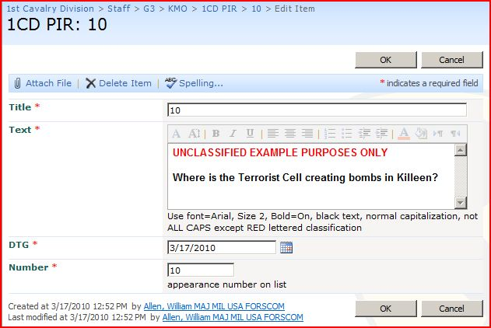

**Figure 3. Example of a PIR form for editing (CCIR form is longer but similar.)**

* + - 1. To add a new CCIR, click the word “New” on the toolbar or hover over the black down arrow and select “New Item” (the only choice).
      2. A new item form will appear. See Figure 4 for an example of adding a new PIR to the list; adding a new FFIR/EEFI to each list works in much the same way, but requires more information. Fill in the required information and click <OK> in order to save it.

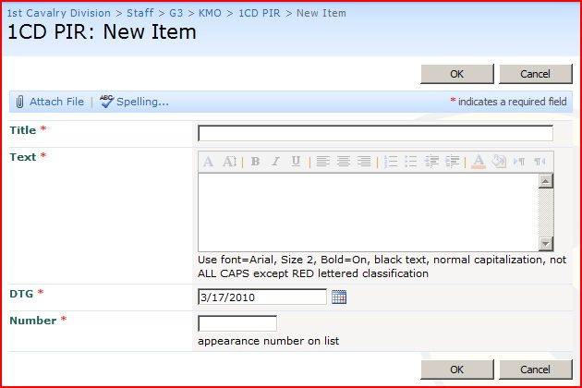

**Figure 4. Adding a new PIR form for editing (the FFIR/EEFI is longer but similar.)**

* + - 1. When a CCIR occurs or there are indicators that one is about to occur, the G3 Battle Captain will make an immediate voice report and post the information to WESTNET tracking as a Significant Activity (SIGACT.) If required, the G3 Battle Captain, or designated representative will do a screenshot of the completed SIGACT and post it to WESTNET manually on a storyboard.
  1. **Request for Information (RFI) Procedures.**
     1. WESTNET and WESTNET-N include a RFI Tracking List (found under Tools on the main menu toolbar) that allows any user to submit an RFI. The default RFI Tracking List screen looks like the following as depicted in Figure 5a:

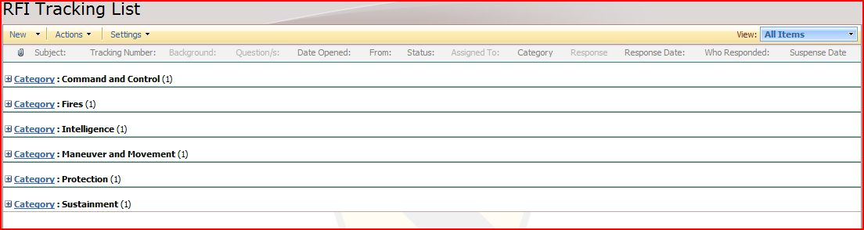

**Figure 5a. RFI Tracking List default view.**

* + 1. To enter a new RFI, the user completes the following steps:
       1. Click on the “RFI Tracking List” title on the Tac Tools > RFI page, under the “RFI Announcements” web part
       2. This brings up the RFI Tracking List toolbar. Select “New,” then “RFIs” on the drop-down menu to bring up a “New Item” form as pictured in Figure 5b:

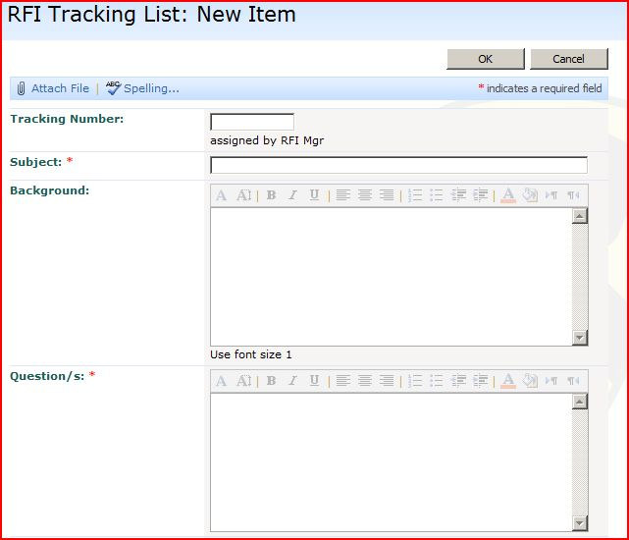

**Figure 5b. RFI “New Item” form (1 of 3)**

* + - 1. Enter a meaningful short “Subject” for the RFI. **Note: The tracking number is to be left blank for use by the RFI Manager.
      2. Enter the detailed “Background” of the subject, being as specific as possible. Provide sufficient details so that the receiving staff action officer will completely understand the request. Submitting organizations should spell out acronyms the first time they are used. If citing a reference (such as an OPORD or FRAGO,) indicate the reference the RFI is based.
      3. Enter the specific “Questions” that the RFI will answer (Figure 5b.)

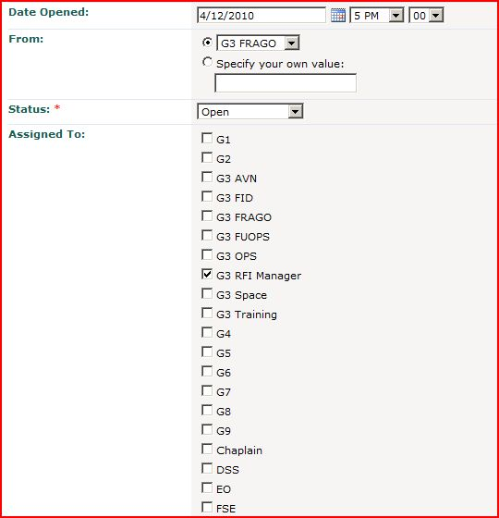

**Figure 5c. Sample RFI New Request form (2 of 3)**

* + - 1. Enter the “Date Opened:” as depicted in Figure 5c. The current date and time the new RFI was started is provided as the default entry.
      2. Enter the “Unit” (or section) from where this RFI is being originated, clicking the black arrow to open the drop-down unit menu. The default is “G3” if no change is made.
      3. The “Status” for a new entry is “Open” so it should not need to be changed.
      4. The “Assigned To:” block is to direct the question to a specific staff section/s or unit/s as the list allows for one or more entries. A partial list is shown in Figure 5c. If the unit or staff section is not listed, a box is provided to add the unlisted section/unit. If one does not know who the question should go to, ensure NO other boxes are unchecked, and the RFI Manager will make the determination. **Note: if the question does not pertain to the default entry “S3 RFI Manager”, UNCHECK the box.

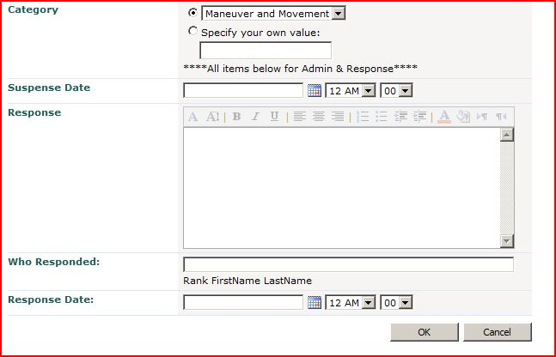

**Figure 5d. RFI New Request form (3 of 3)**

* + - 1. Select the closest Warfighting Function (WFF) “Category” (Figure 5d) from the drop-down box that the particular RFI applies. If there isn’t a specific one, leave this box blank, or specify your own value not covered in the WFF categories in the provided dialog text box.
      2. Click <OK> to submit the RFI. All SharePoint WESTNETs will automatically capture the user’s log-in name and becomes part of the tracker’s record for the RFI just entered.
      3. The remaining parts of the form will be filled in by the G3 RFI Manager to include “Suspense Date, Response, Response Date, and Who Responded.
  1. **Managing Document Files.**
     1. All Division Orders/FRAGOs/CONPLANs are available to the user through the navigation menu on all WESTNETs’ homepages to a document library on the DW Orders sub-site under the main navigation menu “Tools.” The documents are managed in separate libraries based on their respective subject.
        1. Each library contains subfolders for each respective OPORD/FRAGO/CONPLAN allowing the user to access the documents. WESTNET will maintain the current Fiscal Year’s (FY) and previous FY’s collection of orders. Older files on WESTNETs may be periodically transferred to AKO/AKO-S for archiving.
        2. Typically, the only personnel who will post products to the Brigade Orders, FRAGOs, or CONPLANs folders will be the G3 Planner/s, G3 Battle Captain/Watch Officer/Briefing Officer, G3 OPS, or other designated representatives with the proper administrative privileges depending on the network’s portal.
     2. On nearly all other pages within *SharePoint 2010* and AKO, each section and unit will maintain one or more document libraries, lists, links, and other specific web parts which are to be maintained by those personnel within those sections or units with the appropriate permissions. Most pages will be accessible for anonymous “read only” access.
     3. Though the default view for document libraries is viewed as a list on *SharePoint 2010*, users can change the view to a more “Windows-like” view by clicking on the Windows icon on the top of the toolbar ribbon labeled “Open with Explorer” under the Library Tools “Library” tab. (The default view is normally “All Documents” located on the center of the web part’s toolbar.) If there is no label from a smaller screen, the icon is located just below the Outlook and Excel icons next to the “Connect to Office” on the ribbon about 2/3’s along it. This will create a new Windows view of the files and folders, even allowing the user to drag-and-drop items from that window to the user’s desktop or other folders, if the user has the appropriate permissions. Right click to open the options available in “Explorer View.” Just grabbing the files will only COPY them, while <right> click <Cut> and then <Paste> will actually MOVE the files to their new location. Unless the file name is excessively long (see next paragraph,) normal manipulation of folders and files works in a similar manner as an Explorer window on one’s Windows work station. For AKO, the “Tiles” view gives a Windows-like view, while the “Details” view looks like a standard list.
  2. **File Naming Conventions.**
     1. File-naming conventions are critical to document management. Properly named files allow other users to read the file name and know exactly WHAT it is (e.g. a file named “12OCT11” gives no indication what the file is or where it came from, but only gives a vague clue to its date of origin, but maybe not its year, depending on naming conventions.) The standard is that a name should be short and to the point, but because of limitations within *SharePoint 2010,* file names are limited to 255 characters, and the limitation within AKO is 70 characters. Those files with longer than 255 characters in *SharePoint 2010* and the 70 characters in AKO can be uploaded, BUT will create issues when *editing* or *moving* files within a *SharePoint 2010* environment using the “Explorer View” (Windows-like) viewing option or in AKO when renaming the file. Once files are transferred to a file server, there are far less issues, but could still cause issues. However, making a long file name on any file server will also cause issues when transferred onto *SharePoint 2010* or AKO sites. Bear in mind, the complete file name includes the URL address of a *SharePoint 2010* WESTNET when the file is shown as a link in the complete file name (i.e.<<http://extranet.first.army.mil/DW/st/g3/doc/rest_of_file_name_and.extension>>.) This character count is not as big an issue with AKO as it assigns a unique identification (ID) number to all files, folders, and pages (i.e. <<https://www.us.army.mil/suite/doc/123456789>>, but still limits the name to 70 alpha-numeric characters only, to include spaces (which equates to a three character string “%20” on each occurrence of a space in a file name.)
     2. *SharePoint 2010* WESTNETs and AKO will automatically keep track of when the document was last modified, as well as the user ID of the individual who posted or modified that document. But, all files must have a date (YYYYMMDD) embedded in the title to know WHEN the file was originally created or last modified, as moving a file changes the “Last Modified” date, even though the file itself was NOT modified.
     3. When creating orders, annexes and appendices, etc., the file name will always include the unit and base OPORD number and end with the date created or last modified. This is basically a reversal of the naming convention embedded in the header of a standard order as described in *ATTP 5.0.1*. This naming convention will also place the file in numerical sequence within the folders and libraries, making it easier to view in a cascading list. For titles with multiple words, an underscore “_” will be placed between each word. All other spaces will also be annotated with an underscore “_”. This underscore eliminates the automatically generated “%20” character string created within *SharePoint 2010* and AKOWESTNETsfor each space in the file name. **An alternate method of naming files utilizing capitalizing the first letter of each word like this example: (DW_CampHumpNamingMethod.) If capital letters are used as an abbreviation, separate the abbreviations with an underscore “_” like this DW_CamelHumpNamingMETHOD_20121101.** Only use the title of the document on the LAST part of the file name for the attachment or base order/plan number, annex, appendix, tab, exhibit, etc. prior to the date in the interest of character count. Follow this naming convention when using AKO as a best practice so it can easily be transferred to any WESTNET as spaces within an AKO name also count as three characters (%20.)
        1. Use the following abbreviations in the ORDER file names:
           1. Operations Order/Plan/Warning Order: OPORD/OPLAN/WARNO (abbreviated to “DWO/DWP/DWW_” for Division-level documents.)
           2. Annex: Ann and capital letter.
           3. Appendix: App and 01, 02, 03, etc.
           4. Tab: Tab and capital letter (**see 3c below.)
           5. Exhibit: Exh and 01, 02, 03, etc. (**see 3c below.) <<Replaced “Enclosure” in the latest *5-0*>>
           6. Enclosure: Enc (or “E”) and 01, 02, 03, etc. for use in FRAGOs.
        2. Examples of standard naming conventions include the following (**\*\*Note**: **Bolding** is not part of the naming convention, but is used in the following examples to highlight where the title is placed as part of the complete file name):
           1. Division West OPORD 13-009 (OPERATION DIVWEST JUMP)’s file name is: **DWO_13-009_DIVWEST_JUMP**_20091201.
           2. Annex C (OPERATIONS) to OPORD 13-009’s file name is: DWO_13-009_**AnnC_OPERATIONS**_20091201.
           3. Appendix 1 (SYNCH MATRIX) to Annex C to OPORD 13-009’s file name is: DWO_13-009_AnnC_**App01_SYNCH_MATRIX**_20091201.
           4. Tab C (SPINS) to Appendix 2 (PERSONNEL RECOVERY) to Annex E (FORCE PROTECTION) to OPORD 13-009’s file name is: DWO_13-009_AnnE_App02_**TabC_SPINS**_20091201.
           5. Exhibit 2 (WAR SOUVENIRS) to Tab A to Appendix 3 to Annex F to OPORD 13-009’s file name would be: DWO_13-009_AnnF_App03_TabA_**Exh2_WAR SOUVENIRS**_20091201.
        3. **Attempt to avoid creating attachments below the level of exhibit. However, this SOP will follow previous *FM 5.0* guidance using double letters (e.g. AA) for attachments to exhibits and hyphenated double numbers (e.g. 1-1) for attachments two levels below exhibit. Alternately, use letters after exhibit like in the example “iv.” above to avoid drilling down to the double letters or hyphenated numbers. Illustrating going to the extreme using this naming convention with two attachments below exhibit for: Exhibit 2-1 (Route RED Overlay-Block 7 of Village Alpha) to Tab BB (Route RED Village Alpha Overlay) to Exhibit 2 (Route RED Overlay) to Tab B (Road Movement Table) to Appendix 2 (Traffic Circulation and Control) to Annex F (Sustainment) to Division West OPORD 13-009 (OPERATION DIVWEST JUMP) full link name if it existed on the Orders/FRAGOs page of WESTNET-N might be: <https://extranet.first.army.mil/tool/ord/doc/13-1_FY13_TngStrategy/DWO_13-009_AnnF_App2_TabB_Exh2_TabBB_Exh2-1_Route_RED_Village_Alpha_Overlay_20121101> (**\*\*Note**: This file name is still only 152 characters long!)
        4. All other documents should follow standard naming conventions showing unit, section, title of document, and date generated using four digits for year (to avoid confusion,) two digits for the month, and two digits for the day (YYYYMMDD) numerical formatting, which will line up similarly named files sequentially in the document library. For some internal documents for the Division, “DW” could be omitted. If the document could be shared with another unit, “DW” will always be required, and is recommended as a best practice for all file names whenever possible. As a best practice, avoid more than two subfolders whenever possible to keep the links as flat as possible! Examples of these types of files include:
           1. An executive summary from the Division Knowledge Management Working Group could be: **DW_KMWG_EXSUM_20130121**.
           2. A Brigade BUA could be: **120InB_BUA_20120814** (or DW_120InB_BUA…).
           3. A G3/S3 agenda for the weekly Training Teleconference could be: **DW_G3_TNG_TCF_20121001**.
           4. The morning personnel status report for Division West’s Fort Bliss MTC could be: **DW_MTC_Bliss_PERSTAT_20121201**.
           5. Use these naming conventions for our units (skipping spaces and “st,” nd,” “d”, “th” in the file names): 1A, IIIC, DW, 5ArB, 85SC, 120InB, 166AvB, 181InB, 189InB, 191InB, 402FAB, 479FAB, HHD, etc. For subordinate units below this, use another underscore like this: DW_479FAB_HHB, DW_166AvB_1-291AVN; DW_181InB_HHC, DW_85SC_HHD, etc. Internally, the DW suffix may be omitted. When naming units on slides, omit “st,” “nd” “d,” and “th” in their names except on a full title slide or subtitle. Conventional battalion names will use X-XXX, no space and their designation name to include AD, AR, AVN, EN, FA, LSB, and TSBn (for portal URLs, it is shortened to ad, ar, av, e, f, lsb, and t.)
           6. Permission groups will utilize a shortened version of our unit names. All Division West permission groups will begin with “DW …” and spaces are allowed.

Two types of groups will be utilized the majority of the time:

Owners. Will have Full Control permissions on their site, and Read permissions everywhere else, unless specifically changed in certain places (“DW Owners”).

Members. Will have Contribute permissions on their sites and Read permissions everywhere else, unless specifically changed in certain places (“DW Members”).

Other groups including Designers, Approvers, and Visitors will be “by exception” and only when specifically required when one of the above groups would not work.

The group “1A Visitors” includes all “Authenticated Users” verified via CAC, so should cover any visitors to any page if that group is listed as a visitor group to that page. It is always listed on a page until it is restricted access.

Division-level groups and staff will be written as DW Owners, DW G3 Owners, DW Safety Members.

Brigade-level groups and staff will be created using their brigade numeric designation only and written as DW 5 Owners, DW 120 S3 Members, DW 479 EO Owners.

Battalion-level groups and staff (as required) will be created using their battalion numeric designation only and written as DW 1-383 Owners, DW 2-290 Members, or DW 3-381 S3 Members.

All groups will have their description written in based on their type, either “Owners” or “Members.”

Owners: “This group has Full Control over their site.” Can designate and link to the page this relates to as an option.

Members: “This group has Contribute permissions on their site.” Can designate and link to the page this relates to as an option.

* 1. **Alerts**. In order to reduce the needed to physically check areas of interest within libraries, lists and other web parts in order to see if new documents have been added, changed, deleted, etc., users can set up “Alerts” within *SharePoint 2010* WESTNETs which will notify them when activity has occurred within that web part. (**\*\*Note**: Users that have “remote status” or “portal access only” accounts cannot use this feature as there is not an *Outlook* mailbox tied to this type of account. In order to set an alert, complete the following steps:
     1. Navigate to the library, list, or other web part you would like to monitor and click its title to enter the web part. (Since one is using a CAC on NIPR, one will automatically be logged into WESTNET-N, with your name displayed in the upper right side of the page “Last, First SSG USA FORSCOM”. Notice if one authenticated with AKO, the name will be the AKO email name and NOT the Enterprise name “firstname.lastname@us.army.mil”).
     2. Hover over the toolbar at the top, click on the small black arrow to the right of “Actions,” then “Alert Me” on the bottom of the “Actions” drop-down list. This will open a “New Alert” page as depicted in Figure 5.

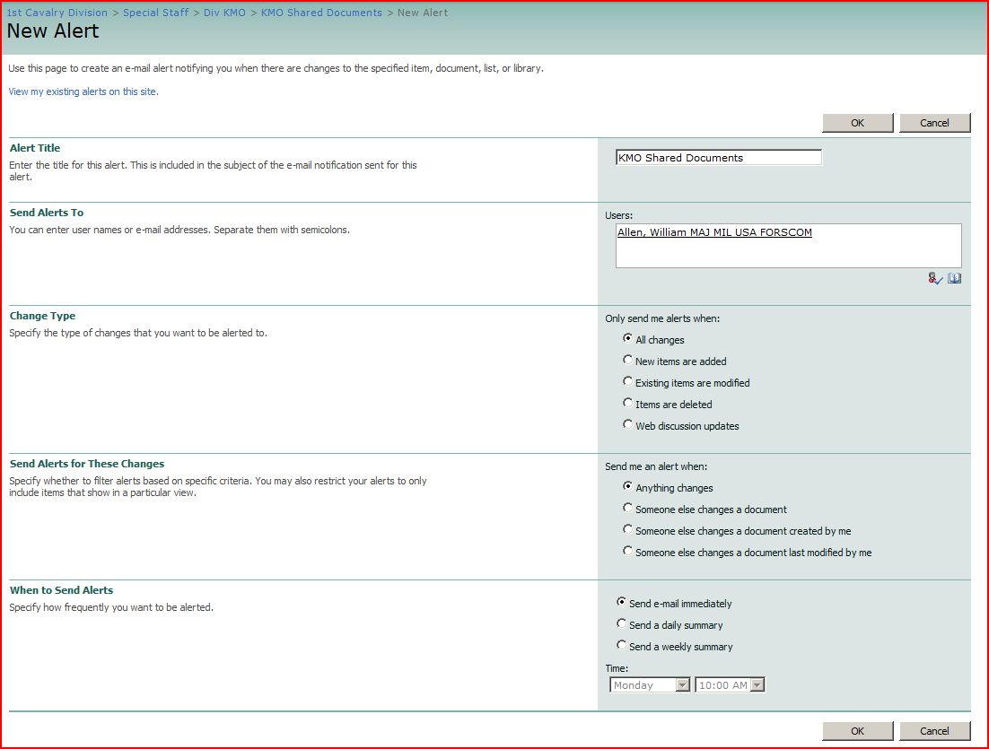

**Figure 5. New Alerts Sample Page**

* + 1. Accept the name in the “Alert Title” dialog box, which corresponds with the name of the particular list or library, or one can create a different name for this alert in the provided box. This name becomes part of the Subject line on one’s AKOor *Outlook* email notification message.
    2. The “Send Alerts To” dialog box will contain your underscored user name (signifying this user name is recognized as a valid email account.) **Administrators and those with extended permissions can change users, or add additional users to this alert if they are in the Division’s domain. Click the “checkmark” icon on the bottom right of the dialog box to confirm the name/s as recognized accounts, or click the “open book” icon to its right to enter the search function to find domain users to add to the alert.**
    3. Choose the “Change Type” of alert you wish to receive. Depending on the choice, one may receive multiple email alerts for the same file that is posted and then changed one or more times. Choosing “All changes” will cover all possibilities.
    4. The “Send Alerts for These Changes” specifies whether to filter alerts based on the chosen criteria for the alert. Again, one may receive multiple email alerts for the same file, depending on the option chosen. Choosing “Anything changes” will cover all possibilities.
    5. Use the “When to Send Alerts” to specify how frequently you wish to be alerted to include sending the email alert immediately, daily, and weekly (specify the day of the week and time of day.) Choosing “Send e-mail immediately” obviously gives the fastest result.
    6. Users should be discriminatory in the types and number of alerts they subscribe for obvious reasons. Subscribing to a great number of alerts can inundate the user with too much information, thereby negating the advantage of this feature. WESTNET has a self-imposed limit of 100 alerts per user, but a recommended limit is no more than five (5) immediate alerts per user.
  1. **Managing Photos and Other Multimedia Files on *SharePoint 2010* WESTNETs.**
     1. Photos and related multimedia are handled in much the same way as document files. Users and staff sections can upload the digital photos as files to their respective libraries.
     2. Photos can be kept in a regular document library or the more specialized “Picture Library” web part which can render thumbnail views easier.
     3. Because photo-type files can be proportionally larger than other files sized in mega-bytes (MB,) users should be vigilant in the number of photo and multimedia-type files within their web pages in order to avoid being “space hogs” on DIVWESTNETs. Older photos should be moved to the Archive SIPR server on a regular basis. **The recommended amount of data kept on *SharePoint 2010* WESTNETs is three (3) months or 90 days, with older files transferred to NIPR AKO file folders, or SIPR/CENTRIX-K Archive file servers.**
     4. Due to the vast numbers of photos generated by certain staff sections based on their mission (i.e. Safety, PAO, etc.) it is highly recommended their files be uploaded to the server or AKO/AKO-S directly instead of *SharePoint 2010* WESTNETs. For WESTNET-N, use AKO for picture files older than 90 days. Remember, AKO and AKO-S does not have sizing restrictions on organizational files, so there is indefinite spaces for files placed there.
     5. Photos and other multimedia files should be labeled with unit, event and creation date. If a group of photos are all related to a particular event, a folder with the proper label of the photo collection can be the “File name” for the particular file collection, and the individual files can keep their digital camera “default” name.
     6. Loading a photo with the generic name given by the digital camera is useless for all users to know what the photo is, when it was created, and ultimately may only be taking up valuable *SharePoint 2010* WESTNETs’ space with very few users bothering to click inside to see that file/s.

1. **Collaboration Tools.**
   1. **Tasking Lists (Taskers.)**
      1. Nearly every page on *SharePoint 2010* WESTNETs contain a “…Tasks” list web part for the utilization of each staff section or attached unit to track their tasks. It can also serve as a list of enduring tasks for all users in that section or unit. The Task List web part is typically “turned off” and kept on the backside of a page for use at a future time if the section or unit wishes to bring it onto the page use its features. A sample tasking screen can be seen in Figure 6:

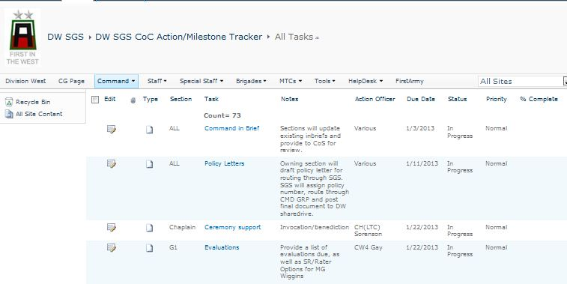

**Figure 6. Example of a SGS Staff Task Tracker list.**

* + 1. Tasks may be assigned from higher units/sections to subordinate units or staff sections, or as a means to maintain situational awareness. This system is not designed to replace the use of standard OPORDs or FRAGOs, but rather to augment a unit/staff’s ability to quickly task out requirements based on priorities of the higher unit/section or command group.
       1. To enter a task, select “New” and “New Item,” (the only option,) on the drop-down list.
       2. Fill in the required information and select <OK>
       3. Ensure permissions are set so the tasked user can then update the status of the tasking as it progresses through to completion.
       4. Users will update their tasks a minimum of once a week, or as required, until completed.
  1. **Calendar.** Most pages have a calendar to manage on *SharePoint 2010* WESTNETs. These calendars are typically shared, allowing users to coordinate with other units/sections for meetings and events. The *SharePoint 2010* calendars are compatible with *Microsoft Outlook* and its calendar features, allowing the user to enter data into *SharePoint 2010* WESTNET calendars and export some or all of the events to be added onto the user’s *Outlook* calendar.
     1. Additional information about the displayed event can be observed by placing the cursor over the event on the calendar.
     2. To enter a new event, click on the calendar’s title to bring up the calendar’s toolbar as shown in Figure 7a. (If one does NOT see the toolbar, one is not inside the calendar where the edits can be made.)

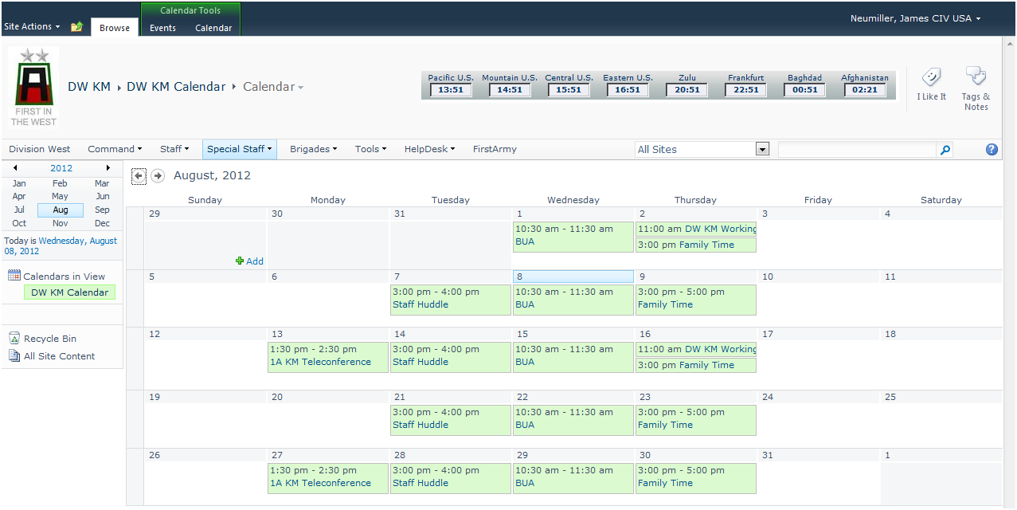

**Figure 7a. Sample *SharePoint 2010* Calendar Page.**

* + 1. At the top portion of the calendar, click on “New,” then “New Item” (the only choice) on the drop-down menu. This will open up a “New Event” form as shown in Figure 7b.

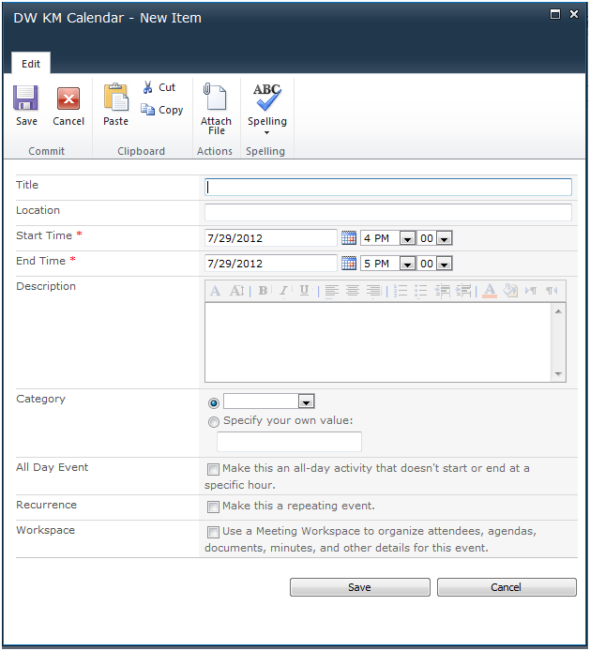

**Figure 7b. New Calendar Event Item Form**

* + 1. If this event is going to be a recurring event, check the “Make this a repeating event” box. This will add additional editing options on the calendar “New Item” form as shown in Figure 7c.

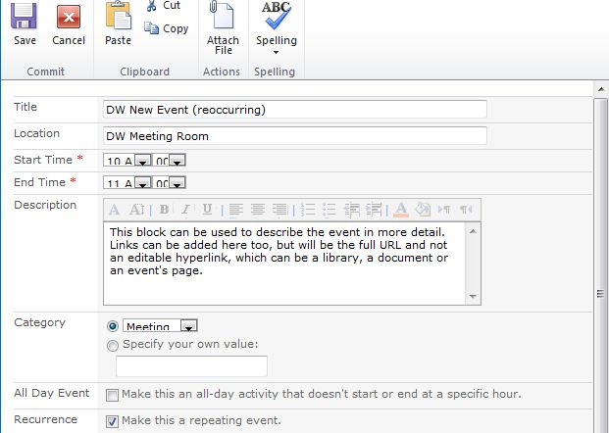

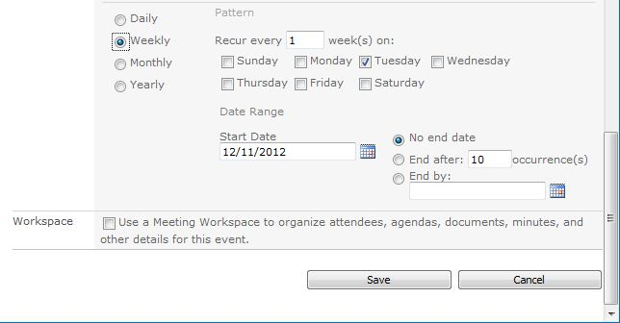

**Figure 7c. New Item form for a Calendar Reoccurring (repeating) “Weekly” Event**

* + 1. Select one of the “Recurrence” radio buttons (daily/weekly/monthly/yearly) on the left side. Each respective type of *recurrence* will prompt the user for slightly different information on the right side of these radio buttons. In the “Date Range” portion on the lower half, select a “Start Date” (effective date) of the event, and an end date. The radio button to the immediate right of the “Start Date” labeled “No end date” will be marked as the default end date setting. It is recommended that no more than a year from the start date of the recurring event be entered, which will typically be the length of time one event will occur in a fiscal year (FY) before revisions may be revisited. *SharePoint 2010’s default “end date” for a “No end date” entry is sometime past a couple decades.*
    2. Disregard the “Workspace” radio button, as this feature only works with those having administrative permissions. If a workspace is desired, request an additional subpage for that working group or meeting!
    3. Click <Save> to save the new entry. If this calendar needs to have the event APPROVED by the calendar’s Owner, the event may appear as “Pending approval” and most likely will not be viewable for anyone other than the user who entered the event, the approval authority (Owner) and Portal Administrators. Once the event is APPROVED, the event will appear on the *SharePoint 2010’s* calendar for all users that have viewing permissions.
    4. The calendar feature does not allow a user to enter an event that automatically populates other users’ calendars, unless it is a calendar DISPLAY (List View web part) on a separate web page. In order to coordinate for the meeting/event, the user must still notify the other participants to add the event to their respective calendars. If the *SharePoint 2010* calendar has been exported to an *Outlook* calendar, the new event will appear upon a refresh. New entries on the connected *Outlook* calendar will also populate the *SharePoint 2010* calendar. If one is using ‘Calendar Overlays’ to group events into categories by color, the colored events will not transfer to an *Outlook* calendar.
  1. **Discussion Forums and Wikis (if utilized.)**
     1. Another capability that *SharePoint 2010* WESTNETs or AKO can provide is the ability to quickly assist in the exchange of information through the use of “Team Discussion” (or Forums.) Any page on WESTNET can have this feature added. To check to see if your page has this already uploaded on the backside, but is not viewable on the page, click “View All Site Content” on the upper left-hand corner of a typical page on *SharePoint 2010* WESTNETs, and scroll down until you see the category “Discussion Boards” underneath the “Lists” category. If one is there, its title will end with “ … Team Discussion.” AKO pages can also have this channel added to a page.
     2. Developing other general forums or wikis along the line of War Fighter Functions, staff sections, or working groups can be created as the need arises. All new forums will be reviewed and approved by the G3 by submitting a request through the Division KMO.
     3. The intent behind the forums, threaded discussions, and wikis is to allow all users to quickly share a piece of information, such as a TTP/s, that may quickly benefit other Soldiers in the Division. Units and all Soldiers within Division West should feel free to share ideas in these forums.
     4. A basic forum page can be seen in Figure 8a:

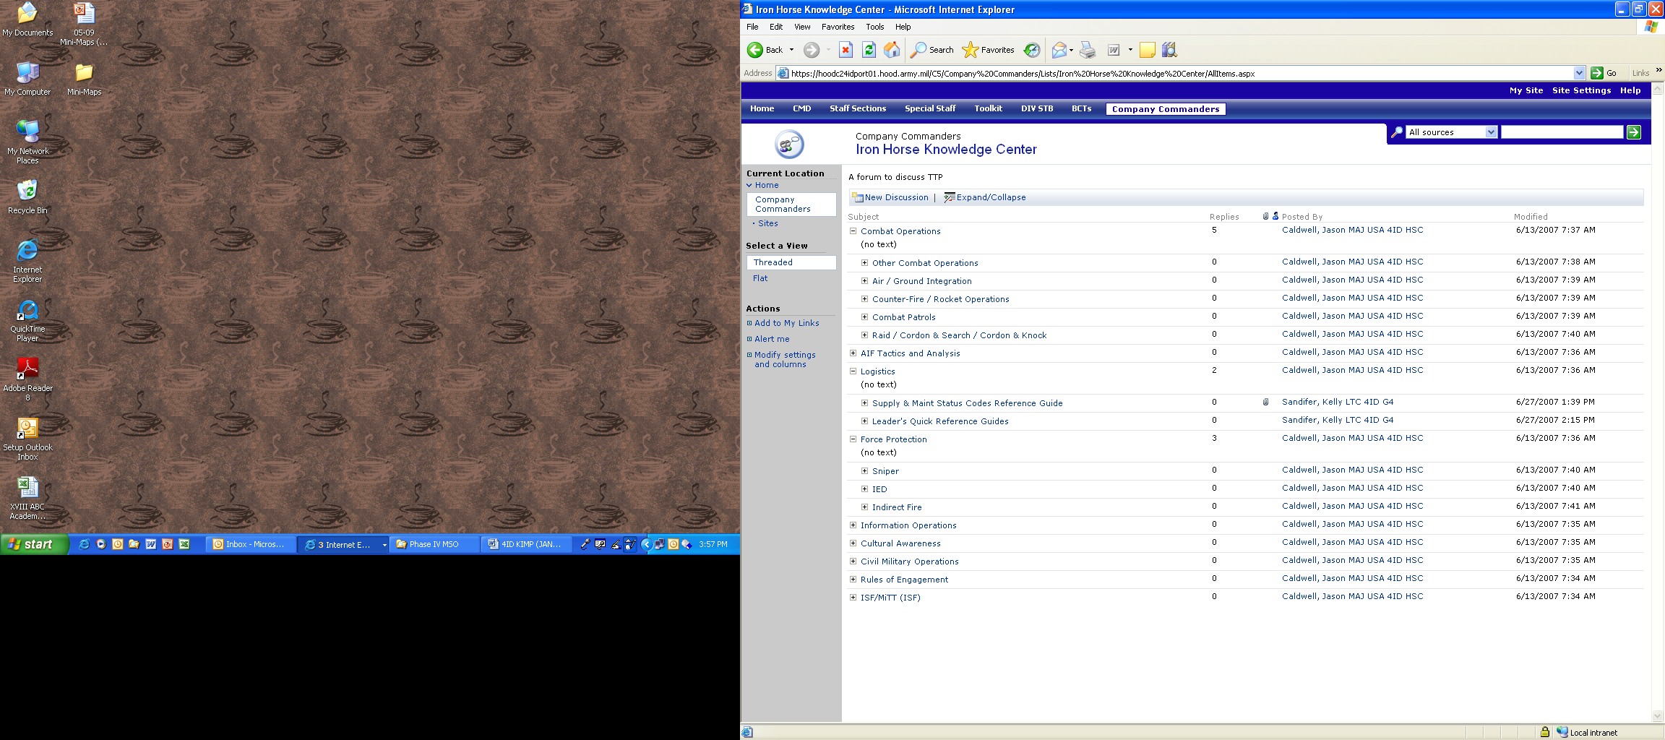

**Figure 8a. Example of a Discussion Forum on a SP Page**

* + - 1. From the basic page, the user can expand down into any discussion subject. The user can reply to existing messages or create a “New Discussion” within the same thread.
      2. Owners of the discussion group will be the manager of their group, with the Division KMO periodically policing the forums and discussions for their appropriateness and professionalism. Messages that are deemed inappropriate due to content will be removed and a notification will be sent to the poster. Messages that include a particularly good or insightful piece of information may be added as a general link to WESTNET for wider dissemination.
      3. An example of a wiki is shown in Figure 8b . Further links to different topics can be explored by clicking on the listed topics near the top or within other areas displayed on the page.

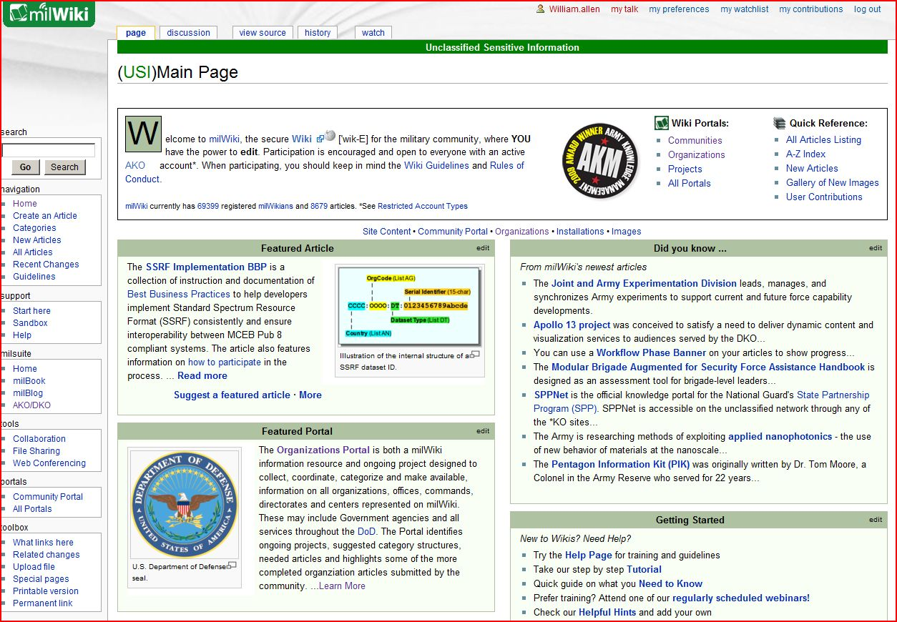

**Figure 8b. Example of a partial Wiki page from milWiki**

1. **Additional Digital TTPs.**
   1. **Bandwidth.** Digital bandwidth is a limited war-fighting resource and should be treated like a class of supply. Division West automated information distribution (WESTNETs and AKO), electronic mail systems, video-teleconferencing systems and other networked automation tools are critical consumers of this precious resource. The following list of digital rules of engagement (DROE) will guide Division West KM operations and efficient use of digital bandwidth.
   2. **Email.**
      1. Email attachments on the network are to be no larger than 5MB in size. Attachments could technically range up to 10MB; however, the header information and body of the email count against the 5MB limit. The Exchange server will return large attachments as undeliverable. Post ALL documents on *SharePoint 2010* WESTNETs or AKO and email the link or notification to its intended recipient/s. **\*\*Note**: *SharePoint 2010* WESTNETs have an imposed file maximum size limit of 50MB. *PowerPoint* files that are larger than 50MB may be optimized with a simple tool such as *NXPLite*, to reduce the file smaller than 50MB or by compressing large images contained in the slides of a slide deck. Instructions for this function can be found at: <http://office.microsoft.com/en-us/powerpoint-help/reduce-the-size-of-your-powerpoint-files-HA001116882.aspx>.   
           
         For all other file types, look at its content and reduce what is on it, or break the file into smaller parts with similar file names denoting it as parts, in order to meet the 50MB uploading limit.
      2. Do not broadcast email messages to distribution lists containing “all users.” Email messages should only be sent to the intended recipients. Staff sections and subordinate unit KMRs/Page POCs will assess the need for email distribution lists within their area and coordinate with the Division G6 to build appropriate distribution lists. Owners of these lists will have edit permissions to add/delete personnel as required.
      3. All signature blocks on the bottom of an email will contain as a minimum the following items:
         1. Full name of the sender.
         2. Rank.
         3. Section or unit they are from.
         4. Physical office location. (Room Number, Building Number, etc.)
         5. Office or primary phone number to include area code.
         6. Optional items can include alternate email addresses, DSN/cell phone/Blackberry numbers, and unit/section portal page links.
   3. **Media Storage.** The standard to use for all collaboration is to use WESTNET/AKO-S for SIPR and WESTNET-N/AKO for NIPR; with the alternate method being CD/DVD to store data and/or pass data between users and between NIPR to SIPR. If required, and permitted, external hard disk drives (HDDs,) or FireWire external HDDs can be used to transfer files. Thumb drives and similar devices are **prohibited on any Fort Hood, Division West, or DoD network!** At certain times, the G6 may open up a SIPR / NIPR address temporarily, targeted to a server device on the network, to copy files until a certain time, then disconnected, in order to be transported to another destination for contingency or redeployment operations. However, the preferred method remains WESTNET. WESTNET and WESTNET-AKO-S are classified SECRET, with WESTNET-N and WESTNET-AKO classified up to UNCLASSIFIED/FOUO. For any approved media used to receive copied transferred files, the labeling of this media must also be marked with the highest rating from the system it was received from, whether it is SIPR or NIPR. All external HDDs or CDs/DVDs will be marked with the following information:
      1. Classification: Marked as either UNCLASSIFIED, CONFIDENTIAL, SECRET, TOP SECRET, or SCI. If media is unmarked, one MUST treat all electronic transfer as CLASSIFIED unless otherwise marked. Classification can be hand-written on the disk label; however, if available, **green** (green-UNCLASSIFIED), **blue** (blue-CONFIDENTIAL), **red** (red-SECRET), **purple** (purple-CENTRIX), **orange** (orange-TS), or **yellow** (yellow-SCI) labels are the preferred method.
      2. File name(s) of documents or other file(s), or a specific grouping name of files residing on the media. Ensure they are the complete file name(s) and named IAW the presiding guidelines. A table of contents could accompany the media for easier identification of its contents.
      3. The section or unit that created the file (e.g. G2, G3 OPS, Safety, 120InB, etc.)
   4. **Video.** NO full motion video will be carried over the local or wide area network (LAN/WAN) unless specifically authorized by the G6. Exceptions will be made on a case-by-case basis and then only in support of operational needs. Video files should not be “streamed live,” (opened and viewed from the server,) but instead download the files to a local work station, and view the new video locally.
   5. **Outside Agency Collection Efforts.** During various times, whether in garrison (umbrella weeks) or in full-spectrum operations, agencies from various DoD or other organizations may visit one or more units or staff sections in order to collect information from the Division for a specific task and purpose. When these efforts are completed, a copy of the final product, AAR, out-briefing, etc. will be given to the Division G3 and saved on the appropriate NIPR/SIPR portal for later reference and historical purposes. Agencies that do not agree in advance to render their product to the Division will not be allowed to collect ANY TYPE of data from any permanent or attached Division subordinate units at any time.
2. **Troubleshooting & Making Changes.**
   1. **Technical Problems.** Users that are having technical difficulty with WESTNETs, WESTNET-N, or AKO/AKO-S should first contact their unit/section Page POC/KMR or their local IASO/S6 representative. Bear in mind, WESTNET-N originates in Rock Island, Illinois, and therefore subject to problems occurring from their Network Enterprise Center (NEC) or your local NEC. If further assistance is required, users should request that their designated Page POC submit a work order utilizing the WESTNET/WESTNET-N “Portal Work Orders” link on the drop-down menu of the G6 Help Desk on the main navigation bar, or via a link on the KMO’s web page. Alternately on AKO/AKO-S, first contact your AKO Page POC and then the KMO or KM Portal Team if the POC cannot assist or is unavailable. Users should keep in mind that there are only a few portal administrators for the entire Division, so response times may not be immediate, based on priorities of work. For simple questions, a phone call or email to the KMO/KM IT specialist may quickly solve the issue. The current Portal Team’s contact information is on the *SharePoint 2010* WESTNET homepages, the KMO webpage and the G6 webpage.
   2. **Submitting Changes.** Page POCs/KMRs can submit recommended changes to the layout of their pages to the Division KMO and KM IT Specialist. This recommendation can be submitted via a *PowerPoint* slide that shows the proposed layout of the page, or brought to the regularly scheduled KMWG. A well-thought out page design may have text boxes pointing to the new areas, drawing out the concept of a web part zone, or simply writing out a detailed description of what is requested. Approved layouts will be turned over to the WESTNETs Portal Team administrators with the goal of implementing the change/s within five (5) working days. An example of a recommended layout is shown in Figure 9:

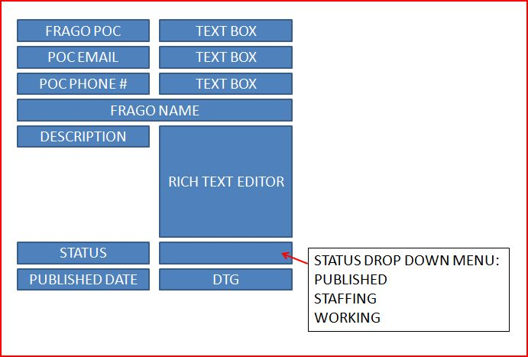

**Figure 9. PPT of a Proposed Page Layout**

* 1. **WESTNET Surveys.** Periodically the Division KMO will design a web-based survey for users to complete concerning the effectiveness of WESTNETs and/or AKO/AKO-S. Comments from the survey will be considered for improvements or modifications to SIPR/NIPR Portals and addressed at the KMWG.
  2. **Approving Portal Changes.**  At the KMWG, recommended changes will be discussed based on submitted changes, suggestions brought up at the meeting, or survey results when available. Recommendations that are approved by a simple majority of the KMWG will be implemented and made available to the entire Division. The KMWG meets on a regular basis in accordance with the latest Division Battle Rhythm schedule, but recommendations for immediate change can be submitted with a regular WESTNET work order for immediate approval or rejection by the Division KMO.
  3. **KIMP Changes.** Send written comments and recommendations concerning this SOP via email or hardcopy memorandum to the Division KMO. The submission of a Portal work order is not the proper method.

Headquarters, Division West

Ft Hood, Texas

Exhibits.

A KM Definitions.

B. SIPR Portal and Network Structure. TBP by G6.

C. Best Practices.

D. Disaster and Recovery Plan. TBP by G6.

E. AKO Administrator Guide.

F. SharePoint Administrator Guide.

The above exhibits and KIMP are located in the Division West G3 OPSOP Library:

<https://extranet.first.army.mil/DW/st/g3/doc41/Forms/AllItems.aspx>

<https://ako.first.army.mil/DW/st/g3/doc41/Forms/AllItems.aspx>