**Procedures for Paid Apps through Government Purchase Card**

1. Setup:

a. GPC holder must have the current version of Apple iTunes installed on their system. An Enterprise CoN was issued for iTunes v9 on 10 Aug 2010. Apple QuickTime and Safari Browser are included in the iTunes installation. Both applications also have valid CoNs.

b. The **GPC holder** must establish a single iTunes account in their name with the billing information tied to their GPC to be used for official transactions. Recommend use @us.army.mil e-mail address to establish the official account for receipt purposes.

c. The **device user** must establish an iTunes account that can receive apps issued by the GPC holder. See “Procedures for Free and Gifted Apps” below. Recommend official use gifted apps be sent only to @us.army.mil accounts.

2. Process:

a. When an official request for an app that has an associated fee is received, the GPC holder logs into the iTunes Store on their PC, locates the app, and "Gifts" that app to the authorized recipient's iTunes account. Note that free apps cannot be gifted. See “Procedures for Free and Gifted Apps” below to establish an account for free apps.

b. Once the GPC holder "Gifts" the app, the authorized recipient(s) logon to their iTunes account and can download the app to their device.

c. A receipt will be sent to the GPC holder’s e-mail address used to create the account.

**Procedures for Free and Gifted Apps**

1. Setup:

a. Use your @us.army.mil e-mail account with the iTunes Store. This account will not be associated with a method of payment. Use a non-army e-mail account to purchase personal (paid) apps.

b. Logoff any current iTunes account associated with the device. (Go to Settings, Store, Sign Out)

c. On the Apple Device, go to the App Store and locate an approved Free app.

d. Select Free App and Install.

e. If prompted, select “Create a New Account”

f. Agree to the terms and conditions

g. Enter the e-mail address of the account created in step “a” along with desired password, security question, and date of birth.

h. For your @us.army.mil account select “None” under “Billing Information” for Credit Card and do not enter iTunes Code. Enter billing address information and complete the process. For your personal account, enter desired payment information for non-reimbursable purchases.

i. Logon to your e-mail address created in step “a” above and follow instructions to verify the iTunes Store Account (typically involves clicking a link). NOTE: Depending on your group policy settings, you may be required to verify your account on a computer connected to a commercial internet connection with iTunes loaded. See your IMO if you are unable to verify your account with the link provided on your networked computer.

j. Setup is complete. You can now download a free app. Note: Paid apps should not be purchased through your @us.army.mil account.

2. Process:

a. Locate a free app in the iTunes Store and choose Install.

b. Enter the e-mail address and password of the “Free” iTunes account information established with the setup procedures above. App will then download. Repeat for next app.

c. For gifted apps, you will receive a notice that you were sent an app and will be given the opportunity to download the app to your device using your @us.army.mil account.

**General Steps to Create User iTunes Account**

**with No Accounting Information**

1. Sign out of any existing accounts. Locate an app in the iTunes Store and install.

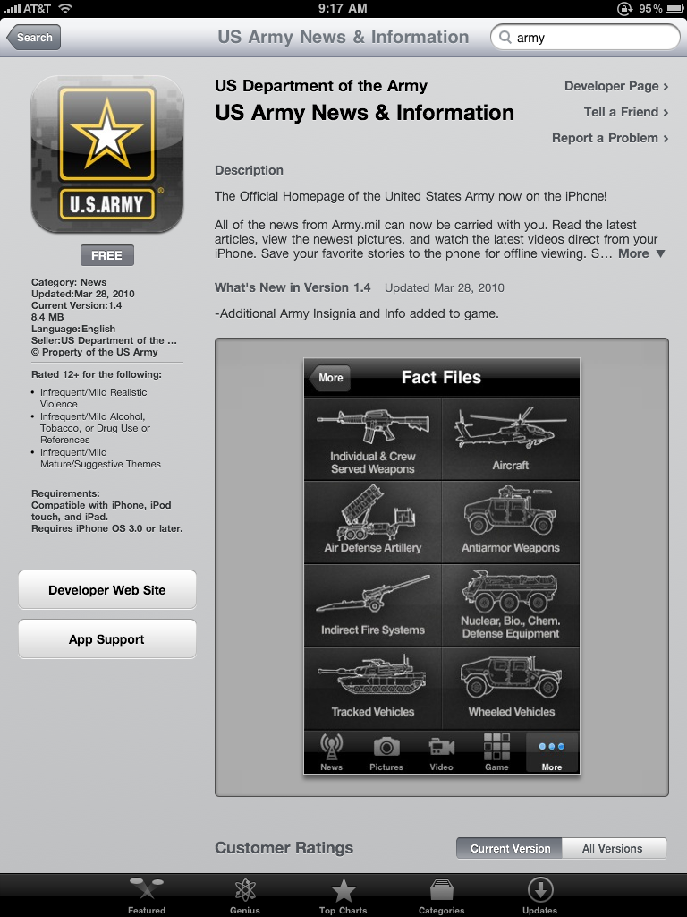

1. Select “Create New Account”

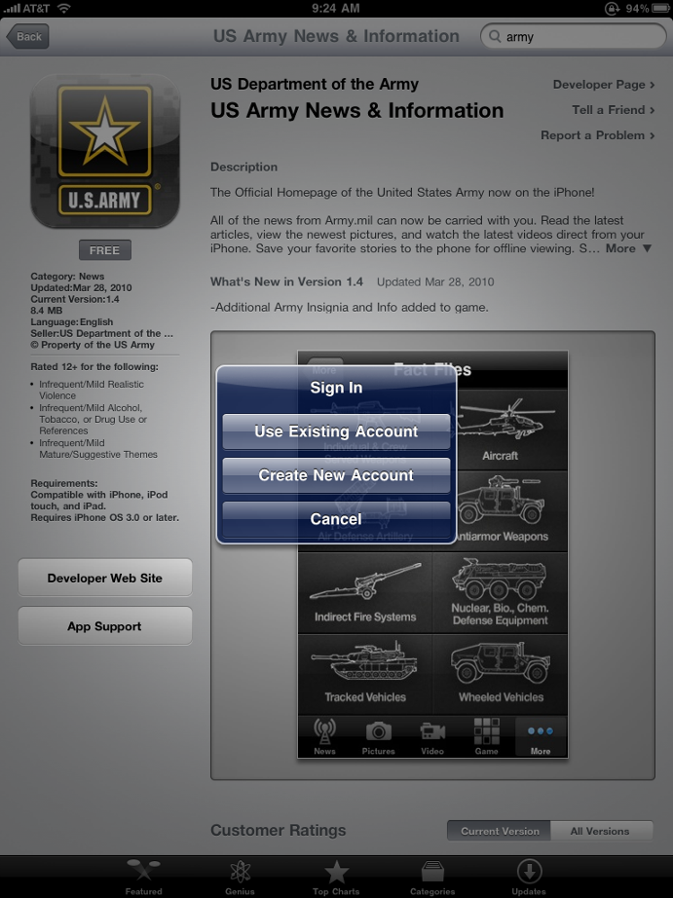

1. Select “United States” as location.

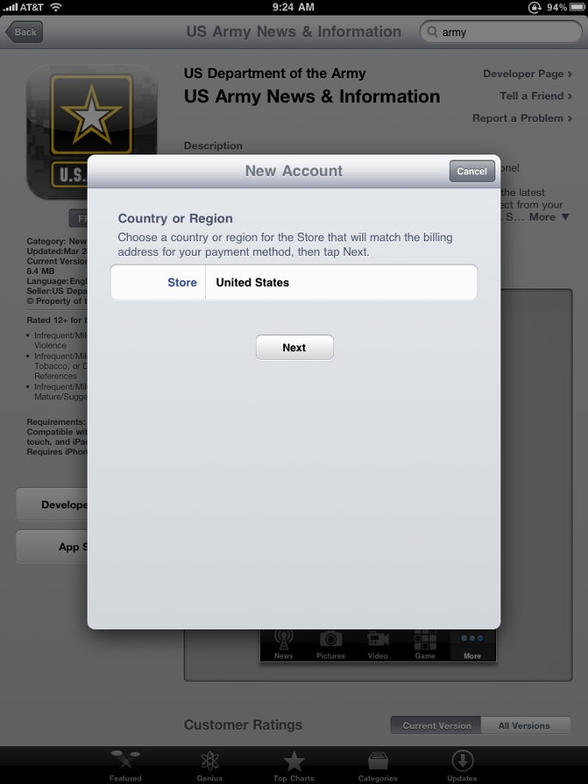

1. Read and agree to terms.

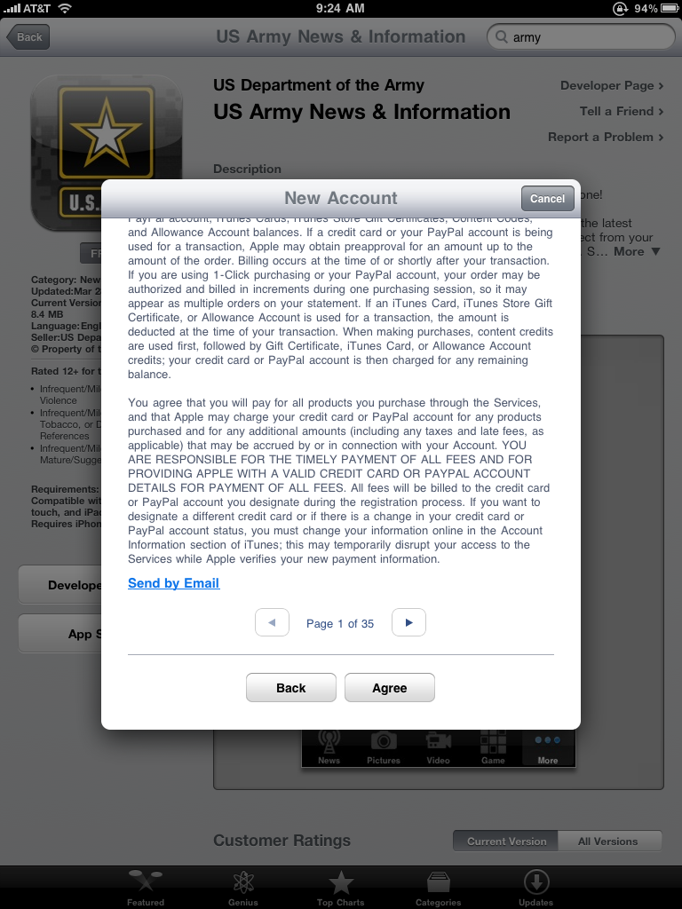

1. Enter your @us.army.mil e-mail address as the account ID. Complete the rest of the required information and proceed.

your.ako@us.army.mil

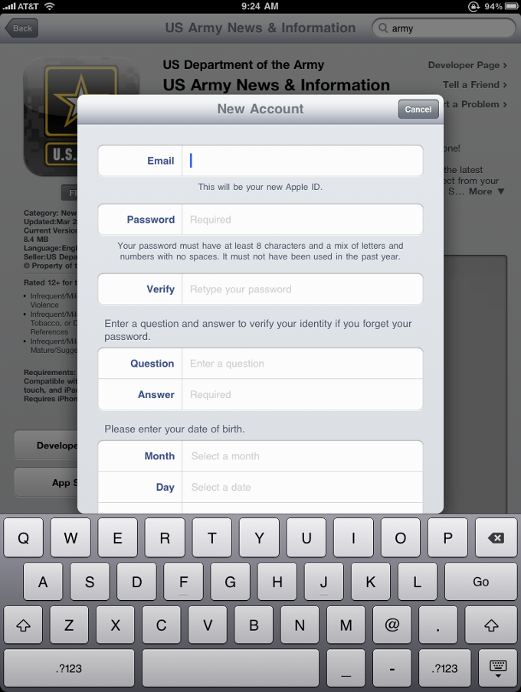

1. On Billing Information screen, Select dropdown for Credit Card and select “NONE”. Do not enter an iTunes Gift Card number. Enter remainder of required information (Name, address, phone) and continue.

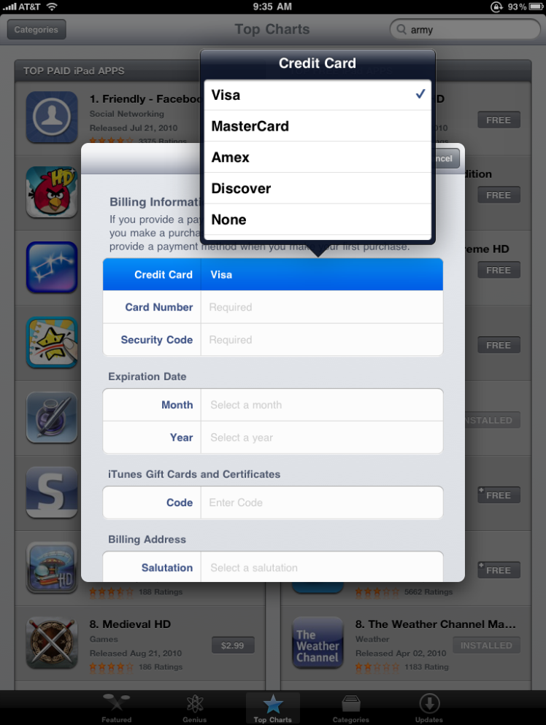

1. An e-mail will be sent to the address you entered as you Apple ID. You must click on the link in the e-mail to verify your account before it becomes active. NOTE: Depending on your group policy settings, you may be required to verify your account on a computer connected to a commercial internet connection with iTunes loaded. See your IMO if you are unable to verify your account with the link provided on your networked computer.

See your e-mail to Verify Your Account

