**M256, 120mm Abrams Main Gun**

**Flare Out**

Almost daily, soldiers and marines are conducting live fire training with the Abrams main battle tank. This training includes use of the 120mm M256 main gun system. It is critical that this system perform as designed to maximize training and ensure safety of the crew.

Recently, several tank crews have experienced a little known event called a “Flare out.” A flare out occurs shortly after a main gun is fired. Essentially, it is a secondary flame/flare seen outside the main gun after the large initial blast (flame/fire) dissipates. The below pictures shows an actual flare out.

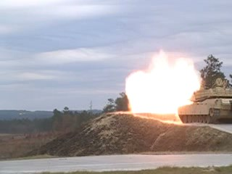 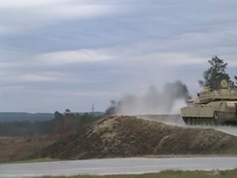 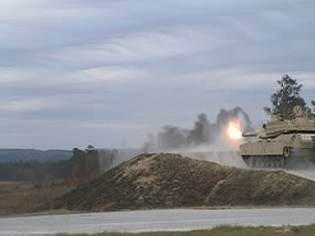

Initial blast, flame and fire Pause, no blast effects Secondary blast, flame and fire

A flare out takes place outside of the gun and is not seen as a safety issue. However, the concern is that this event could be a prelude to a flareback which can be hazardous to a crew inside of a tank turret. A flareback is detailed in TM 9-2350-264-20 and describe as occurring when fuel-rich gases formed by the normal burning of propellant enter crew compartment, mix with oxygen, and are ignited by some source. These gases are a normal part of firing and are always present for some duration after firing unless somehow evacuated.

No firm cause for a flare out has been yet determined. TCM-ABCT at Ft Benning, GA, Benet Labs at Watervliet Arsenal, PM-MAS and ARDEC at Picatinny Arsenal, JMC at Rock Island Arsenal and other technical organizations continue efforts to determine a cause for a flare out as well as corrective actions for a tank crew/unit to take should a flare out occur.

As efforts continue towards resolution of this issue, a crew/unit check list has been developed for use when a flare out occurs. In the event of a flare out, the tank crew should immediately cease fire and use the check list to gather critical information about the event. If a fault is found, this fault must be corrected before main gun live fire of the tank can continue. If no fault is found, the unit commander will decide when to place the tank back into a live fire mode. The unit should continue to monitor the performance of this tank to ensure no further issues develop.

It is important that this crew check list be accurately filled out and sent to the listed Points of Contact as soon as possible. This information is a key part of resolving causes, concerns, and proper corrective action to prevent a flare out event.