**Vulnerable Point 360 (VP 360) Practical Exercise**

**General Description of the Task:**

During this practical exercise Soldiers will perform a VP 360. The VP 360 is conducted when there is a high threat of a Command Wire IED (CWIED) at a vulnerable point (VP). VP 360 is conducted under CREW coverage. The VP will be isolated at approximately 50-100 meters in an attempt identify any command wire. This task is complete when the squad has effectively eliminated the CWIED threat in relation to the VP.

**Prior to the Start: (Prep Time: 1 hr)**

The instructor will:

1. Prepare: Select a realistic VP in the training area large enough to facilitate a squad moving approx. 100 meters in any direction from the designated VP (Intersection, Bridge, and Culvert). Ensure that the VP allows the enemy line of sight of the VP, so Soldiers can predict a high threat side. Review with the squad the main teaching points of the Danger Area class to refresh the Soldier’s memory. Talk through the VP 360 prior to conducting a walk-through of the task.
2. Setup: Prepare the VP 360 Practical Exercise site one day prior to training with 1-2 Command Wires.

1. Brief - Tell the Soldiers the following: “I will go over the required steps to follow when conducting a VP 360.” **NOTE. Paraphrase the following in your own words:**

1. Stop short of the desired VP, 50-100 meters minimum.

2. You will conduct a 5/25/200 meter checks.

3. You will set the conditions for the maneuver by establishing security, dominate the ground, and place additional person in cover if available

4. Form up VP 360 team.

5. Start the VP 360 drill starting on “High Threat” first.

6. The #1/front man searches safe route using most capable HHD (MD/GPR) and mark safe area as required.”

**NOTE. *Insure to mention details about parallel marking and importance of marking turns. Discuss with Soldiers the two methods of Marking. Ensure you discuss the pros and cons for each.***

8. The #2/second man carries the DSP-27 or STRIDER and provides security for #1 man.

9. The #3 and #4 man carry the THOR III Low and Med bands. #4 may be required to destroy marks.

10. The VP 360 is complete when team has moved all the way around VP back to the start point completing the isolation.

1. Notify: Upon completion of the lane, explain how the Soldiers, as Master Trainers, can go back to their units and have the Soldiers perform a VP 360 practical exercise. Share lessons learn as necessary.

.

**Performance Learning Objectives (The Learner**  **will…)**

mitigate the command wire threat at a vulnerable point (VP).

**Critical Teaching Points (The Learner will know …)**

1. how to identify the high threat side.
2. that the most capable HHD is used by the #1 man.
3. the correct spacing between Soldiers moving on the isolation.

**Safety Precautions:**

1. Safety must be paramount in the complex outdoor environment and is everyone's responsibility.
2. During the training process, instructors will utilize the 5-Step Risk Management process to determine the safest and most complete method to train. Every precaution will be taken in the field conditions given.
3. The instructor will brief the Soldiers on for outdoor contingencies (i.e. rally points, severe weather, WBGT/Kestrel set up, etc).

**Equipment** (This is the total equipment needed for the PE)

|  |  |
| --- | --- |
| x 2 VMC-1 or CIEA | THOR III suites |
| x 2 VMR-2 | Marking Material (as per SOP) |
| x 1 DSP-27 or STRIDER | Training area with appropriate VP to conduct training. (culvert or intersection) |
| Command Wire IED (75 meters) |  |

**Squad Rotation Schedule: Completion: 80min / Reset 10 min per iteration**

|  |  |  |  |
| --- | --- | --- | --- |
| **Iteration** | **Station 1 Compound** | **Station 2 VP 360** | **Station 3 4 Man Drill** |
| **1** | Squad 1 | Squad 2 | Squad 3 |
| **2** | Squad 2 | Squad 3 | Squad 1 |
| **3** | Squad 3 | Squad 1 | Squad 2 |

**Diagram or Picture of Practical Problem Setup:**

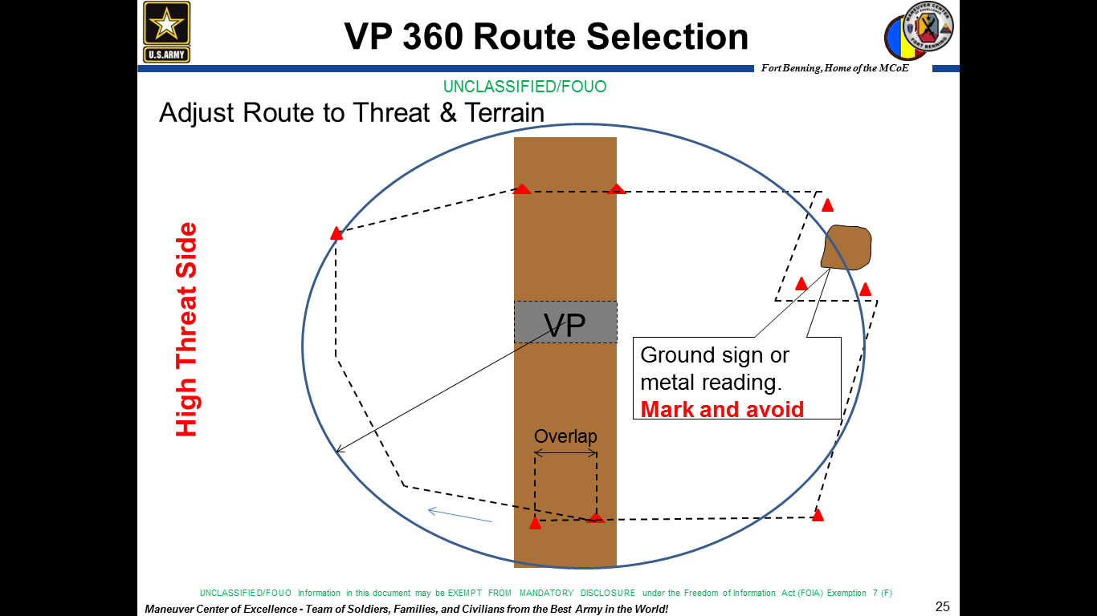

50-100 M