**Hand Held Devices (HHD) Assessment (Day 1)**

**General Description of the Assessment:**

This is a hand on assessment to determine if the Soldiers meet the DCT-MT training course HHD pre-requisites. Each Soldier will demonstrate the ability to put the HHD into operation. The HHD assessment consists of three stations and will run for approximately 45 minutes per station. The HHD assessment is complete when the Soldier puts the HHD into operation or the instructor determines that the Soldier is not properly trained.

**Prior to the Start – (Prep time 1 hour)**

The instructor will:

1. Prepare: Identify a suitable location to conduct the HHD Assessment. Select a site that has enough room to operate the VMR-2 (Minehound), VMC-1 GIZMO, CEIA, DSP-27, STRIDER, THOR III, and BALDR.
2. Setup: Lay out 6 x Minehound, 6 VMC-1 GIZMO, 6 x CEIA, 4 x DSP-27, 3 x STRIDER, 3 x THOR III and 4 x BALDR. Set up one lane per station and assign the following equipment to the groups: **Station 1,** Minehound; **Station 2,** DSP-27 and STRIDER; and **Station 3,** CIEA, THOR III, and BALDR. Ensure that the DSP-27/STRIDER Station has a command wire laid out with enough length and double stranded so it can be detected by both the DSP-27 and the STRIDER. Select a suitable area for the Minehound lane; the Soldiers will use this area to dig in the GPR test pieces.
3. Brief - Tell the Soldiers the following: “we will assess your ability to place each HHD into operation. We will also assess your general knowledge questions related to each HHD. The rotation between the stations will be in a clockwise direction. At the BALDR and STRIDER stations, you will receive training in C-IED equipment instead of an assessment because most FORSCOM CI2C’s do not have the BALDR and STRIDER.”
4. Notify: Let the DCT-MT Senior Instructor know if there are any changes to the site set-up or HHD equipment being assessed.

**Performance Learning Objectives – (The Learner will…)**

1. place HHD’s into operation.
2. place the THORIII / BALDR into operation.

**Critical Learning Points – (The Learner will know how to…)**

1. operate the Minehound and how to adjust the MD and GPR parameters.
2. calibrate the VMC-1 GIZMO and CEAI for Low and High metal content.
3. conduct a proper sweep technique.
4. detect and verify command wire with the DSP-27 and STRIDER.
5. place the THOR III and BALDR into operation

**Safety Precautions:**

1. Safety must be paramount in the complex outdoor environment and is everyone's responsibility.
2. During the training process, instructors will utilize the 5-Step Risk Management process to determine the safest and most complete method to train. Every precaution will be taken in the field conditions given.
3. The instructor will brief the Soldiers on for outdoor contingencies (i.e. rally points, severe weather, WBGT/Kestrel set up, etc).

**Equipment per Team:**

|  |  |  |
| --- | --- | --- |
| 6ea complete Minehound kits | 4ea complete BALDR kits | 2ea High Metallic (HM) IED component |
| 6ea complete CEAI kits | 3ea complete THOR III suites | 2ea RCIED simulators |
| 4ea complete DSP-27 kits | 3ea shovels | 2ea Low Metallic (LM) IED component |
| 3ea complete STRIDER kits | 3ea mattock | 1ea spool copper wire min 50’ |

**Squad Rotation Schedule: (Average time is 50/10 minutes per iteration)**

|  |  |  |  |
| --- | --- | --- | --- |
| **Iteration** | **Minehound / CEIA / GIZMO** | **THORIII & BALDR** | **DSP27/STRIDER** |
| **1** | Squad 1 | Squad 2 | Squad 3 |
| **2** | Squad 2 | Squad 1 | Squad 2 |
| **3** | Squad 3 | Squad 3 | Squad 1 |

**Diagram or Picture of Practical Problem Setup:**

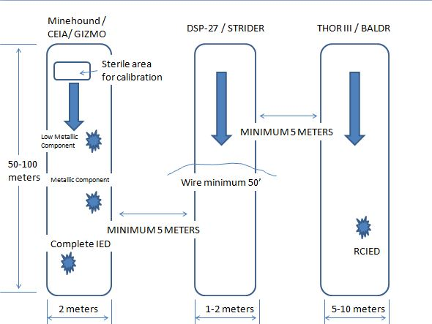

**CEIA / GIZMO**