“How to Operate a TSEM”

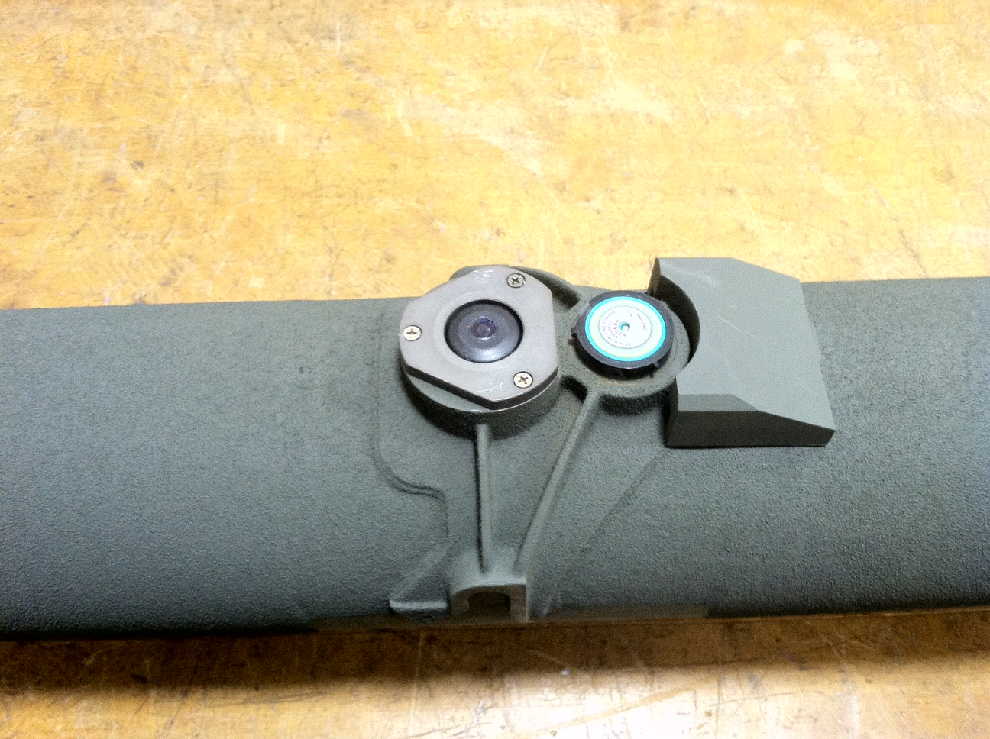

**TOW System Evaluation Missile**

**Close Combat Weapon System**

**Design**

* **Test the firing sequence from the MGS (Missile Guidance System) to the TML (Tow Missile Launcher)**
* **Verifies: Pre-fire, Fire, and Wire Cut**

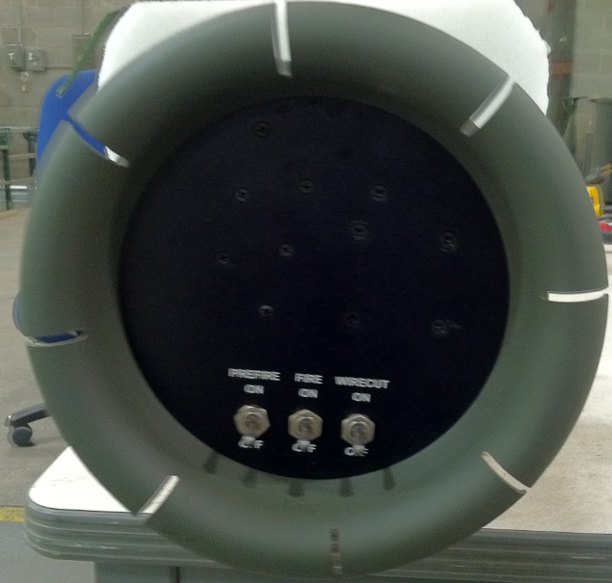

**Procedures for operating a TSEM**

* Push and hold lock latch on loading handle and pull down
* Load TSEM into the outboard (left-side) of the TML.
* Pull up loading handle. Release lock latch
* Verify Pre fire, Fire, and Wire cut Circuit Breakers are set-to “On”
* Select TOW and verify the missile icon is displayed in the TAS Biocular Assembly
* Select appropriate missile on the system control box MSL1/MSL2, and verify the “TOW 2 B” icon appears inside the Missile Icon in the TAS Biocular Assembly.
* On the system control box, move Arm, Safe, Reset switch to “Arm”
* At the GHR (gunners hand station), energize palm and squeeze the red trigger button for one second and then release.
* Verify proper sequence of pre-fire, fire, and wire cut circuit breakers; also, check for hang fire and mis-fire presences while testing.
* In approximately 25 seconds, verify Biocular display has the message “Wire Cut Performed” and wire cutter circuit breaker has tripped.
* Deselect Missile/Deselect TOW
* Repeat the process for the in-board (right- side) of the TML.
* (Note: If circuit breakers do not trip in proper sequence, reference step 11)
* 10.) Deselect missile/Deselect TOW
* 11.) If circuit breakers do not trip in proper sequence in one tube (in-board/outboard), insert TSEM into the other side that was not used, and rerun test.
* a. If circuit breakers still do not trip, after placing it in both in-board and outboard send TSEM back to OEM. If the circuit breaker fails to trip on one side and works on the other, replace the ACU.
* (Note: Follow VDMs troubleshooting procedures to verify and isolate any failure codes.)
* Note: These PMCS procedures should be done every 180 days in the sequence called out in the manual. After the completion of the test, remove and store TSEM in the appropriate container.

**Interval Testing**

* Testing should be done every 180 days
* When troubleshooting technical errors on the TML

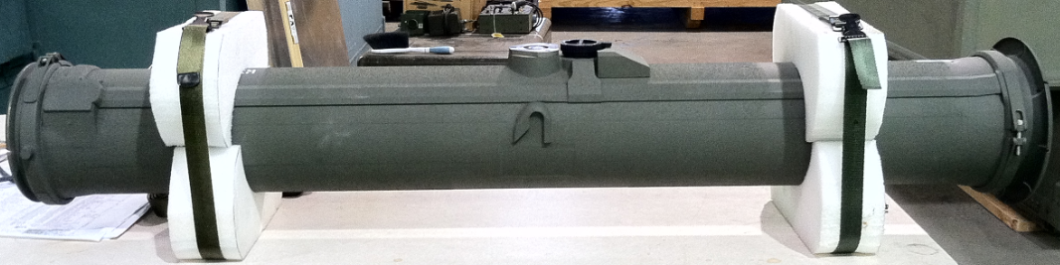

**Packaging Display**

