**Objective Gunners Protective Kit (OGPK) Personal Weapons Safety**

Soldiers firing their personal weapon within the confines of the OGPK have fired into the inside armor and ballistic shield causing bullets to ricochet about the turret and into the crew compartment. Soldiers using improper firing procedures from the OGPK have caused injuries to themselves and other Soldiers within the vehicle.

Primary Causes

The primary causes of the incidents of turret ricochets mishaps are:

* Test Firing of non-mounted weapon inside of the OGPK. Units are allowing Soldiers to test fire their M16/M4 and M249 from the OGPK into the test fire pit.
* Weapons Errors. Gunners using their individual weapon (usually an M4 carbine) while in the OGPK have shot and hit elements of the OGPK causing ricochets that have severely wounded them and other crew members inside the MRAP.

Actions to control turret firing mishaps should include the following:

* Maintain muzzle awareness
* When using the M68 CCO, the two eyes open method is the preferred method of aiming. This method allows a much greater field of view and makes scanning for targets much easier.
* Leaders should never allow a Soldier to test fire a personal weapon from the turret.
* Individual weapons should be test fired before mounting the vehicle or hand the weapon to another crew member to test fire the weapon if not feasible to dismount.
* Gunners should brace against the forward edge of the OGPK or as far forward as possible and support the rifle on the OGPK ensuring the barrel extends beyond the wall or edge of the OGPK.
* Ensure weapons are on safe at all times until ready to engage a target.

**WARNING**

**Gunners using their individual weapon (usually an M4 carbine) while in the**

**OGPK have shot and hit elements of the OGPK causing ricochets that have**

**severely wounded them and other crew members inside the MRAP.**

**KNOW WHERE YOUR MUZZLE IS POINTING WHEN USING YOUR INDIVIDUAL WEAPON INSIDE THE OGPK!**

**WARNING**

**Gunners, always test fire your personal weapon from the ground and not from**

**the OGPK - all of the recent ricochets off OGPK components were during mounted**

**test fire into the test fire pit. Just because you have a clear line of sight**

**on the target doesn't mean your bullet path from the barrel is clear.**

**KNOW WHERE YOUR MUZZLE IS POINTING WHEN USING YOUR INDIVIDUAL WEAPON INSIDE THE OGPK!**

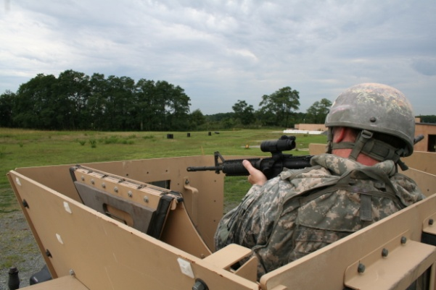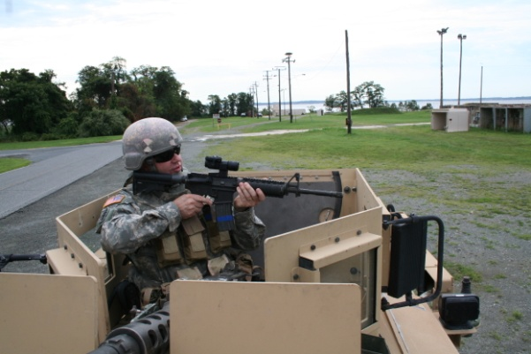

Figure 1. **Improper firing procedures from the OGPK**. Soldier is too far back from the side causing the barrel to drop below the rim for close in engagements. The M68 CCO is a reflex (nontelescopic) sight. It uses a red aiming reference (collimated dot) and is designed for the two eyes open method of sighting. If one eye sighting method is used for close in targets less than 50 meters it is possible to lose muzzle awareness while in the OGPK. The offset of the CCO and barrel is approximately three inches.

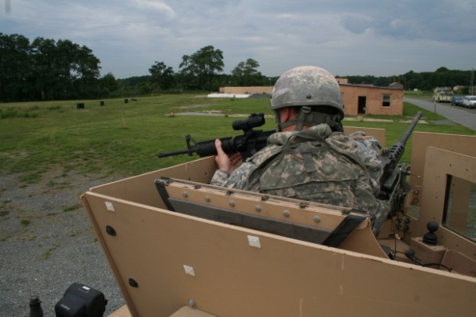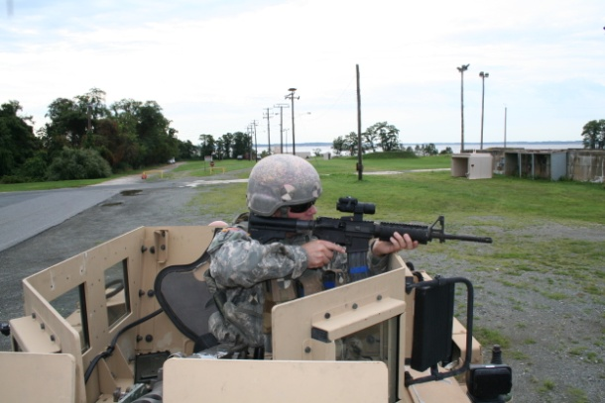

Figure 2. **Proper firing position from an OGPK.** The close proximity of the target in relationship to the shooter requires the shooter to move forward to the side of the OGPK closest to the target in order to ensure the barrel extends beyond the OGPK. Lean forward over the edge of the OGPK while resting back of the hand on the edge. This position keeps the majority of the barrel well forward of the edge and will provide stability on a moving vehicle.

**Note**

**Keep Both Eyes Open. With both eyes open you will be more aware of your surroundings.**

**Improper Position Proper Position**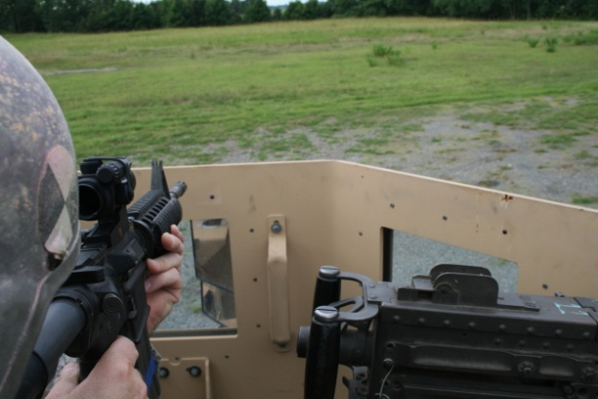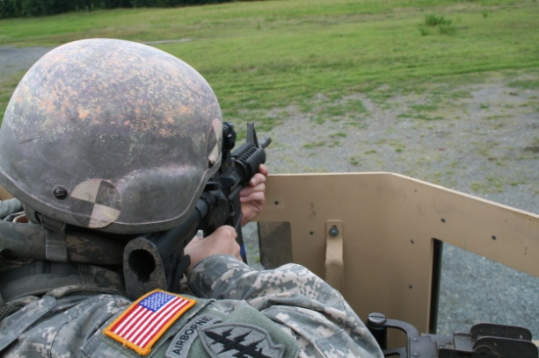

Figure 3. The Soldier on the left is more vulnerable to accidental round impacts into the OGPK by standing back from the side of the OGPK. The Soldier on the right is in a stable firing position by placing the back of his hand on the edge of the OGPK. The position on the right is the preferred position to engage targets less than 50 meters.

**Improper Position Proper Position**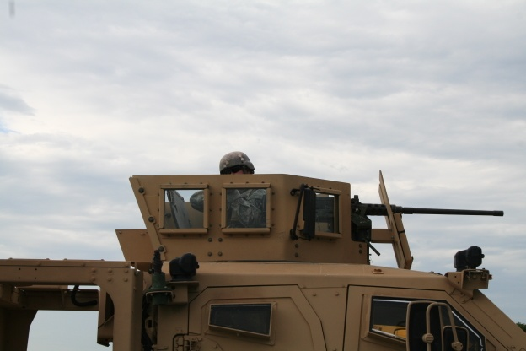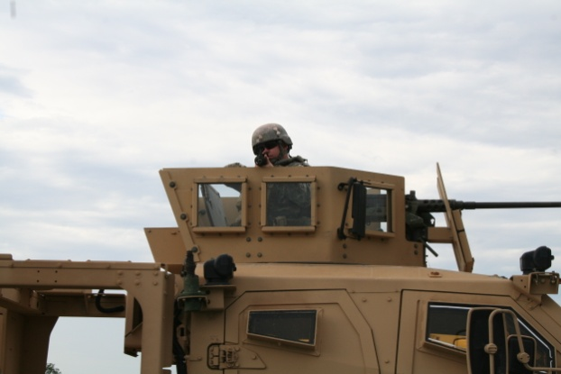

Figure 4. Notice the difference between the two firing positions. The left photo shows the Soldier is positioned to the rear of the OGPK. The CCO is sighted just above the edge, but the weapon barrel does not clear the edge of the OGPK when attempting to engage close in targets. The right photo shows a Soldier in a proper firing position with the barrel well forward of the edge of the OGPK.