**Marking Demonstration (Day 3)**

**General Description of the Practical Exercise**

In this PE, Soldiers will learn to properly mark the safe lanes. Each Soldier will learn how to identify reasons to mark the safe lanes and/or IEDs, as well as Command Wire with both detailed and minimum markings, and to identify aids to marking. The marking demonstration will run for approximately 30 minutes.

**Prior to the Start (Prep Time: 1 hr)**

The instructor will:

1. Prepare: Set up the marking demonstration site with various examples of safe lanes marked with different materials: flour (white / add carpenders chalk for color), paint, shaving cream, colored tape, engineer tape, and rock or popsicle sticks with colored tape.
2. Setup: Establish several safe lanes using the various marking materials available. Flour (white / add carpenders chalk for color), paint, shaving cream, colored tape, engineer tape, and rock or Popsicle sticks with colored tape. Conduct each example of the safe lane for approximately 10 meters in length and 1.5 meters in width. Ensure that the safe lanes have straight away and turning points on the lane. Mark safe lanes on the road and off the road so the Soldiers can see the different marking techniques used and to demonstrate examples of how to mark IEDs and Command Wire.
3. Brief - Tell the Soldiers the following: “At this station, we will demonstrate the techniques used to correctly mark IEDs/Command Wire and how to mark a safe lane during dismounted operations. You will also understand the reasons to mark and aids that you can use in marking IEDs/Command Wire and safe lanes both day and at night.”
4. Notify: Inform the Soldiers that these are just examples of different techniques that are used in the theatre of operations, but their own SOPs and current enemy TTPs may require them to change or modify how they actually use these methods.

**Performance Learning Objectives (The Learner** **will…)**

1. identify the reasons to mark. Mark to inform and mark to avoid.
2. know how to mark a safe lane.
3. discuss actions for IED and Command Wire finds detailed and minimal marking.
4. identify aids in marking / equipment used both day and night.

**Critical Learning Points (The Learner** **will know how to…)**

1. properly mark a safe lane.
2. properly mark IEDs and Command Wire.

**Safety Precautions:**

1. Safety must be paramount in the complex outdoor environment and is everyone's responsibility.
2. During the training process, instructors will utilize the 5-Step Risk Management process to determine the safest and most complete method to train. Every precaution will be taken in the field conditions given.
3. The instructor will brief the Soldiers on for outdoor contingencies (i.e. rally points, severe weather, WBGT/Kestrel set up, etc).

**Equipment for Establishing Safe Lanes**

|  |  |  |
| --- | --- | --- |
| Colored Tape | Flour (may add color chalk) | Shaving Cream |
| Markers | Spray Paint | White engineer tape |

**Squad Rotation Schedule** (Completion: 30 min)

One Marking Demonstration will be given for the entire class. No need for a rotation schedule.

**Diagram or Picture of Practical Problem Setup**

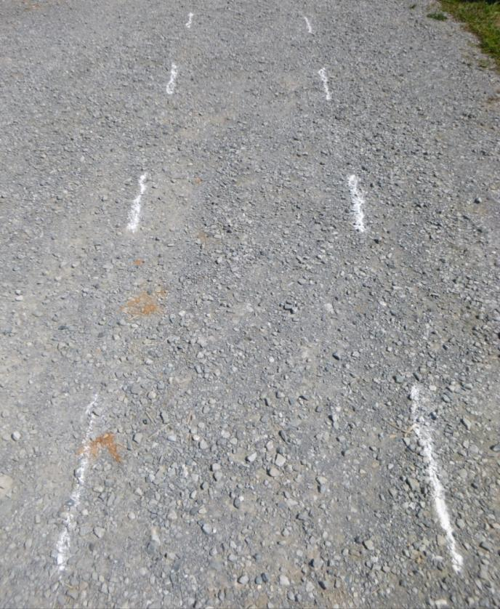Safe Lane Marking

Make the path wide enough so personnel or vehicles can clearly see a safe route.

When marking a lane it is essential that you take into account the agencies that need to work in that area and the equipment the patrol have to carry.

It’s important to remember that the lane is wide enough for a Soldier to go down on one knee to take up a firing position.

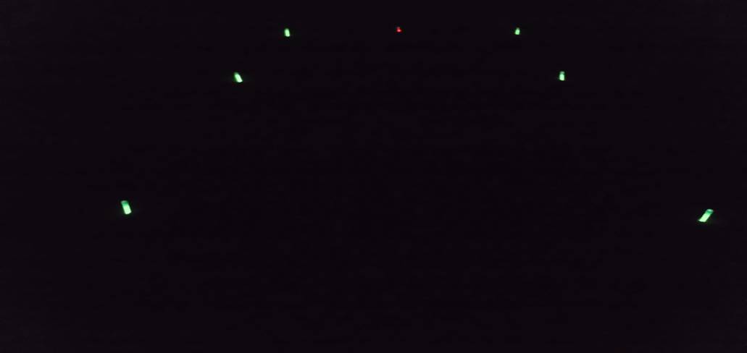Limited Visibility

If marking is to be used at night, the lane must be indicated by a light and have a different color to indicate the IED. This picture shows a green safe path using light sticks and a red light stick indicating an IED.

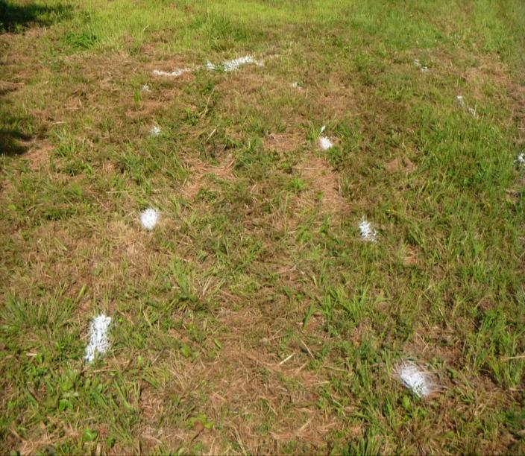

Same marking system used but the spray paint is more of a permanent feature. Flour will dissipate with moisture and is easily destroyed. NOTE: *Other marking materials are to be used in the same manner for demonstration.*



Here, the line has been placed 1m back and parallel with the command wire. This will help EOD when they approach the target.

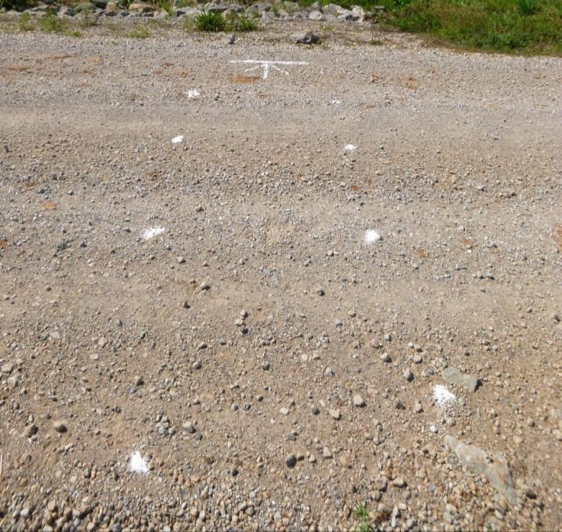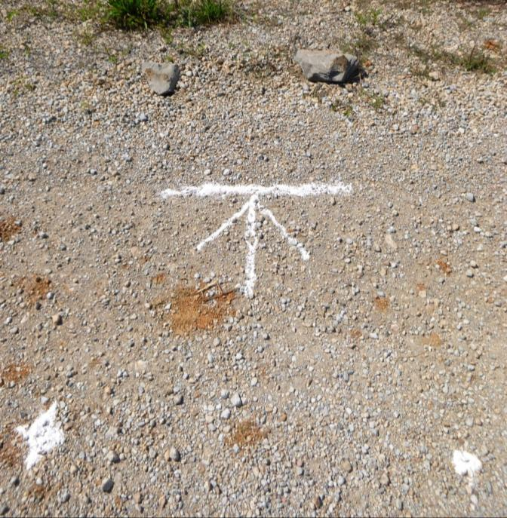 This example is using flour on a hard surface that is easily recognizable. The line is placed 1m back with the arrow pointing at the IED. NOTE: *Ensure everyone in the patrol is aware of your marking SOP.*