[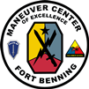](https://portal.tradoc.army.mil/sites/mcoe/cdid/cdid_/MBL/SFDF/SitePages/Home.aspx)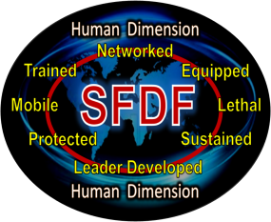

**[Squad:](https://portal.tradoc.army.mil/sites/mcoe/cdid/cdid_/MBL/SFDF/SitePages/Home.aspx)**

**[Foundation of the Decisive Force](https://portal.tradoc.army.mil/sites/mcoe/cdid/cdid_/MBL/SFDF/SitePages/Home.aspx)**

**[November 2013](https://portal.tradoc.army.mil/sites/mcoe/cdid/cdid_/MBL/SFDF/SitePages/Home.aspx)**

***[Update](https://portal.tradoc.army.mil/sites/mcoe/cdid/cdid_/MBL/SFDF/SitePages/Home.aspx)***

**3 December 2013**

**This update includes highlights on:**

* **SFDF Overview**
* **SFDF Integrated Capabilities Development Team (ICDT)** **Update with insights from 8th Army Command Sergeant Major.**
* **Counter-Unmanned Aerial Systems (C-UAS)**
* **SFDF Working Actions**
* **Upcoming Events**

**SFDF Overview**

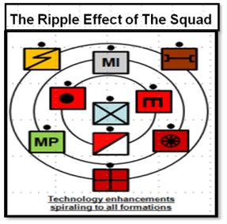The Squad Foundation of the Decisive Force (SFDF) goal is to enable dismounted Squads across all formations to obtain overmatch regardless of the operational environment. When the Squad obtains overmatch, the ripple effect will enhance and improve combat effectiveness throughout all formation levels. SFDF directly supports the MCoE number one priority to improve combat effectiveness of brigades through the execution of the SFDF initiative and addresses the Maneuver Warfighting Challenges (MWFC). The Army Strategic Planning Guidance, 2013, identifies the Soldier and Squad as the Centerpiece of Army Modernization. SFDF is not just a MCoE initiative; it has second and third order of effects across all formations.

The integration of Training and Leader Development; Mission Command; Mobility; Power and Energy; The Human Dimension; Lethality; and Force Protection results in improved individual and unit capabilities. SFDF seeks gap mitigation solutions through sponsored annual and future exercises. The final report for the Squad Dismounted Non-Network Enabled (DNNE) exercise is due in Dec 2013. The Maneuver, Fires Integration Exercise (MFIX) is scheduled for execution in the 3rd and 4th Quarter of FY 14. SFDF also extracts data and capability findings from Army Expeditionary Warrior Experiments (AEWE) reports and reviews additional experimentation reports to reduce duplicative efforts.

**SFDF – Integrated Capabilities Development Team (ICDT) Update**

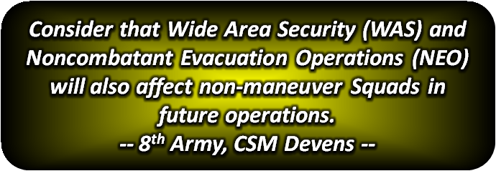

**The SFDF ICDT is comprised of** the Chairman, COL Barnett, and the following teams within the MCoE: the Measures of Effectiveness (MOE) team from the Maneuver Battle Lab (MBL), Training and Leader Development team from DOTD and the Materiel team from Soldier Division. The Chairman’s opening comments at the 14 Nov 2013 SFDF-ICDT stressed the importance of maintaining transparent collaboration with all Centers of Excellence (CoE) and key stakeholders to mitigate Squad Gaps and achieve overmatch. ([Executive Summary (EXSUM)](https://portal.tradoc.army.mil/sites/mcoe/cdid/cdid_/MBL/SFDF/All%20Documents%201/EXSUM_SFDF%20ICDT%20Update_14%20Nov%202013_(FINAL)_v1.pdf) and [SFDF-ICDT slide deck](https://portal.tradoc.army.mil/sites/mcoe/cdid/cdid_/MBL/SFDF/All%20Documents%201/SFDF-ICDT%20Slide%20Deck_FINAL_(Last%20Updated%20on%2013%20Nov%202013_v1).pptx))

* + **The MOE team briefed** findings from the Army Expeditionary Warrior Experiments (AEWE) Spiral-H Report, findings from the SFDF-Dismounted Non-Network Enabled Limited Objective Experiment (DNNE-LOE) and provided recommendations to the ICDT to leverage the Army Materiel Systems Analysis Activity’s (AMSAA) Infantry Warrior Simulation (IWARS) system to determine non-materiel and materiel solution feasibility to address gaps.
  + **The Training & Leader Development team briefed** recent MCoE leader development initiatives and updates from a number of strategies, courses, and programs that impact training and leader development at the Squad level. The brief updated the community on Advanced Situational Awareness Training (ASAT), Engagement Skills Trainer II (EST II) and Counter Improvised Explosive Device (CIED) training.
  + **The Materiel team briefed** initial findings of the Squad Gap review to clarify gap statements, the ongoing SFDF - Maneuver, Fires Integration Exercise (MFIX) collaboration of the Fires Center of Excellence (FCoE) and the MCoE. The MFIX will focus on Counter-Unmanned Aerial (C-UAS), Situational Awareness, Fires, Protection,and Power (energy).
  + **Closing Remarks from ICDT Chairman:**
    - Continue to collaborate with USPACOM, the CoEs, Key Stake Holders, and DA to synchronize efforts.
    - Consider government funding implications and its impact on gap mitigation with non-materiel and materiel solutions.
    - A major challenge is the synchronization and streamlining of multiple lists and documents across the community to prevent redundancy.
  + **Comments from 8th Army, CSM Devens:**
    - As the focus continues to shift to the USPACOM region, implement capability training at home station to include Jungle and Arctic scenarios.
    - Consider that Wide Area Security (WAS) and Noncombatant Evacuation Operations (NEO) will also affect non-maneuver Squads in future operations.
    - Engage with TRADOCs Asymmetric Warfare Group (AWG) on their initiatives for Squad Leader success in Weapons of Mass Destruction Effect (WMDE) operations and subterranean warfare that we are recognizing will be a challenge for our small units as they operate decentralized.
    - Collaborate with 8th Army G3 to develop forward area assessments.

**Readiness**

***… Crisis, when it occurs, will likely confront Eighth Army with sudden regime instability, potential environmental disaster, humanitarian crisis and the threat of WMD weapons…***

[***“How We Fight”, Eight Army Commander’s Guidance***](http://8tharmy.korea.army.mil/HWF.pdf)

**Counter-Unmanned Aerial System (C-UAS) Findings**

* The proliferation of all classes of UASs (threat and friendly) complicates Airspace Control (AC) and Air Defense Artillery (ADA).
* Doctrine and TTPs are not understood or fully developed.
* Army needs to develop C-UAS materiel solutions, TTPs and doctrine for employment in BCTs. ([Document Link](https://portal.tradoc.army.mil/sites/mcoe/cdid/cdid_/MBL/SFDF/All%20Documents%201/Counter-Unmanned%20Aerial%20System%20(C-UAS)_Emerging%20Insights%20v1%2002h_20131021.pptx))

**SFDF Working Actions**

* MFIX planning efforts.
* Assist in synchronization of Capability Based Assessments (CBA) on Small Arms Gaps, Squad Gaps, and Soldier Functional Area Analysis (FAA) and Functional Needs Analysis (FNA).
* Engage TRADOC’s AWG on their initiatives for Squad Leader success in WMDE operations and subterranean warfare.
* Timeline for future SFDF-ICDT’s.
* Army Co-Create: is an online platform that will connect Soldiers, Civilians, makers ans scientists in real-time development of solutions to enhance warfighter performance and safety. This new platform will engage a broad audience to tackle military challenges. Learn more at <ArmyCoCreate.com>.

**Upcoming Events**

* ***3 Dec 2013: SFDF participates in meeting with Center for Strategic & International Studies (CSIS).*** Focus on Soldier as a System (SaaS) and how lessons learned from OIF/OEF will influence future Soldier requirements. CSIS intent is to bring greater attention to one of the CSA's top priorities a Ready and Modern Army.
* ***10 Dec 2013: Cut-off date for solution submission for the MFIX.***
* ***10-11 Dec 2013: SFDF-MFIX Action Officer Working Group (AOWG), Ft Sill, OK.***

[**SFDF Portal**](https://portal.tradoc.army.mil/sites/mcoe/cdid/cdid_/MBL/SFDF/SitePages/Home.aspx)

**SFDF Team**

***SFDF*** *Project Officer:*[*CPT Jedidiah Zaffke*](mailto:jedidiah.m.zaffke.mil@mail.mil)*, 706-626-8610*

***SAIC –*** *Program Integrator:* [*Mr. David Dice*](mailto:david.t.dice.ctr@mail.mil)*, 706-545-4736*

***SAIC******-*** *Information Manager:* [*Mr. Joe Parker*](mailto:joseph.m.parker1.ctr@mail.mil)*, 706-545-8831*

***Maneuver Center of Excellence, Fort Benning, GA***