**Accessing Your GPR Settings:**

- Rotate selector knob to “Setup”

- Toggle “Mode” button until GPR only is lit.

- Press and hold “C” button until you hear a beep.

- You are now ready to change your GPR settings.

|  |  |  |  |
| --- | --- | --- | --- |
|  | | | |
| LED | Adjustment | Range | Default |
| 11 | Start Point  “Top - Down” | 30 – 80 | 30 |
| 11F | Stop Point  “Bottom – Up” | 255 – 100 | 255 |
| 12 | Linear Gain  “GPR Sensitivity” | 10 – 50 | 28 |
| 11 + 12 | Time Variable Gain (TVG)  “GPR Power” | 1 – 10 | 1 |

**Changing GPR Settings:**

These settings allow you to make changes to the ceiling and

floor.(Shallow and Deep Target Amplification).

- Press the “C” button to toggle from one parameter

setting to another.

- Press + or – to change the selected setting.

- There are four adjustable settings each with their

own LED indicator.

**Storing GPR Settings:**

Settings are stored in memory and can be changed

as needed.

- Press and hold C for 3-4 seconds.

- LED 5-8 will illuminate and return to the volume setting

- Settings have now been saved and can be recalled.

**Recalling GPR Settings:**

You need to be in N or M in order to recall your GPR

settings.

- Toggle “Mode” button until GPR only is lit.

- Press and hold “C” for 3 seconds until LED 5-8 illuminate.

- Release “C”, LEDs will flash and a beep will be heard.

- You have successfully recalled your saved settings.

**Setup for Metal Detection in Normal Soil:**

Operating in Normal Soil and do not need to

compensate for minerals, follow these steps.

- Rotate selector knob to N

- Toggle “Mode” button until MD only is lit.

- Lower search head to the ground and wait for alert to

subside.

- Detector is now ready for metal detection in normal soil.

*You may now test the detector with the MD test piece.

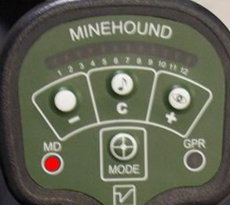

**Setup for Metal Detection in Mineralized Soil**

- Rotate selector knob to M

- Toggle “Mode” button until MD only is lit.

- Conduct Automatic or Manual soil compensation.

- Detector is now ready for metal detection in mineralized

soil.

* You may now test the detector with the MD test piece.

**Automatic Soil Compensation for MD:**

Operating in Mineralized Soil and need to

compensate, follow these steps.

**-** Rotate selector knob to M

- Toggle “Mode” button until MD only is lit.

- Place search head on the ground.

- Press and hold C until you hear a short beep.

- While holding C, raise and lower the search head.

- When you hear a beep, release C.

- The detector has now compensated for mineralized soil.

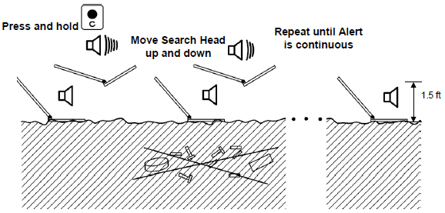

**Manual Soil compensation for MD:**

If you are operating in mineralized soil and want to manually compensate, follow these steps.

- Rotate selector knob to M

- Toggle “Mode” button until MD only is lit.

- Hold down C and + buttons until a short beep is heard.

- Once the beep is heard, release ONLY the + button.

- While holding C, adjust with the + or – buttons.

**Automatic Frequency Assignment:**

- Place detector in “Setup”

- Toggle “Mode” button until MD only is lit.

- Press + and – simultaneously for 4 seconds.

- Odd and even LEDs will alternate.

- Process will take 3 minutes.

- When complete, the detector will return to volume

control.

- Place the detector back in to N or M

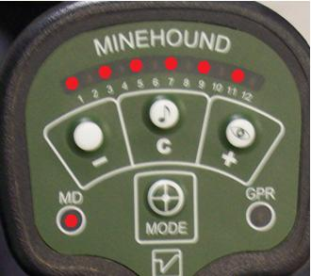

**Manual Frequency Assignment:**

- Rotate selector knob to “Setup”

- Press and hold C for 4 seconds until it beeps.

- While holding C, press + or – to select channel.

- When complete, release C

- Place the detector back in to N or M

**Alert Configurations:**

All alert modes are changed while switching from the off

position.

- **Audio alerts only**: Press and hold “C” button while

turning on the detector.

- **LED** **alert for MD/LED and AUDIO for GPR**: Press and hold

the + button while turning on the detector.

- **LED and AUDIO alert for MD and GPR**: Press and hold

the “C” button and the + button while turning on the

detector.

*Settings will be saved when detector is turned off.

**Sweep Techniques:**

- Operator will conduct a 180 degree sweep from left to right

- Cover at least ½ half the width of search head over the left

and right edges of the lane

- Forward no more than 1/3 the length of search head using

MD only

- Search head must be parallel to ground

- No more than two inches above the ground

- Avoid common sweep mistakes: Cupping, Pushing, and

Hooking.