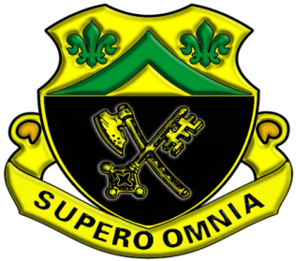 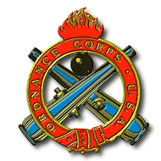

The Abrams Training Division’s mission is to provide technical instruction to Initial Entry Soldiers for Military Occupational Specialty 91A, Abrams Systems Maintainer. The Abrams System Maintainer course last 16 weeks. The course is broken down into two main parts, Hull & Turret. Soldiers that complete the 91A course will maintain the most lethal ground combat system on earth, the M1A2 SEP V2 Abrams Main Battle Tank. Abrams Training Division also provides technical instruction for the 91A-Advanced Leaders Course and Additional Skill Identifier D-8, the Assault Breacher Vehicle. Go Ordnance!

