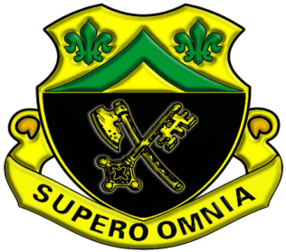 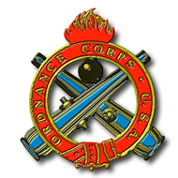

Welcome to the Abrams Turret Branch, My name is Mr Stan James. During your 8-week iteration in my branch you will be trained on how to maintain the M1A2 SEP v2 tank turret subsystems. The annexes you will learn are Maintain Turret Electrical System, Maintain Turret Hydraulic System, Maintain Fire Control System, and Maintain the M256 Cannon Tube w/associated equipment. This will all be taught using the Army Learning Model (or ALM) 2015 which incorporates simulations, simulators, and most importantly…critical thinking. You will be taught by the most experienced military and civilian instructors in the 91A community. Again welcome and ask plenty of questions as we prepare you for the operational force. Go Ordnance!!!

