

51st Military Police Battalion
South Carolina Army National Guard

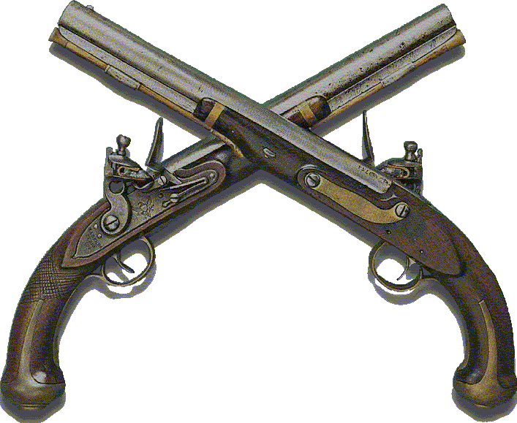

PLANNING SOP

“Ready to Respond”
January 2009

SOUTH CAROLINA ARMY NATIONAL GUARD
51ST Military Police Battalion
400 S. Greer Road Florence, SC 29506
51MP-CDR 1 January 2009

MEMORANDUM FOR All Bn Main CP Personnel

SUBJECT: Battalion Planning Standard Operating Procedures

1. REFERENCES. 51st MP BN Tactical SOP dated October 2008.

2. PURPOSE. To standardize the planning process for the battalion and battalion assets.

3. APPLICABILITY. This SOP is applicable to 51st MP BN personnel, attachments, and other units under operational control. The battalion planning process is standardized except when modified by order of the Battalion Commander, his authorized representative, or specific METT-T considerations.

4. DEFINITIONS.

a. IPB. Intelligence Preparation of the Battlefield
b. MDMP. Military Decision Making Process
c. COA. Course of Action
d. HPT. High Payoff Target: A target whose loss to the enemy will contribute to the success of the friendly course of action.
e. HVT. High Value Target: Assets that the enemy commander requires for the successful completion of a specific course of action.

5. RESPONSIBILITY. The battalions BOS representatives are responsible for providing recommendations for planning.

LAWRENCE MILLER
LTC, LG
Commanding

TABLE OF CONTENTS

SUBJECT PAGE

MDMP Steps Overview 4
Step 1: Receive the Mission 4
Step 2: Conduct Mission Analysis 6
Step 3: COA Development 6
Step 4: COA Analysis (Wargame) 7
Step 5: COA Comparison 10
Step 6: COA Approval 10
Step 7: Orders Production 11
Timeline 12
Mission Analysis Tools:
Mission Analysis Worksheet 13
Who Reads What (of Bde OPORD) 14
Assets Available Worksheet 15
Commander’s Guidance Worksheet 16
Staff Need to Know Questions for the Commander 19
COA Development Tools:
COA Development Checklist 21
Offensive COA Worksheet 21
Defensive COA Worksheet 22
COA Worksheet 23
COA Sketch 24
COA Standard Operational Graphics 25
COA Analysis Tools:
Decision Support Matrix I Template 26
Execution Matrix 27
Wargaming Matrix 28
Synchronization Matrix 30
Bn Daily Synchronization Meeting 31
Synchronization Meeting Seating Chart 32
Target Synchronization Matrix (TSM) 33
Rehearsal Scheme of Maneuver 34
WARNORD #1 Format 35
WARNORD #2 Format 36
WARNORD #3 Format 37
Scout FRAGO 39

TABLE OF CONTENTS

SUBJECT PAGE

OPORD Format 40
OPORD Sign Out Log 42
OPORD Seating Chart 43
Briefing Agendas:
Mission Analysis 44
COA 45
Wargame 46
OPORD 47
Confirmation Brief (Bn to Bde) 48
Confirmation Brief (Co to Bn) 49
Concept Backbrief (Rn to Bde) 50
Concept Backbrief (Co to Bn) 51
Synchronization Meeting 52
Rehearsal Agenda 53
Commanders Conference Call 54
Briefing Tools Checklists 55
Mission Analysis 55
COA 56
Wargame 56
OPORD 57
Synchronization 58
Rehearsal 58
SIGACTs Definition 59
Task and Purpose List 60
Definitions of Tactical Tasks 61
Staff Estimates 64
TOC Status Chart Layout 66
Battalion Commander’s Wake-Up Criteria 67
TFW Field Battle Rhythm 68
TF 1-87 Battle Rhythm 69

MDMP Overview

1. GENERAL. The MOMP planning process begins with the receipt or anticipation of a new mission. The Bn XO develops the staff planning timeline. The MDMP consists of the following steps with sub tasks:

Step 1: Receive the Mission Step 4: COA Analysis/Wargame (Omitted if Receive Bde Order single COA)
Issue Warning Order #1 COA Analysis
Step 2: Mission Analysis Step 5: COA Comparison (Omitted if single Conduct 17-Step Mission Analysis COA)
Mission Analysis Briefing to CDR Step 6: COA Approval
CDR’s Guidance to Staff COA Decision Brief to CDR
Issue Warning Order #2 Step 7: Orders Preparation/Production
Initial RFIs to Higher Hq Orders Approval
Step 3: COA Development Order Reproduction
Develop COA(s)/Hasty Wargame Issue OPORD
COA Briefing to Cdr (If desired) Confirmation Briefing
Detailed Wargame
Wargame Brief to CDR
Issue Warning Order #3

Step 1: Receive the Mission:

1. Task 1: Receive the Brigade OPORD. Bn Cdr, S3, S2, FSO, and LNO attend the Bde OPORD. The LNO gets a copy of the Bde OPORD in hard copy, and if possible on a thumb drive, and all graphics. He brings all products to the TOC for Mission Analysis while the orders group attends the order. He has the Bn Cdr’s driver make an overlay for the Cdr.

2. Task 2: Prepare for the MDMP (Starts with the receipt of Bde WARNORD #1):
a. XO:
• Develops an Initial Timeline.
• Clerk types the timeline and provides to each staff member.
• Directs time for off-shift Battle CPT, Shift NCO and RTO’s to be present for MDMP.
b. TOC NCOIC:
• Sets up plans area and gathers Planning Tools.
• Ensures MDMP charts, easels and agendas (in sequence) are in plans SICP.
• Ensures Mission Analysis Charts are created on easel paper (title on blank paper).
- Div Mission & Intent - Risk
- Bde Mission, Intent, CCIR & HPTs - Facts/Assumptions
- Available Assets - Bn Mission
- Higher HQ assets in our AO - Bn Cdr’s Intent (Key Tasks bulleted & Endstate)
- Specified Tasks - Bn CCIR (PIR, FFIR, EEFI)
- Implied Tasks - MDMP timeline
- Constraints - Operational Timeline
• Has adequate supply of maps, blank overlays, acetate, alcohol pens & markers.
• Ensures appropriate SOPs, FMs and Battle Books are in the plans SICP.

c. Staff:
• Prepares for MDMP by updating running estimates.
• Conducts IPB with the S2.
• Each staff member prepares his Mission Analysis Worksheet and updates estimates.
• Staff provides XO with recommendations for “Commanders Guidance”
d. S2: Conducts IPB with staff assistance and prepares overlays for MDMP.
- EN SITTEMP - PZ/LZ/DZ overlay
- MCOO - Elevation overlay
- Line of sight overlay
e. S3 Air / Battle CPT or the Shift NCO:
• Produces WARNORD #1 for XO or S3 approval (See format on page 35).
• WARNORD #1 is sent out over the Bn Command net. The on duty Battle Captain verifies all
elements received the WARNORD.
• For Mission Analysis, the off duty Battle Captain becomes the maneuver staff planner until the S3 returns from the Bde TOC. If the on duty Battle Captain becomes the maneuver staff planner, the Shift NCO assumes all Battle Captain duties.

3. Task 3: Upon the receipt of the Brigade OPORD/FRAGO:
Bn Cdr issues initial planning guidance.
TOC NCOIC ensures Opns Assistant makes 2 copies for distribution:
• Original - File in the Bde Orders Book.
• Copy 1 - Bn XO
• Copy 2 - Distributed to staff sections
Staff is responsible for reading specific portions of the Bde OPORD for mission analysis. See page 14 for “Who reads What”. The Bn XO and S-3 will read the entire OPORD.

4. Task 4: Prepare for Mission Analysis.
• Off shift RTOs and NCOs produce graphics for the Plans map board from the Bde’s 1:50,000 graphics. The Battle Captain is the QC.
• TOC NCOIC posts graphics on the plans map for all to view.
• The Bde LNO assumes control of the RFI Log Book
• Opns Assistant begins typing the Bn OPORD shell, prepares (measures and cuts) acetate for graphics, and ensures maps reflect the current AO and Al. Off duty RTOs assist as necessary.
• Off duty Battle Captain and BICC prepare force ratio data and evaluates overall force ratio. They use the generic combat power data shown on page 21 for this task.
• Battle CPT extracts Bde Annexes appropriate for Bn WARNORD #2 (i.e., ROE, etc).
• S3 Air or Shift NCO draws terrain and/or OBJ sketch for COA development.
• TOC NCOIC sets up the plans area for Msn Analysis. The following charts/tools will be displayed:
- Briefing Agenda - IPB Overlays - Specified, Implied, Essential Tasks
- Map Board - Enemy Situation/MCOO - Available Assets
- Brigade Operations Overlay - Line of Sight - Facts and Assumptions
- Timeline - Vegetation/Hydrology - Constraints
- Div Mission, Intent, Concept - PZ / LZ / DZ - Risk Assessment/Management
- Bde Mission, Intent, Concept - Elevation - BN CCIR (PIR, FFIR, EEFI)
- Bn Mission, Intent

Step 2: Conduct Mission Analysis.

1. When each staff member completes their Mission Analysis Worksheet, the Bn XO will review and approve it and then the staff member posts all information to the Mission Analysis charts.
a. Throughout the formal mission analysis, the Chemo will be the designated scribe. The scribe will record all necessary information on the charts and take notes of all discussions. The Shift NCO will record and process all RFIs IAW the TOCSOP.
b. IPB. The ADA officer provides enemy air avenues of approach to the S2. The Engineer Officer provides the templated enemy obstacle overlay to S2. The ESO provides templated enemy fire support elements to the S2. The S3 works with the S2 to develop the enemy maneuver plan.
c. Each of the staff members must have key information available from their estimates to contribute to the mission analysis and to prepare for COA development.
• FSO: Type, quantity, and number of rounds available of supporting IDF assets, minutes smoke available, minutes of suppression, range fans of supporting artillery, CAS available to battalion, and attack aviation available.
• ENG: Mobility assets available and capabilities, counter mobility capability, and survivability assets, by type and time, available.
• Maneuver: Movement rates (day, night, on different terrains); both opposed & unopposed.
d. As mission analysis is conducted, each staff member begins writing their portion of warning order #2, if applicable. Input is provided to the Opns Assistant immediately after the mission analysis brief.
e. The following is a list of products completed during Mission Analysis:
Enemy Situation Templates (SITTEMP). S2
Modified combined obstacle/avenue of approach overlay S2
Staff Estimates All
Initial Enemy Event Template. S3, S2
Specified, Implied, and Essential Task Lists. All
Forces Available. All
Constraints. All
Facts and Assumptions. All
Risk Analysis . All
Initial Commander's Critical Information Requirements (CCIR). All
Initial Reconnaissance and Surveillance Plan (R&S). S3, S2
Detailed Timeline. XO, S3
Restated Mission. S3
Commander’s Intent. Bn Cdr
Commander’s Guidance. Bn Cdr
Warning Order (WARNORD #2) S3 Air/Battle CPT

Step 3: Course of Action Development.

1. Preparation and setup for COA development include the following:
Shift NCO:
- Redistributes supplies as needed.
- Repositions planning easels and butcher blocks for COA development.
- Ensures the following are present:
• Briefing Agenda
• Map Board with Bde Opns Overlay and BN S2’s Enemy Situation Overlay
• Battalion Mission Statement
• Commanders Intent
• Commander’s Guidance for COA Development Posted
• Mission Analysis Tools

SIGO or S3 Air: Creates terrain sketch and COA sketch (if not done previously).
Staff:
- Continue to update estimates
- Assists the S3 in Generating Options and Arraying Initial Forces

2. A COA development checklist is at Page 21. An offensive COA worksheet is provided on page 21, and defensive COA worksheet is provided on page 22.

3. A Course of Action Statement and Sketch is written on a COA chart and is presented with task organization during the COA Briefing. A COA Sketch Format is on page 24. The COA statement must include the following:
• Purpose of the Operation
• Form of Maneuver
• Task and Purpose for Main Effort and Supporting Efforts
• Addresses Battlefield Framework (Deep, Security, Close, Rear, Reserve)
• Decisive Point
• Risk
• End State (Friendly Forces, Enemy Forces, Terrain)

4. After developing a COA, the XO and Staff conduct a hasty wargame to ensure the COA is suitable, feasible, acceptable, distinguishable from other COAs, and is complete with COA sketch and statement.

5. Products resulting from COA Development are:
- COA Sketch and Statement
- Task & Purpose for each Subordinate Unit (Including Combat Support) & BOS
- Generic Task Organization
- Operational Graphics
-
6. The staff may conduct a COA briefing prior to wargaming and if the Commander desires. The COA briefing agenda is shown on page 45.

STEP 4 - COA ANALYSIS (WAR GAME):

1. Identifies which COA accomplishes the mission with minimum casualties while best positioning the force to retain the initiative for future operations.

2. The staff will prepare the following tools prior to the conducting the wargame:
a. S3.
(1) Wargame Worksheets (PSOP location)
(2) Large map or sketch of operational area with operational graphics and enemy most
probable COA.
(3) Task Organization with details on available assets.
(4) Symbols for DPs, NAIs, targets, friendly unit locations. b. 52.
b. S2.
(1) Enemy SITTEMPs (MPCOA & MDCOA)
(2) List of assets available to the enemy.
(3) Symbols for enemy unit locations.
c. ESO
(1) Status of FS Assets
(2) Symbols for FS Assets (FA, NGF, CAS, FSCM)

d. EN:
(1) Status of EN Assets
(2) Symbols for EN Assets
e. ADA:
(1) Status of AD Assets
(2) Symbols for AD Assets
f. TOC NCOIC ensures the following are present:
(1) Seating Chart
(2) Briefing Agenda
(3) Map Board with Battalion Operations Overlay and BN S2’s Enemy Situation Overlay
(4) Updated Facts and Assumptions
(5) Division and Brigade Mission and Commander Intent Statements (6) Battalion Mission
Statement
(7) Commander’s Intent
(8) Task Organization
(9) Critical Events War Gamed/War Game Technique Use
(10) Possible Enemy Reactions
(11) Strengths and Weaknesses of the COA
(12) Modifications to the COA
(13) War Game Results
(14) Synchronization Matrix
3. War-Gaming Responsibilities:
a. XO.
(1) Leads wargame effort, coordinates staff actions and keeps all focused
(3) Identifies key events
(4) Ruthlessly monitors the clock
(5) Ensures staff stays within the CDR’s intent and guidance
(6) Ensures the process is disciplined, methodical, and swift
b. S2.
(1) Role plays the enemy commander
(2) Identifies IRs to support decision points
(3) Identifies NAIs that support TAIs and DPs
(4) Refines the situation template
c. S3.
(1) Assists the XO identify significant events to wargame
(2) Fights the Bn TF
(3) Assumes the XO’s responsibilities in his absence
d. BOS/Staff
(1) Wear the Red Hat for their area of expertise
(2) Ensure assets are used w/in their capabilities, limitations, doctrine, and TTP
(3) Help identify HVTs and HPTs
(4) Note any items for synchronization
(5) Identify shortfalls that require support from higher
e. Battle Captain (Off Duty).
(1) Record actions on the wargame worksheet
(2) Note estimated friendly losses
(3) Note refinements to the task organization and tasks for sub-units
(4) Note locations or events that might cause commitment of the Reserve
(5) Note possible locations for DPs
(6) Note possible locations of TAIs
(7) Note EEFI, FFIR, and CCIR
(9) Note estimated duration of critical events

f. B1CC. Note the:
(1) HVTs
(2) Enemy DPs “Fight” friendly intel assets
(3) NAIs
(4) Enemy losses
(5) Time, location, and tasks for collection assets (for the R&S plan)
(6) Additions or refinements to the PIR
g. S4. Note the:
(1) Critical weapons systems lost
(2) Ammo expenditure
(3) Water resupply needs
(4) Fuel requirements
(5) Expected demands for supply and maintenance
(6) Transportation requirements
(7) Locations of LRPs
(8) Supply routes
(9) Expected times and supplies in LOGPACs
h. S1. Note the:
(1) Location, time, and number of expected friendly casualties
(2) Location and time that treatment assets will be required
(3) Location and time that evacuation assets will be required
(4) Evac routes
i. ESO: For each critical event, determine the location, time, and desired effects for FS assets to support the BOS Scheme of Maneuver. Determine who will control the fires and the control measures required to prevent fratricide. Determine priority and allocation of assets by event. Recommend HPTs to the S3 based on S2’s HVTs. Recommend FSCM to the S3.
j. ADAO. For each critical event, determine the priority of protection, potential location of ADA assets, and the primary target lines.
k. Engineer. For each critical event, determine the location, time, and tasks for engineer assets and any requirements for breaching, mines, or Class IV.
I. CHEMO (Scribe). Determine potential points for the enemy to use chemical weapons and where the BDE could employ smoke to gain an advantage over the enemy.
m. SIGO. Determine the best locations to facilitate communication between the Bn Cdr and the Co Cdrs; the Bn Cdr with the TOC; the TOC with the TAC; and the TOC with the Cbt Trains throughout the battle via FM, MSE, TACSAT, HF, etc.
4. Wargame Products:
(1) Task Organization (4) Decision Support Template
(2) Synchronization Matrix (5) Recon & Surveillance Plan Matrix
(3) Decision Support Matrix
5. The wargame should result in a Decision Support Matrix and/or Template. See page 26 for procedures and steps on developing this product.
a. Decision Support Template (DST) is essentially a combined intelligence estimate and operations estimate in graphic form. It provides a structured basis for using document and experience to reduce battlefield uncertainties and to make decisions.
b. The DST relates the detail of the event template to decision points of significance to the commander. It identifies critical battlefield areas, events, and activities which require tactical decisions by time and location. Selection of decision points (DPs) depend heavily upon availability of maneuver, fire support, and MI assets.
c. Decision Points (DP) identify the areas, events and points where tactical decisions are required. They indicate where decisions should be made in order to achieve the most desired effect on the enemy at the target area of interest (TAI) corresponding to that decision. DPs must be placed far enough in advance of the expected location of the event to ensure sufficient time to allow confirmation that the expected event (the decision criteria) will occur.

d. DECISION SUPPORT TEMPLATE. The DST consists of:
(1) Operations Graphics.
(2) Decision Points (DPs).
(3) TAIs (only those linked to decision points; area TAIs are depicted as EAs, point TAIs are depicted as targets).
(4) Time Phase Lines (TPLs) - draw operational phase lines for control that equate to the Event Template TPLs and label movement rates to the TPLs.
(5) Enemy Objectives (OBJs).
e. DECISION POINTS. Factors affecting placement include time required:
(1) For intelligence collection to receive the event that has taken place.
(2) To process the information.
(3) To advise the commander the decision criteria has been met.
(4) For commander to make his decision.
(5) To disseminate the decision to the proper maneuver, FS, or CS asset.
(6) For the asset to implement the decision/achieve desired effects.
f. DECISION SUPPORT MATRIX. The DSM is based on the DST and is used to script (from wargaming and synchronization) decisions the commander may have to make, to include:
(1) Activation of maneuver contingencies.
(2) Commitment of reserves.
(3) Reposition of maneuver elements.
(4) Execution of dynamic obstacles and demolitions.
(5) Delivery of fires (CAS, FA) into TAIs (can include direct fires).
g. Decisions may be activated when criteria is met. Criteria can either be friendly or enemy based activity, but are normally enemy based.

STEP 5- COA COMPARISON

1. Each staff officer analyzes and evaluates the advantages and disadvantages of each COA from his perspective and presents his findings for others consideration.
2. Using evaluation criteria developed earlier, the staff outlines each COA, highlighting advantages and disadvantages.
3. Staff identifies the COA that:
a. Has the highest probability of success against the most likely enemy COA and the most dangerous enemy COA.
b. Poses the minimum risk to soldiers, equipment, and mission accomplishment.
c. Best positions the force for future operations.
d. Provides the best flexibility to meet “unknowns”.
e. Provides maximum latitude of initiative by subordinates.
4. Most common technique is the decision matrix, using evaluation criteria to assess effectiveness and efficiency of each COA.
5. Staff identifies its preferred COA and makes recommendation.

STEP 6 - COA APPROVAL (Cdrs Decision Briefing)
1. Decision Briefing format/products include:
• Seating Chart • COA Statements
• Briefing Agenda • Critical Events War Gamed
• Battalion Mission Statement • Evaluation Criteria
• Commander's Intent • Decision Matrix
• Map Board with Brigade Operations Overlay and • Recommendation
BN S2’s Enemy Situation Overlay COA Sketches
2. Commander decides on COA.
3. Staff immediately issues a warning order (Warnord #3).

STEP 7-ORDERS PRODUCTION

1. Staff refines the COA, completes the plan and prepares to issue the order.

2. Orders Production. Each staff member produces their portion of the OPORD and supporting annexes. The portion is reviewed and approved by the XO. Once approved, the portion is provided to the Operations Assistant for insertion into the OPORD. Once the OPORD is consolidated, the XO reads the entire order for final proofing. The OPORD is then provided to the Commander for approval. OPORD format is shown on pages 40-41. The goal for the staff is to make the order as short as possible. Supporting annexes which can be published with WARNORDS will be. Final OPORD written products are limited to the following quantities:

Products Pages
• OPORD 6
• Target List (FA) 1
• Objective sketch 1
• Graphics 1
• Time Schedule 1
Total: 10

3. The Opns Assistant reproduces 30 copies of the OPORD with assistance from the RTOs. The OPORD sign-out (and distribution) sheet is shown on page 42. OPORDs are numbered IAW the distribution to ensure accountability for all OPORDs. If the Scout Platoon Leader receives an OPORD, he it returns it to the TOC before insertion.

4. OPORD Briefing.
a. The OPORD briefing format is on page 47.
b. The OPORD seating chart is on page 43.
c. The following products are used for the OPORD briefing. The TOC NCOIC is responsible for ensuring the products are present and displayed properly.
• Seating Chart • Brigade Mission Statement
• TOC Battle Drills 1 & 2 and TOC Sector Sketch • Brigade Commander’s Intent
• Briefing Agenda • Objective Sketches
• Battalion Mission Statement • PZ/LZ Sketches
• Commander’s Intent Statement • FS Sketch
• Task Organization • Obstacle Sketches
• IPB Overlays • Tasks to Subordinate Units
• Operations Overlay • Coordinating Instructions
• CSS Overlays • Concept of Support
• Synchronization Matrix • Risk Assessment
• Division Mission Statement • Safety
• Division Commander’s Intent

TIMELINE

Mission: As of (dtg):

ALLOCATED REMARKS ACTUAL TIME
Start End START END | Time used
Brigade WO#1
Brigade WO#2
Summit WO #1
3 hrs* Receive Brigade OPORD
45 min Copy Order
20 min” Initial Timeline
1 hr Read Brigade OPORD
30 min* Summit WO #2
45 min Summit Mission Analysis
30 min Rehearse Mission Analysis Brief
40 min Mission Analysis Brief
20 min commanders Guidance
30 min AAR / Break
4 hr 30 min
45 min* Summit WO #3
2 hr COA Development
30 min Hasty Wargame
30 mm Rehearse COA Brief
1 hr COA Brief
30 min AAR / Break
4 hr 30 min
1 hr* Summit WO #4
3 hr Wargame
30 min Rehearse Wargamed COA Brief
1 hr Wargamed COA Brief
30 min AAR / Break
5 hr
2 hr 30 mm Summit OPORD Production
1 hr Review / Proofread OPORD
1 hr Final Corrections to OPORD
1 hr Reproduce OPORD
30 min Prepare AO for OPORD
30 min Briefing Products Complete & Reviewed
30 mm Summit OPORD Rehearsal
OPORD - 15 Get Set Time
1 hr 30 mm Issue Summit OPORD
1 hr Summit Confirmation Briefings
10 hr
1 hr Summit Backbrief
2 hr Prep for Brigade Backbrief
2 hr* Bde Backbrief
3 hr
27 hrs 30 mm Total time used

1 hr 30 min Company OPORDs
1 hr Bde COMMEX
1 hr Summit COMMEX
3 hr Bde Maneuver Rehearsal
2 hr Summit Maneuver Rehearsal
Hours Available __________ / 3 = ________ (Planning Time Available)

51ST MP BN MISSION ANALYSIS WORKSHEET

1. Specified Tasks:

2. Implied Tasks:

3. Forces Available.

- Equipment:

- Vehicles:

- Personnel:

4. Constraints:

5. Facts:

6. Assumptions:

7. Recommended CCIR.

- PIR:

- EEFI:

- FFIR:

8. Issues/Concerns:

Who Reads What
Portion of the OPORD | Individual (s)
Base OPORD | Everyone
Task Organization | Everyone
Intelligence | S2, S3, Chemo, FSO, Engr & ADA PIt Ldrs
Operations Overlay | Everyone
Fire Support | FSO
Rules of Engagement | Everyone
Engineer | Engr PIt Ldr
Air Defense | ADA PIt Ldr
Signal | Sigo
Service Support | S1, S4, Chaplain
NBC Operation | Chemo
Provost Marshall | S3
Reconnaissance and Surveillance Operations | S2, S3, FSO
Deep Operations | S3, FSO
Rear Operations | S1, S3, S4, FSO
Airspace Command and Control | S3 Air, FSO, ADA PIt Ldr
Army Aviation | S3 Air
Command & Control Warfare (C2W) | S2, S3, FSO, Chemo, Sigo
Electronic Warfare | “ “
Operations Security | “ “
Deception | “ “
Psychological Operations | “ “
Civil Military Operations | S3, S4, S5 (if available)
Public Affairs | S1

Note: XO and S3 read the entire OPORD.

Assets Available Worksheet

Maneuver (Infantry, Armor, AT, Avn): | Mob/Ctr-Mob/Surv:
Intelligence: | Logistices (Med Spt, Svc Spt, Water, Fuel, etc)
Fire Support (Arty, NGF, CAS, COLT, Q36, ATK AVN): | C2:
ADA:

Commander’s Guidance Worksheet

OPORD # AS OF:
Tentative Task Organization:

Gator Bear Bushmaster Cobra Bn Control

Bn Mission Statement:

Commander’s Intent:
Key Tasks:

Endstate:

Decisive Point(s):

Defeat Mechanism:

CCIR (PIR, EEFI, FEIR):
PIR:

Commander’s Guidance Worksheet (Page 2)

COA(s) to Consider:

Visualization of the Battlefield - Phasing I Battlefield Framework (Deep/Recon, Close, Rear, Reserve, Security, Civil Military Ops, TCPs)

Intel (Use of Intel assets, Scouts Task/Purpose, Recon Guidance, Enemy Most Likely/Dangerous COAs)

Maneuver: (Task, Purpose)
Gator:

Bear:

Bushmaster:

Cobra:

Anti-Tank:

Aviation:

Other:

Commander’s Guidance Worksheet (Page 3)

Fire Support: (Task {Neutralize, Suppress, Destroy} Purpose, POF, FS for Recon, Observers Plan, Counterfire Plan, Smoke, Fire Control Measures, CAS)

Engineer: (M/CM/S, Priority of Effort, Priority of Support, Minefields, Guidance/Concept for Tactical Obstacles, Volcano, FASCAM, MOPMS)

Air Defense: (Priority of Protection, Positioning/Security Guidance)

CSS (Priority, Manning, Water, CL I, III, IV, V, VIII, IX, CASEVAC, ATLS,)

C2: (Location of TOC, TAC, RETRANS, Key Leaders)

CA:

PSYOPS/Deception (Target, Story, Method, Goal)

Force Protection:
Fratricide Protection:
NBC Posture:
Safety:
Soldier Load:
Risk (Areas where it is acceptable):

Time Plan:
Type Order/Rehearsal:

Staff Need to Know Questions for the Commander

S2
- Enemy COAs to Consider for Wargame
- PIR
- Targeting Guidance
- Confirm HPT
- Desired Enemy Perception of Friendly Forces
- R&S Guidance

S3
- Decisive Point
- Battlefield Organization
- COA Development Guidance
• COAs to Consider
• Concepts to Consider or not Consider
• Shaping the Battlefield
- Task Organization
- Where/What risk to Accept
- Recon/Counter-Recon Guidance (Composition & C2)
- CCIR
- Deception Guidance
• Desired Action of Enemy
• Who Enemy Target Is
• Amount/Type of Resources to Commit to Deception
- Resource Guidance (Composition, Mission, Priorities, C2)
- Comparison Criteria

FSO
- Desired Effects on HPTs
- Attack Effects (Destroy, Neutralize, Suppress)
- Guidance for Special Munitions (Smoke, Laser-Guided, FASCAM, etc)
- How & Where Fires will be used to Support the Scheme of Maneuver
- Restrictions for Fires to Preclude interference with the Scheme of Maneuver
- When are Fires Critical
- Fire Control Measures
- Priorities of Fire
- SEAD Guidance

ENG
- Priority of Heavy Equipment
- Priority of Effort (M/CM/S)
- Priority of Support
- Intent of Obstacle Groups (Turn, Disrupt, Fix, Block)
- FASCAM and Volcano Use and Duration
- Management Guidance of CL IV, Eng CL V Materials

NBC
- MOPP Posture
- Employment of Smoke

Staff Need to Know Questions for the Commander(Cont)

ADA
- Priorities of Protection
- Positioning Guidance (if applicable)

CSS
- CSS Priorities
- CL IV
- CL V
- CASEVAC
- Maintenance Priorities
- Replacement Priorities

C2
- Use of Time Considerations
- CP Positioning Guidance
- Positioning of the Cdr
- Force Protection Measures
- Type of Order
- Type of Rehearsal

COA Development Checklist

Force Ratio Values
The base for all the corresponding values is 1 = 1 Infantry Rifle Platoon and 1 also equals 1 enemy rifle platoon. All other values are based off the corresponding firepower equivalents.
US Forces | Enemy Forces
Type Unit Value | Type Unit Value
Light Inf PIt 1.0 | Inf PIt 1.0
AT Pit 2.0 | BTR PIt 2.0
Engr PIt 1.0 | BMP-1 PIt 3.0
M113A3 Plt (lnf or Engr) 3.0 | BMP-2 PIt 3.6
M2 PIt 4.0 | AT PIt 2.0
M1 PIt 6.0 | T-54 PIt 3.0
M1A1 PIt 6.3 | T-62/64 PIt 3.5
M1A2 PIt 7.0 | T-72 PIt 4.5
M60A3 PIt 4.5 | T-80 PIt 5.8
4xAH-1 6.0 | 4xHIND-D 6.0
4xAH-64 8.0 | VTR (.50 Cal) 3.0
4xOH-58D 4.0 | VTR (Main Gun) 3.5
4xCargo w/M2s or MK-19s 1.8 | 4xTechnical 1.0
Artillery
FA Bn (105, T) 1.0 | 2S1 Bn (122, SP) 2.5
FA Bn (155, T) 1.6 | D-30. (122, T) 1.0
FA Bn (155, SP) 3.3 | 2S3 Bn (152, SP) 3.0
FA Bn (203, SP) 3.75 | MRL Battery 3.5
MLRS Battery 3.5

OFFENSIVE COA WORKSHEET

Force Ratios | Friendly Mission | US:Enemy | Notes
 | Attack | 3 : 1 | Prepared/Fortified
 | Attack | 2.5 : 1 | Hasty Defense
 | Counterattack | 1 : 1 | From a Flank

Attack Frontages/Depths (KMs)
 | Brigade | Battalion | Company
Zone of Attack | 8-15 | 2-3 | .5-1
Main Axis | 3.5 | 1-2 | .3-.5
Intermed Obj Depth | 8-15 | 2-4 | .5-1
Subsequent Obj | 20-30 | 8-15 | 3-5

Type Terrain | Foot Infantry | Armored or Mech
GO | 4 kmph (day) | 24 kmph (day)
 | 3.2 kmph (night) | 24 kmph (night w/lights)
SLOW GO | 2.4 kmph (day) | 16 kmph (day)
 | 1.6 kmph (night) | 8 kmph (night/black out)
NO GO | 1.0 kmph (day) | 1.0 kmph (day)
 | .1 to .5 kmph (night) | .1 to .5 kmph (night)

DEFENSIVE COA WORKSHEET

Force Ratios | Friendly Mission | US:Enemy | Notes
 | Attack | 1 : 3 | Prepared/Fortified
 | Attack | 1 : 2.5 | Hasty Defense
 | Counterattack | 1 : 1 | From a Flank

Defense Frontages/Depths (KMs)
 | Brigade | Battalion | Company | Platoon
Frontage | 10-15 | 3-5 | .5-1 | .3-.5
Depths | 7-10 | 2-3 | .5 | .1-.2
Gaps Between units if Covered by Fire | NA | .5-2 | .5-1.5

Enemy Opposed Rates of Movement (Prepared Defense) KMPH
Resistance | Go Terrain |  | Slow Go Terrain |  | No Go Terrain
Intense (1:1) | .6 | .5 | .5 | .3 | .15 | .1
Very Heavy (2:1) | .9 | .6 | .6 | .4 | .3 | .2
Heavy (3:1) | 1.2 | .7 | .75 | .5 | .5 | .3
Medium (4:1) | 1.4 | .8 | 1.9 | .6 | .5 | .5
Light(5:1) | 1.5 | .9 | 1.1 | .7 | .6 | .5
Negligible | 1.7+ | 1.0 | 1.3 | 8+ | .6+ | .6+

COA WORKSHEET

Task Organization
Co/Tm ME/SE | Co/Tm ME/SE | Co/Tm ME/SE | Co/Tm ME/SE | Co/Tm ME/SE
Task:

Purpose:

Risk:

Fire Support

Sub-Unit Tasks

COA Statement

Battlefield Framework:

Recon and Security
Operations:

Close Operations:

Deep Operations:

Rear Operations:

Reserve:

Other Critical Battlefield Operating Systems:

COA SKETCH

COURSE OF ACTION SKETCH

COA STATEMENT: The battalion crosses the LD at 0100 along a direction of attack with one company (three infantry platoons, one engineer platoon and one Stinger section) in the lead; followed by the command group; another infantry company (three infantry platoons, one Stinger section); and a third infantry company (minus) in trail (two infantry platoons and the AA platoon). At Checkpoint 2, the company (minus) and antiarmor platoon move to seize Hill 652 to support by fire the main attack. An infantry platoon establishes an ambush vic NV 140857 to destroy enemy armored vehicles to prevent the enemy from reinforcing on OBJ WOLF. The lead company seizes OBJ 1 to allow the trail company (battalion main effort) to pass through and seize the decisive terrain. The trail company passes through OBJ 1, seizes OBJ 2 and prevents enemy security forces from firing on TF 1-12 as they attack sought along Wheeler Road and east along Osborne Road.

COA STANDARD OPERATIONAL GRAPHICS (lAW Div TACSOP)

(NOTE: All names must be deconflicted with the Bde)

1. Objectives/Engagement Areas for 51st MP BN (Union Generals):

- Meade - Hooker - Grant - Warren
- Sherman - Sedgwick - Sheridan - Burnside
- Custer - Mcpherson - Hancock - Howard
- McClellan - Doubleday - Pope - Thomas

2. Areas of Operation/Assembly Areas for 51st MP BN (States):

- California - Hawaii - Nevada - Missouri
- Texas - Illinois - Colorado - Vermont
- Oregon - Virginia - Maine - Arizona
- Florida - Alabama - Georgia - Arkansas
- Kansas - Kentucky - Ohio - Idaho

3. Routes/Axis of Advance for 51st MP BN (Female Names):

- Mary - Sally - Judy - Susan
- Debby - Fran - Nancy - Rhonda
- Beth - Betty - Jane - Amanda

4. Main Supply Routes for 51st MP BN (Planets):

- Jupiter - Saturn - Mercury - Venus
- Pluto - Earth - Mars

5. Phase Lines/Landing and Pick-up Zones for 51st MP BN (Tools):

- Hammer - Rake - Hoe - File
- Spade - Ax - Shovel - Pliers
- Crowbar - Wrench - Vise

6. Battle Positions/Checkpoints for 51st MP BN (Numbers):

- Use numbers 60 through 69

DECISION SUPPORT TEMPLATE

LEGEND

DECISION SUPPORT MATRIX
DECISION POINT | 
TRIGGER:

DESIRED EFFECT

TIME REQUIRED

NAIs/TAIs

OBSERVERS

DECISION BY:

CCIR

MANEUVER

FIRE SUPPORT

IEW

ADA

M/CM/S

CSS

C2

Bn Synchronization Meeting

1. The battalion will conduct a synchronization meeting daily IAW the Battle Rhythm.

2. Attendees are: Bn XO Engineer Chemo FSO
S3 S3 Air A/S3 CA
S2 ADA Psyops

3. Final Products:
Decide - HPTL High Payoff Target List
Detect - R & S plan (FRAGO)
Deliver - Attack Guidance Matrix / Schemes of Maneuver / Fire Plans (FRAGO)

4. Participants must have or coordinate for the following to prepare for the synchronization meeting:
S2: Current Enemy Situation (SITTEMP)
HVTL (Current)
Cdr’s PIR
Status of R&S Plan
Future Enemy HVTs, COAs (Event Template)
Proposed PIR
S3: Changes to Cdr’s Intent
Changes to Task Organization
FRAGOs from higher HQ (usually received lAW TFW battle rhythm)
Current Combat Power
Status of subordinate elements
Planned operations
Maneuver assets available
FSO: Current Target Synchronization Matrix (TSM)
Proposed HPTs and their Locations
Proposed TSM
Status of FS Assets
ALL: Status of Assets Available
Capabilities and Limitations of Friendly Assets
Capabilities and Limitations of Enemy Assets

Synch Mtg Seating Chart

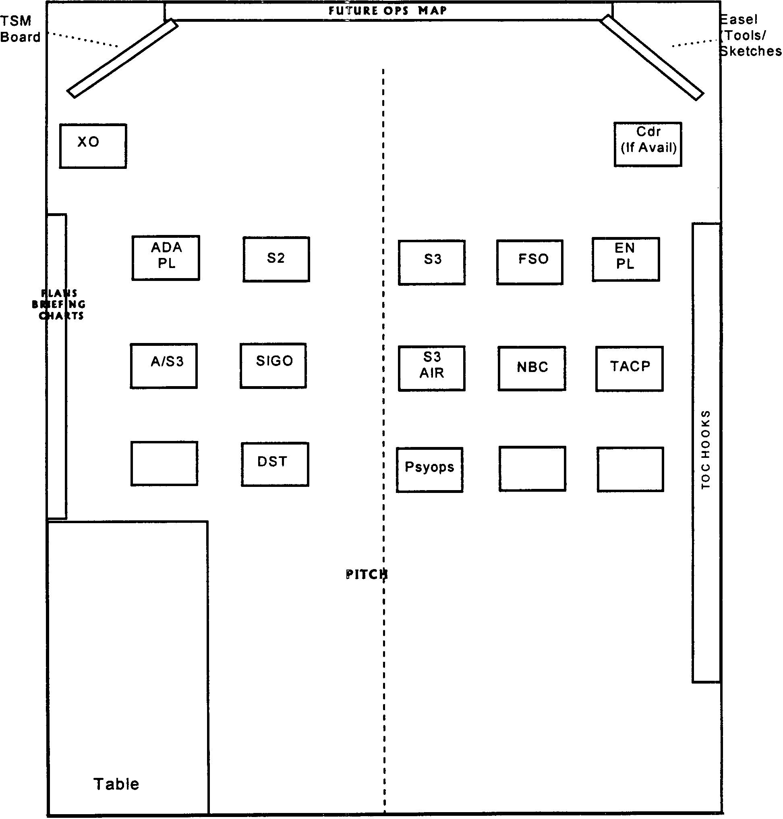

Target Synch Matrix
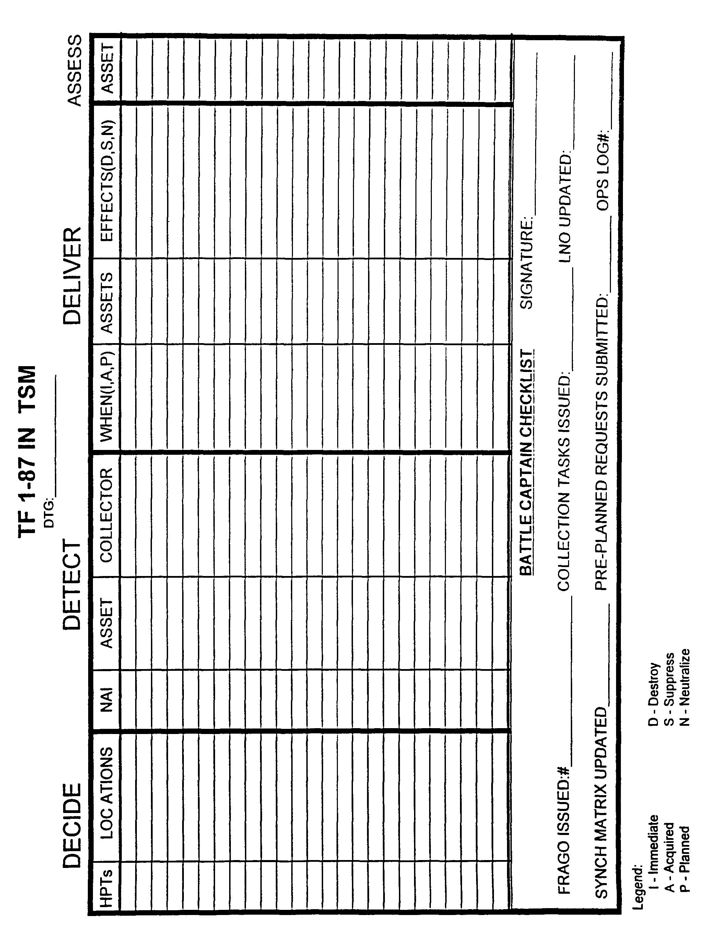

Rehearsal Scheme of Maneuver

1. Introduction & Rules includes the following:
• Type of Rehearsal
• Good Rehearsal = Everyone understands the plan; plan is synchronized
• Cdr’s, FSOs, Spec PIt Ldrs & Staff enter & exit the fight when you expect to
begin and end tasks in each critical event
• PLs listen and go through motions as respective Co Cdr speaks through event
• S2 plays the enemy commander; BICC plays intel assets
• Enemy Commander briefs MDCOA at end of event; Bn Cdr addresses Ctr-
Reaction
• S3 briefs decision points as they occur each event
• Restrict discussion to the one event being addressed
• Address changes/recommendations to the plan

2. Sequence of rehearsal for each event is (main effort will usually begin the maneuver brief portion):
• S3 - Event Overview (Bde & Bn) / Conditions Set
• S2 - Enemy Actions / Intent
• FSO
• BICC - Current Intel / Recon Situation
• Predator 6
• Gator 6
• Bear 6
• Bushmaster 6
• Cobra 6
• Killer 6
• Havoc 6
• Reserve
• ATLS
• By exception: Engr, ADA, SIGO, CHEMO
• S2 - Enemy Most Dangerous COA
• Bn Cdr - Counter Reaction

3. The following is what each briefer briefs:
• Intel (what do you see)
• Maneuver (Task, Purpose, Actions)
• FS (Fires Avail, Priority Targets)
• C2 (Communications, CP locations)
• CSS (CASEVAC, if casualties)

TO THE TOP WARNING ORDER #1 FORMAT

WARNORD # DTG/Zone Reference: Map Series Page of
Line 1: Task Organization
A. No Change B. Small Change C. Major Changes
Line 2: Brigade Task Force Mission

A. Attack E. Establish Lodgment I. Defend MOUT
B. Attack A Strong Point F. Movement to Contact J. Delay
C. Attack MOUT G. Search and Attack K. Withdraw
D. Raid H. Defend L.
Line 3: Expected Tasks

A. Seize H. Disrupt 0. Canalize V. Reconnoiter
B. Secure I. Fix P. Isolate W. Deny
C. Occupy J. Interdict Q. Overwatch X. Contain
D. Retain K. Breach R. Screen Y. Isolate
E. Destroy L. Feint S. Cover Z. Defeat
F. Neutralize M. Demonstrate T. Guard Aa. Follow/Support
G. Suppress N. Block U. Clear
Line 4: Method of Movement

A. Air Assault D. Organic Vehicles G.
B. Air Movement E. External Vehicles
C. Foot March F. Infiltrate
Line 5: Objective/Area of Operation
A. OBJ Vicinity: D. Grid:
B. Grid: E. Grid:
C. Grid: F. Grid:
Line 6: Tentative Time Schedule

A. Expected Time Of Operation: E.
B. Earliest Time To Move: F.
C. Begin Preparation for Movement Now (Yes / No) G.
D. Guidons to Bn TOC: H.
Line 7: Additional Information

Official:  S3 CDR | Annexes: | Classification:

Warning Order #2 Format to 51st MP BN Planning SOP

Copy ____ of ____ Copies
51st MP BN (LI)
________________(LOC)
________________(DTG)
WARNORD #2 to OPORD _____________
Terrain Analysis

1. SITUATION.
a. Threat Forces. Enemy Most Probable and Most Dangerous COA.
b. Friendly Forces. Mission and Intent of higher and adjacent units.
c. Task organization changes from higher.
2. MISSION. Restated Mission
3. EXECUTION.
Commanders Initial Intent
a. Concept of Operation
(1) Commander’s COA Development Guidance.
(2) Scout Frago (if applicable)
b. Coordinating Instructions. Include all known and pertinent information.
(1) Updated Time Schedule
(2) Description of Bn AO (Reference sketch or overlay of AO)
(3) Movement Orders
(4) Additional or new Recon and/or Security Instructions
(5) Priorities and instruction for combat support, combat service support
(6) Initial guidance on rehearsals
(7) Initial CCIR
- PIR
- EEFI
- FFIR
(8) Initial IR
(9) Deception Guidance
(10) Risk Guidance
4. SERVICE AND SUPPORT. TBP in OPORD ______.
5. COMMAND AND SIGNAL. TBP in OPORD ______.

ACKNOWLEDGE:

LTC
OFFICIAL:

S3

WARNING ORDER #3

WARNORD # DTG/ZONE Reference: Map Series Page of pages

TASK ORGANIZATION: SEE CONTINUATION SHEET
LINE 1: SITUATION

A. ENEMY

B. FRIENDLY

LINE 2. MISSION

LINE 3. EXECUTION:

BDE CDR’S INTENT
KEY TASKS:

END STATE:

OFFICIAL:  S3 CDR | ANNEXES: | CLASSIFICATION

CONTINUATION SHEET, WARNING ORDER #3

CONTINUATION SHEET, WARNING ORDER #________
Page ___ of ___ pages

OFFICIAL:  S3 CDR | ANNEXES | CLASSIFICATION

SCOUT FRAGO
1. SITUATION: A. LIGHT: |  | DAY |  | BMNI | SR | SS |  |  | EENT |  | MR |  | MS |  | ILL | WEATHER FORECAST
FRIENDLY UNIT LOCATIONS
LEFT:
RIGHT:
FRONT:
SOF:
LRSD:
COORDINATION POINTS:
C. ENEMY LOCATIONS KNOWN:  1 4  2 5  3 6 |  |  |  |  |  |  | ENEMY LOCATIONS SUSPECTED:  1 4  2 5  3 6
2. A. MISSION BN:

B. BN CDR’S INTENT:

3. SCOUT MISSION:

SCOUT INTENT:

SNIPER TARGET/INDIRECT FIRE ENGAGEMENT CRITERIA
SELF DEFENSE ONLY | TARGET OF OPPORT. ENEMY OPS |  |  |  |  |  |  |  |  | PREPLANNED TGT
D. INSERTION
E. EXTRACTION |  |  |  |  |  |  |  |  |  | NLT E&E TIME/LOCATION
F. ACTIONS ON COMPROMISE:
G. WITHDRAWL/ENGAGEMENT CRITERIA
H. NAI | PURPOSE |  |  |  |  |  |  |  |  |  |  | PIR |  |  |  |  |  | TIM
4. SERVICE/SUPPORT
A. CLASS I:
B. CLASS V:
C. CLASS IX:
D. METHOD OF RESUPPLY:
E. CACHE POINT/RESUPPLY POINT:
F. MEDEVAC: |  |  | DAY |  |  |  |  | DAY |  |  |  |  |  | DAY |  |  | DAY
5. COMMAND /SIGNAL
A. BDE/CAN:
B. BNCMD:
C. SCT PRIMARY
D. 81mm:
E. A CO 311 MI
F. OF 1 NET

OPORD FORMAT
(CLASSIFICATION)

Copy _____of _____Copies
51st MP BN
Place of issue (coordinates)
DTG of signature

OPERATION ORDER_______

Reference(s):
a.
b.
c. Time Zone Used Throughout the Order:

1. SITUATION

a. Enemy Forces. See ANNEX B (INTELLIGENCE).
b. Friendly Forces.
(1) Mission two levels up.
(2) Intent two levels up.
(3) Mission one level up.
(4) Intent one level up.
(5) Adjacent Units.
c. Attachments and Detachments. See ANNEX A (TASK ORGANIZATION).
EFFECTIVE TIME.

2. MISSION

3. EXECUTION

Commander’s Intent: Key tasks, Endstate.
a. Concept of the Operation. ANNEX C (OPERATION OVERLAY).
(1) Maneuver.
(2) Fires. ANNEX D (FIRE SUPPORT).
(a) Purpose, Priority, Allocation, Restrictions.
(b) Critical Fire Support Tasks.
(3) Intelligence. See ANNEX B (INTELLIGENCE).
(4) Electronic Warfare. See ANNEX T (ELECTRONIC WARFARE).
(5) Engineer. See ANNEX F (ENGINEER).
(6) Air Defense. See ANNEX G (AIR DEFENSE).
b. Tasks to Maneuver Units.
c. Tasks to Combat Support Units.
d. Coordinating Instructions.
(CLASSIFICATION)

(CLASSIFICATION)

(1) CCIR.
(2) Updated Timeline.
(3) MOPP Level.
(4) NBC Threat Status.
(5) Air Defense Warning/Weapons Control Status.
(6) Media Message.

4. SERVICE SUPPORT. See ANNEX I (SERVICE SUPPORT).

5. COMMAND AND SIGNAL
a. Command.
b. Signal. See ANNEX H (SIGNAL).

Acknowledge.

(BN CDR)
LTC

OFFICIAL

(S3)
S3

ANNEXES:
ANNEX A: TASK ORGANIZATION ANNEX P: SPARE
ANNEX B: INTELLIGENCE ANNEX Q: OPSEC
ANNEX C: OPERATIONS OVERLAY ANNEX R: PSYOPS
ANNEX D: FIRE SUPPORT ANNEX 5: DECEPTION
ANNEX E: RULES OF ENGAGEMENT (ROE) ANNEX T: ELEC. WARFARE
ANNEX F: ENGINEER ANNEX U: CIVIL MILT. OPS
ANNEX G: AIR DEFENSE ANNEX V: PUBLIC AFFAIRS
ANNEX H: SIGNAL ANNEX W: PERSONNEL
ANNEX I: SERVICE AND SUPPORT ANNEX X: SAFETY
ANNEX J: NBC OPERATIONS TIMELINE
ANNEX K: MILITARY POLICE DECISION SUPPORT MATRIX
ANNEX L: R & S OPERATIONS DECISION SUPPORT TEMPLATE
ANNEX M: AVIATION
ANNEX N: REAR OPERATIONS
ANNEX 0: A2 C2

(CLASSIFICATION)

OPORD Sign Out Log
COPY NUMBER | OWNER | SIGNATURE
Original | Bn TOC Orders Book
1 | S1
2 | S2
3 | S3
4 | S4
5 | Bn XO
6 | Bn Cdr
7 | Bn CSM
8 | TOC NCOIC
9 | S3 Air
10 | 81mm Mtr Plt Ldr
11 | Med Plt Ldr
12 | Support PIt Ldr
13 | AT Pit Ldr
14 | SIGO
15 | FSO
16 | Engr PIt Ldr
17 | ADA PIt Ldr
18 | TACP
19 | 131 Co Cdr
20 | 132 Co Cdr
21 | 133 Co Cdr
22 | HHD Cdr
23 | Bde Headquarters
24 | O/C
25 | O/C
26
27
28
29
30

OPORD SEATING CHART

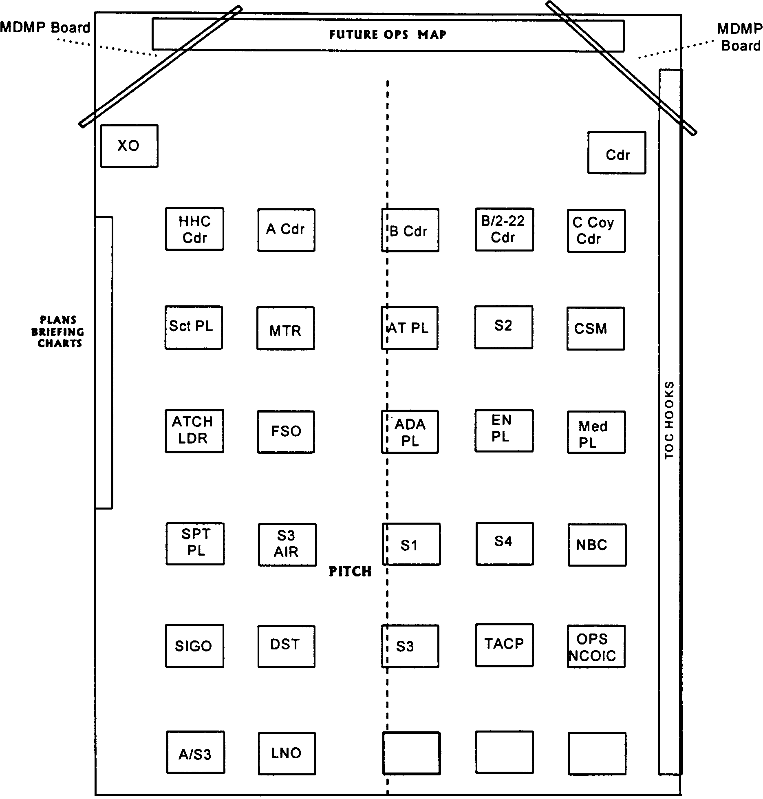

Mission Analysis Brief Agenda

Brief Briefer
Introduction XO
Review Bn Cdr’s Initial Guidance XO
Review Bn AO/AI S3
Division Mission & Intent S3
Bde Mission and Bde Cdr’s Intent S3
Bde Concept of Operations to Include Deception plan on the Obj S3
Bde Cdr’s OCIR S3
Initial IPB Products S2
Forces/Assets Available S3
Specified/Implied Tasks S3
Essential Tasks S3
Constraints S3
Risks S3
Facts S3
Assumptions 53
CSS Analysis S1/S4
Restated Mission S3
Proposed CCIR S3
Review Scribes Notes Scribe
Timeline XO
Receive Cdr’s Guidance CDR

COA Brief Agenda

Brief Briefer
Introduction/Review Timeline XO
Updated IPB S2
Possible Enemy COAs (Event Template) S2
Review Bn Restated Mission S3
Review Div and Bde Mission and Intent S3
Updated Facts and Assumptions S3
Review Bn Cdr’s OQA Guidance S3
Brief COA Statements and Sketches S3
Rationale for each OQA S3
BOS Support of COA (If Applicable) BOS
Receive Cdr’s Wargame Guidance CDR

Wargame Brief Agenda

Brief Briefer
Introduction/Review Timeline XO
Updated IPB S2
Enemy COAs Used in Deliberate Wargame S2
Review Div & Bde Mission & Intent S3
Review Bde Concept of Operations (Including Deception) S3
Review Friendly OQA(s) to Wargame S3
Updated Facts and Assumptions S3
Wargame Technique Used S3
Critical Events Wargamed S3
Possible Enemy Actions and Reactions S2/S3
Modifications to the COA S3
Strengths and Weaknesses of the COA S3
Results of the Wargame S3
BOS Brief as Applicable BOS
Receive Cdr’s Guidance for the OPORD CDR

OPORD Brief Agenda

Brief Briefer
Introduction/Roll Call XO
Introduction of all Visual Aids XO
AO/AI S3
Friendly Situation, Higher HQ’s Mission and Intent S3
Enemy Situation S2
Task Organization S3
TF Mission S3
TF CDR’s Intent CDR
CCIR S3
Concept Of Operations S3
Fires FSO
M/S/CM ENPL
Counter Air ADA PL
Air S3 Air
NBC Chemo
Coordinating Instructions S3
Service & Support SI/S4
Cmd & Signal Sigo
Cdr’s Guidance CDR

Confirmation Brief (BN to BDE)

1. Brigade Commander’s Intent;

2. Specified Tasks:

3. Mission: Task and Purpose:

4. Coordination Requirements:

5. Problems, Concerns, Issues:

Confirmation Brief (Co to Bn)

Roll Call XO
Battalion Task Force Commander’s Intent Briefer
Hasty Mission Analysis
- Specified Tasks
- Implied Tasks
- Essential Tasks
Restated Mission
Intent
Task Organization
Status of Your Unit
- Personnel
- Equipment
- Movement Needed
- Other Constraints
Questions
Required Assistance to Meet Time Schedule
Closing Remarks Bn CDR

Concept Backbrief Agenda (Bn to Bde)

1. Mission Statement
2. Commander’s Intent
3. Task Organization
4. Intel (What We are Facing - Use Graphics Overlay, Bde Requires 1:50,000)
5. Concept of the Operation (Use Operations Overlay, Bde requires 1:50,000;
May Use COA sketch)

a. Maneuver (Using Battlefield Framework and Operations Overlay on Map
and COA Sketch/ Diagram or Map)

b. Identify Main and Supporting Efforts with Task and Purpose
c. Concept of Fires
6. Concept of Logistical Support (Brief Off Operations Overlay - May Use COA Sketch)
a. General
b. CASEVAC
7. CP Locations (on Operations Overlay)
8. Questions/ Issues /Concerns

Concept Backbrief (Co to Bn)

Roll Call XO
Brigade Mission / Intent (Task and Purpose) Briefer
Battalion Mission / Intent (Task and Purpose)
Enemy Situation
- Current Enemy Activities
- What You Expect to See
- Enemy Weaknesses You Intend to Exploit
- Terrain/Weather Impacting on Your Mission
Your Mission (Task and Purpose)
Your Intent
Task Organization
Concept of Operation (Include Sketch)
Fire Support
- Direct Fire Weapons
- Indirect Fire Weapons
- Fire Control Measures
- FA Observer Plan Obstacle Plan
- C2 for Emplacement
- Plan to Observe
- Integration into Maneuver and Fire Support Plans
Patrol and Security Plan
Air Defense (If Applicable)
Coordination Require with Adjacent Units
CSS War-Stoppers
- Transportation
- Water
- Equipment
- Supplies/Re-Supply Operations
- Personnel
CASEVAC Plan
EPW Collection Plan
Soldier Load Issues
Location of Key Leaders
Critical Times
Risk Assessment / Mitigation
Questions/Required Assistance
Closing Comments CDR
Review Time Schedule XO

Synchronization Meeting Agenda

Roll Call XO
Agenda XO
Focus of Targeting XO
- Changes in Mission, Commanders Intent, Task Org
- Specific Enemy (Mortars, ADA, etc...)
- Time (next 24 hours)
Weather / Illumination Data S-2
Current Enemy Situation (Including BDA over last 24 hrs) S-2
- Status of R&S
Enemy Most Probable COA (Next 24-48 hours) S-2
- Predictive Analysis of Future Enemy Locations & Activities S-2
Changes to PIR (Recommendations) S-2
Review Current OPS (Friendly Locations and Activities) S-3
Review Status of Available Assets (Combat Power) S-3
New Requirements from Higher HQ S-3
Review Bde and Bn HPT List S-3
Planned Operations (Next 24-48 hours) S-3
Review Current Target Synch Matrix FSO
- FS Assets Available
- Review Attack Guidance Matrix
Nominate Targets S-2
Develop New Target Synch Matrix S-3
Resynch BOS XO
Recommend Changes to EEFI & FEIR S-3
Collection Taskings/FRAGO S-2/FSO/S-3
Summary XO

Rehearsal Agenda

Roll Call XO
Introduction & Rules/Orientation XO
TE 1-87 Mission / Intent S3
TF 1-87 Task Organization S3
Concept of Operations S3
Critical Events to Rehearse XO
Critical Event # 1 – Stage (PZ Posture) by Lifts All
Critical Event # 2 – Land/Movement to BPs, by lifts All
Critical Event # 3 – Establish BPs, by Lifts All
Critical Event # 4 – Actions on Contact All
Enemy, Civilians, Media
Review Issues/Taskings XO
Review Timeline XO

*All units bring concept sketch and/or ICONs to place on the terrain model
*RD is scheduled for 1 hour

Commander’s Conference Call

Significant Activities Last 12 hours
Significant Activities Next 12 hours
Anticipated Enemy Actions Next 12 hours
*Current Combat Power (by Company size element and any specific
items of interest as applicable)
Logistical Concerns I Issues (if applicable)

Briefing Sequence is:

131 MP CO
132 MP CO
133 MP CO
HHD

* Combat power is reported as Green (80-100%), Amber (60-79%), Red (40-59%), or Black (0-39%).

Briefing Tools Checklists

1. The following checklists are used to ensure all products/tools necessary to conduct a briefing are present and in the correct order. The description column refers to how the tool is displayed. If a tool shown is on “butcher block paper”, this refers to a chart pack paper with the title written on top and necessary information listed below (it is not acetated). Display slide refers to a tool posted on the Plans Status Chart board (8½” x 11”). All agendas are acetated and posted separately from the butcher block paper.

a. Mission Analysis:

TOOL DESCRIPTION
Agenda Butcher Block Paper
Ops Map with Bde Ops Overlay Posted Plans Map / Overlay
Division Mission & Intent Butcher Block Paper
Brigade Mission and Intent
Brigade Cdr’s CCIR
Weather/Ilium Data (NVG Windows) 8½” x 11” Paper (posted)
MCOO Plans Map / Overlay
Doctrinal Templates 8½” x 11” Paper (posted)
Enemy Situational Template Plans Map / Overlay
Forces/Assets Available 8½” x 11” Paper (posted)
Higher HQ Assets in AO “
Specified Task List Butcher Block Paper
Implied Task List
Constraint List
Risk
Facts
Assumptions
Bn Restated Mission
Proposed CCIR
Timeline 8½” x 11” Paper (posted)
Issues Butcher Block Paper

b. COA Briefing:
TOOL DESCRIPTION
Agenda Butcher Block Paper
Timeline 8½” x 11” Paper (posted)
Ops Map with Initial Bn Ops Overlay Posted Plans Map / Overlay
Doctrinal Templates 8½” x 11” Paper (posted)
Enemy Situational Template Plans Map / Overlay
Initial Enemy Event Template “
Bn Restated Mission Butcher Block Paper/Display Slide
Bn Commander’s Intent
Division Mission & Intent
Brigade Mission and Intent
Facts Butcher Block Paper
Assumptions “
Forces/Assets Available 8½” x 11” Paper (posted)
Higher HQ Assets in AO “
COA Sketch & Statement Butcher Block Paper
Evaluation Criteria (IF > one COA)
Decision Matrix (IF > one COA)
Butcher
Recommendation (IF > one COA)
Proposed CCIR
Brigade Cdr’s CCIR Butcher Block Paper/Display Slide
Issues Butcher Block Paper

c. Wargame Briefing:
TOOL DESCRIPTION
Agenda Butcher Block Paper
Ops Map with Bn Ops Overlay Posted Plans Map / Overlay
Doctrinal Templates 8½” x 11” Paper (posted)
Enemy Situational Template Plans Map / Overlay
Enemy Event Template(s) “
Division Mission & Intent Butcher Block Paper/Display Slide
Brigade Mission and Intent “
Bn Task Organization Butcher Block Paper
Bn Mission Butcher Block Paper/Display Slide
Bn Commander’s Intent “
COA Sketch & Statement Butcher Block Paper
OBJ Sketch (if applicable)
Facts
Assumptions
Wargame Matrix w/Critical Events Posted Wargame Matrix Posted
CCIR (Bde & Bn) Butcher Block Paper/Display Slide
HPTL (Bn Proposed) Butcher Block Paper
Timeline 8½” x 11” Paper (posted)
Issues Butcher Block Paper

d. OPORD Briefing:

TOOL DESCRIPTION
Agenda Butcher Block Paper
Seating Chart 8½” x 11” Paper (posted)
TOC Sector Sketch/TOC Battle Drills Sector Sketch/Display Slides
Ops Map with Bn Ops Overlay Posted Plans Map / Overlay
Division Mission & Intent Butcher Block Paper/Display Slide
Brigade Mission and Intent “
Weather/Ilium Data (NVG Windows) 8½” x 11” Paper (posted)
Doctrinal Templates “
Enemy Situational Template Plans Map / Overlay
Enemy Event Template(s) “
Bn Task Organization Butcher Block Paper
Bn Mission Butcher Block Paper/Display Slide
Bn Commander’s Intent
Bn CCIR
COA Sketch & Statement Butcher Block Paper
OBJ Sketch (if applicable) “
Air Movement Table Butcher Block Paper (IF Applies)
PZ/LZ Sketches “
Fires Overlay/Sketch Plans Map / Overlay
Fire Support Execution Matrix Butcher Block Paper
Obstacle Overlay/Sketch Plans Map / Overlay (IF Applies)
Obstacle Execution/Survivability Matrix Butcher Block Paper (IF Applies)
ADA Coverage Overlay Plans Map / Overlay
Chemical Overlay (Contaminated Areas Plans Map / Overlay (IF Applies)
& Decon Rtes/Points)
CASEVAC Plan/Overlay Plans Map / Overlay
CSS Overlay “
Concept of Support Butcher Block Paper
Risks
Facts
Issues
Timeline 8½" x 11” Paper (posted)

e. Synchronization Briefing:

TOOL DESCRIPTION
Agenda Butcher Block Paper|
Seating Chart 8½” x 11” Paper (posted)
Ops Map with Bn Ops Overlay Posted Plans Map / Overlay
Weather/Ilium Data (NVG Windows) 8½” x 11” Paper (posted)
Doctrinal Templates “
Enemy Situational Template Plans Map / Overlay
Enemy Event Template(s) “
Enemy Combat Power (Cut Sheet) Display Slide
R & S Overlay Plans Map / Overlay
Bn CCIR Display Slide
Bn Combat Power Charts
Division Mission & Intent
Brigade Mission and Intent
Current Bn Task Organization Butcher Block Paper
Current Bn Mission Display Slide
Current Bn Commander’s Intent “
New Bde Frago & Overlay Plans Map / Overlay
Bde/Bn HPTL Display Slide
TSM Butcher Block Paper
Assets Available (ALL BOS) Display Slides
Issues Butcher Block Paper
Timeline 8½" x 11” Paper (posted)

f. Rehearsal:

TOOL DESCRIPTION
Agenda Butcher Block Paper
Ops Map with Bn Ops Overlay Posted Plans Map / Overlay
Terrain Model (if applicable) Terrain Model
Weather/Ilium Data (NVG Windows) 8½” x 11” Paper (posted on easel)
Enemy Situational Template Rehearsal Map / Overlay
Enemy Event Template(s)
R & S Overlay
Current Bn Task Organization Butcher Block Paper
Current Bn Mission
Current Bn Commander’s Intent
Critical Events List
Sequence of Events (What to Rehearse)
Issues
Timeline 8½” x 11” Paper (posted)

SIGACTS DEFINITION

FRATRICIDES
ROE VIOLATIONS/CHANGES
ENEMY SIGHTINGS/CONTACTS
OCIR
NBC EVENTS
CONTROL MEASURE EVENTS
(LD, LOA, PL, CHANGES TO CONTROL MEASURES, PZ, 12, BREACHES, OBJ STATUS)
CASEVAC EVENTS
REMBASS/GSR EMPLACED
SCOUT STATUS CHANGE
Q36 DOWN (MAINT OR BY EN CONTACT)
AVN/VIP IN AO
COB REPORTS
COMSEC COMPROMISE
EPW REPORTS/STATUS
HEAT/COLD INJURIES
TASK ORG CHANGES
ORDERS RECEIVED/ISSUED
MINEFIELD REPORTS (EN & FRIENDLY)
VOLCANO STATUS
MOPMS STATUS (ON HAND, EMPLACED, RCU)
ADW/WCS CHANGE
RETRANS STATUS
OTHER UNITS IN AO
MSR STATUS CHANGE
NO COMMO WITH UNITS (>2 HRS)
RESERVE/QRF COMMITTED

Tasks and Purpose List

TACTICAL TASKS:
ENEMY TERRAIN FRIENDLY
ATTACK BY FIRE BLOCK RETAIN GUARD
BYPASS CANALIZE SECURE SCREEN
CONTAIN FIX SEIZE SUPPORT BY FIRE
DESTROY NEUTRALIZE OCCUPY
INTERDICT RUPTURE
SUPPRESS DEFEAT
DISRUPT CLEAR
BREACH REDUCE
ISOLATE DEFEAT

TACTICAL PURPOSES (IN ORDER TO):
PREVENT DIVERT ENABLE DECEIVE
DENY OPEN ENVELOP SURPRISE
CAUSE PROTECT ALLOW CREATE
INFLUENCE SUPPORT

TYPE OF OPERATIONS:
ATTACK COUNTERATTACK DEFEND
MOVE TO CONTACT RETROGRADE MOVILITY
COUNTERMOBILITY SURVIVABILITY RIVER CROSSING
RELIEF IN PLACE RAID PURSUIT
EXPLOITATION BREAKOUT DELAY
FOLLOW AND ASSUME FEINT SEARCH AND ATTACK
FOLLOW AND SUPPORT RECON

CONTROL MEASURES/TECHNIQUES PROCEDURES:
STRONG POINT BATTLE POSITION SECTOR
BATTLE HANDOVER PASSAGE OF LINES PASSAGE POINT
OBJECTIVE AXIS DIRECTION OF ATTACK
AMBUSH ENGAGEMENT AREA PHASE LINE
ZONE CHECKPOINT TRP

FORMS OF MANEUVER TYPES OF OFFENSIVE OPERATIONS
PENETRATION MOVEMENT TO CONTACT
INFILTRATION ATTACK
TURNING MOVEMENT EXPLOITATION
ENVELOPMENT PURSUIT
FRONTAL ATTACK FEINT
DEMONSTRATION
RAID

DEFINITIONS OF TACTICAL TASKS

ATTACK BY  FIRE | Fire (indirect & direct) employed to destroy the enemy from a distance when the mission does not dictate or support occupation of the objective. The intent of fires must be specified (destroy, fix, or suppress).
BLOCK | To deny the enemy access to a given area or to prevent enemy advance in a given direction. Unit should be given degree of success and/or specified time frame. An obstacle effect that integrates time planning and obstacle effort to stop an attacker on a specified avenue of approach or to prevent enemy from exiting an EA.
BREACH | Any means available are used to break through or secure a passage through an enemy defense, obstacle, minefield, or fortification.
BYPASS | Maneuver around and obstacle, position, or enemy force to maintain the momentum of advance. Bypassed obstacles and forces are reported to higher.
CANALIZE | To restrict operations to a narrow zone by use of obstacles, fires, or unit maneuvering or positioning.
CLEAR | To remove all enemy forces and eliminate organized resistance in an assigned zone, area or location by destroying, capturing, or forcing the withdraw of enemy forces so they cannot interfere with friendly units ability to accomplish the mission. The total elimination or neutralization of an obstacle (not done under fire)
CONTAIN | To restrict enemy movement. Accomplished by stopping, holding, or surrounding the enemy or causing him to center his activity on a given front to prevent the movement of any part of his force for use elsewhere. Limits of containment may be expressed in terms of time or geography
DEFEAT | To disrupt/nullify the enemy’s plan and/or subdue his will to fight so he is either unwilling or unable to pursue his mission ... may or may not entail the destruction of any part of the enemy force. Psychological or physical (FM 71-1 00)
DELAY | To trade space for time and inflict maximum damage on the enemy force without becoming decisively engaged, and preserve the force within limits established by the issuing commander.
DELAY FORWARD OF | A high risk mission requiring a unit to prevent enemy forces from reaching the specified area earlier than the specified time or event regardless of the cost.

DELAYING OPERATION | Conducted when the commander needs time to concentrate or withdraw forces, to establish defenses in greater depth, to economize in an area, or to complete offensive elsewhere. Destruction of the enemy force is secondary to slowing his advance.
DELAY IN  SECTOR | Low risk mission which requires a unit to slow and defeat as much of the enemy as possible without sacrificing the tactical integrity of the unit.
DESTROY | To physically render an enemy force combat-ineffective.. To render target so damaged that it cannot function as intended or be returned to usable condition without being entirely rebuilt.
DISRUPT | A task or obstacle effect that integrates tactical planning and obstacle effort to break apart an enemy’s formation and tempo, interrupt the enemy s timetable, cause premature commitment of forces, and/or piecemeal their attack. Comment: A unit assigned a disrupt mission should be told the degree of success to be achieved and/or the duration of the disruption.
FIX | To prevent the enemy from moving any part of his force from a specific location and/or for a specific period of time by holding or surrounding them to prevent their withdrawal for use elsewhere.
GUARD | To protect the main force by fighting to gain time, while also observing and reporting information, and preventing enemy ground observation of and direct fire against the main body by reconnoitering, attacking, defending, and delaying
INTERDICT | A tactical task oriented on the enemy to prevent, hinder or delay the use of a route or approach by enemy forces. Comment: A force assigned an interdict task should normally be assigned the degree or success to be achieved and/or the duration of the interdiction in relationship to the purpose.
ISOLATE | Tactical task to seal off an enemy from its source of support, to deny an enemy unit from having contact with other enemy forces.
NEUTRALIZE | To render the enemy incapable of interfering with a friendly operation. Takes a target out of action temporarily.
OCCUPY | A force moves into an objective, key terrain, or other area without opposition and controls the entire area. To remain in an area and retain control of that area.

RECON | To obtain information on the enemy, potential enemy, or characteristics of an area, forms include route, zone, area, and recon in force. NBC recon uses special equipment to determine presence or extent of NBC contamination. Engineer recons focuses on requirement to clear obstacles, or improve routes, fords, and bridges.
REDUCE | To gain control over an enemy position or objective. To create lanes through or over an obstacle sufficient to allow the attacking force to accomplish its mission.
RETAIN | To occupy and hold a terrain feature to ensure it is free of enemy occupation or use.
RUPTURE | To create a gap in enemy defensive positions quickly.
SECURE | To gain possession of a position or terrain feature, with or without force, and to deploy in a manner which prevents its loss or destruction by enemy action. Physical occupation is not required.
SEIZE | To clear a designated area or terrain feature and gain physical control of it. The enemy may or may not be occupying the terrain.
SUPPORT BY FIRE | Task where a maneuver element moves to a position where it can engage the enemy by direct fire to support a maneuvering force.
SCREEN | To observe, identify, and report information as part of a security force, while only fighting in self-protection. A task to maintain surveillance, provides early warning, or impede, destroy, and harass enemy recon without becoming decisively engaged.
SUPPRESS | Use of direct and/or indirect fire or other means (ECM & Smoke) to limit the ability of the enemy to observe and deliver effective fire on friendly forces. Effects of suppression generally last only as long as the suppressive fires.

Staff Estimates

1. The sub-tasks listed below outline the actions and information that must result from a sound, effective staff estimate when employing the decision making procedure. Key is for the staff, guided by the BN XO, to maintain updated and forward oriented (time) charts and information at their work stations on a continuing basis. This will allow rapid estimates to be developed. Present estimates orally. Critical to the preparation of the staff estimates is the availability of current, relevant information. As the staff prepares their estimates each must have access to higher OPORD annexes that apply to their position. The estimate items listed below are not all inclusive. Required information may vary IAW METT-T and Bn Cdr’s information requirements.

a. Each staff member prepares a staff estimate of his area of responsibility that
(1) Analyzes how factors influence mission accomplishment.
(2) Are developed through consultation with other staff officers to receive critical, relevant, and accurate information.

b. The TF staff prepares the information shown below. Information listed is also prepared for higher and adjacent units.
(1) S2. Analyzes the enemy situation within the area of interest and the characteristics (weather and terrain) of the area of operations in terms of how they can effect the mission. The S2 presents conclusions and make recommendations concerning the effect of the AO on:
(a) Friendly and Enemy Fires
(b) Probable Enemy COA
(c) Enemy Vulnerabilities the TF Can Exploit
(d) Feasibility of Various Friendly COAs (once developed)
(e) Status of Intelligence Collection Assets
(2) S3. Analyzes all the factors which could affect the mission to determine all reasonable COA and their COA and their effect on friendly forces. The operations and commander’s estimate use the same format and generally have the same content. The staff operations estimate culminates in a recommendation.
(a) Time Available
(b) Current Status of TF units
• Task Organization
• Combat Strength
- Crews, Squads, Platoons - Weapons Systems
- Vehicles - Class III and V Status
• Location and Activities
(c) S3 Assessment of TF Capability to Conduct Operations
(d) Missions and Commander’s Intent of Brigade, Division, and Adjacent Units.
(3) FSO.
(a) Current FS Unit Status
• Available DS, GS, GSR Units • FS Unit Manning (Operational
Capability)
• TF Mortars • Location and Status / Activities
• Operational Tubes, Cannons and FISTs
(b) Availability of Projectiles and Fuses
(c) FSO Assessment of FS Capabilities in Terms of Strengths and Weaknesses
(4) ADA.
(a) Current Air Defense Artillery Unit Status
• Available Units • Unit Manning (Operational Capability)
• Operational Launchers and Guns • Location and Activities

(b) Current Status of AD Munitions
(c) ADO Assessment of Air Defense Capabilities
(d) Air Defense Weapons Control Status
(e) Early Warning Control Status
(5) ENG.
(a) Current Engineer Unit Status
• Units and Equipment Available
• Manning (Operational Capability)
• Location and Activities
(b) Status of Engineer Class V
• Bangalore Torpedoes • AT & AP Mines • Fuzes
• MICLIC • Detonation Cord • Wire and Pickets
• GEMs • Crater Charges • Explosives (C4, etc...)
(c) TF engineer assessment of capability to support the TF Analysis of survivability capabilities, resources, and availability of earth moving equipment Analysis of threat mobility/ countermobility assets and capabilities.
(6) NBC
(a) Available TF NBC Defense Capabilities
• Available Chemical Unit Support
- Smoke Platoon
- Decontamination Units/Sites
- NBC Reconnaissance Vehicles
• Status of NBC Personnel
• On Hand NBC Defense Equipment
• Current Status of NBC CL V
(b) Assessment of NBC Defense Capabilities
(7) S1/S4.
(a) Current Maintenance Status
• DA Form 2406 Report (MAINSTAT)
• Repair Parts (CL IX)
• Maintenance Asset Locations and Activities (UMCP, Field Trains)
• Key Maintenance Personnel Status
• Available DS and GS Support
• BMO’s Assessment of Capabilities in Terms of Strengths and Weaknesses
(b) Current Logistics Status
• CL I, II, III, IV, V, and VII (LOGPACs, Field Trains)
• Logistics Asset Locations and Activities (Combat Trains, LOGPACs, Field Trains)
• Key Logistics Personnel Status
• Available DS and GS Support
• S4’s Assessment of Capabilities in Terms of Strengths and Weaknesses
(c) Current Medical Support Status
• Medical Treatment Locations and Activities (BAS and Field Trains)

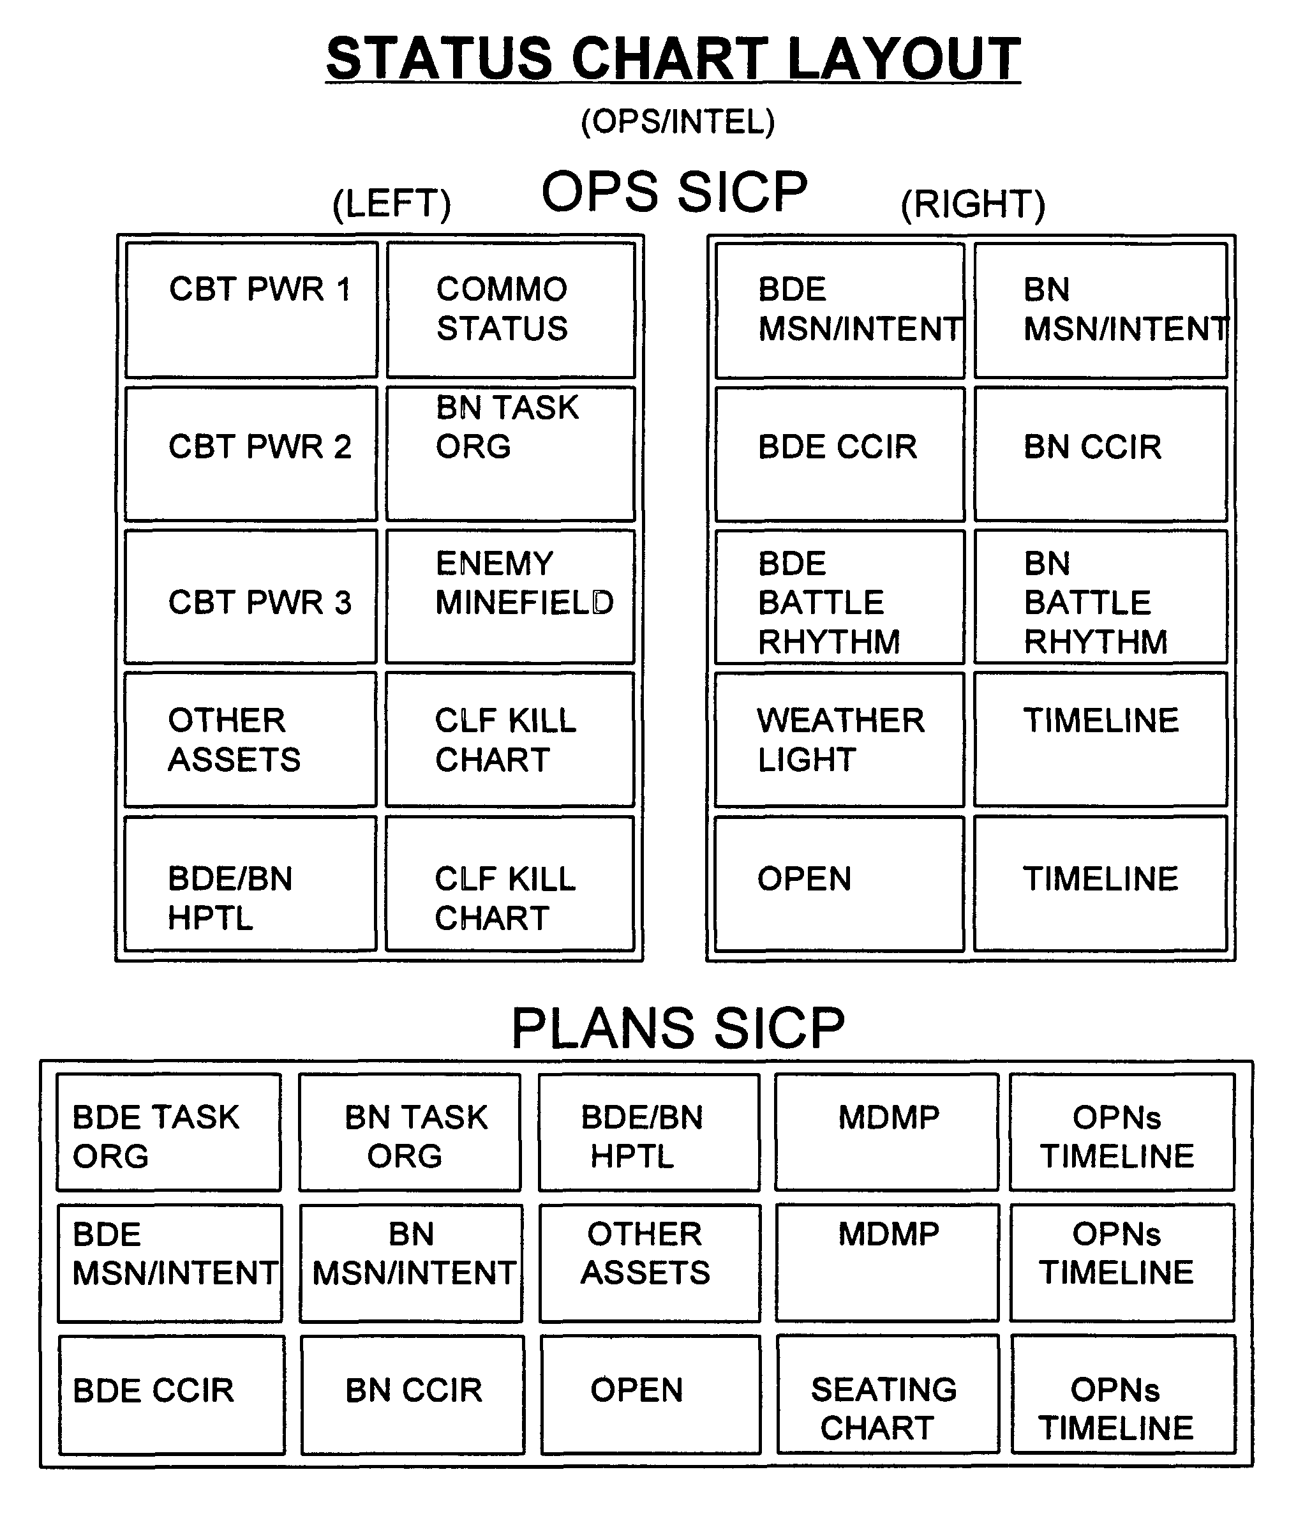

Commander’s Wake Up Criteria

Wake Up the Battalion Commander if any of the following events occur:

1. CCIR event happens.
2. Loss of a MP Team.
3. Loss of an MP squad.
4. Loss of an AT system/vehicle.
5. Two hours out of commo with any unit/element, including Bde.
6. Loss of a Co Cdr, Pri Staff Officer, or the Spt PIt Ldr.
7. Loss of a sensitive item.
8. Unit reports critical shortage of CL V or water.
9. Enemy hits (attacks) our BAS or TOC.
10. Fratricide.
11. Real world Injury (Hot weather, Cold weather, etc.).
12. Additional / Mission Dependent Criteria:
As Of:

TFW Battle Rhythm

