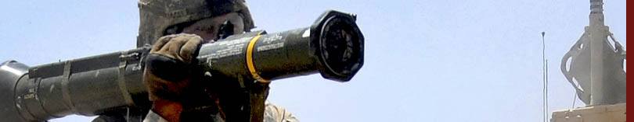**PD Combat Munitions**

# M141 Bunker Defeat Munition (BDM)

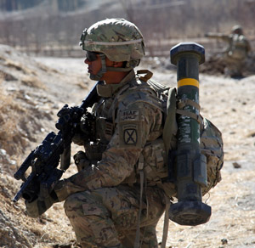The M141 BDM meets the requirement to fill the lightweight “Bunker Buster” void in the Army inventory. The man-portable system is highly effective against targets including fortified positions, such as earth and timber bunkers, and is capable of breaching masonry walls and neutralizing light armored vehicles at ranges of 15-250 meters. The disposable weapon shares its warhead with the USMC shoulder-launched multipurpose assault weapon (SMAW) and is also known as the SMAW-D.

In a U.S. News and World Report article, American Soldiers said, “After a brief rest, the team set off to pursue the Ansar fighters fleeing toward the border. Insurgents were rumored to stay in these caves. A hail of gunfire erupted from the caves as the targets approached. [Grit] pulled out a new cave-busting antitank missile called a ‘SMAW-D.’ The sound of the explosion was deafening. The SMAW-D demolished the cave. The firing from inside ceased.”

<http://www.pica.army.mil/pmccs/SLM_Safety_Videos.html>

# M84Non-Lethal Hand Grenades

|  |
| --- |
| M84 Stun Hand Grenade |
|  |
|  |
| XM104 Non-Lethal Bursting Hand Grenade |

The M84 Stun Grenade uses a bright flash and loud report to disorient individuals allowing for dispersal or easier apprehension. It is intended for use in confined spaces such as room clearing.

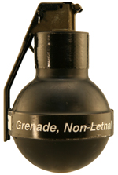The XM104 Non-Lethal Bursting Hand Grenade produces a shower of high velocity rubber pellets that sting and disorient potential targets.

<http://www.pica.army.mil/pmccs/CombatMunitions/NonLethalAmmo.html#nogo13>

**66mm NL Grenades**

The L96A1 Riot Control Grenade projects a cloud of riot control agent at extended ranges to subdue and disperse large groups. The M98 and M99 are the latest in a growing arsenal of NLM. The M98 Distraction Grenade releases three stun sub-munitions that produce a bright flash and loud report to disorient individuals or large groups. The M99 Blunt Trauma Grenade fires three sub-munitions that each release a shower of high velocity rubber pellets into a crowd.

|  |  |  |
| --- | --- | --- |
| L96A L96A1 Riot Control Grenade | M99 M98 Distraction Grenade | M99 |

# MCCMM5 Modular Crowd Control Munition (MCCM)

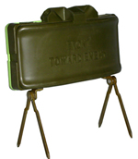

The MCCM, a non-lethal variant of the Claymore munition, is the Army and Marine Corps’ first non-lethal area coverage munition. It provides crowd control and force protection and temporarily incapacitates a large, hostile group without causing life-threatening consequences to the targeted individuals. This gives the field commander the option to apply non-lethal force as a first line of defense against aggressive noncombatants.

The MCCM is similar in appearance to the Claymore mine but is filled with 600 32-caliber rubber balls. It has an effective range of 5 to 15 meters with 60-degree coverage. MCCM is command control initiated and disorients and incapacitates targeted individuals for approximately 10 seconds.

# <http://www.pica.army.mil/pmccs/CombatMunitions/NonLethalSys.html#nogo14> Counter Personnel Systems - Future Items

|  |  |
| --- | --- |
| [M98, Grenade, Launcher: 66mm Non-lethal, Distraction](http://www.pica.army.mil/pmccs/CombatMunitions/NonLethalSys/NonLethalCapSet/CounterPer/counterPers_future.htm) Click image to see larger view | **M98, Grenade, Launcher: 66mm Non-lethal, Distraction** An area target munition that can be fired 80 to 100 meters from a standard LVOSS launcher on selected Armament Carrier HMMWVs as well as from any 66mm smoke launching system found on most armored vehicles. Once fired, it delivers a flash/bang diversionary or warning effect. |
| [M99, Grenade, Launcher: 66mm Non-lethal, Blunt Trauma](http://www.pica.army.mil/pmccs/CombatMunitions/NonLethalSys/NonLethalCapSet/CounterPer/counterPers_future.htm) Click image to see larger view | **M99, Grenade, Launcher: 66mm Non-lethal, Blunt Trauma** An area target munition that can be fired 80 to 100 meters from any standard LVOSS launcher on selected Armament Carrier HMMWVs as well as from any 66mm smoke launching system found on most armored vehicles. Once fired, its burst delivers a payload of rubber, non-penetrating projectiles. It is best used to provide supporting non-lethal fires to crowd control formations. |
| [Mobility Denial System (MDS) (man-portable)](http://www.pica.army.mil/pmccs/CombatMunitions/NonLethalSys/NonLethalCapSet/CounterPer/counterPers_future.htm) Click image to see larger view | **Mobility Denial System (MDS) (man-portable)** A non-hazardous chemical spray system that spreads a slippery gel onto its intended surface in order to inhibit the movement of individuals or vehicles so military personnel can control crowds and isolate facilities located in restricted areas. The man-portable MDS weighs about 55 lbs when loaded and covers up to 2,000 square feet, enabling targeted applications both in and around buildings. |
|  | **Additional items include:**   * [M104 Non-Lethal Bursting Hand Grenade (NLBHG)](http://www.pica.army.mil/pmccs/CombatMunitions/NonLethalSys/NonLethalCapSet/CounterPer/4nlc_41.htm) * 12 Gauge Enhanced Round |