A. Crisis Action Planning (CAP) Overview

1. CAP is the JOPES T10 process based on the development at DOD / COCOM level of time-sensitive plans and orders in response to an imminent crisis. CAP follows prescribed procedures to formulate and implement response in a set timeframe. The requirement for a DIV / JTF may be identified in either the deliberate planning process or the CAP process. (Deliberate planning is conducted principally in peacetime to develop joint operation plans (OPLANs) for contingencies identified in strategic planning documents.) Generally, the employment of the DIV as a JTF in T32 status will not be directly affected by such planning and execution systems, although it may occur as part of a coordinated national response coordinated by NORTHCOM.

2. CAP is based on current events and conducted in time-sensitive situations and emergencies using assigned, attached, and allocated forces and resources. Crisis action planners base their plan on the actual circumstances that exists at the time planning occurs.

3. Optimally, the DIV / JTF headquarters is established before or during CAP course of action development after the warning order is issued; however, the DIV / JTF commander could activate the staff for planning prior to official activation. Close coordination with their Service representative on the COCOM Operations Planning Team (OPT) is generally desirable as it allows the JTF visibility into and some influence over the CAP aspects that pertain to the DIV / JTF. As an example, such involvement may enable the DIV / JTF staff to conduct concurrent planning, mission analysis, and course of action (COA) development.

4. CAP begins when a significant incident or event is reported to an appropriate government agency and ends when the crisis is resolved or forces are withdrawn. Once CAP commences, effective interaction is essential to optimize information flow and coordinate planning activities the various participants. The DIV / JTF staff must develop and maintain a particularly close relationship with the combatant command staff to ensure that planning activities are coordinated. In addition, it is imperative that the DIV / JTF keeps the DIV / JTF subordinate organizations and / or components informed of planning initiatives – the DIV / JTF should strive to have DIV / JTF subordinate organizations or components assigned for planning as early as feasible.

5. The planning process is outlined in Annexes B through F:

6. JPG response to CAP.

- The immediate concern of the JPG is to commence mission analysis and associated problem definition. Mission Analysis begins with an operational appreciation brief and initial guidance from the commander. Throughout this phase close interface with the DIV / JTF commander is essential. This suggests a small JPG (5-10 personnel) of core planners. Once mission analysis has been completed, the entire JPG may be assembled to brief the results of the mission analysis and to disseminate the commander’s planning guidance. Appropriate representation from the JPG will then proceed to COA Development and Analysis.

- Initially the JPG will work continuously to build the plan. The JPG Chief will ensure breaks are taken to ensure information dissemination to staff sections and components. The JPG will provide periodic updates to the battle staff during the planning process. These updates provide a means to cross-talk guidance and clarity throughout the DIV / JTF and subordinate organization staffs.

7. OPLAN / OPORD Development. Generally, the G / J5 develops OPLANS as part of contingency planning. The CAP may require immediate action, necessitating the employment of an existing contingency OPLAN, or possibly the development of an entirely original order. This is the responsibility of the G / J3 FUOPS staff. During CAP, while the FUOPS staff is developing the OPORD, the G / J5 begins development of branch or sequel plans that are based on FUOPS OPORD development. Once a branch or sequel is identified the JPG begins a new planning effort and a mission analysis and COAs are developed for the new contingencies. Once developed these products, in CONOPS format, are placed in a duplicate planning folders for staffing throughout the command section, components, and staff. Critical to these CONOPS are the indicators and information requirements that support them and a method to confirm or deny the hypothesis that underlies that contingency as the indicators and information is collected. Both the JPG and the JOC retain a complete copy of the planning folder. If the indicators begin to appear the G / J3 should direct the JPG to refine the CONOP into an OPLAN for implementation. If sufficient time is unavailable the JOC must be prepared to update, modify, and implement the plan in its extant state based on decision by the DIV / JTF Commander.

8. OPLAN / OPORD format. For most operations the Div / JTF will employ the OPLAN / OPORD format shown in FM 5-0, Army Planning and Orders Production. In some circumstances the DIV / JTF may employ the format shown in Limited CJCS Manual 3122.01, Joint Operation Planning and Execution System (JOPES), Volume I (Planning Policies and Procedures). Annex L, SAMPLE OPERATION ORDER FORMAT. Appendix 1, SAMPLE DIV / JTF OPORD MODIFICATIONS shows a sample DIV / JTF OPORD with commonly used modifications. If there is a requirement for annexes and appendices to support the DIV / JTF OPORD, formats in Limited CJCS Manual (JOPES) 3122.03A, Joint Operation Planning and Execution System Volume II Planning Formats and Guidance and CJCSM 3122.04A, Joint Operation Planning and Execution System Volume II Planning and Execution Formats and Guidance should be used.

Figure 5-1, Plans and Operations Relationships and Functions (From JPub 3-33)

B. Organization (JTF Staff):

1. When employed as a JTF this staff may be modified or augmented with other service, interagency, or allied personnel and specialists. As an example, an operation requiring extensive use of Air Force capabilities would probably lead to the augmentation of this staff with Air Force specialists. For large scale, long term, or extremely complex situations the JTF headquarters may be reorganized onto Boards, Bureaus, Centers, Cells, Working Groups and Teams. (B2C2) (See JPub 3-33 for detailed explanations). In such an instance, the Plans Staff will likely be subordinated to a Plans Board, possibly with decision or executive authority (as delegated) composed of senior officers and chaired by the Chief of Staff or Deputy Commander. The Plans Staff will then likely be reformed into a Plans Group, including additional personnel from critical functions or specialties related to the JTF mission. The Group will then analyze and submit proposed plans to the Plans Board for approval. The Plans Group may also form specialized Plans Teams for specific, single use tasks, and / or Plans Cells, which focus on specific specialized aspects of the JTF mission. Boards, Groups, teams, and Cells should be kept to the minimum number of personnel necessary to accomplish their function without becoming too large to maintain disciplined focus and reach consensus.

2. When preparing to conduct an operation the Plans Staff typically hands off operational responsibility to the Operations Staff as the plan becomes an order. The Plans Staff then begins contingency and branch planning as it analyzes the problem and how the problem is changing as it unfolds and adapts to the actions of the JTF. A technique to achieve better understanding of this complex system is to employ a JTF Assessment Team, which clarifies the mission by deciding:

- What is the problem?

- What must be accomplished?

- What is the availability of assets and forces?

- What types of forces are required?

- What is the sequence for the deployment of forces and why?

- What operations are ongoing?

- The Joint Planning Group:

  - Composition. The Joint Planning Group (JPG) is comprised of the G5 / J5 staff and other staff representatives as shown in figure 5-2. In some situations, particularly when operating as in a complex environment, the JTF may form other bodies, such as a Joint Planning Board of senior officers with executive authority, as well as functionally specialized Joint Planning Working Groups (possibly augmented by the agencies primarily responsible for creating the effects, such as Information Operations, Air Movement Operations, Fires Effects, Effects Integration, or Civil-Military Operations). There is no standard list of who is included in such bodies; rather the composition should vary according to the situation, the planning activities being conducted, and the problem at hand. In general, the group should contain the key personnel with subject matter expertise that bears, directly or indirectly, on the problem; however it should also be kept to a manageable size, possibly by subdividing the body into specialized sub-groups for specific tasks.

  - Responsibilities include preparing and coordinating required OPLANs or OPORDs to support assigned missions. This includes a review of existing plans or orders for applicability to the situation. As operations are executed, the JPG will prepare branch and sequel plans in support of future operations.

  - Augmentation. The JPG is generally expanded when the complexity or scope of the problem is such that additional staff is required; it may also be expanded by the addition of specialized members with particular subject matter expertise. This can be organized by the creation of specialized Joint Planning Cells with assigned responsibilities, such as an IO cell, an effects cell, a medical logistics cell, or an administrative cell to handle the requirements of producing and packaging staff products.
THIS SPACE INTENTIONALLY LEFT BLANK

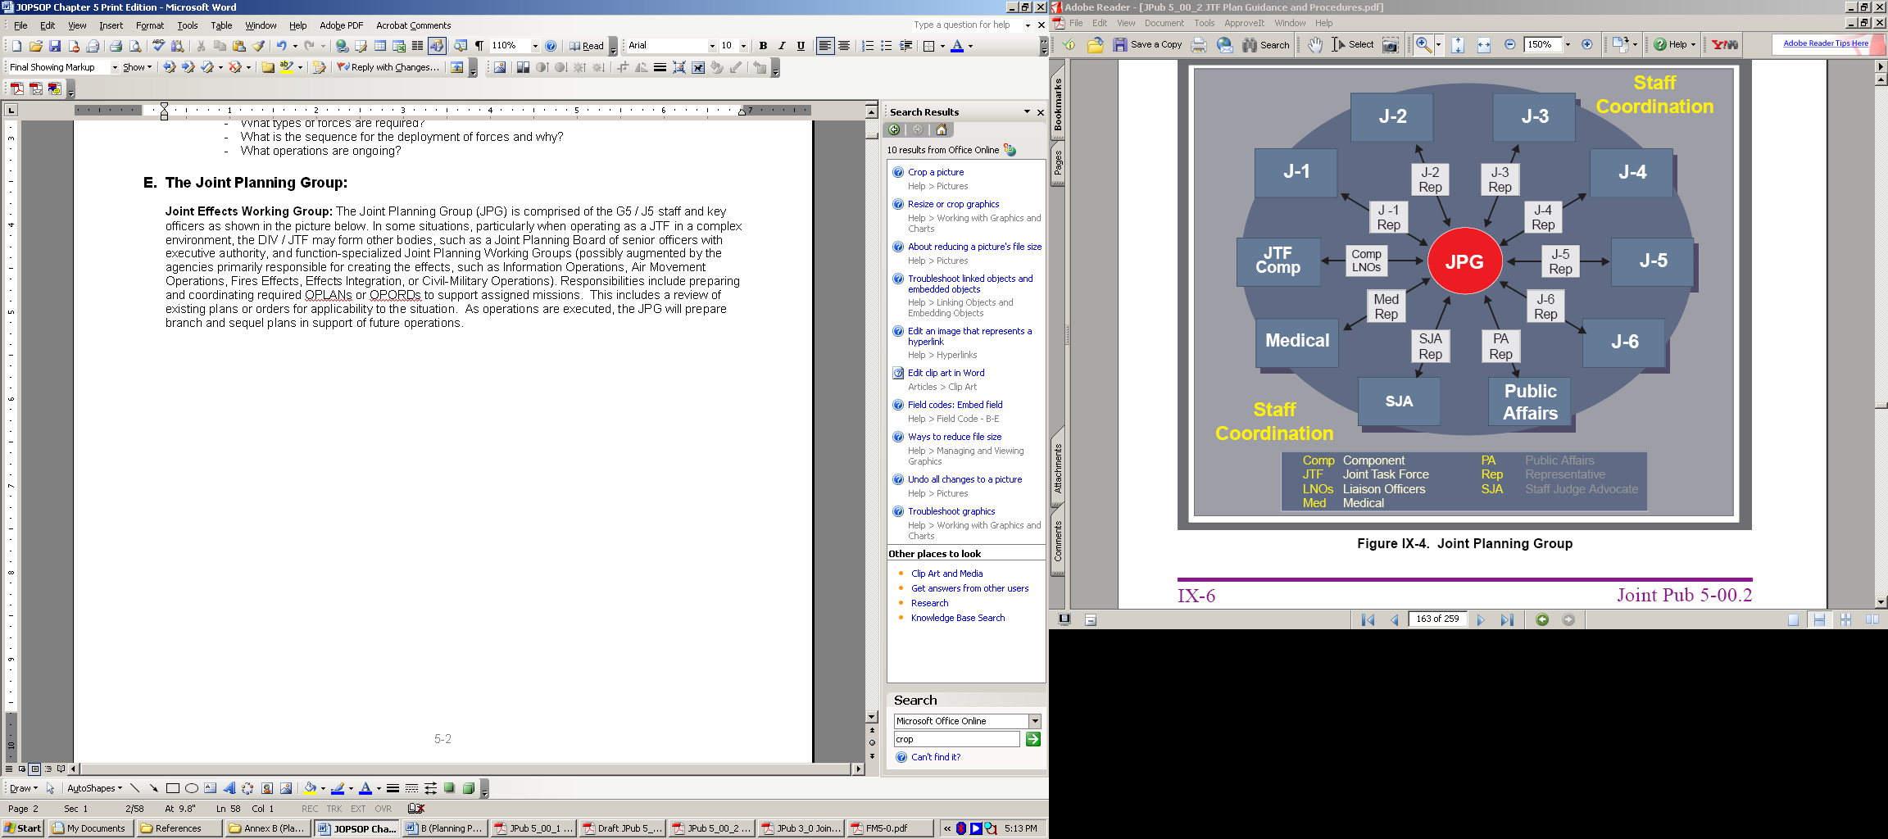

Figure 5-2, Notional Joint Planning Group Organization (from JPub 5-0)

D. JTF Interagency Staff Planning.

1. Interagency operations, once an unusual or higher headquarters occurrence, are now commonplace in the likely operational environment. The coordinated employment of interagency efforts allows for the unified application of all elements of state power to be employed toward a common objective. While simple in concept, however, this can be very difficult in practice and is always complex. Not all agencies will report to the same authority, thus unity of command may be impossible. If unity of command cannot be arranged then unity of effort, wherein agencies agree to cooperate voluntarily, may be the most feasible solution. Even unity of effort, however, may be problematic: different agencies may have different priorities, caveats, perspectives, and methods. When employed as a T32 force, this applies to military forces as well: T32 military forces may have a very different mission and priorities than a T10 force, for example, while T14 (USCG) forces are military forces, they are part of a different federal Department (Department of Homeland Security or DHS). In many interagency efforts the military will not be the lead agency, in which case military efforts may lie at the beginning (contingency planning) and end (apportionment and employment of forces) ends of the operational process.

2. The staff should work with interagency partners to establish common procedures and terminology at the beginning of their collaborative effort or, if possible, before an event during training and rehearsals. This is particularly true in the T32 interagency environment; not only do civilian (to include police) agencies use different terminology, they also may use the same terms but with different meanings. Thus a Police Lieutenant may have responsibility and authority equivalent to a battalion commander, and the term “operational” when used by civilian agencies generally refers to tactical actions in military terminology.

3. The DIV / JTF staff may use some basic steps to building and maintaining coordination among interagency partners, including:

- Define the problem in clear and unambiguous terms that are agreed to by all participants

- Define the objective(s) (These may differ among the various agencies)

- Establish a common frame of reference (i.e. a common structured methodology for analyzing the problem)

- Develop options / courses of action (these may differ among the various agencies)

- Capitalize on the expertise of the various agencies / staff

- Establish roles and responsibilities among the various agencies

- Plan for the transition of key responsibilities, capabilities, and functions

- Use consensus to direct all means toward the commonly agreed objective(s) and problem

4. The JTF may operate with Nongovernmental Organizations (NGOs) or Private Voluntary Organizations (PVOs). These organizations are normally focused on a narrow range of specialized activities. They often have detailed knowledge of the local conditions and situation and may have extensive contacts in the area and are thus a valuable source of information about the area, the problem, and local / civilian attitudes toward the problem. They may also have extensive media contacts. Contacts with them must, however, be subject to discretion. While most are hard working and idealistic, some may or may not be willing to work with US military forces, some have proven to be unscrupulous or have engaged in illegal activities, and some may be agents of, or actively sympathetic to, enemy activities. Even when unwilling to cooperate, however, this range of actors may be logically organized by:

- Identifying all organizations and agencies that should be involved in the operation

- Establishing voluntary coordinating bodies, i.e. boards, groups, and working groups, that will define objectives, analyze problems, make recommendations, and make decisions

- Identifying potential obstacles to cooperation or adversarial motivations

- Developing mitigation techniques to address adversarial efforts

- Identifying available resources by agency and function in order to reduce duplication of effort

- Coordinating assets or efforts in order to create unity of effort or effect

5. Even cooperative organizations may be problematic. The staff should bear in mind that many organizations may resent or resist the establishment of any hierarchical or apparently hierarchical organization and may insist on being seen as “one among equals” regardless of the size or assets of their organization. This may include demands for access to senior level commanders and an unwillingness to coordinate with staff officers. The staff will face the challenge of seeking to inject purpose, focus, discipline, responsibility, and intellectual rigor into a decentralized system of autonomous or semi-autonomous actors; the best technique is to focus on constant and open communication that addresses the problem at hand and on the rendering of mutual assistance.

- Multinational Planning.

1. When operating with the forces of one or more nations, the DIV / JTF will form part of an Alliance or a Coalition. An alliance is the result of formal agreements (i.e., treaties) between two or more nations; a coalition is an ad hoc arrangement between two or more nations for common action. When the members of an alliance form a single military force or headquarters, it is referred to as a Combined headquarters; the military headquarters of a Coalition may be less formally structured and may be limited to the exchange of liaison staff. T32 operations by the forces of several states under separate command or under an interstate agreement answerable to several civil executives may resemble coalition operations in terms of their complex political nature.

2. Deliberate planning for multinational operations is performed through national channels. US doctrine and procedures are generally applicable to this process, although some modification may be necessary to accommodate doctrinal differences, different levels of capabilities, and national caveats that restrict some forces from certain roles. Given such restrictions, unity of effort can be attained by focusing on the following planning elements:

a. Strategic Integration. In support of each treaty or alliance, an organization of bilateral or multilateral bodies is generally established to define strategy and to coordinate direction for planning and executing multinational operations. Within the alliance or treaty structure, US participants ensure that objectives and strategy complement US interests and are compatible with US capabilities. The states of an affected area may form an informal bilateral or multilateral body for the purpose of providing this direction.

b. Theater Integration. The commander of US national forces integrates joint operation planning with multinational planning at the theater or operational level. The DIV / JTF will function within the organic or COCOM chain of command and that of multinational organizations. Within multinational organizations, they will command or support the designated commander of multinational forces and plan, as appropriate, for multinational employment per strategic direction and guidance. Within the US chain of command, they command joint US forces and prepare joint OPLANs. In this dual capacity within the US and multinational chains of command, the US commander coordinates multinational planning with joint operation planning. In a T32 environment, the DIV / JTF may be tasked with the command and / or control of forces from several states; in this case the staff must accept guidance from multiple headquarters and integrate these requirements across DIV / JTF operations.

c. Bilateral Planning. When directed the DIV / JTF commander participates directly with the armed forces of other nations in preparing bilateral OPLANs. Bilateral operation planning involves the preparation of combined, mutually developed and approved plans governing the employment of the forces of two nations for a common contingency. Bilateral planning may be accomplished within the framework of a treaty or alliance or in the absence of such arrangements. Bilateral OPLANs routinely require national level US approval. In a T32 environment there may be several T32 commanders; in such a case the commanders and their staffs should collaborate in order to produce bilateral plans.

d. Multinational Integration. To effectively and efficiently employ multinational forces the DIV / JTF must recognize and accept the differences between US and multinational forces and work to develop a harmonizing approach to planning. The DIV / JTF must make multinational forces feel they are part of a team. Where possible, the DIV / JTF should develop standing procedures to reduce uncertainty among multinational forces (e.g., mutually agreeable terminology and platform to ensure input from multinational forces).

e. Termination Planning: Termination does not imply the end of an operation, but rather the conclusion of military involvement and a transition, either to other agency / follow-on forces or to a new state of peacetime engagement; “the new normal.” The stated end-state objective of a campaign should be thought of, not as an end in itself, but rather as the entry into the “new normal” that is preferable to the extant state of affairs. Planning for termination must be ongoing during all phases of plan development, order development, deployment, and employment of forces and must include careful consideration of what state the various logical lines of operation of the DIV / JTF will be in when they are transferred and what effect this will have on the receiving agency and on the problem. The staff must also determine the criteria to terminate military involvement or transition to a new phase of an operation.

(1) In some cases, particularly single scope contingencies such as disaster response, operations will be terminated in their own right when stated objectives have been met. In others, operations will transition from phase to phase when they have changed to a degree that allows new methods of employment or the assumption of the mission by other agencies or follow-on forces.

(2) The staff must establish the conditions necessary to bring operations to a favorable end; it must also, however, monitor the changing situation in order to understand when objectives or even strategic aims are no longer applicable and should be modified.

(3) In some operations (e.g., stability or support operations), the Plans Staff may have to recognize that the mission is not achievable without restructuring and / or commitment of additional assets; this may occur as a changing situation renders an original force package inappropriate or when the existing forces culminate. Essentially, this is an unplanned transition. In these situations, the DIV / JTF commander may recommend to the higher headquarters commander that further action as organized will not achieve the desired end state and that the DIV / JTF must be replaced, reorganized, reinforced, or receive different capabilities in order for the higher headquarters to succeed.

f. Transition Planning. Transitions may be based on time or events and generally mark the achievements of specific objectives and the change of DIV / JTF physical and / or logical lines of operation to re-orient on new objectives. As with termination, planning for transitions must also extend throughout the planning process and into operations and redeployment. Transferring the control of an operation to another agency or follow-on force requires detailed planning and execution. This process is situation dependent and each transfer will have its own characteristics and requirements. In interagency environments, high-level approval is often essential, along with long-lead times.

- DIV / JTF Campaign Planning:

1. The DIV / JTF staff typically plans at the Operational level of war, although it may also engage in tactical actions when employed as part of a Corps / 3-star JTF. The process of developing an Operational plan is called Operational Design; the product is called a Campaign Plan. A campaign is a series of related actions that contribute to an operational objective or strategic aim and whose effects are arranged in time and space for the best possible effect. Such planning incorporates all available elements of national power, from across the interagency spectrum, and are typically extremely complex in direct relation to the components of the systemic problem in which the effects will be created and the elements of national power that will be employed. Campaign Plans, due to the complex nature of the problems they address, are typically broad, conceptual descriptions of how abstract strategic aims will be translated into specific tactical actions.

2. The elements of national power are generally grouped according to the acronym DIMEFIL; it is the “toolkit” that may be used on the system that comprises the problem:

- D: Diplomatic
- I: Information
- M: Military
- E: Economic
- F: Financial
- I: Infrastructure
- L: Legal

3. The components of the systemic problem are generally grouped according to the acronym PMESII; it is the problem that the DIMEFIL toolkit is used on. The PMESII system is shown in figure 5-3.

- P: Political
- M: Military
- E: Economic
- S: Social
- I: Information
- I: Infrastructure

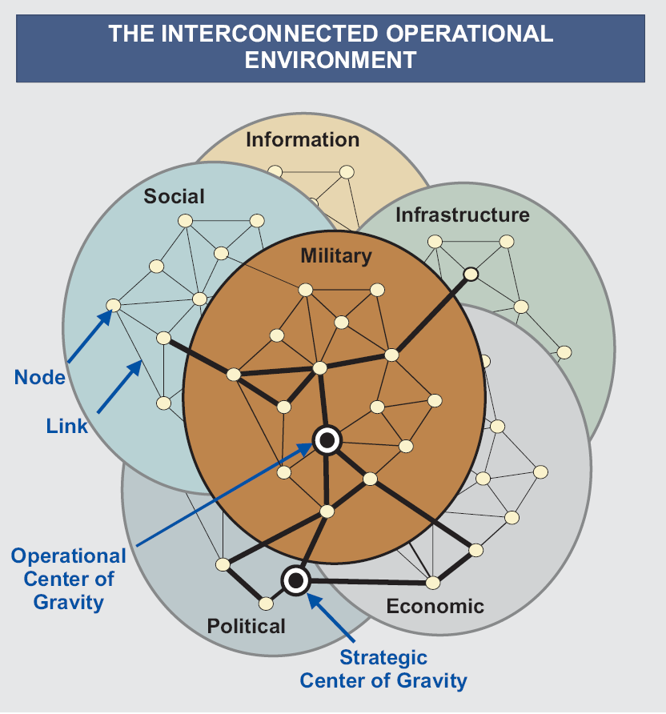

Figure 5-3, The PMESII System (from JPub 3-0)

4. The product of employing the DIMEFIL tools on the PMESII components is generally the achievement of a physical objective or effect; it may also be the achievement of a logical objective. These objectives are intermediate between your current state and an end-state, or objective, which is the purpose of the campaign. These objectives are generally laid out along Lines of Operation (LOO), diagrams that arrange the objectives, and actions to be taken, according to space and / or time. In doing so, the staff can intuitively view and understand in context the various events and decisions they must deal with; this enables them to achieve the best possible results from multiple efforts by seeing and avoiding conflict between efforts and by seeing opportunities for and creating synergy among multiple efforts. LOOs are typically oriented on a Center of Gravity (COG), which may be thought of as a physical or logical thing or place that can be attacked directly or indirectly and is the source of enemy power or the hub of the problem at hand. In operations against a conventional military force there is usually only one; however in complex operational environments with multiple logical lines of operation there may be several. Other objectives may include Decisive Points, which are the keys to attacking a COG (sometimes referred to as Nodes, which are employed in emerging Joint Doctrine to describe components that link with others to form a larger system). The point is to identify what effect or outcome is desired and then to identify what cognitive states or physical targets to direct the effort against in order to seize the desired objective or achieve the desired result. Example Lines of Operation, with intermediate objectives, are shown below:

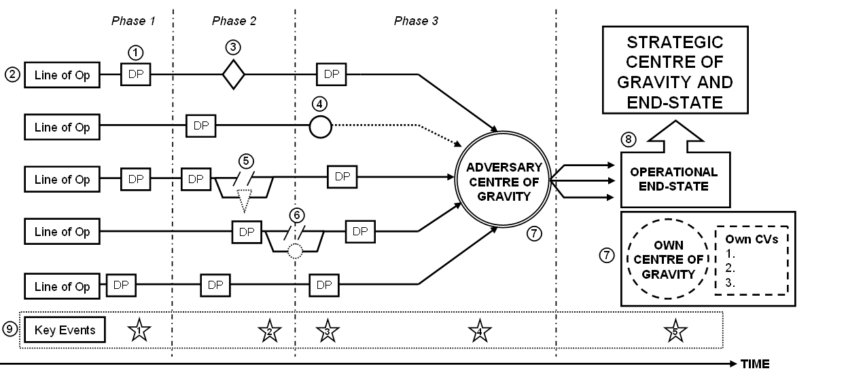

Figure 5-4, A Campaign Planning Schematic, from JDP-01

a. This is a diagram of a Campaign Plan according to Lines of Operation. In this diagram, Decisive Points (DP) (1) are sequenced in time and space on LOO (2). They are the key to unlocking the COG; without their completion the COG cannot be destroyed or neutralised. This sequencing may be organized by Phases punctuated by key events (3). Operational Pauses may be introduced where necessary but momentum should be maintained elsewhere in order to avoid Culmination. A Culmination Point (4) is reached when an operation or battle can just be maintained but cannot be further developed to any great advantage.

b. Branches (5) are contingency plans which can be introduced to LOO whenever necessary, typically in order to take advantage of emerging opportunities; they are continuously refined as the campaign develops. Sequels (6) are contingency plans introduced when phases are not completed as planned, and so are generally employed as “Plan B” when a planned operation does not succeed.

c. As stated above, the adversary COG (7) at the operational level is his source of strength; that thing which enables him most resists your imposition of the operations desired objective. Without the neutralisation or destruction of the adversary's COG, this objective cannot be reached. It may also be useful to show the friendly COG as it is the source of friendly power, or friendly ability to impose the desired end-state, and thus the thing that most needs protection.

d. The objective, or end-state (8), provides the focus for campaign planning and all activities should be judged against their relevance to its achievement. The operational objective will usually be given by the Military Strategic Authority and may be a list of objectives or a statement. It needs analysis in order to identify measurable conditions which together indicate that the end-state has been achieved.

e. It may also be useful to include a line showing key events (9). These might be political or strategic events, such as the deadline for compliance with a UN resolution or the holding of national elections, or military or force flow events such as the date an adversary 2nd Echelon force might be ready for combat or the estimated time for the completion of mobilisation.

f. LOO may be depicted graphically, particularly during operations against an opposing military force, as shown below. A force operates on interior lines when its operations diverge from a central point. The friendly force is thus closer to separate enemy forces than the enemy forces are to each other. This allows a weaker friendly force to mass combat power against separated enemy forces. A force operates on exterior lines when its operations converge on the enemy. This offers the opportunity to encircle and annihilate a weaker or less mobile enemy; such operations require that friendly forces have a significant advantage in either combat power or mobility (or both).

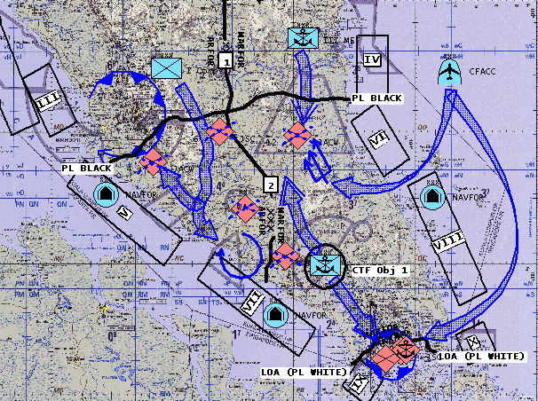

Figure 5-5, Example Physical Lines of Operation concept sketch, depicting an amphibious operation from an exercise based on the Indonesian Peninsula, with land, sea, and air Lines converging on operational objectives indicating desired tactical effects. See FM 3-90 for details. These friendly forces are employing superior air and sea mobility to operate on exterior lines and converge on dispersed enemy forces.

g. LOO may also be depicted logically, particularly during complex operations dominated by non-military PMESII factors, such as in Stability or Support Operations as shown below.

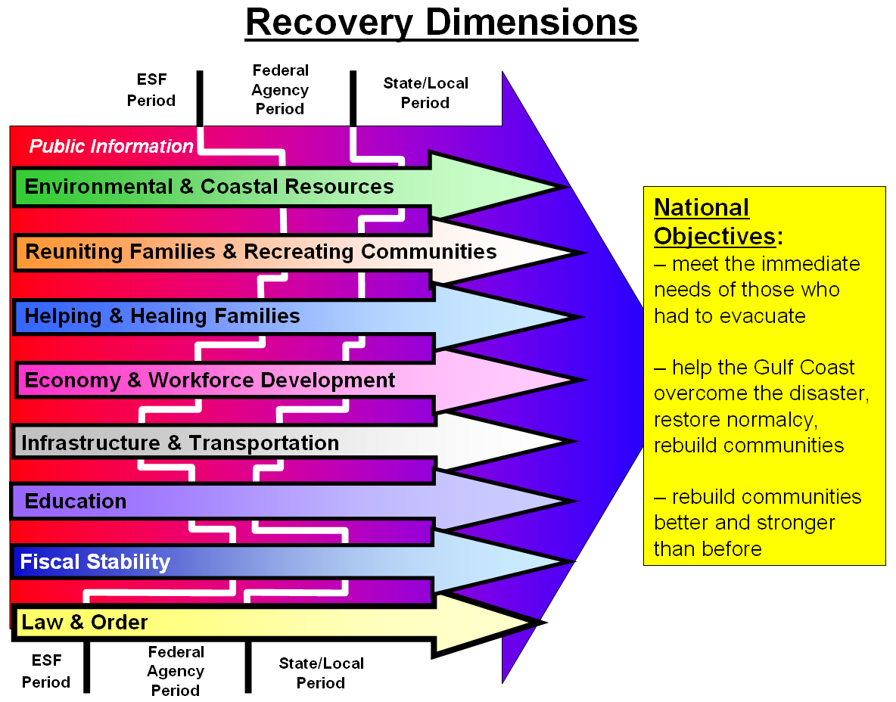
Figure 5-6, Logical Lines of Operation sketch used by the operational planning group for Principal Federal Official (VADM Allen, USCG) during the response to Hurricane Katrina and based on the FEMA Emergency Support Functions (ESF).

h. In these cases it may also be useful to “layer” the LOO, as shown in the succeeding sketches.

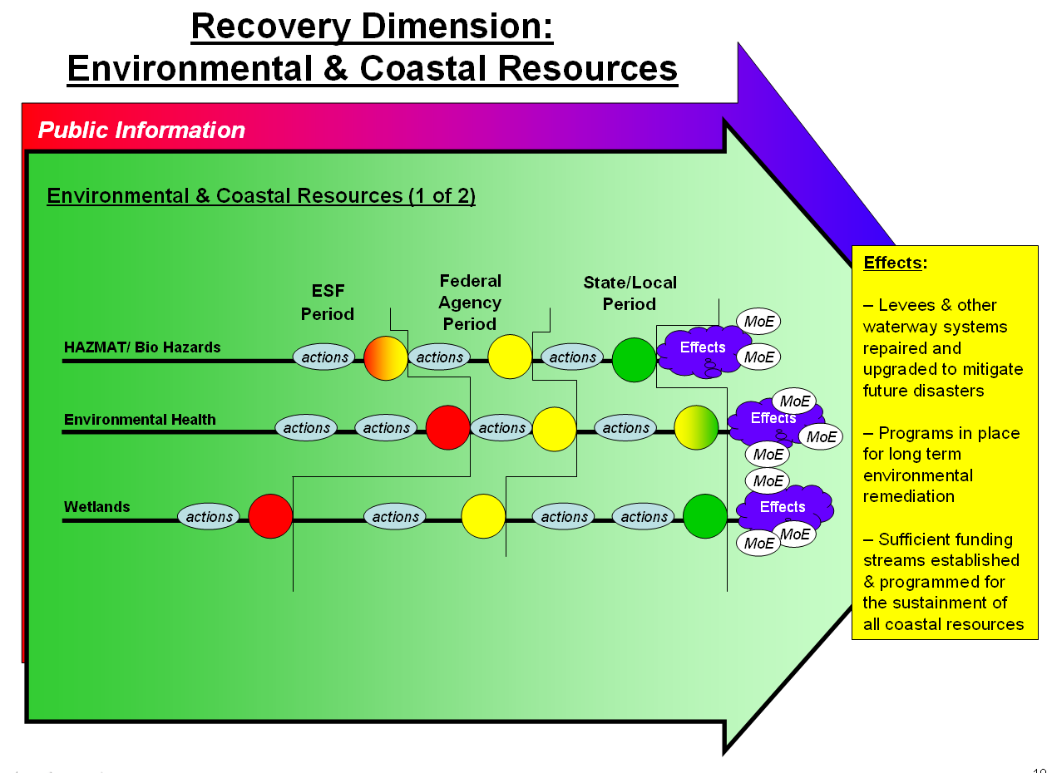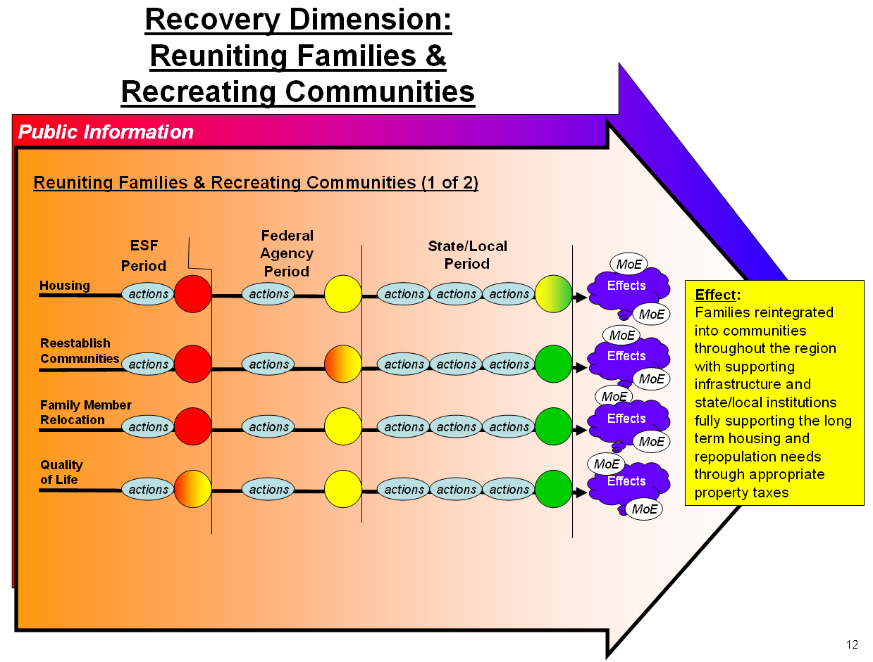

Figures 5-7 and 5-8, Logical Lines of Operation Extracted from the “Layered” Diagram in Figure 5-6

5. There is not a standard way to depict a LOO, which is only a way to depict the logical construct for how the planner expects to address the situation at hand using the tools at his disposal. A Physical LOO may be a subset of a larger Logical set of LOOs, i.e. as the M (or Military) LOO in a larger PMESII diagram. The most important part of this process is to ensure that the Plans Staff develop an accurate understanding of the system they are acting upon and how they will act upon it. The planners must be cautious of certainty and standardized responses: Schematizations and the formulation of rules obscure the constant need to adapt action to context; the Plans Staff must keep track of constantly changing conditions and never treat any image of a situation as permanent. In order to do this, the Plans Staff must ask questions. The key questions to ask when developing a Campaign Plan are:

- What is the problem (or problem system) and what will it take to change it to the desired end-state? What objective(s) achieve the strategic aim(s)? What future do you envision as a result of the operation?
- What is the COG or COGs that the effects and / or actions will be directed against?
- What effects, when created, support the achievement of the objectives? (Note: Effects describe system behavior in the operational environment)
- How will those effects be arranged to create synergistic results?
- What actions or tasks, and in what sequence, will create those effects? (Note: Tasks direct friendly action)
- How will the actions be arrayed in order to produce the desired effects?
- What resources are necessary to undertake those actions?
- How will you analyze the results of your actions? How much of your analysis is science of war, vice art?
- Where / when does likely risk occur, including “second order” or non-linear” effects, when performing these actions?
- What opportunities are you creating that you can act on? How will you recognize and act on opportunities when they arise?

6. These questions should address the elements of operational design, shown below:

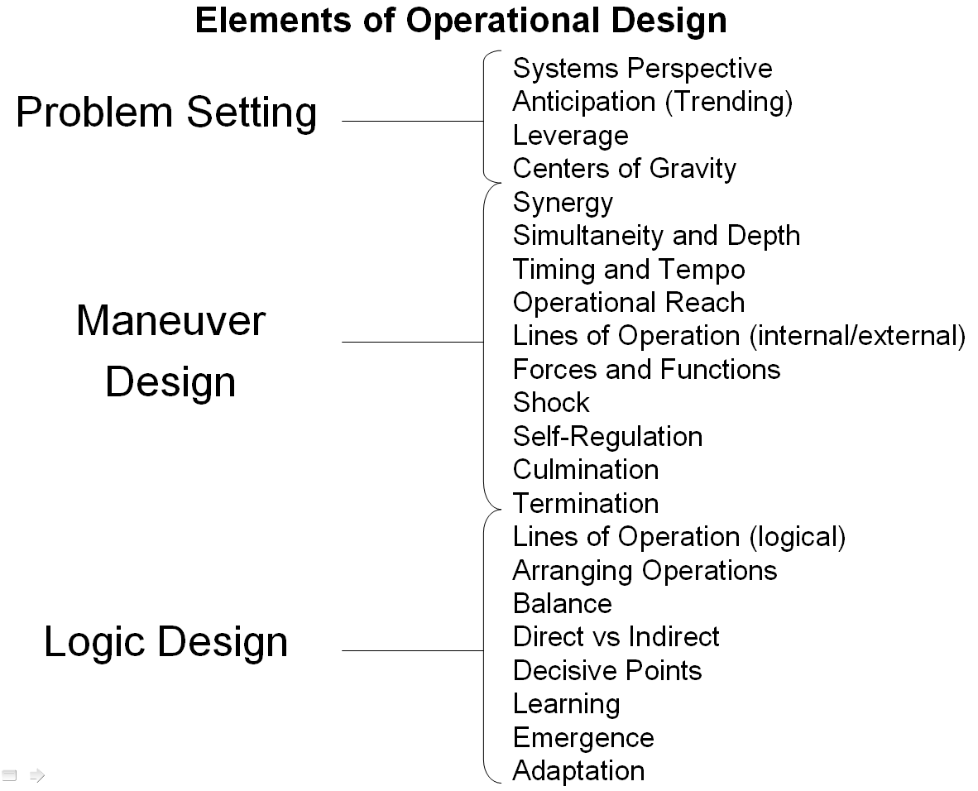

Figure 5-9, The Elements of operational Design

7. In practice, however, achieving objectives will be often be difficult owing to chance, imperfect knowledge or understanding of a problem that results in unintended effects, enemy adaptation, changing or evolving circumstances, and resource and time constraints. Additionally, enemy mistakes may provide the opportunity to exploit fleeting opportunities. A Campaign Plan, rather than resembling a sprint with a start, course, and finish, is more akin to a never-ending marathon in which there are no finish lines but only new paths to unanticipated course legs. Planning for termination is thus the planning for the termination of the current effort and entry into a subsequent phase or “new normal” state rather than the definitive termination of a problem. The staff must understand this and the changing trends and adapt and pace DIV / JTF actions accordingly in order to avoid culmination or persistence in actions that are no longer appropriate to changed circumstances.

8. A methodology to mitigate these problematic aspects of Campaign Planning begins by building a phased system of adaptive cycles. It does not set a fixed course and objectives but, rather, delimits broad outcome-based objectives, possibly derived from strategic goals, and identifies intermediate objectives and decision points for assessment of and modifications to the Campaign Plan. In this way operations proceed in increments of effort directed at objectives; over time the Plans Staff reassesses the environment, problems, enemies, objectives and efforts and adjusts future plans accordingly. This assessment typically consists of cyclic IPB, Targeting, Intelligence Synchronization, and Risk Management. From this point you then engage in a series of small, incremental steps oriented on intermediate objectives. Each iteration serves two purposes: an incremental step toward your strategic goals and also an experimental verification of your hypothesis about the system and how it will react. This is the "Observation" portion of an OODA loop executed in this iteration; an opportunity to revise the estimate of the DIV / JTF, the enemy, and the problem, adapt accordingly, and proceed with the next iteration / experiment. The path to the ultimate outcome is thus a variable path of course corrections, mistakes, reactions, and opportunities seized along the way. Looking at it from a joint process standpoint, the campaign is generally planned using the Joint Operation Planning Process and JPub 5-0, while the tactical iterations are planned using small-scale single service methods such as the MDMP. The Military Decision Making Process (MDMP) serves as the Army’s analytical methodology for planning both initial operations and for planning operations that are significantly changed from or represent departures from, original plans. Typically, however, the reissue of an OPORD and complete MDMP is not necessary every time a new action is conducted; time constraints and the continuation of previous LOO typically allow for an accelerated MDMP (per FM 5-0) or a Rapid Decisionmaking and Synchronization Process (RDSP) (per FMI 5-0.1) (See Figure 5-10, below).

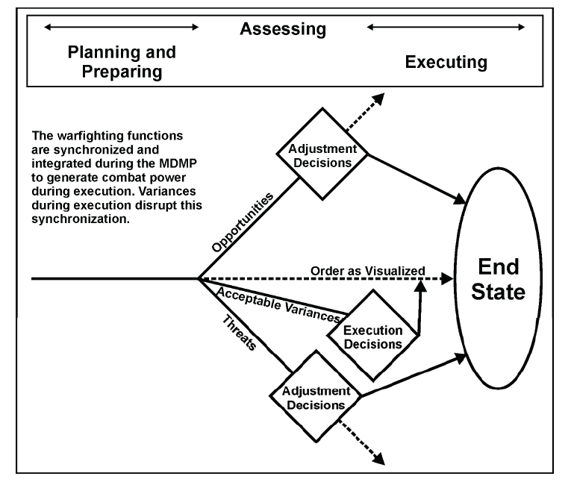

Figure 5-10, the RDSP (From FMI 5-0.1)
APPENDIX 1

CHECKLIST FOR CRISIS ACTION PLANNING PROCESS

Y/N
CAP PHASE I – SITUATION DEVELOPMENT
What are the national and military strategies and US national security policy for the region or country?
What is the nature of the conflict or crisis that might require military resources to resolve it? Can other elements of National Power (economic, diplomatic, informational) be used to influence the outcome? If so, what type of military support will they need? What type of support can they provide to the joint task force (DIV / JTF)?
What are or might be the potential missions or tasks?
Will action be unilateral or multinational?
What is the current situation (who, what, when, where and why)?
How will the adversary conceptualize the situation? What are the goals, objectives, strategy, intentions, capabilities, methods of operation, vulnerabilities, and sense of value and loss?
What steps can be taken to collect additional information?
What is the status of communications with key US and foreign government agencies and personnel? Has a list of key phone numbers been established?
Has the combatant commander developed an intelligence collection plan?
Has the combatant commander deployed sufficient organic reconnaissance resources? Should national assets be tasked or repositioned?
Has the combatant commander established a joint communications control center?
Are any US or multinational forces conducting operations within the DIV / JTF joint operations area (JOA)? What type? Duration? Who commands those forces?
What is the status of communications to and/or from and within the JOA?
Has the combatant commander established an information operations cell?
CAP PHASE II – CRISIS ASSESSMENT
Are noncombatant evacuation operations (NEO) needed?
Are there any US or other DOD civilian noncombatants in the JOA? How many? Where are they located? Are they in any danger?
Is there a noncombatant evacuation plan for this JOA? Has the Department of State authorized a NEO? Has the Department of State asked for DOD assistance?
Should psychological operations (PSYOP) assets be used during the NEO?
Have agencies or commands (e.g., National Imagery and Mapping Agency or environmental support facilities) that provide specialized or long-lead support been notified of the ongoing analysis and the potential for future support? What dedicated communications should be established with these agencies or commands for use by operations, intelligence, and logistic personnel?
What requests, if any, have been made by the foreign government(s)? What is the DOS position?
What security assistance may be provided to the foreign government(s) concerned?
What humanitarian assistance may be provided to the foreign government(s)?
What sources have been identified to fund assistance efforts?
Does the United States have any treaty or legal obligations?
Are there status-of-forces agreements with the foreign government(s)?
Is a military coordinating committee required?
Is the civil-military operations center (CMOC) established to coordinate and facilitate US and multinational force operations with other government agencies, international organizations, nongovernmental organizations, and foreign nation agencies and authorities? Is the CMOC established to provide access for non-military agencies desiring assistance and coordination from the military?
What coordination and assistance will be required for other government agencies, international organizations, nongovernmental organizations, and foreign national agencies and authorities?
Is there a current plan for the area or situation?
What type and level of PSYOP is most advantageous for the current situation?
What are the key friendly, adversary, and neutral target groups and their PSYOP vulnerabilities?
Has a teleconference been established to support the operation?
What is the Joint Operation Planning and Execution System (JOPES) plan identification number applicable to the operation?
Is a database maintained by the combatant command that is current or applicable to the situation?
Are there adequate provisions to maintain secrecy, achieve surprise, and preserve the security of US forces against attack?
What operations security and military deception measures are required? Is a cover story required or available? Are diversionary actions needed to support the preparation, deployment, and employment of forces?
What national-level actions are necessary to protect secrecy and execute deceptions?
What are foreign governments’ (including hostile) attitudes toward US intentions and military capabilities? How could these be shaped to US advantage?
What are the reactions of friendly, neutral, and unfriendly foreign governments?
What level of opposition can be expected from hostile governments?
What support can be expected from friendly and allied and coalition governments?
What access and overflight assurances do friendly forces have for deployment or employment operations?
What are the public affairs implications and responsibilities for the area?
Is there a joint information bureau? (See Annex F, "Public Affairs," in subject operation plan (OPLAN) or operation order [OPORD])
Has a DOD media pool been activated?
CAP PHASE III – COURSE OF ACTION (COA) DEVELOPMENT
What precisely must be accomplished in the crisis to strengthen or support the objectives established by the Secretary of Defense?
What are the general operations, intelligence, and logistics requirements to support the actions so as to bring about the Secretary of Defense objectives?
Do the military objectives identified take into account exploitable adversary vulnerabilities that are critical to the commander, joint task force’s (DIV / JTF) responsibilities and intent or are critical to the adversary’s intent?
From the DIV / JTF’s perspective, are the military objectives attainable?
What is the commitment of the adversary to own course of action (COA)?
What are the current rules of engagement (ROE) in the area?
Do they need to be changed because of the current situation?
Who should recommend changes?
Is the authorization to use riot control agents required as an alternative to the use of deadly force to save lives?
Has Secretary of Defense approval been requested or received?
Are riot control agents and protective equipment available to friendly forces?
What forces are readily available and when could they arrive on the scene?
What reception and operations support facilities are needed and available?
What types and amounts of logistic support are available from friendly and allied nations?
Are joint or multinational interoperability considerations involved?
Is medical support adequate to support planned operations?
What medical support is available in the objective area or provided for in the OPLAN or OPORD?
Are special operations forces (SOF) required? Are SOF coalition support teams required? (e.g., what are desired effects?)
What is the unit readiness of the available or allocated forces?
What are the major constraints before forces can be committed?
What is the status of geospatial information and services support within the area?
What are the environmental (meteorological, oceanographic) support capabilities and constraints within the area? Who is coordinating environmental support?
Will special CJCS-controlled communications assets, such as the joint communications support element, be required?
Are Army or Air Force PSYOP units, or Navy supporting units, required?
What is the command relationship of civil affairs (CA) and PSYOP forces?
Will the use of deception operations enhance mission success for each COA being considered?
Has the United States Transportation Command (USTRANSCOM) tasked subordinate and supporting commands or agencies to enter the JOPES database requirements for development of deployment estimates?
Has Tactical Exploitation of National Capabilities Program support from the combatant command been requested?
Have plans for the use of space systems (e.g., for reconnaissance, surveillance, warning, navigation, communications, targeting, weather) been integrated into DIV / JTF plans?
What is the status of strategic mobility resources and supporting elements? Are facilities, airports, seaports, and lines of communications capable of supporting the operation?
What are the logistic factors that affect actions under consideration?
Is aerial refueling required during deployment and/or employment?
Will intermediate staging bases be required?
What is the backup COA?
What all-source intelligence resources are available? Has the full range of intelligence capabilities been employed to ensure maximum intelligence support to planning efforts by the combatant commander? By the Secretary of Defense? Has DIV / JTF declared emergency reconnaissance and implemented signals intelligence operational tasking authority?
Has coordination been conducted with United States Strategic Command (USSTRATCOM) to determine whether repositioning or launch of space systems is required for DIV / JTF operations?
Will electronic warfare units, such as radar jammers or communications jammers, be required?
Which airports and seaports are available to friendly forces?
Are runway lengths and weight-bearing capacities adequate for the planned forces?
Are pier capabilities and depth of water sufficient to accommodate sealift?
Will use agreements need to be coordinated with other nations?
Have sufficient contracting officers with adequate contracting authority been assigned?
Has a sufficient amount of local currency been obtained to support the exercise or operation?
Has local civilian labor support been acquired?
Have adequate funds been identified to support the COA?
Have procedures been established to ratify irregular purchases?
What procedures must be established to protect information exchange between the United States and foreign forces and governments?
Have standard DIV / JTF Special Technical Operations billets been activated and indoctrination conducted on special access programs?
CAP PHASE IV – COURSE OF ACTION SELECTION
What COA has been selected? Have the pros and cons of each alternative, with regard to adversary options, been fully and objectively assessed (wargamed)?
What decisions have yet to be made? What changes to ROE are required?
CAP PHASE V – EXECUTION PLANNING
Is the mission clear? Is DIV / JTF’s intent clear?
Are the ROE adequate for the DIV / JTF mission?
Will the selected COA accomplish the objectives?
If it will not, has this been clearly outlined to the combatant commander?
Is the COA consistent with the law of armed conflict?
Are command relationships clear, unambiguous and understood by all parties?
Between the combatant commander and subunified and supporting commanders?
Command and control (C2) of SOF? Mission launch authority once the concept of operations has been approved joint special operations task force or DIV / JTF?
For C2 of CA and PSYOP forces?
Before operations commence, has the theater J-2 established a joint intelligence center? Has the DIV / JTF J-2 established a joint intelligence support element?
Has a joint search and rescue center been designated or established?
Has the DIV / JTF elected to designate functional component commanders (e.g., joint force air component commander [JFACC], joint force land component commander, joint force maritime component commander, joint force special operations component commander)?
Have the authority and responsibilities for functional component commanders been established by DIV / JTF?
Have the functional component commands’ staffs been organized so that component representation reflects the composition of the joint force?
Are commanders of the other DIV / JTF components aware of the functional component commanders’ assigned authority and responsibilities?
Have liaison officers from the other DIV / JTF components been assigned to the functional component commanders to facilitate coordinated joint force operations?
Has an airspace control authority been assigned? (Normally assigned as a JFACC responsibility, if designated.) Is required liaison provided?
Has an area air defense commander been assigned? (Normally assigned as a JFACC responsibility, if designated.) Is required liaison provided?
What is the status of communications?
Have multiple means of communications been provided for?
Is there a spectrum management plan and a host-nation approval plan?
Are the joint communications-electronics operation instructions adequate?
Is there a requirement for joint airborne communications assets?
Have common communications security materials (authenticators, operations codes, and keylists) been identified for all circuits, networks, and users?
Are there any other special command, control, communications, and computers requirements to include Global Command and Control System capability for DIV / JTF components?
What country clearances are required for overflight, landing or staging? What are the existing (or needed) agreements for overflight; staging; transit and refueling for combat, cargo, and evacuation aircraft; and basing rights?
What forces and concept of operations are available if the adversary escalates abruptly?
Has sufficient coordination with allies been conducted?
What constraints have been placed on USTRANSCOM’s components (e.g., allocation of lift assets)?
What is the status of space system support coordination?
If a theater missile threat exists, has a special request for tactical warning support been made to USSTRATCOM’s J-3 (per the Joint Service Tactical Exploitation of National Systems Manual)? Additionally, has USSTRATCOM been requested to provide support from the Tactical Event Reporting System (TERS), to include equipment required to receive TERS downlink data (e.g., constant source and joint tactical terminal)?
Has military satellite communications (MILSATCOM) support been coordinated with the Defense Information System Agency MILSATCOM Systems Office?
Has Defense Satellite Communications System Ground Mobile Facility support been coordinated with the appropriate regional space support center?
Has USSTRATCOM been requested to provide a Joint Space Support Team to support the DIV / JTF and to serve as a focal point for the coordination of space systems support?
Has the adversary situation changed appreciably; if so, what are the effects on the selected COAs?
Have all necessary actions been taken to provide for self-defense of DIV / JTF forces? Have fielding and employment of nonlethal weapons been considered?
Will the predicted environmental conditions adversely affect the operation? Who will provide environmental updates to decision makers?
Is logistic and administrative planning adequate?
Has the OPORD been published?
Do the component commanders’ plans adequately address the coordinated employment, direction, and control of their forces in conformity with the DIV / JTF concept of operation?
CAP PHASE VI – EXECUTION
Has intelligence identified front line adversary movements or changes in the disposition of rear echelon, strategic, or other critical units, particularly special forces?
What is the status of the deployment as planned? Are any phasing or prioritization changes required based on changes in the situation, mission, or strategic lift availability? Are additional forces required?
Are any other changes necessary to ensure that military action will accomplish the objectives intended?
Are there sufficient civil-military planners to coordinate escalation in military assistance to civilian governments and infrastructure?

