

Planning

“There is a type of staff officer who seems to think that it is more important to draft immaculate orders than to get out a reasonably well-worded order in time for action to be taken before the situation changes or the opportunity passes.”

B.H. Liddell Hart, *Thoughts on War* 1933

TABLE OF CONTENTS

|  |  |  |
| --- | --- | --- |
| **PAGE** | **SUBJECT** | **AS OF** |
|  |  |  |
| 4 | TABLE OF CONTENTS | 14 NOV 10 |
| 5 | MILITARY DECISION MAKING PROCESS OVERVIEW |  |
| 10 | STAFF RESPONSIBILITIES |  |
| 14 | MISSION ANALYSIS |  |
| 25 | MISSION ANALYSIS BRIEF |  |
| 26 | COURSE OF ACTION DEVELOPMENT |  |
| 31 | COURSE OF ACTION DEVELOPMENT BRIEF |  |
| 32 | COURSE OF ACTION ANALYSIS |  |
| 40 | COURSE OF ACTION ANALYSIS BRIEF |  |
| 41 | TOOLS FOR WARGAMING |  |
| 42 | DECISION SUPPORT TEMPLATE |  |
| 44 | DECISION SUPPORT MATRIX |  |
| 45 | COURSE OF ACTION COMPARISON |  |
| 48 | COURSE OF ACTION BRIEF |  |
| 49 | CONFIRMATION BRIEF FORMAT |  |
| 50 | BACKBRIEF FORMAT |  |
| 52 | BATTLE BOARD LAYOUT |  |
| 53 | EXECUTION MATRIX |  |
| 55 | TERRAIN MODEL EQUIPMENT |  |
| 56 | PRE-TARGETING MEETING |  |
| 58 | TARGETING MEETING |  |
| 61 | TARGETING DECISION MEETING |  |

The Military Decision Making Process

The purpose of the plans SOP is to take the doctrinal template as outlined in FM 5-0 and tailor the process to the unit‟s capability and manning structure. By codifying responsibility and ownership for the various steps and products generated during MDMP, unit’s can streamline the process and generate tactically sound orders meeting the commander’s intent in less time. This allows subordinate elements a distinct advantage on the battlefield by providing them the one resource the Army can never resupply- time.

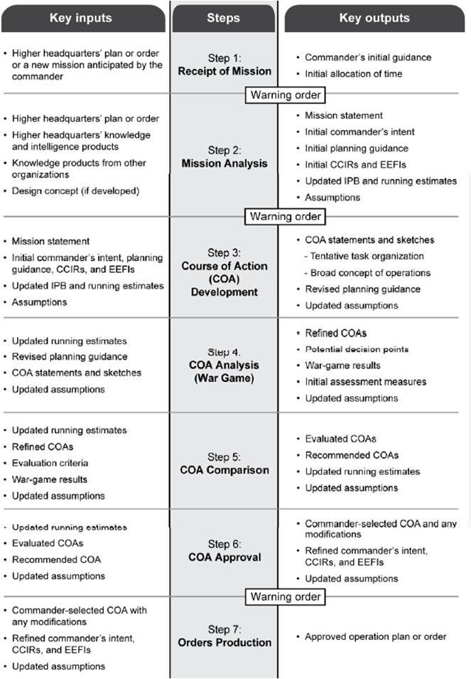

Receive the Mission

PURPOSE: This appendix prescribes the format and procedures for Step 1 of the MDMP process, Receipt of mission.

**ORDERS GROUPS FOR BCT ORDERS:**

**ORDERS GROUP A:** TF CDR, TF CSM, S2, S3, and TF FSO

**ORDERS GROUP B:** TF CDR, TF CSM, TF XO, Primary Staff, TF FSO, JTAC,

**ORDERS GROUPS FOR SQDN ORDERS:**

**ORDERS GROUP A:** TF CDR, CSM, S3, S2, FSO, JTAC, Company Commanders

**ORDERS GROUP B:** TF CDR, CSM, XO, Primary Staff, Company Commanders, SeparatePLs, FSO, JTAC

**ORDERS GROUP C:** TF CDR, CSM, XO, Primary Staff, FSO, JTAC, CompanyCommanders, Company FSOs, Separate PLs, OIC/NCOIC for any enablers

**Products due by staff section at end of Receipt of Mission:**

Timeline determined and posted. (XO)

Order received, catalogued, and copied. (S3 SGM)

Commander‟s initial guidance received. (XO)

MDMP duties clarified. (XO)

This step initiates the decision making process. It begins with the receipt of a new mission and ends when **Warning Order #1** is issued to subordinate and supporting units. When possible, the commander, the S-3, the S-2, the LNO (A/OPS NCO), S6 (if available) and the FSO attend the order. If possible, the LNO will send a complete copy of the brigade order for the remainder of the staff to start working mission analysis products before the orders group returns. The staff will not wait for the orders group to arrive before updating staff estimates.

**Read the order and appropriate annexes before coming to mission analysis, and begin preparing for mission analysis if time permits.**

After reading through the order, the staff must determine what the tactical problem is that they need to solve. A staff may never recover from investing time and energy into solving the wrong problem.

Receive the Mission- Staff Responsibilities

ALL STAFF- after reading the base order and assigned annexes: Update Staff Estimates

XO

1. Alerts staff of pending planning requirement
2. Develops the initial planning timeline
3. Brief commander and staff on mission, instructions and developments.
4. Plan Leader’s / Staff reconnaissance.
5. Determines initial planning and operational timelines (TAB A)
6. Receive and publishes commander’s initial guidance (TAB E)
7. Determines changes in SOP responsibilities for MDMP (TAB C)

AS3

1. Provide staff copies of higher headquarters operations order.
2. Issue WARNO # 1 and receive and log subordinate and supporting units acknowledgement of Warning Order #1.
3. Read entire order to identify any potential tasks hidden in staff annexes
4. Conduct an initial time analysis.
5. With S2, determine initial reconnaissance requirements.

Off-Shift Battle CPT- Provide assistance as required.

S2:

1. Provide Assistant S3 with pertinent enemy information to the warning order that is already known (prior to IPB).
2. Gather materials needed for Mission Analysis

AS2:

1. Begin set up of the planning area to facilitate Mission Analysis (position map boards, copy overlays, inventory/distribute selected briefing boards/slides for Mission Analysis)

Receive the Mission

S1/S4: Gather materials needed for the next step of the Mission Analysis

Chemical Officer (CHEMO)

* 1. Assist the AS3 in preparation of Warning Order 1
  2. Assist the AS2 in the preparation of the planning area.
  3. Gather materials needed for the next step of Mission Analysis

**What Tools are Needed for Mission Analysis?**

* Appropriate field manuals, including FM 5-0, FM 1-02, and FM 2-01.3.
* All documents related to the mission and area of operations (AO), including the higher
* Headquarters’ OPLAN and OPORD, maps and terrain products, and operational graphics.
* Higher headquarters’ and other organizations’ intelligence and assessment products.
* Estimates and products of other military and civilian agencies and organizations.
* Both their own and the higher headquarters’ SOPs.
* Current running estimates.
* Any design products, including the design concept.

**Commander's Initial Guidance**

When practicable, the commander will issue verbal guidance about the upcoming operations. This guidance includes:

* The initial operational time line.
* Planning Timeline (Deliberate, Condensed, Team)
* Necessary coordination to perform, including liaison officers (LNOs) to dispatch.
* Authorized movement (to include positioning of C2 system nodes).
* Additional staff tasks, to include specific information requirements.
* Collaborative planning times and locations (if desired).
* Initial IR or CCIR (as required).

S2, S3, FSO

All Staff

Responsibility for BDE Annexes

|  |  |  |  |  |  |  |  |
| --- | --- | --- | --- | --- | --- | --- | --- |
| **ANNEX A – TASK ORGANIZATION (S-3)** | |  |  |  |  |  |  |
| **ANNEX B – INTELLIGENCE (S-2)** | |  |  |  |  |  |  |
| Appendix 1 | – Intelligence Estimate |  |  |  |  |  |  |
| Tab A – Terrain (Engineer Coordinator) | |  |  | SQDN S3, ENG, S6 | |  |  |
| Tab B – Weather (Staff Weather Officer) | |  |  |  |  |  |  |
| SQDN S3 | |  |  |  |  |
| Tab C – Civil Considerations | |  |  |  |  |
|  |  |  |  |  |  |
| Tab D – Intelligence Preparation of the Battlefield Products | | | | | SQDN S3, |  |  |
| Appendix 2 | – ISR Synchronization Matrix |  |  |  | Fires |  |  |
| Appendix 3 | – Counterintelligence |  |  |  |  |  |  |

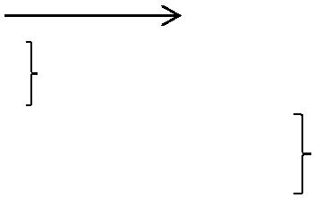

Appendix 4 – Signals Intelligence

Appendix 5 – Human Intelligence

Appendix 6 – Geospatial Intelligence

Appendix 7 – Imagery Intelligence

Appendix 8 – Measurement and Signature Intelligence

Appendix 9 – Open Source Intelligence

Appendix 10 – Technical Intelligence

Appendix 11 – Soldier Surveillance and Reconnaissance



**ANNEX C – OPERATIONS (S-3)**

~~Appendix 1 – Design Concept~~

|  |  |  |  |  |  |  |  |  |
| --- | --- | --- | --- | --- | --- | --- | --- | --- |
| Appendix 2 – Operation Overlay | | | |  |  |  |  |  |
| Appendix 3 – Decision Support Products | | | |  |  |  |  |  |
| Tab A – Execution Matrix | | |  | All Staff | | |  |  |
| Tab B – Decision Support Template and Matrix | | |  |  |  |  |  |  |
|  |  |  |  |  |  |
| Appendix 4 – Gap Crossing Operations | |  |  | ENG |  |  |  |  |
| Appendix 5 – Air Assault Operations | |  |  |  |  |  |  |  |
|  |  |  |  |  |  |  |
| ~~Appendix 6~~ | ~~– Airborne Operations~~ | | |  |  |  |  |  |
| ~~Appendix 7~~ | ~~– Amphibious Operations~~ | | |  |  |  |  |  |
| ~~Appendix 8~~ | ~~– Special Operations (G-3 [S-3])~~ | | |  |  |  |  |  |
| Appendix 9 – Battlefield Obscuration (CBRN Officer) | | | |  |  | CHEMO | |  |
| Appendix 10 – Information Engagement (S-3) | | | |  |  |  |  |  |
|  |  |  |  |  |



Appendix 11 – Airspace Command & Control (S-3 or Airspace C2 Officer)



Appendix 12 – Rules of Engagement (SJA)



Tab A – No Strike List (S-3 with SJA)

Tab B – Restricted Target List (S-3 with SJA) ~~Appendix 13 – Military Deception (G-5)~~

~~Appendix 14 – Law and Order Operations (Provost Marshal) Tab A – Police Engagement~~

~~Tab B – Law Enforcement~~

Appendix 15 – Internment and Resettlement Operations (Provost Marshal) 

SQDN S2

SQDN S3

S1, S4

Responsibility for BDE Annexes



|  |  |  |  |  |  |  |  |  |
| --- | --- | --- | --- | --- | --- | --- | --- | --- |
| **ANNEX D – FIRES (Chief of Fires/Fire Support Officer)** | | | | | | | |  |
| Appendix 1 – Fire Support Overlay | | |  |  |  |  |  |  |
| Appendix 2 – Fire Support Execution Matrix | | | |  |  |  |  |  |
| Appendix 3 – Targeting | | |  |  |  |  |  |  |
| Tab A – Target Selection Standards | | |  |  |  |  |  |  |
| Tab B – Target Synchronization Matrix | | |  |  |  |  |  |  |
|  |  |  |  | SQDN FSO |  |
| Tab C – Attack Guidance Matrix | | |  |  |  |  |  |
|  |  |  |  |  |  |
|  |  |  |  |  |  |
| Tab D – Target List Work Sheets | | |  |  |  |  |  |  |
|  | SQDN S2 | |  |  |  |
| Tab E – Battle Damage Assessment (S-2) | | | |  | |  |
| Appendix 4 | – Field Artillery Support | |  |  |  |  |  |  |
| Appendix 5 | – Air Support |  | JTAC |  |  |  |  |  |
| Appendix 6 | – Naval Fire Support | |  |  |  |  |  |  |
| Appendix 7 | – Command and Control Warfare (EWO) | | | | | | |  |



|  |  |  |
| --- | --- | --- |
| Tab A – Electronic Attack |  |  |
| Tab B – Electronic Warfare Support |  |  |
| SQDN EWO |  |
| Tab C – Computer Network Attack |  |
|  |  |
|  |  |
| Tab D – Computer Network Exploitation |  |  |

**ANNEX E – PROTECTION (Chief of Protection/Protection Coordinator as designated by the commander)**

~~Appendix 1 – Air and Missile Defense (Air and Missile Defense Coordinator) Tab A – Enemy Air Avenues of Approach~~

~~Tab B – Enemy Air Order of Battle~~

~~Tab C – Enemy Theater Ballistic Missile Overlay Tab D – Air and Missile Defense Protection Overlay Tab E – Critical Asset List/Defended Asset List~~

~~Appendix 2 – Personnel Recovery (Personnel Recovery Coordinator)~~

|  |  |  |  |  |  |  |  |  |  |  |  |  |
| --- | --- | --- | --- | --- | --- | --- | --- | --- | --- | --- | --- | --- |
| Appendix 3 – Fratricide Prevention | | S2, S3 | |  | |  |  |  |  |  |  |  |
| ~~Appendix 4 – Operational Area Security (Provost Marshal)~~ | | | | | |  |  |  |  |  |  |  |
| Appendix 5 – Antiterrorism (Antiterrorism Officer) | | |  | | |  | TF S2 | | | |  |  |
| Appendix 6 | – CBRN Defense (CBRN Officer) |  |  |  |  | TF CHEMO | | |  | | |  |
| Appendix 7 | – Safety (Safety Officer) | **TF MEDO** | | |  |  |  |  |  |  |  |  |
|  |  |  |  |  |  |  |  |
| ~~Appendix 8~~ | ~~– Operations Security (Operations Security Officer)~~ | | | | | | |  |  |  |  |  |
|  | TF Eng | | |  |
| Appendix 9 | – Explosive Ordnance Disposal (EOD Officer) | | | | |  |  |  |  |
|  |  |  |  |  |  |  |
| Appendix 10 – Force Health Protection (Surgeon) | | | | | |  |  | |  | |  |  |
|  | TF MEDO | | |  |  |  |
|  |  |  |  |  |  |  |  |  |  |  |  |  |

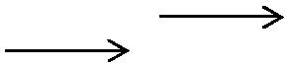

Responsibility for BDE Annexes



**ANNEX F – SUSTAINMENT (Chief of Sustainment [S-4])**

Appendix 1 – Logistics (G-4 [S-4]) Tab A – Sustainment Overlay

Tab B – Maintenance

Tab C – Transportation

Exhibit 1 – Traffic Circulation and Control (Provost Marshal) Exhibit 2 – Traffic Circulation Overlay

Exhibit 3 – Road Movement Table

Exhibit 4 – Highway Regulation (Provost Marshal) Tab D – Supply

Tab E – Field Services Tab F – Distribution

Tab G –Contract Support Integration Tab H – Mortuary Affairs



Tab I – Internment and Resettlement Support Appendix 2 – Personnel Services Support

Tab A – Human Resources Support (G-1 [S-1]) Tab B – Financial Management (G-8)

Tab C – Legal Support (Staff Judge Advocate)



Tab D – Religious Support (Chaplain) ~~Tab E – Band Operations (G-1 [S-1])~~

Appendix 3 – Army Heath System Support (Surgeon) Tab A – Medical Command and Control

|  |  |  |
| --- | --- | --- |
| Tab B – Medical Treatment |  |  |
| Tab C – Medical Evacuation |  |  |
| SQDN S1 |  |
| Tab D – Hospitalization |  |
|  |  |
|  |  |
| Tab E – Dental Services |  |  |

Tab F – Preventive Medicine

SQDN S4

SQDN S1

Chaplain

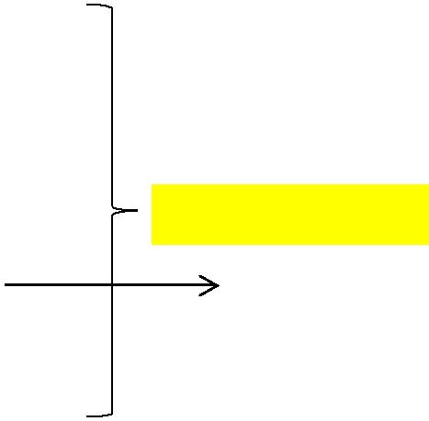

SQDN MEDO

|  |  |  |  |  |  |
| --- | --- | --- | --- | --- | --- |
| Tab G – Combat and Operational Stress Control | |  | Chaplain |  |  |
| ~~Tab H – Veterinary Services~~ | |  |  |  |  |
|  |  |  |  |
| Tab I – Medical Logistics | | |  |  |  |
| Tab J – Medical Laboratory Support | | |  |  |  |
| **ANNEX G – Engineer** | | |  |  |  |
| Appendix 1 – Mobility/Countermobility | | |  |  |  |
| Tab A – Obstacle Overlay | | |  |  |  |
| Appendix 2 – Survivability (Engineer Officer) | | |  |  |  |
| SQDN ENG | |  |
| Appendix 3 – General Engineering | | |  |
| ~~Appendix 4~~ | ~~– Geospatial Engineering~~ | |  |
|  |  |  |
|  |  |  |
| Appendix 5 | – Engineer Task Organization and Execution Matrix | |  |  |  |
| Appendix 6 | – Environmental Considerations | |  |  |  |



All Staff Sections

SQDN S4

Responsibility for BDE Annexes

|  |  |  |  |
| --- | --- | --- | --- |
| **ANNEX H – SIGNAL (G-6 [S-6])** | |  |  |
| Appendix 1 – Information Assurance | |  |  |
| Appendix 2 | – Voice and Data Network Diagrams |  |  |
| SQDN S6 |  |
| Appendix 3 | – Satellite Communications |  |
|  |  |
| Appendix 4 | – Foreign Data Exchanges |  |  |
| Appendix 5 | – Electromagnetic Spectrum Operations |  |  |



**~~ANNEX I – Not Used~~**

|  |  |  |  |  |  |  |
| --- | --- | --- | --- | --- | --- | --- |
| **ANNEX J – PUBLIC AFFAIRS (Public Affairs Officer)** | | |  |  | SQDN S1 & Additional |  |
|  |  | Duty Officer |  |
|  |  |  |  |  |  |
| **ANNEX K – CIVIL AFFAIRS OPERATIONS (S-9)** | | | FSO |  |  |  |
|  | |  |
|  |  | |  |  |  |  |
|  |  |  |  |  |  |  |
| **ANNEX L – ISR (S-3)** | SQDN S2 & S3 |  |  |  |  |  |
|  |  |  |  |  |  |  |
| **~~ANNEX M – ASSESSMENT (G-5 [S-5] or G-3 [S-3])~~** | | |  |  |  |  |



**~~ANNEX N – SPACE OPERATIONS (Space Operations Officer)~~ ANNEX O – Not Used**

**ANNEX P – HOST-NATION SUPPORT (S-4)** 

**~~ANNEX Q – Not Used~~**

**ANNEX R – REPORTS (G-3 [S-3])**



**~~ANNEX S – SPECIAL TECHNICAL OPERATIONS~~**

**~~ANNEX T – Not Used~~**

**~~ANNEX U – INSPECTOR GENERAL~~**

**ANNEX V – INTERAGENCY COORDINATION (S-3)**

**~~ANNEX W – Not Used~~**

**~~ANNEX X – Not Used~~**

**~~ANNEX Y – Not Used~~**

**ANNEX Z – DISTRIBUTION (S-3)**

**Mission Analysis Sequence**

* **Step 1. Analyze the higher headquarters plan or order**
* **Step 2. Perform initial intelligence preparation of the battlefield**
* **Step 3. Determine specified, implied, and essential tasks**
* **Step 4. Review available assets and identify resource shortfalls**
* **Step 5. Determine constraints**
* **Step 6. Identify critical facts and develop assumptions**
* **Step 7. Begin composite risk management**
* **Step8. Determine initial commander’s critical information requirements and essential elements of friendly information**
* **Step 9. Develop initial ISR synchronization plan**
* **Step 10. Develop initial ISR plan**
* **Step 11. Update plan for the use of available time**
* **Step 12. Develop initial information themes and messages**
* **Step 13. Develop a proposed mission statement**
* **Step 14. Present the mission analysis briefing**
* **Step 15. Develop and issue initial commander’s intent**
* **Step 16. Develop and issue initial planning guidance**
* **Step 17. Develop COA evaluation criteria**
* **Step 18. Issue a warning order**

22 June 2010

Mission Analysis

**Mission Analysis consists of the following 17 steps, not necessarily sequential, and results in some of the products listed in Figure 2.**

1. Analyze the Higher Headquarters’ order.
2. Conduct initial Intelligence Preparation of the Battlefield (IPB).
3. Determine specified, implied, and essential tasks.
4. Review available assets.
5. Determine constraints.
6. Identify critical facts and assumptions.
7. Conduct tactical risk assessment.
8. Determine initial commander‟s Critical Information Requirements

(CCIR).

1. Determine the initial reconnaissance annex.
2. Plan use of available time.
3. Write the restated mission.
4. Conduct a Mission Analysis briefing.
5. Approve the restated mission.
6. Develop the initial Commander’s Intent.
7. Issue the Commander’s guidance.
8. Issue a Warning Order.
9. Review facts and assumptions.

***MISSION ANALYSIS PRODUCTS***

**Modified Combined Obstacle Overlay / Avenues of Approach Overlay Enemy Situation Templates**

**Initial Event Template Specified / Implied Task List**

**Limitations (Constraints and Restrictions) Detailed Timeline**

**Risk Analysis- focus on tactical risk more than accidental risk Restated Mission**

Mission Analysis

**DUTIES AND RESPONSIBILITIES**

Purpose: This annex outlines the duties and responsibilities for each member of the staff during step two (mission analysis) of the MDMP. The positions listed are based on the ICCC course and are not all-inclusive.

Staff responsibilities.

AS3:

1. Enforce adherence to the approved planning timeline and/or adjust timeline as necessary.
2. Write restated mission.
3. Plan use of available time. This entails developing the operations timeline and continuing the management of the planning timeline. The operations timeline must be completed in conjunction with the S2‟s development of the enemy timeline.
4. Read the Higher HQ OPORD, FRAGO, and/or WARNORD. In Step 1 (Receive the Mission), the Higher HQ OPORD was read but not to the level of detail required.
5. Assign assets to execute the initial R & S Plan
6. Determine specified and implied tasks, and constraints for the maneuver BOS.
7. Review available combat related assets for the maneuver BOS (infantry and armor primarily).
8. Develop initial FFIR and any EEFI that may be needed
9. Compile tasks, available assets, facts, and assumptions from each staff member.
10. Prepare charts and area for the mission analysis brief to the commander.
11. Prepare WARNORD #2
12. Oversee the construction of the terrain model.

Mission Analysis

**Intelligence Prep of the Battlefield**

S2:

1. Conduct IPB:
   1. Define the operational environment (terrain, weather, AO/AI)
   2. Describe environmental effects on operations:

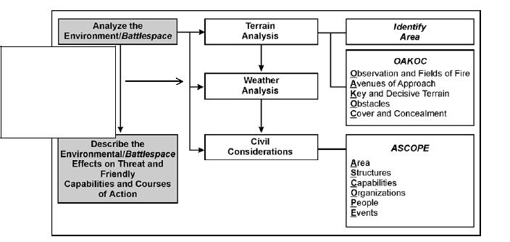

**Military Aspects of**

**Weather**

Visibility

Wind

Precipitation

Cloud Cover / Ceiling

Temperature

Humidity

Pressure

1. Evaluate the threat- composition, disposition, tactics, training, logistics, operational effectiveness, communications, intelligence, recruitment, support, and reach
   1. Take the threat doctrine and tactics and build an enemy template
   2. Using template, describe threat capabilities
   3. Account for the enemy within the AI; the template must account for higher echelon enablers- FA, CAS, CCA, reserve elements, etc
   4. Remember that the enemy is not limited by our graphic control measures

Mission Analysis

1. Determine enemy COAs- they must meet the same criteria as our COA- Feasible, Acceptable, Suitable, Distinguishable, Complete

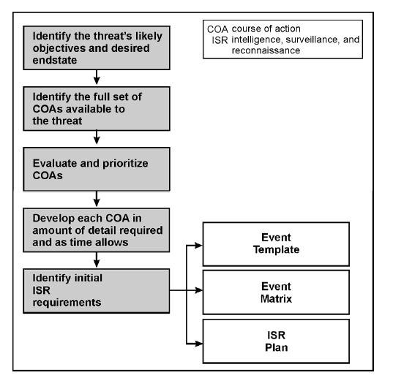

Mission Analysis

1. Build the SITEMP- terrain will effect the enemy to the same extent is does our forces. By laying the threat doctrinal template over the MCOO and applying some analysis, the enemy‟s plan will become much clearer. To do this well, you need to master terrain analysis and understand the capabilities of the enemy‟s systems.
2. The enemy will not plan to lose- he will do everything within the capabilities of his forces to win.
3. The SITEMP is a team effort- the S2 section serves as the enemy commander, but each staff section completes an analysis of threat composition, disposition, capabilities, strengths, and weaknesses within their own specific BOS. This information is then presented to the S2 for inclusion in his overall analysis. Know your enemy counterpart as well as you know yourself. Essentially, the staff is building the OPFOR CONOP.
4. 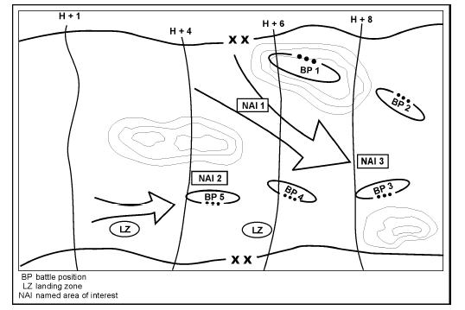Identify initial ISR requirements and start developing the event template. The event template and matrix must be completed before the finalized Reconnaissance and Surveillance Plan; however, terrain reconnaissance, and any specific information needed by the commander may be focused on. The ISR plan should focus on determining the threat COA to help focus subsequent staff planning and rehearsals.

**Event Template**

-Depicts NAI activity or lack of it -Time Phase Lines depict actions for each COA

-Develop the indicators that would determine which COA enemy is executing

Event Matrix

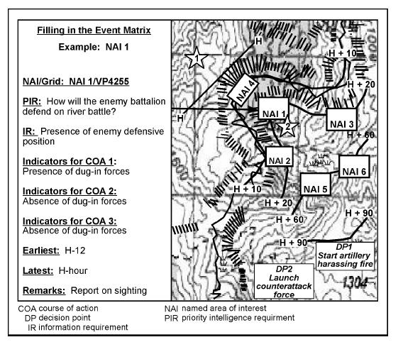

**Event Matrix**

-details type of activity in each NAI

-times that NAI is active

-develop indicators for each event

1. Assist in the completion of the initial R & S Plan. Information from the preceding step is presented to the S3 Air (or S3) and appropriate staff members to complete the R & S Plan. If time permits the staff conducts an R & S huddle.
2. Compile reverse BOS analysis from staff.
3. Provide initial recommendations to PIR list to the S3 Air.

Mission Analysis

Staff responsibilities.

FSO

1. Higher Commander‟s intent for fires and effects,
2. Essential Fires and Effects tasks
3. Specified Fires and Effects tasks
4. Implied Fires and Effects tasks
5. Limitations and assets available.
6. FIST status.
7. BDE fire support plan & current FS coordination measures
   1. FA organization for combat.
   2. FA unit available and support relationships.
   3. Current ammo status.
      1. # minutes of smoke.
      2. # of FASCAM.
      3. # of Excalibur
   4. Current location of FA units.
8. Mortar Platoon
   1. Organization for combat.
   2. Mortar tube status
   3. Mortar unit available and support relationships.
   4. Current ammo status.
      1. # minutes of smoke
      2. # suppression missions
   5. Current location of Mortars.
9. IO assets available
   1. PA
   2. CA
   3. PSYOP
   4. EW
   5. THT
10. CAS allocated to the BDE.
11. COLTs allocated to SQDN.
12. Recommended Effects Tasks

Mission Analysis

Staff responsibilities.

S1:

1. Provide specified and implied tasks, facts, constraints, and assumptions as they relate to the personnel aspects of sustainment WFF, to the A/S3.
2. Provide status of personnel replacement to COA development.
3. Status of leaders and critical MOS shortages.
4. Replacement priorities.
5. Tracking changes to PERSTATS due to Task Org changes (attachments and detachments)
6. Manifesting requirements and locations

MEDO:

1. MEDEVAC assets & current location (call signs and frequencies)
2. MEDEVAC “Timed phase lines.” – range rings for assets
3. Casualty estimates.
4. Current Status of Class VIII and location of resupply nodes
5. Tactical risk management

S4:

1. Assets allocated in the Task Organization.
2. Status of assets allocated (equipment and vehicles). Focus on the status at company level.
3. Class VII replacement requirements / ORF vehicles available
4. Location and capabilities of BSB or SB level assets
5. Projected combat power at LD

Mission Analysis

A/S-3 Engineer:

1. Provide specified and implied tasks, facts, constraints, and assumptions as they relate to the mobility/survivability BOS, to the A/S3.
2. Provide list of engineer assets available into the A/S3s overall list of assets available to the unit.
3. Conduct reverse BOS analysis on the threat mobility/survivability BOS. Provide information to the S2
4. Provide engineer input to the initial R & S plan either through the R & S huddle or informally to the S3
5. Conducts Terrain Analysis and develops the MCOO with the S2
6. Terrain associated PIR input provided to S2

Chemical Officer:

1. Conduct reverse BOS analysis on the threat chemical capabilities. Provide information to the S2
2. Assist in the preparation of the mission analysis brief.
3. Prepare terrain sketch for COA Development.

S6/BSO

1. Conduct Signal IPB IAW FM 34-30
2. Provide specified and implied tasks, fact, assumptions, and constraints as they relate to signal and C2 BOS to the A/S3
3. Provide list of Signal Assets available and the current status of them to the A/S3 for roll-up into MA slides.
4. Conduct reverse Signal analysis on the Enemy Signal capabilities. Provide S2 with results.
5. With S2, develop the communication support plan for the initial Recon and Surveillance Plan.

Mission Analysis Brief

“That was a great effort by the staff on getting the

Mission Analysis brief put together. The only thing missing from it was, I don‟t know- analysis. I‟ll see you guys in 8 hours for the redo”

- Colonel Schweitzer, Commander 4th Bde / 82nd ASQDN

Don‟t be those guys…..

**Mission Analysis Briefing Agenda**

* **Mission and commander’s intent – 2 Up.**
* **Mission and commander’s intent – 1 Up.**
* **Proposed problem statement.**
* **Proposed mission statement.**
* **Review of commander‟s initial guidance.**
* **Initial IPB.**
* **Staff analysis.**

– Specified, implied, essential tasks; facts and assumptions; constraints; forces available and resource shortfalls.

* **Initial risk assessment.**
* **Proposed information themes and messages.**
* **Proposed CCIRs and EEFIs.**
* **Initial ISR plan.**
* **Recommended timeline.**
* **Recommended collaborative planning sessions.**

22 June 2010

**Course of Action Development**

1. **Assess relative combat power**
2. **Step 2. Generate options**
3. **Step 3. Array forces**
4. **Step 4. Develop a broad concept**
5. **Step 5. Assign headquarters**
6. **Step 6. Develop COA statements and sketches**
7. **Step 7: Conduct COA briefing**
8. **Step 8: Select or modify COAs for continued analysis**

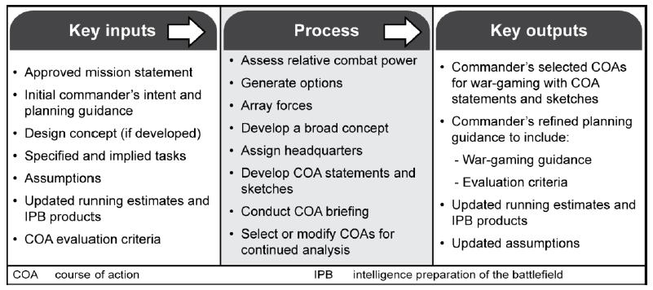

A course of action (COA) is a broad potential solution to an identified problem. The COA development step generates options for follow-on analysis and comparison that satisfy the commander‘s intent and planning guidance. During COA development, planners use the problem statement, mission statement, commander‘s intent, planning guidance, and the various knowledge products developed during mission analysis to develop COAs. Each prospective COA is examined for validity using the following screening criteria:

1. ***Feasible****. The COA can accomplish the mission within the established time, space, and resource**limitations.*
2. ***Acceptable****. The COA must balance cost and risk with the advantage gained.*
3. ***Suitable****. The COA can accomplish the mission within the commander‘s intent and planning**guidance.*
4. ***Distinguishable****. Each COA must differ significantly from the others (such as scheme or form of**maneuver, lines of effort, phasing, day or night operations, use of the reserve, and task organization).*
5. ***Complete****. A COA must incorporate-*

* How the decisive operation leads to mission accomplishment.
* How shaping operations create and preserve conditions for success of the decisive operation or effort.
* How sustaining operations enable shaping and decisive operations or efforts.
* How22 Juneoffensive,2010 defensive, and stability or civil support tasks are accounted for.
* Tasks to be performed and conditions to be achieved.

COA Development

1. GENERAL
   1. A COA is a possible plan open to the Commander that would accomplish the mission. The staff usually states a COA in essential, concise terms with the details determined during the wargame. The staff may revise, modify, or change the COA during the wargame. The staff develops COAs for all the staff to analyze.
   2. Each COA must be able to pass the “FAS-DC test.” Each COA must be **F**easible,

**A**cceptable, **S**uitable, **D**istinguishable and **C**omplete.

* + 1. Feasible- COA can accomplish the mission within the established time, space, and resource limitations
    2. Acceptable- COA must balance the cost and risk with the advantage gained
    3. Suitable- COA can accomplish the mission with the commander‟s intent and planning guidance
    4. Distinguishable- Each COA must differ significantly from others
    5. Complete- incorporates how decisive operation leads to mission accomplishment, how shaping operations create and preserve conditions for success of the decisive operation or effort, how sustaining operations enable shaping and decisive operations or efforts, how tasks are accounted for, tasks to be performed and conditions to achieve
  1. The staff will generally receive a fairly detailed course of action from the commander during

Commander‟s Guidance. From this COA, created to defeat the enemy Most Probable COA, the staff will generate branches and sequences from that main COA to defeat the enemy Most Dangerous COA and any other possible Enemy COAs.

1. DUTIES AND RESPONSIBILITIES OF STAFF

a. Tasks Common to All

Determine if each COA meets selection criteria Risk Management

Prepare boards and handouts for COA Briefing Rehearse briefing

b. XO

Determine Potential Decisive Point (w/respect to time, space, terrain) Purpose of the operation

Pick Locations for Commander, XO, S3, TOC, CTCP

COA Development

c. S3

* 1. Analyze Dynamics of Combat Power
  2. Determine Potential Purposes of Decisive and Shaping Efforts
  3. Determine Potential Tasks of Decisive and Shaping Efforts
  4. Ensure Force Ratios are adequate for DE and SEs
  5. Analyze Proposed FEBA
  6. Propose designation of reserve, with criteria/trigger to commit
  7. Location of Engagement Areas (Defense) or Attack Objectives
  8. Propose responsibilities for Area of Operations (AO)
  9. Graphic Control Measures employed throughout operation
  10. Generic Designation of Headquarters
  11. All HQ‟s control 2-5 subordinate units
  12. FEBA or LD/LC / Boundaries / Control Measures Annotated
  13. Designation of Main and Supporting Efforts on COA Sketch by phase
  14. Objectives and Engagement Areas with obstacles depicted
  15. Write COA statements and sketches
  16. Develop High Priority Target Lists (HPTLs) for each COA
  17. Assist in development of Commander's Critical Information Requirements (CCIR) for each COA
  18. Propose Facts and Assumptions for each COA
  19. Key Events Listed on War-Gaming Synch Matrices.

1. Assistant S-3 (A/S3)
   1. Recorder
   2. Array Units Two Levels Down
   3. Any Special C2 Requirements Fulfilled (e.g. passage of lines)
2. S2
   1. List Enemy Strengths, Weaknesses and Capabilities
   2. Post Enlarged Sketch of Enemy MPCOA and Event Template
   3. Produce High Value Target List by category and target
   4. Key Events Listed on War-Gaming Synch Matrices.
   5. Develop and compile a complete list of CCIRs for each COA.
3. AS2
   1. Analyze Force Ratios
   2. Post Enlarged Sketch of Enemy MPCOA and Event Template
   3. Analyze Proposed FEBA
   4. Draw Overlay of Terrain for COA Sketches

COA Development

1. S1/S4
   1. List all friendly/enemy combat multipliers in WFF
   2. Priorities and locations for CSS elements
   3. Establish CSS Plan before, during, and after mission
   4. Estimate Casualties and Consumption of Class III,IV,V
2. Effects Coordinator
   1. Concept of fires and effects
   2. Draft Effects Execution Matrix concept
   3. Draft target list
   4. Draft Target Synchronization Matrix
   5. Draft Fire Support Plan to support the R&S Plan
   6. Provide recommendations for High Priority Target List
   7. Fire Support Coordination Measures depicted on all sketches
3. A/S-3 Engineer
   1. List all friendly/enemy combat multipliers in WFF
   2. Priorities and locations for engineer assets
   3. Integration of obstacles (defense)/breach assets (offense)
   4. Prepare Obstacle Execution Matrix, Engineer Timeline, and Survivability Matrix (Defense)
   5. Objectives and Engagement Areas with obstacles depicted
4. Chemical Officer (CHEMO)
   1. List all friendly/enemy combat multipliers in WFF
   2. Priorities and locations for Chemical assets/elements
   3. Propose MOPP levels
   4. Prepare COA Sketches and Statements
5. Signal Officer (S6)
   1. Determine C2 Feasibility Criteria / Line of Sight Analysis
   2. List all Friendly/Enemy Signal Assets (w. S3 NCO)
   3. Priorities and locations of Signal Assets/ Elements (PACE plan by unit/location)
   4. Recommend location of C2 nodes.

COA Development

1. REQUIRED PRODUCTS FROM COA DEVELOPMENT SUB-STEPS:
   1. Analyze Relative Combat Power – **(A/S3)**
      1. RCPA Worksheet. **(A/S3 & S2)**
      2. Force Ratios. **(A/S3)**
   2. Generate Options –
      1. Decisive Point. **(XO)**
      2. Task and Purpose of Main and Supporting Efforts. **(S3)**
   3. Array Initial Forces – **(S3)**
   4. Develop the Scheme of Maneuver / Phasing for the operation– **(S3)**
      1. Graphic Control Measures. **(S3)**
      2. Risk Management Worksheet. **(XO)**
      3. High Payoff Target Lists (HPTLs) for each COA. **(FSO)**
         1. HVT- what the enemy requires for success
         2. HPT- target if lost by the enemy, will contribute greatly to success of friendly COA
      4. CCIR for each COA. **(A/S3 & S2)**
   5. Assign Headquarters – Generic Task Organization. **(XO/CDR)**
      1. Locations for CDR, XO, S3, TOC, and TAC. **(A/S3 & S6)**
   6. Prepare COA Statement and Sketch – **(A/S3)**
      1. COA statement(s) with task organization, facts, and assumptions. **(A/S3)**
      2. Obstacle Execution Matrix, Survivability Matrix, and Engineer Timeline **(TF ENG )**
      3. COA sketches on overlays. **(S3 NCO)**
      4. Fires concept **(FSO)**
      5. Concept of support **(S4)**
      6. COA briefing boards and handouts. **(S3 NCO)**
2. TASKS THAT SHOULD BE COMPLETED TO FACILITATE STEP IV, COA ANALYSIS
3. Synch Matrices with Key Events (or other recording tools) prepared for Wargaming.
4. Enemy Forces Arrayed for First Key Event.
5. Friendly Forces Arrayed for First Key Event.
6. Wargaming Technique established.
7. Evaluation Criteria established and posted.
8. Enlarged Sketch of AO with means to post and move friendly and enemy forces.
9. Commander‟s Guidance received for number of friendly and enemy COAs to wargame
10. Assign Scribe for wargame

**COA Development Briefing Agenda**

**Updated IPB. Possible enemy COAs.**

**The approved problem statement and mission statement.**

**The commander‘s and higher commander‘s intent.**

**COA statements and sketches, including lines of effort if used. The rationale for each COA, including—**

**Considerations that might affect enemy COAs. Critical events for each COA.**

**Deductions resulting from the relative combat power analysis. The reason units are arrayed as shown on the sketch.**

**The reason the staff used the selected control measures. The impact on civilians.**

**How it accounts for minimum essential stability tasks. Updated facts and assumptions.**

**Refined COA evaluation criteria.**

22 June 2010

COA Analysis

**GENERAL.**

Wargaming is our method for visualizing how the battle will unfold. We will wargame the selected COA to determine the feasibility of the COA; make adjustments; determine/confirm CCIR, NAIs, and decision points; synchronize our operation.

The commander will be present for and drive the wargame, and the XO will orchestrate it. The S2 will fight the enemy COA as determined by ISR plan, and the S3 will fight the friendly COA.

During the wargame, the battle staff will consider the enemy‟s most dangerous COA and will discuss what the friendly actions would be. All of the BOSs will be represented at the wargame and will comment in their respective area both from a friendly and enemy perspective during each critical event. For sake of time, each briefer must stay focused and brief concise action, reaction, and counteraction in their specific area.

The battle staff will use the Action-Reaction-Counteraction method for the selected critical events. The A/S3 will record the wargame on the wargaming worksheet to be used to prepare several products to include the operations order, R&S plan, and the decision support matrix.

**PREPARATION**. The battle staff will prepare the following tools prior to theconduct of wargaming:

XO

Determine Evaluation / Decision Matrix Criteria With CDR, selects wargaming method.

A/S3 and NCO

Wargame Worksheets (PSOP location).

Large map or sketch of operational area with operational graphics and enemy most probable COA.

List all Friendly Forces / Task Organization for each COA Symbols for DPs, NAIs, targets, friendly unit locations. Prepares Synchronization Matrix for each COA.

COA Analysis

S2.

1. Enemy SITTEMPs (MPCOA & MDCOA).
2. List of assets available to the enemy.
3. Symbols for enemy unit locations.

S4/S1/ADO/ENG/TIO

1. Ensure all CS/CSS assets are known to all

FSO must know the following information:

1. FA units available.
2. Current ammo status, number of volleys available to the BCT.
3. Current locations of FA units.
4. When in position to fire.
5. FA priority of fires.
6. Recommendation for allocation of priority targets and FPFs.
7. Current and O/O fire support coordination measures.
8. Mortar status.
9. Recommended mortar location.
10. Recommended FIST / COLT allocation/use (don’t forget “angle T”).
11. Current ammo status and any perceived problems.
12. CAS allocated to the BDE and recommendation for employment.
13. Draft Effects Execution Matrix
14. High Payoff Target List
15. Target Synchronization Matrix
16. BDE Essential Effects Tasks
17. IO assets available
18. BDE essential effects tasks
19. SQDN essential effects tasks
20. High Payoff Target List

COA Analysis

A/S-3 Engineer

1. Engineer units available.
2. Current location of Engineer units.
3. Current status of Class IV/V available to BCT.
4. Priority of effort/support to the BCT.
5. Recommendation for allocation of FASCAM VOLCANO.

**EXECUTION**

Critical Events. The XO and S3 will select the critical events that we‟ll wargame and will establish a time schedule for each.

Setting the Stage. The S3 will explain the battlefield framework to include the graphics and unit locations. Each WFF rep will discuss the location of his assets and their task/purpose. The S2 will describe the most probable enemy situation. The XO will roll call each WFF rep for any additional enemy information in his WFF area.

Role Playing. The S2 and S3 will fight the enemy and friendly respectively to ensure clear visualization of the battle. The S2 and S3 will state the casualties that they believe they will inflict and take during each move. The XO will be the arbitrator. The recorder will capture significant events and tasks for the commander, sub-units, staff, and WFF reps. Each critical event is fought, one at time, through a series of action, reaction, and counter-action drills. The S2 or S3 will initiate each event, and the WFF reps will provide applicable input, by roll call, for each event. The recorder uses his wargame notes to complete the OPORD. The Staff / WFF Reps take notes to assist the units in their preparation for the fight, complete their annexes, and assist in their understanding of how the battle will unfold.

COA Analysis

**DUTIES AND RESPONSIBILITIES**

XO

1. Leads wargame effort.
2. Coordinates staff actions and keeps all focused.
3. Identifies key events.
4. Ruthlessly monitors the clock.
5. Ensures staff stays within the CDR‟s intent and guidance.
6. Acts as the honest broker ensuring the process is disciplined, methodical, and swift.

S2.

1. Role plays the enemy commander.
2. Identifies IRs to support decision points.
3. Refines the situation template.
4. Displays critical enemy decision points
5. Projects enemy reactions to friendly actions
6. Predicts enemy casualties and losses
7. Refines friendly NAIs, High Value Targets, and Event/Situational Templates

S3.

1. Assists the XO identify significant events to wargame.
2. Fights the Brigade TF.
3. Assumes the XO‟s responsibilities in his absence.

WFF/Staff.

1. Wear the Red Hat for their area of expertise (Reverse BOS Analysis).
2. Ensure assets are used within their capabilities, limitations, doctrine, and TTP.
3. Help identify HVTs and HPTs.
4. Note any items for synchronization.
5. Identify shortfalls that require support from higher.

COA Analysis

A/S-3.

1. Record actions on the wargame worksheet. Fill out Synch Matrix on computer.
2. Note estimated friendly losses.
3. Note refinements to the task organization.
4. Note locations or events that might cause commitment of the Reserve.
5. Note possible locations for Decision Points.
6. Note possible locations of TAIs.
7. Note EEFI, FFIR, and CCIR.
8. Note tasks for sub-units.
9. Note estimated duration of critical events.
10. Recorder
11. Arrays Friendly Forces two levels down
12. Ensures tools are gathered for the war-game
13. Records each event's strengths and weaknesses
14. Annotates rationale for decisions at each critical event
15. Identifies branches / sequels or contingencies that require planning

AS2.

* Plays the role of collection manager
* Maintains murder board to track Enemy losses.
* Time, location, and tasks for collection assets (for the R&S plan).
* Additions or refinements to the PIR.

COA Analysis

S4.

1. Status of critical combat systems (Combat Power Report).
2. Status of all Classes of Supply.
3. CL III/V in the CTCP and Field Trains/ Available resupply from DSA/EAD.
4. # of ambulances available.
5. Location of AXP.
6. Location of other medical assets (adjacent higher).
7. # of recovery vehicles available (location/type).
8. Unit maintenance status by company (Focus on specialty platoons).
9. Status of Co vehicles/assets.
10. Fuelers available.
11. Recommendation for employment of the CTCP and FAS.

S1.

1. Location, time, and number of expected friendly casualties.
2. Location and time that treatment assets will be required.
3. Location and time that evacuation assets will be required.
4. Evac routes.
5. Projects numbers and times when replacements will be available

FSO For each critical event, determine the location, time, and desired effects for:

1. FS assets to support the WFF Scheme of Maneuver.
2. Determine who will control the fires and the control measures required to prevent fratricide.
3. Determine priority and allocation of assets by event.
4. Recommend HPTs to the S3 based on S2’s HVTs.
5. Recommend FASCM to the S3.
6. Complete Target Synch Matrix.
7. Provide input to ensure the proper effects is achieved

COA Analysis

FSO Continued::

1. IO assets to support the BOS Scheme of Maneuver.
2. Determine priority and allocation of assets by event.
3. Recommend HPTs to the S3 based on S2’s HVTs.
4. Provide input to Target Synch Matrix.
5. Provide input to ensure the proper effects is achieved

A/S-3 Engineer.

1. For each critical event, determine the location, time, and tasks for

engineer assets and any requirements for breaching, mines, or Class IV.

1. Calculate feasibility of engineer support by COA

Chemo.

1. Determine potential points for the enemy to use chemical weapons and criteria / triggers for employment
2. Where the BDE could employ smoke to gain an advantage over the enemy.
3. Determine chemical defense feasibility for each COA
4. Recommend MOPP levels for each phase of COAs

SIGO. Determine the best locations to facilitate communication between:

1. The BDE Cdr and the SQDN Cdrs;
2. The BDE Cdr with the TOC;
3. The TOC with the DTOC;
4. The TOC with the BDE Trains throughout the battle via FM, MSE, TACSAT, HF, etc.
5. Identify likely areas where communications will be disrupted / services lost

COA Analysis

**PRODUCTS OF WARGAMING BY STAFF SECTION**

Gather the Tools – (All)

List all Friendly Forces – (A/S3)

List Assumptions – (A/S3)

List Known Critical Events and Decision Points– (S3/XO)

Determine Evaluation Criteria – Decision Matrix Criteria. (CDR)

Select the War-Game Method (XO/S3)

Select a Method to Record and Display Results (XO/S3)

War-Game the Battle and Assess Results – (All)

Refined COAs and enemy event templates. (XO & S2) Refined Task Organization. A/S3

Synchronization Matrix or Sketch-Note Worksheet (A/S3)

Refined CCIR with associated Latest Time Information is of Value. (S2)

Refined R and S plan with graphics. (S3/S2) Refined Risk Management Worksheet. (CHEMO) Decision Support Template for each COA. (S2)

**COA Analysis Briefing Agenda**

•Higher headquarters‘ mission, commander‘s intent, and military deception plan.

•Updated IPB.

•Friendly and enemy COAs that were war-gamed including —

Critical events.

Possible enemy actions and reactions. Possible impact on civilians.

Possible media impacts. Modifications to the COAs. Strengths and weaknesses. Results of the war game.

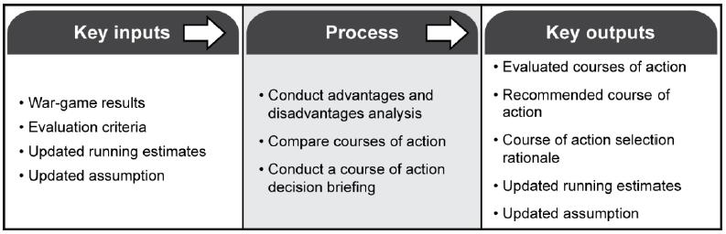

Gathering the Tools for Wargaming

In order to conduct an effective and efficient wargaming, substantial time and effort must be applied to gathering the tools. At a minimum this includes:

1. Terrain model depicting Area of Operations and area of interest. If time permits, a separate terrain model depicting the decisive action (actions on the objective) will be built as well
2. Enemy unit icons built for all elements within the AO/AI for both MLCOA and MDCOA
3. Fire Support Matrix & Overlay
4. Concept of Support & CSS Overlay
5. ISR Collection Matrix & Overlay
6. Updated Task Organization
7. Updated ATO for CAS
8. Current Staff Estimates
9. Friendly unit icons built to include all enablers and attachments
10. Range fans built for friendly and enemy weapon systems
11. Synch matrix displayed with the first action column already filled out
12. Decision point templates built
13. Graphic control measures displayed / sufficient materials on hand to build more as required
14. Targets (enemy and friendly plotted)
15. Murder board on hand to capture BDA
16. Note taking material with scribe- optimally a member of current operations helps to scribe in order to facilitate the transition of the mission from plans to current operations

Decision Support Template

**General.**

To define the procedures/steps for developing the Decision Support matrix (DSM) and the Decision Support Template (DST).

Decision Support Template (DST) is essentially a combined intelligence estimate and operations estimate in graphic form. It provides a structured basis for using document and experience to reduce battlefield uncertainties and to make decisions.

The DST relates the detail of the event template to decision points of significance to the commander. It identifies critical battlefield areas, events, and activities which require tactical decisions by time and location. Selection of decision points (DPs) depend heavily upon availability of maneuver, fire support, and MI assets. This makes DP selection primarily an S3 function.

DP Placement is critical. DPs identify the areas, events and points where tactical decisions are required. They indicate where decisions **should** be made in order to achieve the most desired effect on the enemy at the target area of interest (TAI) corresponding to that decision. DPs must be placed far enough in advance of the expected location of the event to ensure sufficient time to allow confirmation that the expected event (the decision criteria) will occur.

**DECISION SUPPORT TEMPLATE.** The DST consists of:

Operations Graphics.

Decision Points (DPs).

TAIs (only those linked to a decision point; area TAIs depicted as EAs, Point TAIs depicted as targets).

Time Phase Lines (TPLs) - draw operational phase lines for control that equate to the Event Template TPLs and label movement rates to the TPLs.

Enemy Objectives (OBJs).

Decision Support Template

**DECISION POINTS.** Factors affecting placement include time required:

For intelligence collection to receive the event that has taken place. To process the information.

To advise the commander the decision criteria has been met. For commander to make his decision.

To disseminate the decision to the proper maneuver, FS, or CS asset. For the asset to implement the decision/achieve desired effects.

**DECISION SUPPORT MATRIX.** The DSM is based on the DST and isused to script (from wargaming and synchronization) decisions the commander may have to make, to include:

Activation of maneuver contingencies. Commitment of reserves.

Reposition of maneuver elements.

Execution of dynamic obstacles and demolitions.

Delivery of fires (CAS, FA) into TAIs (can include direct fires).

Decisions may be activated when criteria is met. Criteria can either be friendly or enemy based activity, but are normally enemy based. They will be linked to either PIR or FFIR.

Decision Support Template



|  |  |  |  |  |  |  |  |  |  |  |  |  |  |  |  |
| --- | --- | --- | --- | --- | --- | --- | --- | --- | --- | --- | --- | --- | --- | --- | --- |
|  |  | **CONDITIONS** | | | |  | **DECISION POINT #** | | | | |  | **ACTIONS** | |  |
|  |  |  |  |  |  |  |  |  |  |  |  |  | |  |  |
|  |  | **ENEMY CONDITIONS (PIR)*:** | |  |  |  | **DECISION (IF…AND…THEN):** | | | |  | **MANEUVER**: | | |  |
|  |  |  |  |  |  |  |  |  |  |
|  |  | **PIR #:** | |  | |  | **If** | | | |  |  |  |  |  |
|  |  |  |  |  |  |  | **and** | | | | |  |  |  |  |
|  |  | **SOR to PIR #:** | | | |  | **then** | | | | |  |  |  |  |
|  |  | **Primary Observer:** | | | |  |  |  |  |  |  |  |  |  |  |
|  |  |  |  |  |  |  |  |  |  |  |  |
|  |  |  |  |  |  |  |  | **FIRES**: |  |  |  |
|  |  |  |  |  |  |  |  |  |  |  |  |  |  |  |
|  |  | **Alternate Observer:** | | | |  |  |  |  |  |  |  |  |  |  |
|  |  | **How Long Does These Conditions** | | | |  |  |  |  |  |  |  |  |  |  |
|  |  | **Last?** | | | |  |  |  |  |  |  |  |  |  |  |
|  |  |  |  |  |  |  |  |  |  |  |  |  | |  |  |
|  |  |  |  |  |  |  |  |  |  |  |  | **INTEL/RECON**: | | |  |
|  |  |  |  |  |  |  |  |  |  |  |  |  |  |  |  |
|  |  |  |  |  |  |  |  |  |  |  |  |  |  |  |  |
|  |  |  |  |  |  |  |  |  |  |  |  |  |  |  |  |
|  |  |  |  |  |  |  | **COA SKETCH:** | |  |  |  |  |  |  |  |
|  |  |  |  |  |  |  |  |  |  |  |  |  | |  |  |
|  |  |  |  |  |  |  |  |  |  |  |  | **MOB/SURV**: | | |  |
|  |  | * INCLUDE PIR, NAI, OBSERVER, AND SIR | | | |  |  |  |  |  |  |  |  |  |  |
|  |  |  |  |  |  |  |  |  |  |  |  |  |  |  |  |
|  |  | **FRIENDLY CONDITIONS (FFIR):** | | |  |  |  |  |  |  |  |  |  |  |  |
|  |  |  |  |  |  |  |  |  |  |  |  |  |  |  |  |
|  |  | FFIR #1. | | |  |  |  |  |  |  |  | **ADA:** |  |  |  |
|  |  |  |  |  |  |  |  |  |  |  |  |  |  |  |  |
|  |  |  |  |  |  |  |  |  |  |  |  |  |  |  |  |
|  |  |  |  |  |  |  |  |  |  |  |  | **NBC:** |  |  |  |
|  |  |  |  |  |  |  |  |  |  |  |  |  |  |  |  |
|  |  |  |  |  |  |  |  |  |  |  |  |  |  |  |  |
|  |  |  |  |  |  |  |  |  |  |  |  | **CSS:** |  | **C2:** |  |
|  |  |  |  |  |  |  |  |  |  |  |  | . |  |  |  |
|  |  |  |  |  |  |  | **TIME NEEDED** | | | | |  |  |  |  |
|  |  |  |  |  |  |  | **TO EXECUTE: __ minutes** | | | | |  |  |  |  |
|  |  |  |  |  |  |  |  |  |  |  |  |  | |  |  |
|  |  | **DECISION SUPPORT TEMPLATE / MATRIX (TEMPLATE):** | | | | | | | | | | | | |  |
|  |  |  |  | |  |  |  |  | |  | |  |  |  |  |
|  |  | **CONDITIONS** | | | |  | **DECISION POINT # 3** | | | | |  | **ACTIONS** | |  |
|  |  |  |  |  |  |  |  |  |  |  |  |  | |  |  |
|  |  | **ENEMY CONDITIONS (PIR)*:** |  |  |  |  | **DECISION (IF…AND…THEN):** | | |  |  | **MANEUVER**: | | |  |
|  |  |  | | |  |  | |  |  |  |  |
|  |  |  |  | | |  |  |  |  |  |  |  |  |  |  |
|  |  | **PIR # 2:** |  | | |  | **If** enemy is still combat effective | | | | |  |  |  |  |
|  |  | **What is the disposition of enemy** | | | |  |  |  |  |  |
|  |  |  | on OBJ GB | | | | |  |  |  |  |
|  |  | **forces on OBJ GOLD?** | | | |  |  |  |  |  |
|  |  |  | **and** C2 node is still on OB GOLD | | | | |  |  |  |  |
|  |  |  |  |  |  |  |  |  |  |  |
|  |  | **SOR to PIR #:** | | | |  | DRAGON | | | | |  |  |  |  |
|  |  |  |  |  |  |  |
|  |  |  | **FIRES**: NO CHANGE | | |  |
|  |  | **-Report the location of PK MG** | | | |  | **and** A Co is down to 1 PLT (or | | | | |  |
|  |  |  |  |  |  |  |
|  |  | **positions.** | | | |  | less) combat power | | | | |  |  |  |  |
|  |  | **-Report the location of RPG** | | | |  | **Then** B Co attacks to destroy | | | | |  |  |  |  |
|  |  | **weapons/positions** | | | |  |  |  |  |  |
|  |  |  | enemy on OBJ GOLD BAR | | | | |  |  |  |  |
|  |  | **-Report soldiers in buildings** | | | |  |  |  |  |  |
|  |  |  |  |  |  |  |  |  |  |  |  |
|  |  |  |  |  |  |  |  |  |  |  |  |  | |  |  |
|  |  |  |  |  |  |  |  |  |  |  |  |  | |  |  |
|  |  | **Primary Observer:** | | | |  |  |  |  |  |  | **INTEL/RECON**:NO CHANGE | | |  |
|  |  |  | **COA SKETCH:** |  |  |  |  |  |
|  |  |  |  | |  | |  |  |  |  |
|  |  | **A Co** | | | |  |  |  |  |  |  |  |  |  |  |
|  |  |  |  |  |  |  |  |  |  |  |  |
|  |  | **Alternate Observer:** | | | |  |  |  |  |  |  |  |  |  |  |
|  |  |  |  |  |  |  |  |  |  |  |  |
|  |  | **B Co** | | | |  |  |  |  |  |  | **MOB/SURV**: C Co detaches both engineer | | |  |
|  |  | * INCLUDE PIR, NAI, OBSERVER, AND SIR | | | |  |  |  |  |  |  | squads to B Co | | |  |
|  |  |  |  |  |  |  |  |  |  |  |  |
|  |  |  |  | |  |  |  |  |  |  |  |  |  |  |  |
|  |  | **FRIENDLY CONDITIONS (FFIR):** | | |  |  |  |  |  |  |  |  |  |  |  |
|  |  | FFIR #1. | | |  |  |  |  |  |  |  | **ADA:** N/A |  |  |  |
|  |  | -The loss of 2 or more platoons | | | |  |  |  |  |  |  |  |  |  |  |
|  |  | from A Co. | | | |  |  |  |  |  |  |  |  |  |  |
|  |  |  |  |  |  |  |  |  |  |  |  |
|  |  |  |  |  |  |  |  | **NBC:** NO CHANGE | | |  |
|  |  |  |  |  |  |  |  |  |  |  |  |  |
|  |  |  |  |  |  |  |  |  |  |  |  |  |  |  |  |
|  |  |  |  |  |  |  |  |  |  |  |  |  |  |  |  |
|  |  |  |  |  |  |  |  |  |  |  |  | **CSS:** |  | **C2:** NO CHANGE |  |
|  |  |  |  |  |  |  |  |  |  |  |  | . |  |  |  |
|  |  |  |  |  |  |  | **TIME NEEDED** | | | | |  |  |  |  |
|  |  |  |  |  |  |  | **TO EXECUTE: 6 minutes** | | | | |  |  |  |  |
|  |  |  |  |  |  |  |  |  |  |  |  |  |  |  |  |
|  |  |  |  |  |  |  |  |  |  |  |  |  |  |  |  |

**COA Comparison**

**Staff position duties for Course of Action Comparison**

S-3

* Establish evaluation criteria and evaluate each criteria by COA
* Establish criteria weights using facts and assumptions
* Determine number values for COA rating

AS-3

• Calculate force ratios by COA

S-2

* Determine which COA best defeats MPCOA and MDCOA
* Address enemy reactions to each friendly COA (Allows S-3 to mitigate risk)
* Use calculated enemy combat power to assist S-3 in determining risk

AS2

* Determine effects of terrain and weather on each COA
* Assist S-2

S-1/S-4/MEDO

* Determine anticipated losses by COA and rate from best to worst
* Determine easiest COA to support logistically
* Outline contingencies for COAs that are more difficult to support

Effects Coordinator and ALO

* Calculate force ratio for fires by COA
* Rate course of action by fires coverage
* Outline contingencies for weaker COAs

**COA Comparison**

A/S-3 Engineer

* Determine feasibility of engineer support for each COA
* Rank COAs from most to least difficult to support
* Prepare contingencies to mitigate risks by COA

Air Defense Officer

* Calculate coverage areas for HIMAD and SHORAD by COA
* Recommend best COA for ADA coverage
* Mitigate risk for other COAs

Chemical Officer

* Determine best COA for chemical defense
* Assist AS-3

Brigade Signal Officer (S6)

* Provide COA Comparison for C2
* Recommend Best COA for C2

S7

* + - Provide COA Comparison for IO
    - Recommend Best COA for IO

1. Required products and supporting sub steps
   * Recommended COA
   * Staff estimate for each COA by BOS
   * Completed Decision Matrix
   * Strengths and weaknesses by COA for each evaluation criteria
   * Updated IPB
   * Updated Status of Forces
   * Updated timelines
   * Complete COA Brief

Possible COA Comparison Criteria

**LIC Comparison Criteria**

|  |  |
| --- | --- |
| Protection: | Best preserves the force and limits exposure to no win situations |
| Concentration: | Allows for the rapid concentration of force if the enemy appears in force |
| Population: | Supports best cooperation from local populace |
| Fire Support: | Allows for the use of indirect fires and limits civilian casualties |
| **WFF Comparison Criteria** | |
| C2 | Facilitates redundant communications |
|  | Allows sufficient time to complete the operation |
| Maneuver | Fights as a combined arms team |
|  | Attacks enemy weakness |
|  | Takes advantage of technology |
|  | Simplicity |
| Fires | Allows for observed fires |
|  | Integrates Mortars |
|  | Integrates CAS, AC 130, NVG, Attack Helicopters |
|  | Facilitates the desired effects through IO |
|  | Facilitates fire control measures |
| Intel | Facilitates eyes on the objective |
|  | Accounts for enemy reserve or counterattack |
|  | Best use of key terrain |
|  | Provides observation and fields of fire |
|  | Best use of weather and trafficability |
| Protection | Protects the force |
|  | Supports the scheme of maneuver |
|  | Best use of available assets |
| Sustainment | Facilitates Medical Evacuation |
|  | MSR time/distance |
|  | MSR security |
|  | CSR |
|  | Transportation |
| **Offensive Comparison Criteria** | |
|  | Retains the ability to exploit opportunities or react to the unexpected |
| Flexibility: |  |
| Effects: | Allows for integration of massed indirect fire support assets while minimizing the chance |
|  | possibilities for fratricide. Integrates IO effects into the scheme of maneuver |
| Protection: | Allows for best preservation of the force and maintains the highest COFM at end state |
| Surprise: | Attacks the enemy at an unexpected time or in a manner for which he is unprepared |
| Concentration /mass: | Masses combat power to gain a favorable COFM at the decisive point and time |
| : | Leaves the brigade in a position at endstate that supports follow on missions |
| CSS: | Provides for the preservation of a supply route to move supplies up and casualties back |
| Risk: | The chance that we will not accomplish the mission if something goes wrong |
| **Defensive Comparison Criteria** | |
| Preparation: | Allows the maximum time to prepare the defense |
| Counter Recon: | Best defeats the enemy's recon elements and infiltration attempts |
| Flexibility: | Retains the ability to exploit opportunities or react to the unexpected |
| Effects: | Allows for integration of massed indirect fire support assets while minimizing the chance |
|  | possibilities for fratricide. Integrates IO effects into the scheme of maneuver |
| Protection: | Allows for the best preservation of the force and maintains the highest COFM at endstate |
| Surprise: | Attacks the enemy at an unexpected time or in a manner for which he is unprepared |
| Concentration /mass: | Masses combat power to gain a favorable COFM at the decisive point and time |
| : | Leaves the brigade in a position at endstate that supports follow on missions |
| CSS: | Provides for the preservation of a supply route to move supplies up and casualties back |
| Risk: | The chance that we will not accomplish the mission if something goes wrong |

**COA Brief Agenda**

* **Updated IPB**
* **Possible enemy COAs**
* **Approved problem statement and mission statement**
* **Higher headquarters mission and intent**
* **Commander’s intent**
* **COA statements and sketches, including applicable lines of effort**
* **Rationale for each COA** 
  + Considerations that might affect enemy COAs
  + Critical events for each COA
  + Deductions resulting from relative combat power analysis
  + Reason for unit array
  + Reason for selected control measures
  + Impact on local population
  + How minimum stability tasks are integrated
  + Updated facts and assumptions
  + Refined COA evaluation criteria
* **Timeline**
* **Commander‟s guidance**

22 June 2010

Confirmation Brief Format



1. Higher Commander‟s Intent:
2. Hasty Mission Analysis:
   1. Specified Tasks-
   2. Implied Tasks-
3. Your Restated Mission:
4. Your Intent (tentative):
5. Troops Available / Task Org:
   1. Status of unit
   2. Personnel
   3. Equipment
   4. Other constraints
6. Questions or points you want clarified:

Back Brief Format



1. Task Organization:
2. 2BCT Mission and CDR‟s Intent:
3. TF 1-67AR Mission and CDR‟s Intent:
4. Your Mission:
5. Your Intent:
6. Enemy Strength and Disposition in your AO: Current Enemy Activities in Your AO-

Enemy Most Probable COA-

Enemy Weakness You Intend to Exploit-

Terrain and Weather Impact on Your Mission-

1. Concept: Use a blow up sketch or terrain model showing routes to and from OBJ, danger areas, templated enemy positions and control measures. Detail your objective area and depict or communicate your unit dispositions and control measures of actions on the OBJ, including consolidation, reorganization, and contingencies. Focus on OBJ
2. **Your Decisive Point:**
3. Key Decision Points and Actions to be taken at each:
4. Coordination required / conducted with adjacent and higher units
5. Patrol and security plan:
6. CASEVAC and CSS plan-

Products to Bring:



1. TASK ORGANIZATION
2. MISSION
3. INTENT
4. ENEMY MPCOA IN SECTOR

|  |  |  |  |  |  |  |  |  |
| --- | --- | --- | --- | --- | --- | --- | --- | --- |
| 5 |  | CONCEPT |  |  |  |  |  |  |
| 6 |  | SCHEME OF FIRES |  |  | **BRIEFED FROM SKETCH** |  |  |  |
| 7 |  | SCHEME OF SUPPORT |  |  |  |  |  |
|  |  |  |  |  |  |  |
| 8 |  | C2 PLAN |  |  |  |  |  |  |
| 9 |  | UNIT TIME SCHEDULE |  |  |  |  |  |  |

1. RISK ASSESSMENT (MISSION AND TROOPS)
2. ISSUES / ONGOING COORDINATION

**Note:** Following all back briefs, commanders leave unit graphics with Plans cell.

Operations Order Brief

Doctrinal Tasks

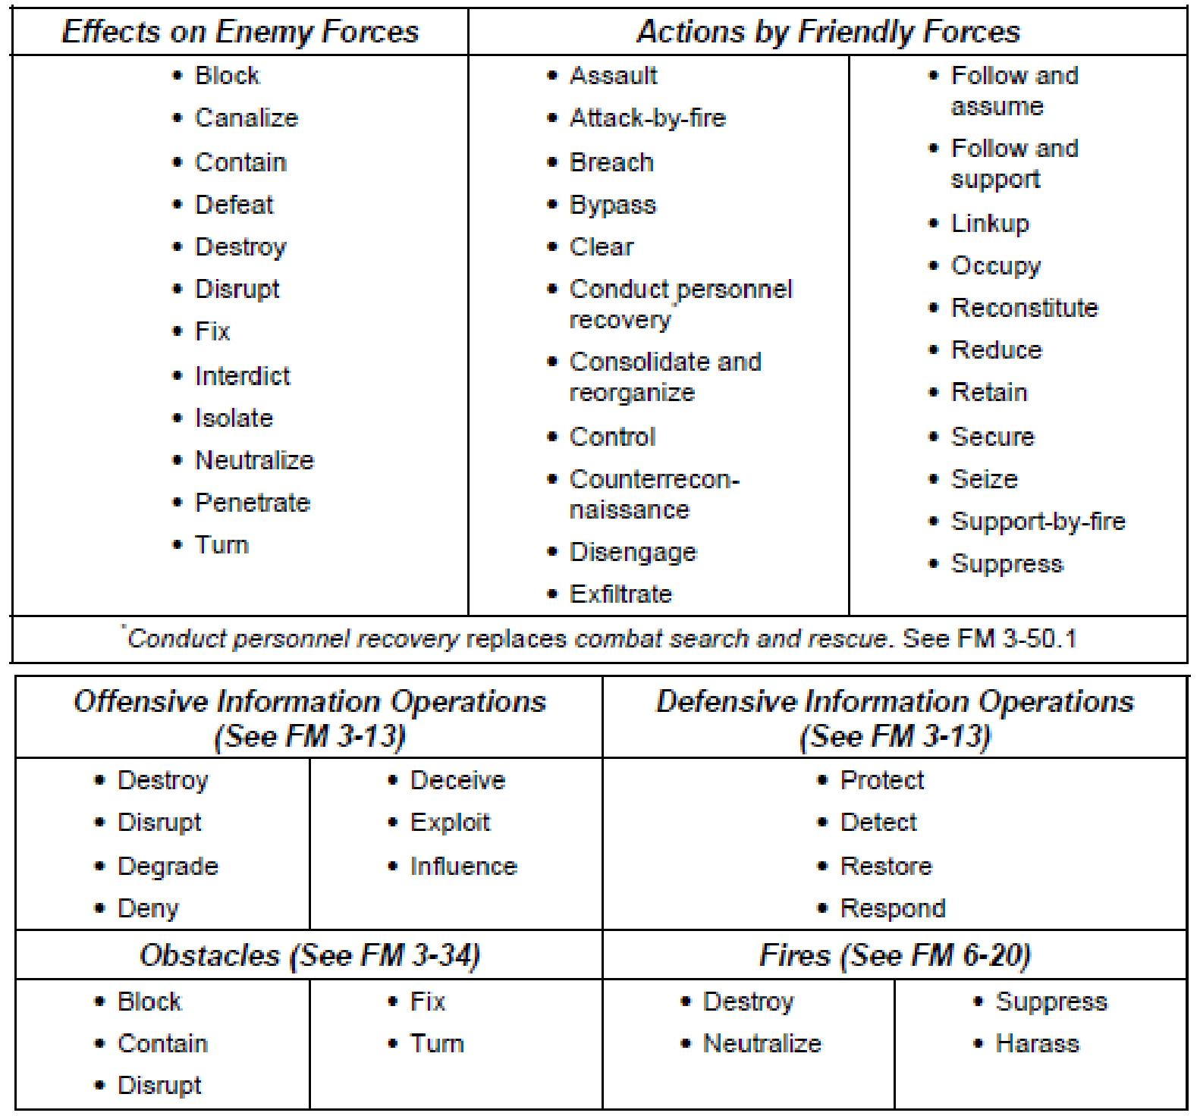

Plans Battle Board

|  |  |  |  |  |  |  |  |  |  |  |  |  |  |  |  |  |  |  |  |  |  |  |  |  |
| --- | --- | --- | --- | --- | --- | --- | --- | --- | --- | --- | --- | --- | --- | --- | --- | --- | --- | --- | --- | --- | --- | --- | --- | --- |
|  | |  | **PLANS MAPBOARD SETUP** | | | | | | | | | | | | | | | | | | | | |  |
|  | |  |  | | |  |  |  |  |  |  |  |  | | | | | | | | |  | |  |
|  | |  |  | | |  |  |  |  |  |  |  |  | | | | | | | | |  | |  |
| **STICKIES (RED,** | |  |  | | |  |  |  |  |  |  |  |  | | | | | | | | |  | |  |
| **BLUE, GREEN,** | |  |  | | |  |  |  |  |  |  |  |  | | | | | | | | | **CLEARANCE** | | |
| **YELLOW /** | |  |  | | |  |  |  |  |  |  |  |  | | | | | | | | | **OF FIRES** | | |
| **ORANGE** | |  |  | | |  |  |  |  |  |  |  |  | | | | | | | | | **PADDLE** | | |
|  | |  |  | | |  |  |  |  |  |  |  |  | | | | | | | | |  | |  |
|  | |  |  | | |  |  |  |  |  |  |  |  | | | | | | | | |  | |  |
|  | |  |  | | |  |  |  |  |  |  |  |  | | | | | | | | |  | |  |
|  | **DIV MISSION** | | |  | **DIV INTENT** | |  | | |  |  | | | | | | | | |  |  |  |  |  |  |  |  |  | **PIR** | | |  |
|  |  |  | | |  |  | | | | | | | | |  |  |  |  |  |  |  |  |  |  |
|  |  |  |  |  |  | |  | | |  |  | | | | | | | | |  |  |  |  |  |  |  |  |  |  |
|  |  |  |  |  |  | |  | | |  |  | | | | | | | | |  |  |  |  |  |  |  |  |  |  | | |  |
|  |  |  |  |  |  | |  | | |  |  | | | | | | | | |  |  |  |  |  |  |  |  |  |  | | |  |
|  | **BCT MISSION** | | |  | **BCT INTENT** | |  | | |  |  | | | | | | | | |  |  |  |  |  |  |  |  |  | **DSM 1** | | |  |
|  |  |  |  |  |  | |  | | |  |  | | | | | | | | |  |  |  |  |  |  |  |  |  |  |
|  |  |  |  |  |  | |  | | |  | **MAP AND OVERLAYS** | | | | | | | | | | | | | | | |  |  |  | | |  |
|  | **TF MISSION** | |  |  | **TF INTENT** | |  | | |  |  |  |  | | |  |
|  |  |  |  | | |  |  |  |  | | |  |
|  |  |  |  | | |  |  |  | **DSM 2** | | |  |
|  |  |  |  | | |  |  | | | | | | | | |  |  |  |  |  |  |  |  |  |  |
|  |  |  |  |  |  | |  | | |  |  | | | | | | | | |  |  |  |  |  |  |  |  |  |  |
|  |  |  |  |  |  | |  | | |  |  | | | | | | | | |  |  |  |  |  |  |  |  |  |  | | |  |
|  | **TF TASK ORG** | | |  | **NESTING** | |  | | |  |  | | | | | | | | |  |  |  |  |  |  |  |  |  |  | | |  |
|  |  |  | | |  |  | | | | | | | | |  |  |  |  |  |  |  |  |  |  | | |  |
|  |  | **DIAGRAM** | |  | | |  |  | | | | | | | | |  |  |  |  |  |  |  |  |  | **DSM 3** | | |  |
|  |  |  |  |  |  | | |  |  | | | | | | | | |  |  |  |  |  |  |  |  |  |  |
|  |  |  |  |  |  | |  | | |  |  | | | | | | | | |  |  |  |  |  |  |  |  |  |  | | |  |
|  |  |  | |  |  | |  | | |  |  | | | | | | | | |  |  |  |  |  |  |  |  |  |  | | |  |
|  | **NAMING** |  | |  |  | |  | | |  | **AO/ AI** | | | | | | | | |  |  |  |  |  |  |  |  |  |  | | |  |
|  | **CONVEN-** |  | |  |  | |  | | |  |  |  |  |  | |  |  | |  |  | | |  |
|  | **TIONS** |  | |  |  | |  | | |  |  | | | | | | | | |  |  |  |  |  |  |  |  |  |  | | |  |
|  |  |  |  |  |  | |  | | |  |  | | | | | | | | |  |  |  |  |  |  |  |  |  |  | | |  |
|  |  |  |  |  |  | |  | | |  |  | | | | | | | | |  |  |  |  |  |  |  |  |  |  | | |  |

|  |  |  |  |  |  |  |
| --- | --- | --- | --- | --- | --- | --- |
|  |  |  |  | **OVERLAY HOLDER** |  |  |
|  | **HINGE** |  |  |  |  |
|  |  |  |  |  |  |
|  |  |  | **OFFICE SUPPLIES:** | | |  |
| **ELECTRONIC EQUIPMENT:** | | |  |
| •Surge protector x 1 | | | •Printer paper (2 x reams) | | |  |
| •Extension cord x 1 | | | •Alcohol pens- red, blue, green, brown, correction pen | | |  |
| •Planner‟s laptop with working battery | | | (S,F,M,B) x 10 each | | |  |
| •Printer, PROXIMA and bag | | | •Stapler and staples | | |  |
| **BOARDS AND CHARTS**: | | | •Yellow note stickies (x 3 pads) | | |  |
| •Plans map board with laminated map sheets | | | •Writeable CDs (x 5) | | |  |
| •Butcher block paper and easel | | | •Supply box | | |  |
| •Dry erase board | | | •Butcher block markers | | |  |
| •100mph tape (2 rolls) | | | •Overlay sheets (1 x box of 8 ½‟‟ x 11‟‟) | | |  |
| •550 cord (1 spool) | | | •Document protectors (1 x box) | | |  |
|  |  |  | •Highlighters | | |  |
|  |  |  | •3x5 cards (1 x package) | | |  |
|  |  |  | •5x8 cards (x 5) | | |  |
|  |  |  | •Alligator clips (4 boxes) | | |  |
|  |  |  | •3 hole punch | | |  |

|  |  |
| --- | --- |
| ***ENEMY*** | |
| ***INTEL*** | ***OBSERVED*** |
|  | ***NAIs*** |
| ***DECISION*** | ***POINTS*** |

|  |
| --- |
| ***MANEUVER*** |

|  |
| --- |
| ***FIRES*** |

|  |
| --- |
| ***COMMAND AND CONTROL PROTECTION SUSTAINMENT*** |

|  |  |  |  |  |  |  |  |  |  |  |  |
| --- | --- | --- | --- | --- | --- | --- | --- | --- | --- | --- | --- |
| **PHASE** | |  | **PHASE I** |  |  | **PHASE II** |  |  | **PHASE III** |  |  |
| **/** | | **ACTION** | **REACTION** | **COUNTER** | **ACTION** | **REACTION** | **COUNTER** | **ACTION** | **REACTION** | **COUNTER** |  |
|  |  |  |
| **EVENT** | | **ACTION** | **ACTION** | **ACTION** |  |
|  |  |  |  |  |  |  |
|  |  |  |  |  |  |  |  |  |
| **TIME** | |  |  |  |  |  |  |  |  |  |  |
|  | **INTEL** |  |  |  |  |  |  |  |  |  |  |
|  |  |  |  |  |  |  |  |  |  |  |  |
|  | **FIRES** |  |  |  |  |  |  |  |  |  |  |
|  |  |  |  |  |  |  |  |  |  |  |  |
|  | **MANEUVER** |  |  |  |  |  |  |  |  |  |  |
|  | **SCOUTS** |  |  |  |  |  |  |  |  |  |  |
|  |  |  |  |  |  |  |  |  |  |  |
|  |  |  |  |  |  |  |  |  |  |  |  |
|  | **RAVEN** |  |  |  |  |  |  |  |  |  |  |
|  |  |  |  |  |  |  |  |  |  |  |  |
|  | **SHADOW** |  |  |  |  |  |  |  |  |  |  |
|  |  |  |  |  |  |  |  |  |  |  |  |

**SQDN**

**CONCEPT**

**A**

**B**

**C**

**D**

**MORTARS**

**FA**

**CCA**

**CAS**

**CLASS III**

**CLASS V**

**FAS / MAS**

**RECOVERY**

**ENGINEERS**

**RISK**

**TOC**

**TAC**

**CTCP**

**RTNS 1**

**RTNS 2**

Reverse Planning Cheat Sheet

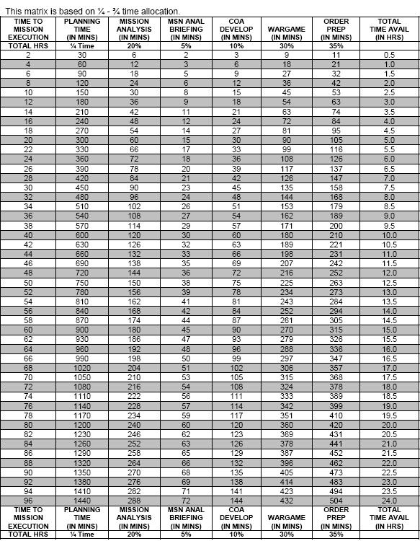

Terrain Model Kit Packing List

OFFICE SUPPLIES: Printer paper (2 x reams)

Alcohol pens- red, blue, green, brown, correction pen (S,F,M,B) x 10 each Stapler and staples

Yellow note stickies (x 3 pads) Writeable CDs (x 5)

Supply box

Butcher block markers

Overlay sheets (1 x box of 8 ½‟‟ x 11‟‟) Document protectors (1 x box) Highlighters

3x5 cards (1 x package)

5x8 cards (x 5) Alligator clips (4 boxes) 3 hole punch

**MILITARY SUPPLIES**:Military stencils

Field tables (x 2)

Flashlight with extra batteries

* 100 MPH tape (1 x roll)
* 550 cord (1 x spool)

**CLEANING SUPPLIES**:

* Broom
* Trash bags (1 x box of large brown / black)

Little green Army men & associated vehicles

**Targeting Process**

Targeting is broken up into three phases based upon our cycle. The briefs associated with each Phase are the Pre-Targeting, Targeting, and Targeting Decision Brief. Each brief builds off of the previous with key outputs and inputs associated with each as well as redundant information between briefs to maintain continuity.

**PRE-TARGETING and Pre-Targeting**

**Meeting (PTM)**

The pre-targeting meeting is the initial targeting meeting and includes the base info for LOEs and targets, both lethal and non-lethal effects. The Agenda is:

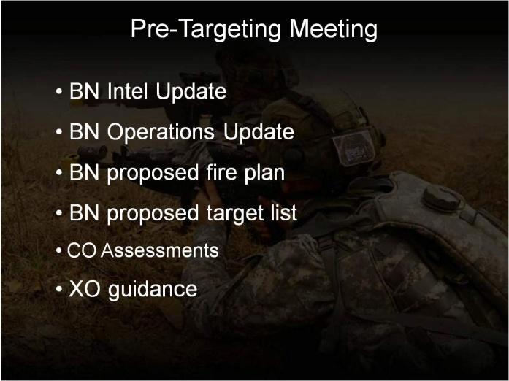

* SQDN Intel Update
* Operational Update
* Proposed Fire Plan
* SQDN Proposed Target List
* Company AO Assessments
* Guidance from the SQDN XO

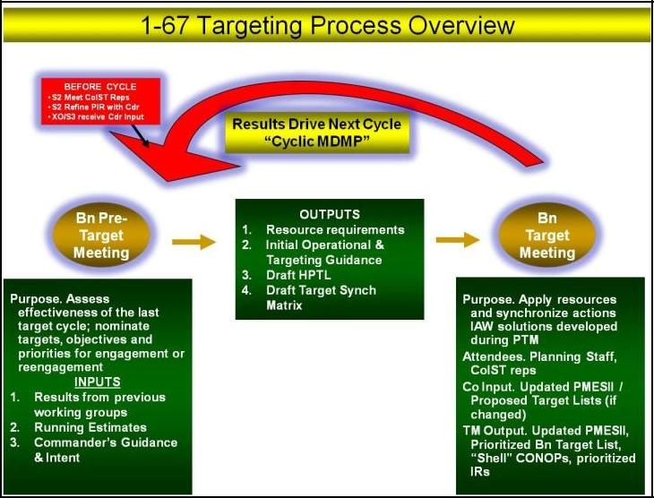

Key inputs are :

* Results from previous working groups
* Running Estimates
* Commander’s Guidance & Intent

Key Outputs are:

* Resource requirements
* Initial Operational & Targeting Guidance
* Draft HPTL
* Draft Target Synch Matrix

**Pre-Targeting and PTM**

The meeting begins with viewing the SQDN LOEs and the events after last cycle‟s meeting. The S2 has a separate slide deck that is imported into the base presentation at the “S2 Slides cue”. His information begins with the weather and flows thru density and frequencies of SIGACTs, CARVER Targets, and estimated ISR assets available.

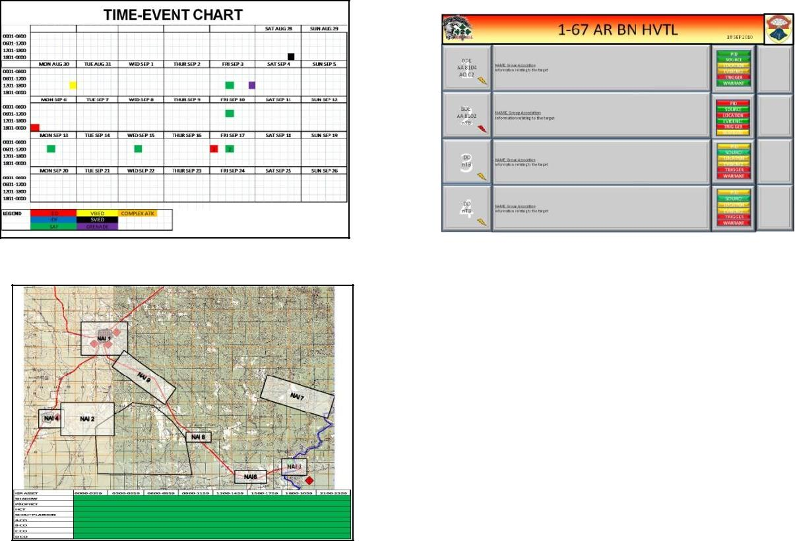

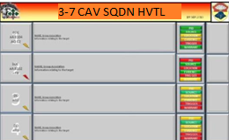

Fires, both lethal and non-lethal effects, S4, S1 and Companies each brief in that order. At the end of the brief, the proposed Targets are reviewed along with guidance from the SQDN Executive Officer. The Outputs are taken and factored into the Targeting Meeting, with full staff attendance.

**Targeting Meeting**

The Targeting Meeting is arranged in the same way as the PTM, with the LOEs up front. However, the next and last are a 24 hr interval, instead of „since the last cycle‟. The S2 slide deck has some of the same slides depicting timeframes of attacks by type. The S2 also presents CONOPs for nomination to the SQDN Target priorities. These CONOPs are created from information presented at the PTM.

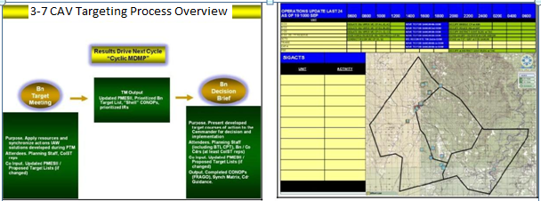

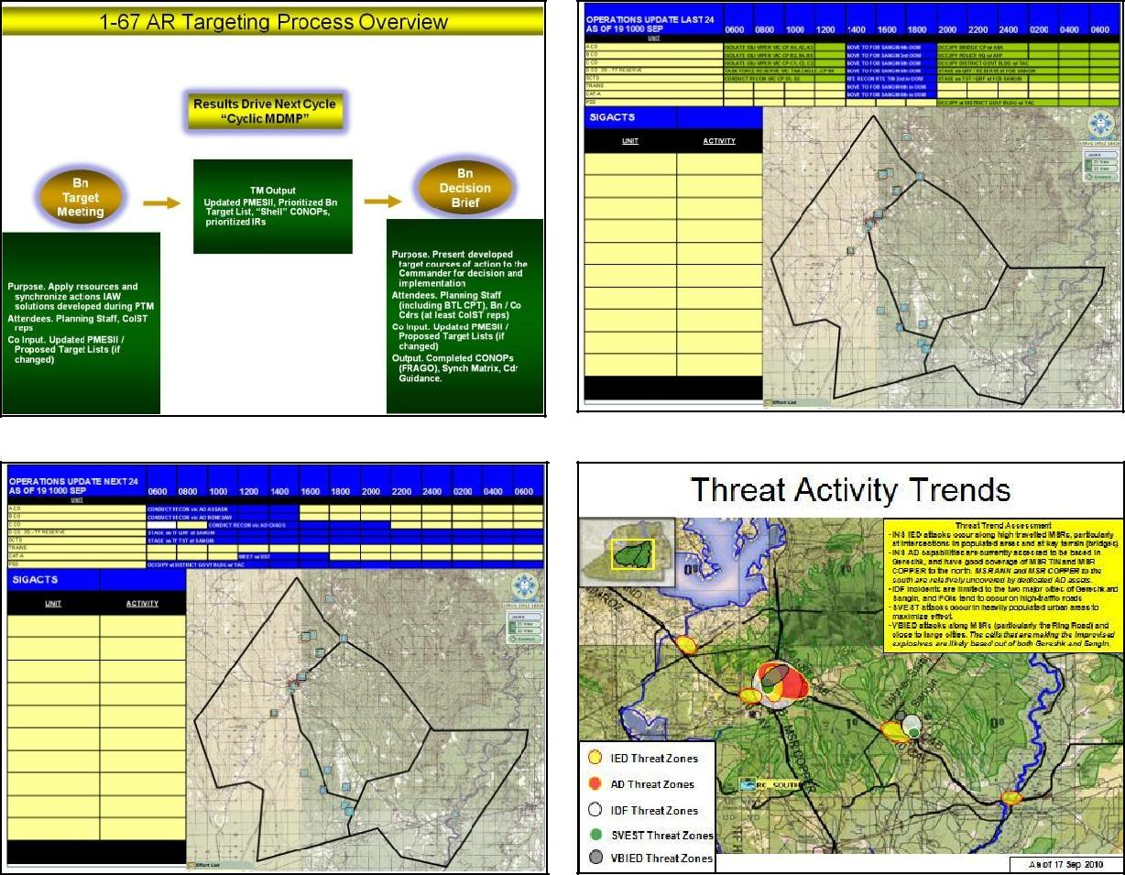

|  |  |  |  |  |  |  |  |  |  |  |  |  |  |  |  |  |  |  |  |  |
| --- | --- | --- | --- | --- | --- | --- | --- | --- | --- | --- | --- | --- | --- | --- | --- | --- | --- | --- | --- | --- |
|  |  |  |  |  |  |  |  |  |  |  |  |  |  |  |  |  |  |  |  |  |
|  | **Emerging Target: Chechen Foreign Fighters** | | | | | | | | |  |  |  |  |  |  |  |  |  |  |  |
|  |  |  | **APPROVAL AUTHORITY IAW DAAM** | | | | | | |  |  |  |  |  |  |  |  |  |  |  |
|  |  |  |  |  |  |  |  |  |  |  |  |  |  |  |  |  |  |  |  |  |
|  |  |  |  | (Notification to RC-S) | | | |  |  |  |  |  |  |  |  |  |  |  |  |  |
|  |  |  |  | **OE & QRF INFORMATION:** | | | | | |  |  |  | **CONCEPT OF THE OPERATION** | | | | |  |  |  |
|  |  |  |  |  |  |  |  |  |  |  |  |  |  |  |
|  | Is this a PIC Province?/ If so Which One: | | | | |  |  | Gereshk | |  |  | This operation takes place in four places: PH1 link up with ANSF and rehearsals , PH 2 | | | | | | |  |  |
|  |  |  |  |  | movement to site, PH3 KIL/capture of Individuals and SSE/TSE, PH 4 retrograde to FOB | | | | | | |  |  |
|  | Method and DTG of contacting the GOV: | | | | |  |  |  |  |  |  | Sangin. | | | | | |  |  |  |
|  |  |  |  |  |  |  |  |  |  |  |  | Key Task: | | | | | |  |  |  |
|  | QRF Unit:: (PLT/CO/SQDN/BCT) | | | |  |  |  | 3/D/1-67 | |  |  | conduct KILL/capture operations IVO SANGIN **(**15RVQ28321378) IOT deny enemy suicide attacks on | | | | | | |  |  |
|  | QRF Composition: (#Pax/#Vehicles) | | | |  |  |  | 6xM1114 | |  |  | civilian and U.S. Military Personnel. | | | | | |  |  |  |
|  |  |  |  |  |  | ISR assets will be deployed to the location of the house prior to the operation IOT observe | | | | | | |  |  |
|  | QRF Location/Reaction Time: | | | |  |  |  | FOB Sangin 10Min | | |  | behaviors and trends of personnel with in the vicinity. | | | | | |  |  |  |
|  | QRF POC, C/S, FREQ, SVOIP: | | | |  |  |  | Dog 31, F533 | |  |  | Once confirmation has been made that Chechen Foreign Fighters are at that location _ | | | | | | |  |  |
|  |  |  |  |  |  | Company will deploy IOT conduct KILL/ capture operation. | | | | | |  |  |  |
|  |  |  |  | **TASK ORGANIZATION:** | | | |  |  |  |  | Detained personnel will be turned over the ANP. | | | | | |  |  |  |
|  | # US PAX: |  | 0 | # AFGH PAX: | |  | 0 | # AUP PAX: | |  | 0 | **Timeline** | | | | | | Risk Assessment: |  |  |
|  |  |  |  | 21 September link up with ANSF | | | | | | High |  |  |
|  |  |  |  |  |  |  |  |  |  |  |  |  |  |
|  |  |  |  |  |  |  |  |  |  |  |  | 22 TDB September Mission Execution | | | | | |  |  |  |
|  | # US UAH: |  | 0 | # AFGH |  |  | 0 | # AUP UAH: | |  | 0 |  |  |  |  |  |  |  |  |  |
|  |  | UAH: |  |  |  |  |  |  |  |  |  |  |  |  |
|  |  |  |  |  |  |  |  |  |  |  |  |  |  |  |  |  |  |  |  |
|  | # US MRAP: |  | 0 | #AFGH NTV: | |  | 0 | # AUP NTV: | |  | 0 |  |  |  |  |  |  |  |  |  |
|  | Total # |  | **0** |  |  |  |  |  |  |  |  |  |  |  |  |  |  |  |  |  |
|  | Vehicles |  |  |  |  |  |  |  |  |  |  |  |  |  |  |  |  |  |  |
|  |  |  |  |  |  |  |  |  |  |  |  |  |  |  |  |  |  |  |  |
|  | Other |  |  |  |  |  |  |  |  |  |  |  |  |  |  |  |  |  |  |  |
|  | Enablers: |  |  |  |  |  |  |  |  |  |  |  |  |  |  |  |  |  |  |  |
|  |  |  |  | **INTELLIGENCE** | | | |  |  |  |  |  |  |  |  |  |  |  |  |  |
|  | Sources have indicated Chechen Foreign Fighters have been seen IVO | | | | | | | | | |  |  |  |  |  |  |  |  |  |  |
|  | Sangin (15RVQ28321378). | | | |  |  |  |  |  |  |  |  |  |  |  |  |  |  |  |  |
|  |  | |  |  |  |  |  |  |  |  |  |  |  |  |  |  |  |  |  |  |
|  | Is there a Warrant Issued for the | | | | N/A | | **Issuing** | |  | N/A |  |  |  |  |  |  |  |  |  |  |
|  |  | Target? | |  | **Authority** | |  |  |  |  |  |  |  |  |  |  |  |
|  |  |  |  |  |  |  |  |  |  |  |  |  |  |  |  |  |
|  | Has the target/location been vetted against protected site and | | | | | | | |  | N/A |  |  |  |  |  |  |  |  |  |  |
|  |  |  | restricted target list? | | | |  |  |  |  |  |  |  |  |  |  |  |  |  |  |
|  | Is the decision to action the target based on a trigger? If so | | | | | | | |  | N/A |  |  |  |  |  |  |  |  |  |  |
|  |  |  | what is the trigger? | | | |  |  |  |  |  |  |  |  |  |  |  |  |  |
|  |  |  |  |  |  |  |  |  |  |  |  |  |  |  |  |  |
|  | **Political Impacts:** | | |  |  |  |  |  |  |  |  |  |  |  |  |  |  |  |  |  |
|  |  |  |  |  |  |  |  |  |  |  |  |  |  |  |  |  |  |  |  |  |
|  |  |  |  |  |  |  |  |  |  |  |  |  |  |  |  |  |  |  |  |  |

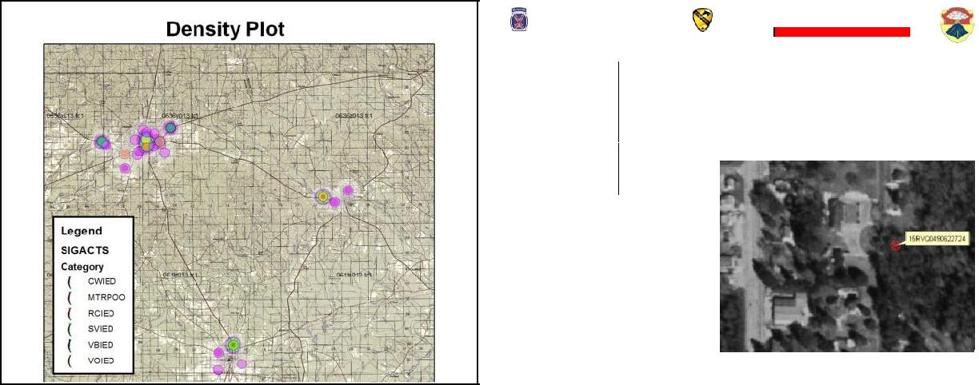

**Targeting Meeting**

The ISR plan is presented to show the proposed NAIs and ISR enablers for the CONOPs created. This plan is created by the S2 shop and vetted through the S2 and S3 Air prior to presentation.

|  |  |  |  |  |  |  |  |
| --- | --- | --- | --- | --- | --- | --- | --- |
|  | **PHASE 2 NAI SANGIN** | |  | **ISR:** |  |  |  |
|  |  | **PHASE 2 NAI Overview** |  |  |  |
|  |  |  |  |  |  |  |
| **Bibi Mahro** |  |  |  |  |  |  |  |
|  |  |  |  |  | **FOB SANGIN** |  |  |
| **CHECHEN** |  |  |  |  |  |  |  |
| **SAFE HOUSE** |  |  |  |  |  |  |  |
| **15RVQ28321378** |  |  |  |  |  |  |  |
|  |  |  |  | **SANGIN** |  |  |  |
|  | **NAI** |  | **NAI** | **MSR CATHY** | **MSR TIN** |  |  |
|  | **4422** | |  |  |  |  |
|  | **4439** |  |  |  |  |
|  |  |  |  | **NAI 4432** |  |  |
| **NAI** |  |  |  |  |  |  |
|  | **NAI 4425** |  |  |  |  |  |
| **4419** | **NAI** |  | **NAI 4436** |  |  |  |
|  | **NAI 4441** |  |  | **LOOKOUT** |  |  |
|  | **4424** |  |  | **TOWER** |  |  |
|  |  |  | **NAI 4435** |  |  |
|  |  |  | **FEYZABAD** |  |  |  |
|  |  |  |  | **NAI 4431** |  |  |  |
|  |  |  |  |  | **PUZAMANDA** | **NAI 4433** |  |
| **NAI 42230** |  | **SVIED Recruitment** |  | **PUMPING STATION** |  | **NAI 4434** |  |
|  |  |  |  |  |  |
|  |  | **SAFE HOUSE** |  |  |  |  |  |
|  |  | **15RVQ2811612521** |  |  |  |  |  |
|  |  |  |  |  |  | **QALA YEAZ** |  |
| **Deh Mazang** |  |  |  | **Rayan** |  |  |  |

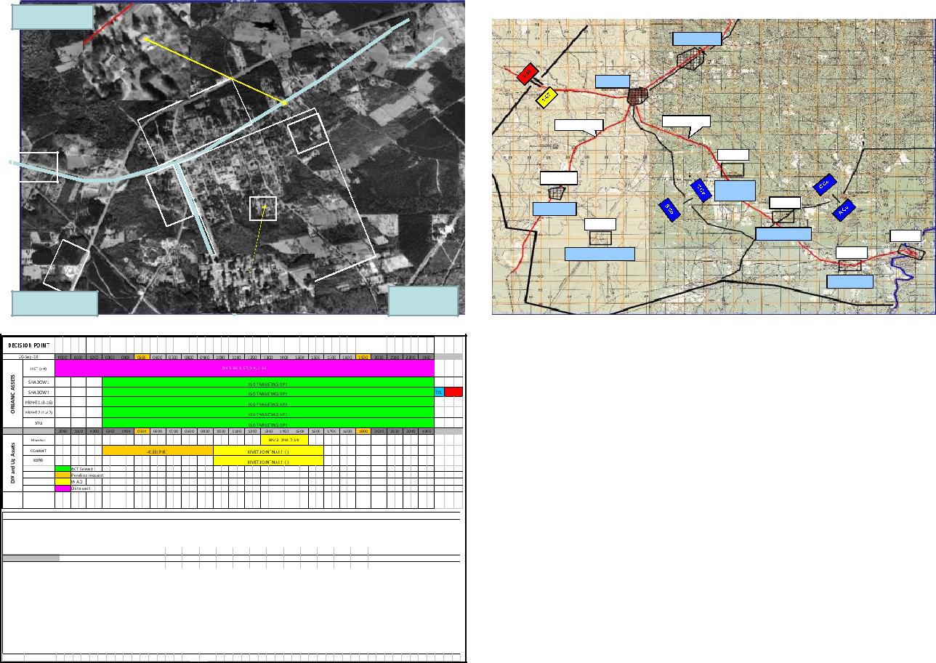

|  |
| --- |
| ***DIV and Up Assets ORGANIC ASS*** |

|  |  |  |  |  |  |  |  |  |  |  |  |  |  |  |  |  |  |  |  |  |  |  |  |  |  |  |
| --- | --- | --- | --- | --- | --- | --- | --- | --- | --- | --- | --- | --- | --- | --- | --- | --- | --- | --- | --- | --- | --- | --- | --- | --- | --- | --- |
| 21-Sep-10 | | 0000 | 0100 | 0200 | 0300 | 0400 | | 0500 | 0600 | 0700 | 0800 | 0900 | 1000 | 1100 | 1200 | 1300 | 1400 | 1500 | 1600 | 1700 | 1800 | 1900 | 2000 | 2100 | 2200 | 2300 |
|  |  |  |  |  |  |  |  |  |  |  |  |  |  |  |  |  |  |  |  |  |  |  |  |  |  |  |
|  | HCT (x4) |  |  |  |  |  |  |  |  |  |  |  | DS 1-10, 1-67, 2-8, 3-16 | | | |  |  |  |  |  |  |  |  |  |  |
|  | SHADOW1 |  |  |  |  |  |  |  |  |  |  |  |  |  |  |  |  |  |  |  |  |  |  |  |  |  |
|  | SHADOW2 |  |  |  |  |  |  |  |  |  |  |  |  |  |  |  |  |  |  |  |  |  |  |  |  |  |
|  | PRPHT1 (3-16) |  |  |  |  |  |  |  |  |  |  |  |  |  |  |  |  |  |  |  |  |  |  |  |  |  |
|  | PRPHT2 (1-67) |  |  |  |  |  |  |  |  |  |  |  |  |  |  |  |  |  |  |  |  |  |  |  |  |  |
|  |  | 0000 | 0100 | 0200 | 0300 | 0400 | | 0500 | 0600 | 0700 | 0800 | 0900 | 1000 | 1100 | 1200 | 1300 | 1400 | 1500 | 1600 | 1700 | 1800 | 1900 | 2000 | 2100 | 2200 | 2300 |
|  | AWT1 |  |  |  |  |  |  |  |  |  |  |  |  |  |  |  |  |  |  |  |  |  |  |  |  |  |
|  | SWT1 |  |  |  |  |  |  |  |  |  |  |  |  |  |  |  |  |  |  |  |  |  |  |  |  |  |
|  | CAS |  |  |  |  |  |  |  |  |  |  |  |  |  |  |  |  |  |  |  |  |  |  |  |  |  |
|  | Hunter |  |  |  |  |  |  |  |  |  |  |  |  |  |  |  | DIV 1, 2 (PIR 7-14) | |  |  |  |  |  |  |  |  |
|  | FMV |  |  |  |  |  |  |  |  |  |  |  |  |  |  |  |  |  |  |  |  |  |  |  |  |  |
|  | COMINT |  | GUARDRAIL NAI 2 (PIR 7- | | | |  |  |  |  |  |  |  |  | RIVET JOINT NAI 2 ( ) | | |  |  |  | GUARDRAIL NAI 2 (PIR | | |  |  |  |
|  | ELINT |  |  |  |  |  |  |  |  |  |  |  |  |  | RIVET JOINT NAI 2 ( ) | | |  |  |  |  |  |  |  |  |  |
|  | MASINT |  |  |  |  |  |  |  |  |  |  |  |  |  |  |  |  | JSTARS NAI 1, 2 () | | |  |  |  |  |  |  |
|  | IMINT |  |  |  |  |  |  |  |  |  |  |  |  |  |  |  |  | JSTARS NAI 1, 2 () | | |  |  |  |  |  |  |
|  |  |  | BCT Tasked | |  |  |  |  |  |  |  |  |  |  |  |  |  |  |  |  |  |  |  |  |  |  |
|  |  |  | Pending request | |  |  |  |  |  |  |  |  |  |  |  |  |  |  |  |  |  |  |  |  |  |  |
|  |  |  | IN AO |  |  |  |  |  |  |  |  |  |  |  |  |  |  |  |  |  |  |  |  |  |  |  |
|  |  |  | DS to unit | |  |  |  |  |  |  |  |  |  |  |  |  |  |  |  |  |  |  |  |  |  |  |
|  |  |  |  |  |  |  |  |  |  |  |  |  |  |  |  |  |  |  |  |  |  |  |  |  |  |  |

Fires section will produce a deck with information, both lethal and non-lethal effects, on the personnel being targeted as well as major problem sets as defined by the SQDN CDR.

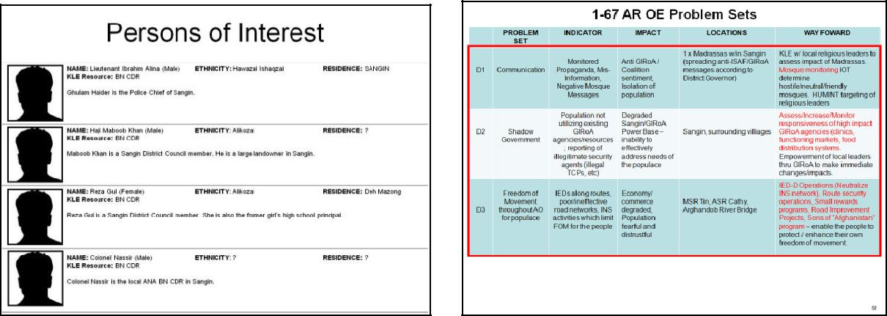

**Targeting Meeting**

The SQDN ENG creates and updates the route statuses of ASR/MSR usage. A tracker of Route Clearance Packages will also be presented for visibility on route clearance frequency.

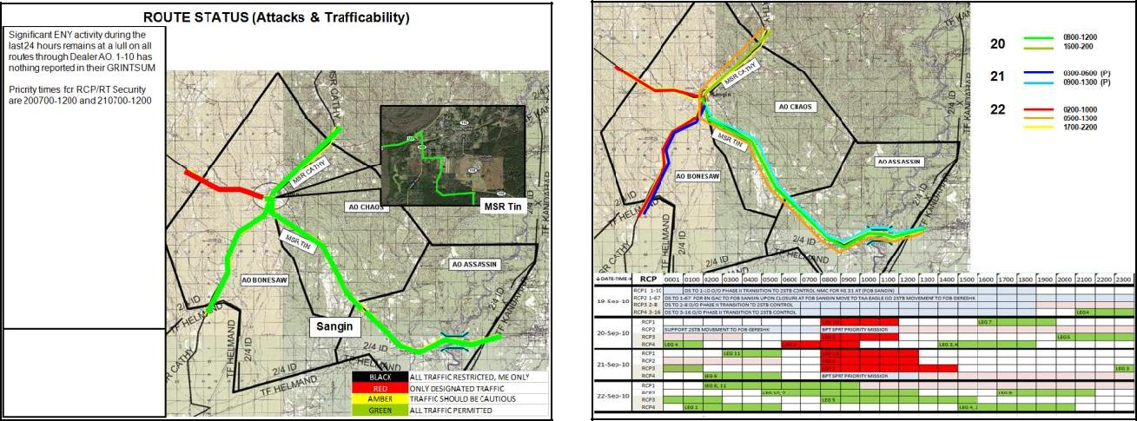

The S4 section includes information about the local District Support Team projects and the status on SQDN level contracts.

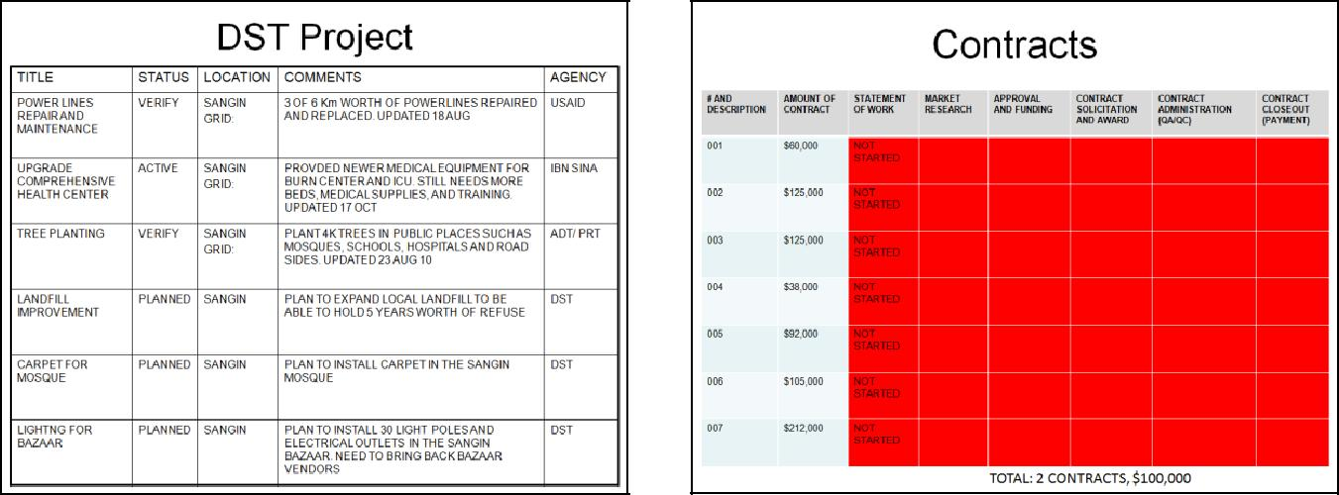

The Targeting meeting ends with the proposed targets, thru S2 and Fires collaboration, presented to the SQDN CDR. The CDR then assigns targets for each company based upon his own criteria.

**Targeting Decision Meeting**

The Targeting Decision Meeting opens with a review of the targeting period as well as the Operating Environment Problem sets from the targeting meeting. The 30 day campaign plan is reviewed for reference and status updates to the SQDN. The last 48 Hours of SIGACTs are also reviewed for situational awareness.

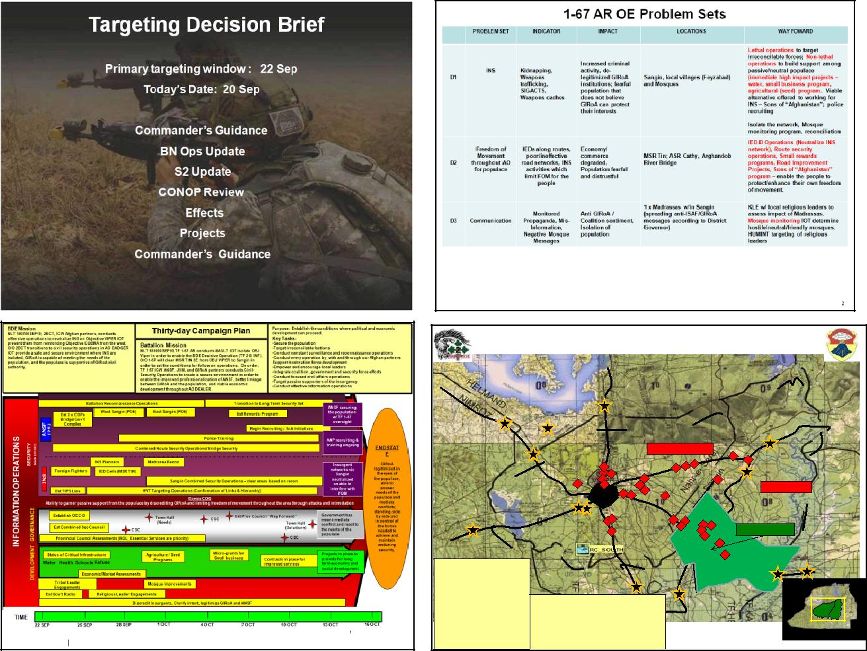

RECENT ACTIVITIES as of 191300SEP10

**1**

**3**

1. **MSR TIN (Ring Road)**
2. **MSR COPPER**
3. **MSR ANN**
4. **MSR CATHY**
5. **Kajaki Dam**
6. **Arghandab River Bridge**
7. **Helmand River Bridge**
8. **Gereshk Airfield**
9. **Lashkar Gah (Prov Capital)**
10. **Agro Co-op**
11. **Sangin Airfield**
12. **Lashkar Gah Airfield**

|  |  |  |  |  |  |  |  |  |  |
| --- | --- | --- | --- | --- | --- | --- | --- | --- | --- |
|  |  | **2** |  |  |  |  |  |  |  |
|  | **5** |  |  |  |  |  |  |  |  |
|  |  |  |  | **Nahr-e Saraj District** | | | **3** |  |  |
|  |  |  |  |  |  |  |
| **7** |  |  |  |  |  |  | **SAF** |  |  |
|  |  |  |  |  |  |  | **VBIED** |  |  |
|  |  | **IDF** |  |  | **IDF** | **IDF** |  |  |  |
|  |  |  | **IED** |  |  |  |  |
|  |  | **IED IDF** |  |  |  |  | **4** |  |  |
|  |  | **SAF** |  | **IDF** |  |  | **SAF** |  |  |
|  | **IDF** | **DF** | **IDF** |  |  |  | **Sangin District** |  |  |
|  |  | **OBJ** |  | **IDF** |  |  |  |  |
|  |  | **VBIEDIED** |  |  |  |  |  |
|  |  | **POO** |  |  |  |  |  |
|  |  | **VIPER** |  |  |  |  |  |  |  |
|  | **10** | **8** |  |  |  |  |  |  |  |
|  |  | **IEDIDF** |  | **POI** | **IDF** |  |  |  |  |
|  |  |  |  |  | **POIIDF** | **IDF** | **SAF** |  |  |
|  |  | **SAF** |  |  |  | **IDF** | **AO Dealer** |  |  |
|  |  |  |  |  |  | **IED** |  |  |  |
|  |  |  |  |  |  |  | **VBIED** |  |  |
|  |  |  |  |  |  |  | **VBIED** |  |  |
|  |  |  |  |  |  |  | **6** | **1** |  |
|  |  |  |  |  |  |  |  |  |
|  |  |  | **2** |  |  |  |  |  |  |
|  |  |  |  | **4** | |  |  |  |  |
| **TOTAL ENEMY BDA SINCE START OF OPERATIONS** | | | | |  |  |  |  |  |
| **1.** | **Mortar Systems** |  | **3** |  |  |  |  |  |  |
| **2.** | **MANPADS** |  | **3** |  |  |  |  |  |  |
| **3.** | **VBIEDs** |  | **6** |  |  |  |  |  |  |
| **4.** | **IEDs** |  | **3** |  |  |  |  |  |  |
| **5.** | **Anti-Tank Systems** | | **No Info** |  |  |  |  |  |  |
| **6.** | **Direct Action Teams-** | | **11** |  |  |  |  |  |  |

**Targeting Decision Meeting Cont.**

The SQDN Target Priorities are reviewed. This starts the CONOP review process. Each company is required to submit their CONOP for the target assigned from the Targeting Meeting for review to the SQDN CDR.



3-7 CAV Target Priority

|  |  |  |  |  |  |
| --- | --- | --- | --- | --- | --- |
| **Priority** | **TGT** | **Task** | **STATUS** | **Remarks** |  |
|  |  |
|  |  |  |  |  |  |
|  |  |  |  | Attending a meeting on |  |
|  | **Sayid** |  | Actionable | 20100920 from 1300- |  |
|  |  | 1700. Sayid will travel with |  |
| **1** | C Co Sangin VQ 23692 17372 | Kill/capture | **20 1300 SEP10 (GT)** |  |
| at least 4x PAX, possibly |  |
|  |  |  | **22 1200 SEP 10 (RT)** |  |
|  |  |  | in a Toyota Hilux and/or a |  |
|  |  |  |  |  |
|  |  |  |  | Mitsubishi Pajero |  |
|  |  |  |  |  |  |
|  |  |  | 2x KLEs completed; | Enhance and build vertical |  |
| **2** | **Gaul Mohammed** | KLE | governance links between |  |
| ongoing |  |
|  |  |  | Province, District, and City |  |
|  |  |  |  |  |
|  |  |  |  | Arriving at location after |  |
|  |  |  | Actionable | evening prayers on |  |
|  | **Safehouse Operatives** |  | 20100919 RON until 0900 |  |
| **3** | Kill/Capture | **19 2200 SEP10 (GT)** |  |
| C Co Sangin VQ 28116 12521 | 20100920; possible |  |
|  |  | **21 1200 SEP10 (RT)** |  |
|  |  |  | kidnapped victims at |  |
|  |  |  |  |  |
|  |  |  |  | location |  |
|  |  |  | Gathering Intel, need |  |  |
| **4** | **Warehouse** | Kill/capture cell | grid | Possible VBIED for TAA |  |
| B Co Feyzabad VQ 22560 04595 | members | **20 0001 SEP10 (GT)** | Eagle |  |
|  |  |
|  |  |  | **21 1000 SEP10 (RT)** |  |  |
|  |  |  |  | Small Rewards program |  |
|  |  | Issue small rewards |  | valid for persons giving |  |
|  |  | Developing small | info leading to detection of |  |
| **5** | **Local Populace** | program info to key |  |
| rewards program | an IED or weapons cache |  |
|  |  | leaders in AO Dealer |  |
|  |  |  | or kill/capture of IED cell |  |
|  |  |  |  |  |
|  |  |  |  | member |  |

**Targeting Decision Meeting**

The CONOPs are presented by the CO CDR and shows any imagery, locations, known activities, and maneuver pertaining to that operation.

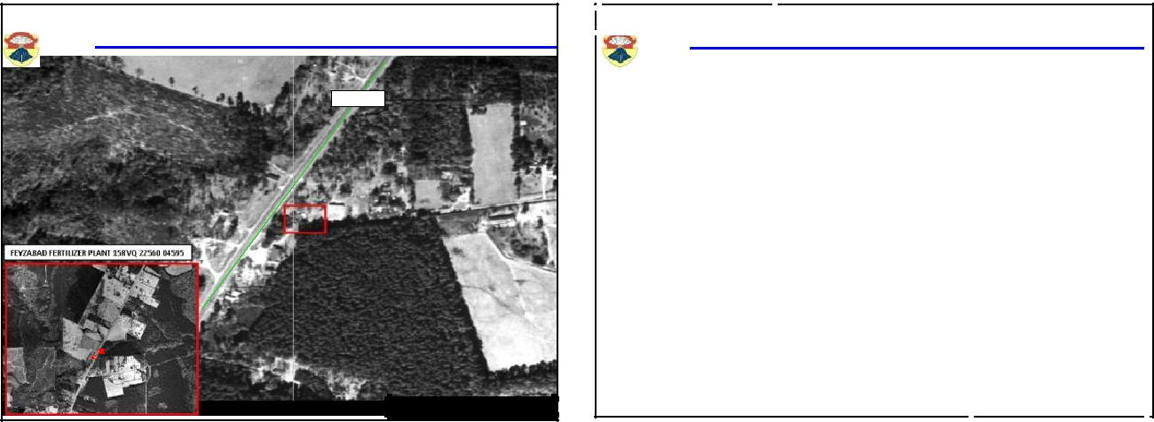

|  |  |  |
| --- | --- | --- |
| **LOCATION OF FERTILIZER PLANT** | **Feyzabad Fertilizer Plant TGT# 167003** |  |
|  |  |
| **MSR CATHY** |  |  |

**Feyzabad Fertilizer Plant TGT# 167003**

**ANALYST ASSESSMENT**

**The fertilizer plant in Gereshk was robbed in order to jump start operations within Sangin District. Feyzabad supports insurgent activity and is close to the districts major city Sangin.**

**Abdul and Hasib have brought in an IED maker to begin “mixing” the fertilizer. Abdul who is reported to hate Americans will use the IEDs against US forces operating in the Sangin district. It is assessed that Abdul and Hasib are associated with Omar who is primarily operating between Sangin and Gereshk. Hasib has made arrangements to bring half of the fertilizer to a new factory location in Gereshk.**

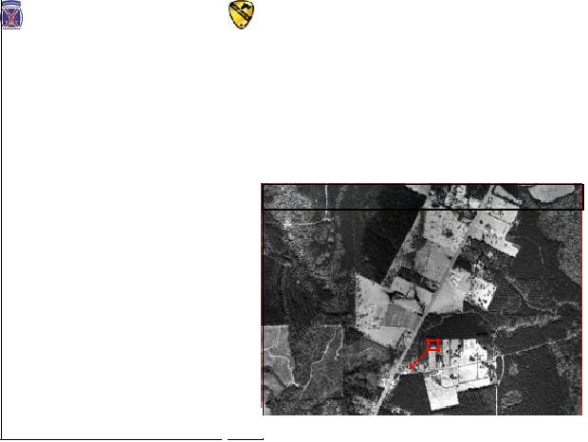

|  |  |  |  |  |  |  |  |  |  |  |  |  |  |  |  |  |  |  |  |
| --- | --- | --- | --- | --- | --- | --- | --- | --- | --- | --- | --- | --- | --- | --- | --- | --- | --- | --- | --- |
|  | **Emerging Target: FERTILIZER PLANT in FEYZABAD** | | | | | | | | | | |  |  |  |  |  |  |  |  |
|  |  |  | **APPROVAL AUTHORITY IAW DAAM** | | | | | | | |  |  | **Mission: 3/B/1-67 AR conducts a cordon and search, vic grid VQ 2256 04595 19** | | | | |  |  |
|  |  |  |  |  | **2200 SEP10 (game time), IOT kill or capture IED making cell personnel and to** | | | | |  |  |
|  |  |  |  | (Notification to RC-S) | | | | | | |  |  | **remove any IED materials found in our AO** | | | |  |  |  |
|  |  |  |  | **OE & QRF INFORMATION:** | | | | | | |  |  |  | **CONCEPT OF THE OPERATION** | | |  |  |  |
|  | Is this a PIC Province?/ If so Which One: | | | | |  |  |  | Gereshk | |  |  | Phase 1: Blue 1 will link-up with ANA at ANA CO headquarters 1hr. Prior to mission. Blue 1 will | | | | |  |  |
|  | Method and DTG of contacting the GOV: | | | | |  |  |  | Phone / Runner | |  |  | call LT Ibraham and coordinate for link-up at the Police Station. | | | |  |  |  |
|  |  |  |  |  |  |  |  |  |  |  |  |  | Phase 2: A/3/B SPs down MSR Kathy with AP B/3/B SPs down MSR Kathy 5 min later w/ ANA | | | | |  |  |
|  | QRF Unit:: (PLT/CO/SQDN/BCT) | | | |  |  |  |  |  |  |  |  | Phase 3: B/3/B establishes outer cordon with ANA | | | |  |  |  |
|  | QRF Composition: (#Pax/#Vehicles) | | | |  |  |  | 30/6 | | |  |  | Phase 4: A/3/B w/ AP conduct initial clearance of OBJ | | | |  |  |  |
|  |  |  |  |  |  | Phase 5: A/3/B conducts sensitive site exploitation | | | |  |  |  |
|  | QRF Location/Reaction Time: | | | |  |  |  | FOB Sangin / 25 min | | | |  | Phase 6: All elements and enablers exfil OBJ down MSR Kathy | | | |  |  |  |
|  | QRF POC, C/S, FREQ, SVOIP: | | | |  |  |  |  |  |  |  |  |  |  |  |  |  |  |  |
|  |  |  |  | **TASK ORGANIZATION:** | | | | | | |  |  | **Timeline:** |  |  |  | Risk Assessment: |  |  |
|  |  |  |  |  |  | **19** 2100 link-up w/ ANP | 19 2205 Begin Initial Search | | | High |  |  |
|  |  |  |  |  |  |  |  |  |  |  |  |  |  |  |
|  | # US PAX: |  | 40 | # AFGH PAX: | |  | 12 |  | # AUP PAX: | |  | 3 | 19 2130 SP | 19 2235 Sensitive Site Exploitation | | |  |  |  |
|  |  |  |  |  | 19 2200 Cordon set | 19 0100 Exfil (conditions dependant) | | |  |  |  |
|  |  |  |  | # AFGH |  |  |  |  |  |  |  |  |  |  |  |  |  |  |  |
|  | # US UAH: |  | 8 | UAH: |  |  | 0 |  | # AUP UAH: | |  | 0 | **FEYZABAD FERTILIZER PLANT 15RVQ 22560 04595** | | | | |  |  |
|  | # US MRAP: |  | 0 | #AFGH NTV: | |  | 2 |  | # AUP NTV: | |  | 1 |  |  |  |  |  |  |  |
|  |  |  |  |  |  |  |  |  |  |  |  |
|  | Total # |  | **11** |  |  |  |  |  |  |  |  |  |  |  |  |  |  |  |  |
|  | Vehicles |  |  |  |  |  |  |  |  |  |  |  |  |  |  |  |  |  |
|  |  |  |  |  |  |  |  |  |  |  |  |  |  |  |  |  |  |  |
|  | Other |  | **MWD T: ID explosives P: Confirm presence of IED cell** | | | | | | | | |  |  |  |  |  |  |  |  |
|  |  | **SWT T: track squirters P: prevent escape** | | | | | | | |  |  |  |  |  |  |  |  |  |
|  | Enablers: |  |  |  |  |  |  |  |  |  |  |
|  |  | **EOD T: Reduce IED material if found P: prevent use of HME** | | | | | | | | | |  |  |  |  |  |  |  |
|  |  |  |  |  |  |  |  |  |  |
|  |  |  |  | **INTELLIGENCE** | | | | | | |  |  |  |  |  |  |  |  |  |
|  |  | |  |  |  |  | |  |  |  |  | |  |  |  |  |  |  |  |
|  | **The fertilizer plant in Gereshk was robbed in order to jump start operations within** | | | | | | | | | | | |  |  |  |  |  |  |  |
|  | **Sangin District. Feyzabad supports insurgent activity and is close to the districts** | | | | | | | | | | | |  |  |  |  |  |  |  |
|  | **major city Sangin. Abdul and Hasib have brought in an IED maker to begin** | | | | | | | | | | |  |  |  |  |  |  |  |  |
|  | **“mixing” the fertilizer. Abdul who is reported to hate Americans will use the IEDs** | | | | | | | | | | | |  |  |  |  |  |  |  |
|  | **against US forces operating in the Sangin district. It is assessed that Abdul and** | | | | | | | | | | |  |  |  |  |  |  |  |  |
|  | **Hasib are associated with Omar who is primarily operating between Sangin and** | | | | | | | | | | | |  |  |  |  |  |  |  |
|  | **Gereshk. Hasib has made arrangements to bring half of the fertilizer to a new** | | | | | | | | | | |  |  |  |  |  |  |  |  |
|  | **factory location in Gereshk.** | | | |  |  |  |  |  |  |  |  |  |  |  |  |  |  |  |
|  | Is there a Warrant Issued for the | | | | N/A | |  | **Issuing** | |  | N/A |  |  |  |  |  |  |  |  |
|  |  | Target? | |  |  | **Authority** | |  |  |  |  |  |  |  |  |  |
|  |  |  |  |  |  |  |  |  |  |  |  |  |  |  |  |
|  | Has the target/location been vetted against protected site and | | | | | | | | |  | Yes |  |  |  |  |  |  |  |  |
|  |  |  | restricted target list? | | | |  |  |  |  |  |  |  |  |  |  |  |  |  |
|  | Is the decision to action the target based on a trigger? If so | | | | | | | | |  | No |  |  |  |  |  |  |  |  |
|  |  |  | what is the trigger? | | | |  |  |  |  |  |  |  |  |  |  |  |  |
|  |  |  |  |  |  |  |  |  |  |  |  |  |  |  |  |
|  |  |  |  |  |  |  |  |  |  |  |  |  |  |  |  |  |  |  |  |

**Political Impacts: None**

The ISR slides in the Targeting Meeting are once again displayed as a combined product showing what is available for each target area with revisions made to the NAIs presented at the Targeting Meeting. ROZ locations are also shown.

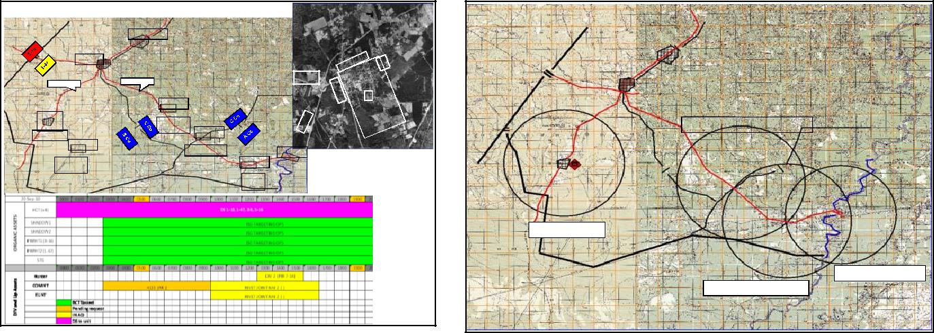

|  |  |  |  |  |  |  |  |  |  |  |  |  |  |  |  |  |  |  |  |  |  |  |  |  |  |
| --- | --- | --- | --- | --- | --- | --- | --- | --- | --- | --- | --- | --- | --- | --- | --- | --- | --- | --- | --- | --- | --- | --- | --- | --- | --- |
| **ISR: 20 SEP 10** | | | | | | | |  |  |  |  |  |  |  |  |  |  |  |  |  |  | **PROPOSED 1-67 ROZ LOCATIONS** | | |  |
|  |  |  |  |  |  |  |  |  |  |  |  |  |  |  |  |  |  |  |  |  |  |  |
|  |  |  |  |  |  |  |  |  |  |  | |  |  |  |  |  |  |  |  |  |  |  |  |  |  |
|  |  |  |  |  |  |  |  |  | **FOB SANGIN** | |  |  |  |  |  |  |  |  |  |  |  |  |  |  |  |
|  |  |  |  |  |  |  |  |  |  |  |  |  |  |  |  |  |  |  |  |  |  |  |  |
|  |  |  |  |  |  |  |  |  |  |  |  |  |  |  |  |  |  |  |  |  |  |  |  |  |  |
|  |  |  |  |  | **SANGIN** | | |  |  |  |  |  |  |  |  |  |  |  |  |  | **NAI** | | | |  |
|  |  |  |  |  |  |  |  |  |  |  |  |  |  |  |  |  |  |  | **NAI** | | **4439** |  |  |  |  |
|  |  |  |  |  |  |  |  |  |  |  |  |  |  |  |  |  |  |  | **NAI 4425** | | | |  |
|  |  |  |  |  |  |  |  | **MSR TIN4** | | | | | | **4419** | | | | | | |  |
|  |  | **MSR** | | | | | |  |  |  |  |  |  |  | **NAI** | | | |  |
|  |  | **CATHY** | | | | | |  |  |  |  |  |  |  |  |  |  |  |  |  | **4424** |  |  |  |  |
|  |  |  |  |  |  |  |  |  |  |  |  |  |  |  |  |  |  |  |  |  | **NAI 4441** | | | |  |
|  |  |  |  |  |  |  |  |  |  | **NAI 4432** | |  |  |  |  |  |  |  |  |  |  |  |  |  |  |
|  |  |  |  |  | |  |  |  |  |  |  |  |  |  |  |  |  |  |  |  |  |  |  |  |  |
|  |  |  | | | |  | |  |  |  |  |  |  |  |  |  |  |  |  |  |  |  |  |  |  |
|  | **NAI** | |  | | |  | |  |  |  |  |  |  |  |  |  |  |  |  |  |  |  |  |  |  |
|  | **4436** |  |  |  |  |  |  |  |  | **LOOKOUT** | |  | |  |  |  |  |  |  | **NAI** |  |  | **ROZ LOOKOUT** |  |  |
|  |  |  |  |  |  |  |  |  | **TOWER** | |  |  |  |  |  |  |  |  |  |  |  |  |
|  |  |  |  |  |  |  | **NAI 4435** |  |
|  | **FEYZABAD** | |  |  |  |  |  |  |  |  |  |  | **42230** | | | | | | |  |  |  |  |  |
|  |  |  | |  |  |  |  |  |  |  |  |  |  |  |  |  |  |  |  |  |  |  |  |
|  |  |  |  |  |  |  |  |  |  |  |  |  |  |  |  |  |  |  |  |  |  |  |  |  |  |
|  |  |  |  | **NAI 4431** | | |  |  |  |  |  |  |  |  |  |  |  |  |  |  |  |  |  |  |  |
|  |  |  |  |  |  |  |  |  |  |  |  | **PUZAMANDA** | |  |  |  |  |  | **NAI 4433** |  |  |  |  |  |  |
|  |  | **PUMPING** | | | |  |  |  |  |  |  |  |  |  |  | **NAI 4434** | |  |  |  |  |  |  |  |  |
|  |  |  | |  |  |  |  |  |  |  |  |  |  |  |  |  |  |  |  |
|  |  | **STATION** | | | |  | |  |  |  |  |  |  |  |  |  |  |  |  |  |  |  |  |  |  |
|  |  |  |  |  |  |  |  |  |  |  |  |  |  |  |  |  |  |  |
|  |  |  |  |  |  |  |  |  |  |  |  |  |  |  |  | **QALA** |  | | | |  |  |  |  |  |
|  |  |  |  |  |  |  |  |  |  |  |  |  |  |  |  | **YEAZ** |  | | | |  |  |  |  |  |
|  |  |  |  |  |  |  |  |  |  |  |  |  |  |  |  |  |  |  |  |  |  |  |  |  |  |

**Targeting Decision Meeting**

Fires once again covers the Key Leaders in the area and their Concept of IO for the targeting cycle. Lethal fire capabilities are reviewed as well as the Air assets available for the next 72 hours.

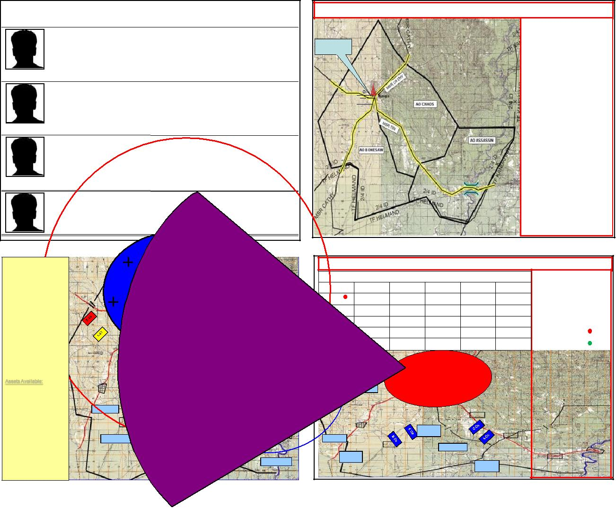

Key Leaders

CONCEPT OF IO

|  |  |  |
| --- | --- | --- |
| **NAME:** Gaul Mohammed (Male) | **ETHNICITY:** ? | **RESIDENCE:** ? |
| **KLE Resource:** SQDN CDR | **AO:** Bonesaw | **Position:** District Governor |

Talking Points: Establishing a JOC at government bldg; priority of developmental projects; INS recruitment of handicapped LNs; creating police training concept; establishing radio in a box at government JOC.

Reaction to KLE: Very receptive to ISAF being in Sangin and the JOC initiative with government and ANP; he wants to work with us as evidenced by him providing info on INS recruitment of handicapped and chechen fighters spreading anti-GIRoA/ISAF messages.

|  |  |  |
| --- | --- | --- |
| **NAME:** Lieutenant Ibrahim Alina (Male) | **ETHNICITY:** Hawazai Ishaqzai | **RESIDENCE:** ? |
| **KLE Resource:** B CO | **AO:** Bonesaw | **Position:** Sangin Police Chief |

Talking Points: Security plan for Sangin and partnership; establishing JOC at ANP station; recruitment of police (only 17 current officers), men won‟t join for fear their families will be harmed; AO is only about a 2x block radius from station

Reaction to KLE: Very receptive to establishing working relationship with ISAF; hesitant to establish JOC because of space constraint.

|  |  |  |
| --- | --- | --- |
| **NAME:** Mullah Naqib (Male) | **ETHNICITY**: Alikozai Dadozai | **RESIDENCE:** Deh Mazong |
| **KLE Resource:** SQDN CDR | **AO:** Bonesaw | **Position:** Alikozai religious leader |
| Talking Points: |  |  |
| Reaction to KLE: |  |  |
| **NAME:** Colonel Nassir (Male) | **ETHNICITY**: ? | **RESIDENCE:** ? |
| **KLE Resource:** SQDN CDR | **AO:** Bonesaw | **Position:** ANA SQDN CDR |
| Talking Points: |  |  |
| Reaction to KLE: |  |  |

RIAB

**MISO** 

**IO Key Tasks:**

T1: Develop specific talking points for KLEs with Gaul Mohammed

P1: IOT influence Gaul Mohammed and legitimize GIRoA

T2: Develop IO themes/messages for Radio in a Box

P2: IOT influence the local population to support GIRoA and alienate INS T3: BPT exploit positive events in AO and mitigate negative events in AO P3: IOT legitimize GIRoA and discredit INS

**TMT:**

T1: Conduct atmospherics

P1: IOT provide feedback necessary to generate IO themes/messages

T2: Distribute handbills that legitimize GIRoA and discredit INS

P2: IOT fracture link between population and INS and strengthen link between population and GIRoA

**TASK & Purpose:**

**CAS / EW / Attack Aviation Requests**

T1: Provide Suppressive Fires

P1: Allow for the seizure of key terrain and establish a foothold in AO

T2: Provide Counter-MTR/Rocket fires

P2: IOT neutralize enemy IDF

Planned Targets

* Historical POO Sites
* TGT(s) along Routes in and out of FOB SANGIN

Proposed Targets

Assets Available: 1x PLT M777

1x LCMR FOB Sangin

MTR Section Q-36/37

4 x 81mm & 120mm Mortars

MLRS in Division AO

**MSR**

**NAI 4436**

**FEYZABAD**

**22 SEPT 2010 (Bonesaw; Fertilizer Plant)**

|  |  |  |  |  |  |
| --- | --- | --- | --- | --- | --- |
| Type | On Station | Off Station | # Sorties | Load | Callsign |
| -10 | 2230; | Approx 2300 | X 2 |  |  |
|  | 22SEPT2010 |  |  |  |  |
|  |  | Approx 2230 | X 2 | 2.75mmRockets |  |
|  |  |  |  | .50 Cal |  |

**CATHY**

**NAI 4432**

**NAI**

|  |  |
| --- | --- |
| **4436** | **LOOKOUT** |

CAS and CCA

T: Provide PGM and Armed Support of full spectrum operations w/I AO

EW

T: Provide IED Pre Det and communication Jamming

Requested

Approved

CCA, CAS, FO/JFO

**PUMPING**

**TOWER**

**FEYZABAD**

**NAI 4431**

**NAI 4435**

|  |  |
| --- | --- |
| **PUZAMANDA** | **NAI 4433** |
| **PUMPING** | **NAI 4434** |

**STATION**

**QALA YEAZ**

**QALA**

**YEAZ**

The SQDN ENG reviews the routes statuses and RCP timelines. Use the same slides as the Targeting meeting and include any updates. The S4 covers local governance targets and contract statuses including the DST.

Governance

|  |  |  |  |  |  |  |  |  |  |  |  |  |  |  |  |  |  |
| --- | --- | --- | --- | --- | --- | --- | --- | --- | --- | --- | --- | --- | --- | --- | --- | --- | --- |
| Ministries: |  | **Initiatives (Currently Ongoing)** | | | | |  | Shortfalls | | | |  |  |  |  |  |  |
|  |  |  |  |  |  |  |  |  |  |  |  |  |  |  |  |  |
| Commerce | **- small business grants** | | | |  |  | **-grant application process is confusing,** | | | | | | | | | |  |
|  |  | **requires LNs to be able to read** | | | | |  |  |  |  |  |  |
| - **women‟s education initiative program** | | | | | |  |  |  |  |  |  |
|  |  |  |  |  |  |  |  |  |  |  |
|  | **- Farid dam electrical distribution initiative** | | | | | | **-is only effective in Sangin, outlying** | | | | |  |  |  |  |  |  |
| Education | **- Sangin landfill expansion** | | | |  |  | **areas are unwilling to send girls to** | | | | |  |  |  |  |  |  |
| - **re-vamping warrant process** | | | |  |  | **school, needs security plan** | | | | |  |  |  |  |  |  |
|  | - **establishing TIPs hotline within Gereshk.** | | | | | | **-electrical distro is to Sangin only, need** | | | | | | | | | |  |
|  | **Although not in our AO, it still provides** | | | | | |  |
| Electricity | **outlying town distro plan** | | | | |  |  |  |  |  |  |
| **provincial authorities with info on our AO.** | | | | | |  |  |  |  |  |  |
|  |  |  |  |  |  |  |  |  |  |  |
|  |  |  |  |  |  | **-establish roving judge system for** | | | | |  |  |  |  |  |  |
|  |  |  |  |  |  |  | **outlying areas** | | | | |  |  |  |  |  |  |
| Water/Sewage |  |  |  |  |  |  | **-limited number of teachers within AO,** | | | | |  |  |  |  |  |  |
|  |  |  |  |  |  | **ministry of ED controls number of** | | | | |  |  |  |  |  |  |
|  |  |  |  |  |  |  |  |  |  |  |  |  |
|  |  |  |  |  |  |  | **teachers sent to AO. Develop process** | | | | |  |  |  |  |  |  |
| Judicial |  |  |  |  |  |  | **for getting teachers from within AO.** | | | | |  |  |  |  |  |  |
|  |  |  |  |  |  |  |  |  |  |  |  |  |  |  |  |  |
|  | **Provincial/District Council Structure** | | | | | |  |  |  |  |  |  |  |  |  |  |  |
| Health |  |  |  |  |  |  |  | Governor | |  |  |  |  |  |  |  |  |
| Transportation |  |  |  |  |  |  |  |  |  |  |  |  |  |  |  |  |  |
|  |  |  |  |  |  |  |  |  |  |  |  |  |  |  |  |  |
| Tribal Leaders | | |  | Village Elders | |  |  | Gov. Reps | |  | Key Business Reps | | | |  |  |
|  |  | X Tribe | |  |  | X Village |  |  | Commerce Rep | |  |  | Name XXXX | |  |  |  |
|  |  | Name | |  |  | Name |  |  | Name | |  |  | Electrical plant owner | | | |  |
|  |  |  |  |  |  |  |  |  |  | |  |  |  |  |  | |  |
|  |  |  |  |  |  |  |  |  |  |  |  |  | Name XXXX | |  | |  |
|  |  | X Tribe | |  |  | X Village |  |  | Health Rep | |  |  |
|  |  | Name | |  |  | Name |  |  | Name | |  |  | Agro Product Store | |  |  |  |
|  |  |  |  |  |  |  |  |  |  | |  |  |  |  | | |  |
|  |  |  |  |  |  |  |  |  |  |  |  |  | Name XXXX | |  | |  |
|  |  | X Tribe | |  |  | X Village |  |  | Education Rep | |  |  |
|  |  | Name | |  |  | Name |  |  | Name | |  |  | Bazaar Rep | |  |  |  |
|  |  |  |  |  |  |  |  |  |  | |  |  |  |  | | |  |
|  |  |  |  |  |  |  |  |  |  |  |  |  | Name XXXX | |  | |  |
|  |  | X Tribe | |  |  | X Village |  |  | District Police Rep | |  |  |
|  |  | Name | |  |  | Name |  |  | Name | |  |  | Food Distro | |  |  |  |
|  |  |  |  |  |  |  |  |  |  | |  |  |  |  | | |  |
|  |  |  |  |  |  |  |  |  |  |  |  |  | Name XXXX | |  | |  |
|  |  | X Tribe | |  |  | X Village |  |  | ANA Rep | |  |  |
|  |  | Name | |  |  | Name |  |  | Name | |  |  | Fuel Distro | |  |  |  |
|  |  |  |  |  |  |  |  |  |  | |  |  |  |  |  | |  |
|  |  |  |  |  |  |  |  |  | ANPRep | |  |  | Name XXXX | |  | |  |
|  |  |  |  |  |  |  |  |  | Name | |  |  | Chai/ Coffee Shop | |  |  |  |
|  |  |  |  |  |  |  |  |  |  | | |  |  |  |  | |  |
|  |  |  |  |  |  |  |  |  | Judicial Rep | |  |  | Name XXXX | |  | |  |
|  |  |  |  |  |  |  |  |  | Name | |  |  | Fertilizer Plant | |  |  |  |
|  |  |  |  |  |  |  |  |  |  | | |  |  |  |  |  |  |
|  |  |  |  |  |  |  |  |  | Electricity Rep | |  |  |  |  |  |  |  |
|  |  |  |  |  |  |  |  |  | Name | |  |  |  |  |  |  |  |
|  |  |  |  |  |  |  |  |  |  | | |  |  |  |  |  |  |
|  |  |  |  |  |  |  |  |  | Transportation Rep | |  |  |  |  |  |  |  |
|  |  |  |  |  |  |  |  |  | Name | |  |  |  |  |  |  |  |



3-7CAV Governance Proposed HVT

|  |  |  |  |
| --- | --- | --- | --- |
| **TITLE** | **LOCATION** | **COMMENTS** |  |
|  |  |  |  |
| **KLE with District Judges** | **Sangin Gov BLDG** | **Court building was destroyed by new Taliban. Topics to discuss: rebuilding of** |  |
|  | **GRID: VQ 27394** | **courthouse, implementing security plan, ways to streamline warrant process.** |  |
|  | **13174** |  |  |
|  | **AO: C CO** |  |  |
|  |  |  |  |
| **KLE with Village leaders to** | **Sangin Gov BLDG** | **Village leaders were asked to create and present top 10 list NLT 24 SEP 10.** |  |
| **discuss top 10 needs of the** | **GRID: VQ 27394** | **Plan to invite CA and DST to this meeting.** |  |
| **villages** | **13174** |  |  |
|  | **AO: C CO** |  |  |
|  |  |  |  |
| **Build Police Academy** | **SANGIN** | **ANA and ANP or working personnel plan on who to send for the „train the** |  |
|  | **GRID: VQ 331 012** | **trainer‟ portion of the Police Academy. Still need to ID site and establish** |  |
|  | **AO: B CO** | **contract. S4 working on contract for Class IV items to be used for security as** |  |
|  | **the site.** |  |
|  |  |  |
|  |  |  |  |
| **Build water storage tanks and** | **SANGIN** | **2 in A Co‟s AO, 1 in B Co‟s AO. Coordinate with village elders to use LNs as** |  |
| **pump system for outlying** | **GRID:** | **work force. Coordinate with Ministry of Water to ensure compliance of** |  |
| **villages** | **AO: B CO** | **standards.** |  |
|  |  |  |
|  |  |  |  |
| **CARPET FOR MOSQUE** | **SANGIN** | **Install carpet in the Sangin Mosque within C Co‟s AO. Bazaar representative is** |  |
|  | **GRID:** | **working on finding the carpet.** |  |
|  | **AO: C CO** |  |  |
|  |  |  |  |
| **LIGHTNG FOR BAZAAR** | **SANGIN** | **Plan to install 30 light poles and electrical outlets in the Sangin. Need to bring** |  |
|  | **GRID:** | **back vendors that fled during Phase 1 operations. Bazaar representative is** |  |
|  | **AO: C CO** | **coordinating with ANP on security plan for the Bazaar.** |  |
|  |  |  |
|  |  |  |  |

**Targeting Decision Meeting**

The meeting concludes with the Targets for the next cycle reviewed and closing comments from the SQDN CDR.



3-7 CAV Target Priority

|  |  |  |  |  |  |
| --- | --- | --- | --- | --- | --- |
| **Priority** | **TGT** | **Task** | **STATUS** | **Remarks** |  |
|  |  |
|  |  |  |  |  |  |
|  |  |  |  | Attending a meeting on |  |
|  | **Sayid** |  | Actionable | 20100920 from 1300- |  |
|  |  | 1700. Sayid will travel with |  |
| **1** | C Co Sangin VQ 23692 17372 | Kill/capture | **20 1300 SEP10 (GT)** |  |
| at least 4x PAX, possibly |  |
|  |  |  | **22 1200 SEP 10 (RT)** |  |
|  |  |  | in a Toyota Hilux and/or a |  |
|  |  |  |  |  |
|  |  |  |  | Mitsubishi Pajero |  |
|  |  |  |  |  |  |
|  |  |  | 2x KLEs completed; | Enhance and build vertical |  |
| **2** | **Gaul Mohammed** | KLE | governance links between |  |
| ongoing |  |
|  |  |  | Province, District, and City |  |
|  |  |  |  |  |
|  |  |  |  | Arriving at location after |  |
|  |  |  | Actionable | evening prayers on |  |
|  | **Safehouse Operatives** |  | 20100919 RON until 0900 |  |
| **3** | Kill/Capture | **19 2200 SEP10 (GT)** |  |
| C Co Sangin VQ 28116 12521 | 20100920; possible |  |
|  |  | **21 1200 SEP10 (RT)** |  |
|  |  |  | kidnapped victims at |  |
|  |  |  |  |  |
|  |  |  |  | location |  |
|  |  |  | Gathering Intel, need |  |  |
| **4** | **Warehouse** | Kill/capture cell | grid | Possible VBIED for TAA |  |
| B Co Feyzabad VQ 22560 04595 | members | **20 0001 SEP10 (GT)** | Eagle |  |
|  |  |
|  |  |  | **21 1000 SEP10 (RT)** |  |  |
|  |  |  |  | Small Rewards program |  |
|  |  | Issue small rewards |  | valid for persons giving |  |
|  |  | Developing small | info leading to detection of |  |
| **5** | **Local Populace** | program info to key |  |
| rewards program | an IED or weapons cache |  |
|  |  | leaders in AO Dealer |  |
|  |  |  | or kill/capture of IED cell |  |
|  |  |  |  |  |
|  |  |  |  | member |  |

Saber 6 Guidance

Go/No Go Targets:

Priorities:

Location: Plans Briefing Room

Attendees: Planning Staffs

Due Outs: Confirm Assets required, Lock-in enablers Special Tasks: None